Headline Data 2024
Whole School Attainment
Individual Class Attainment | 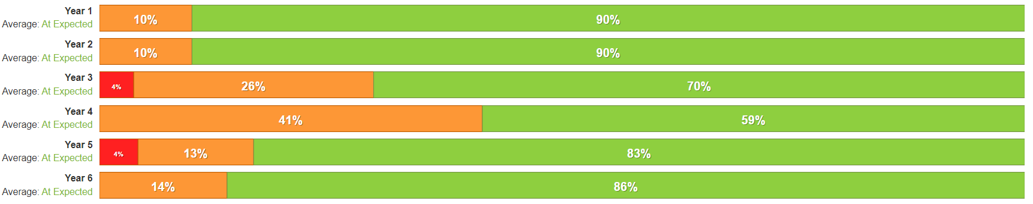
Whole School Progress
Individual Class progress | 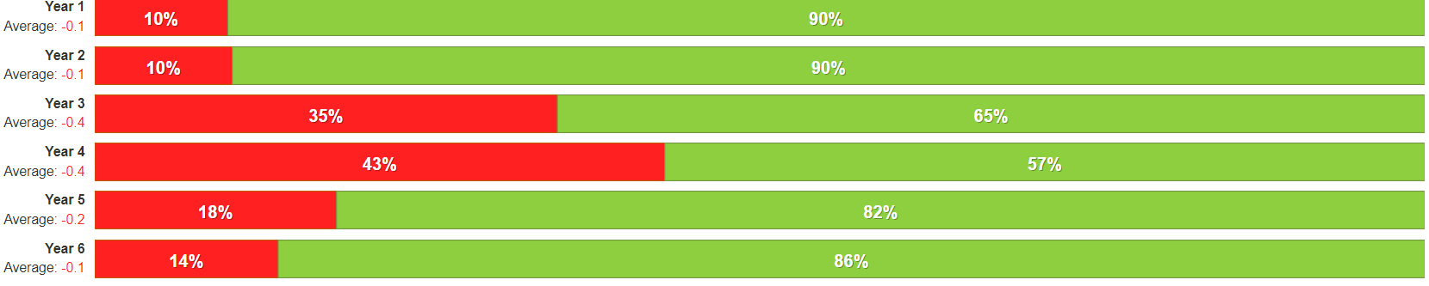

Priorities | Success Criteria
Priority 1: To have clear evidence of progression in Music across all year groups and phases. | 1a. Lesson observations evidence a progressive curriculum that builds upon prior learning.  1b. Work sampling evidence a broad curriculum which is progressive across all year groups.  1c. Clear evidence of progress in all key concepts, knowledge and skills in Music.  1d. Pupil voice demonstrates children are able to talk confidently about their past and current learning, using subject specific and age-appropriate language.
Priority 2: To engage learners with the Music curriculum by ensuring the Music curriculum has exciting breadth. | 2a. Staff have a clear understanding of the definition of ‘breadth’ in the Music curriculum.  2b. Every year group has a wide range of learning opportunities which deepen their understanding.  2c. Children enjoy a range of engaging and inspiring Music activities/trips.  2d. Music performances promote new learning and Musical skills.
Priority 3: To ensure all SEND pupils are able to access the Music curriculum/lessons. | 3a. All teaching specialists have an understanding of the needs of SEND pupils at Roby Park to help support their engagement and success.  3b. SEND pupils access Music curriculum and lessons through the use of adapted resources, instruments and lessons.
Priority 4: To develop non-Music specialists. | 4a. Increased confidence in non-Music specialists.  4b. Enhanced opportunities delivered through the EYFS continuous provision.  4c. Adopted Music vision amongst all staff members.  4d. Clearly defined end points for all year groups understood by all.

Priority 1: To have clear evidence of progression in Music across all year groups and phases.
1a. Lesson observations evidence a progressive curriculum that builds upon prior learning.
1b. Work sampling evidence a broad curriculum which is progressive across all year groups.
1c. Clear evidence of progress in all key concepts, knowledge and skills in Music.
1d. Pupil voice demonstrates children are able to talk confidently about their past and current learning, using subject specific and age appropriate language.

Improvement Aspect | Actions | Personnel | Resources | Timescales
 |  |  |  | Start | Finish
1a. Lesson observations evidence a progressive curriculum that builds upon prior learning. | Monitoring timetable established for Music to cover programme of lesson observations, work sampling and pupil voice. | LC | Subject Leadership Time | December 2022 | Ongoing
 | Monitoring undertaken in conjunction and supported by members of the SLT. | LC | Subject Leadership Time | December 2022 | Ongoing
 | Subject lead to ensure each year group is reviewed when monitoring subject. | LC | Subject Leadership Time | December 2022 | Ongoing
 | Subject lead to give feedback to specialist teacher, in order to develop teaching practise. | LC | Subject Leadership Time | December 2022 | Ongoing
 | Dual Coding is embedded, ensuring children retain relevant sticky knowledge and are able to use age-appropriate subject specific vocabulary linked to their units of learning. | LC  Junior Jam Specialists | Subject Leadership Time  Curriculum Time  PDM/Twilight Time | September 2024 | Ongoing
1b. Work sampling evidence a broad curriculum which is progressive across all year groups. | Class teachers/TA to upload evidence onto class seesaw page. | Class Teachers  TAs |  | September 2022 | On going
 | Subject lead to ensure evidence of Music is being uploaded. | LC | Subject Leadership Time | September 2022 | Ongoing
 | Subject lead to review evidence, to ensure evidence relates to data and is of good quality. | LC | Subject Leadership Time | December 2022 | Ongoing
1c. Clear evidence of progress in all key concepts, knowledge and skills in Music. | Expectations of evidence explained to staff at PDM. Then followed up. | LC | PDM/Twilight Time | February 2023 | Ongoing
 | Evidence should clearly demonstrate progression (beginning of the unit, middle of the unit & end of unit). | Class Teachers  TA | Seesaw | September 2022 | Ongoing
 | All evidence to be uploaded onto Seesaw and will be monitored by subject lead. | Class Teachers  TAs  LC | Seesaw  Subject Leadership Time | September 2022 | Ongoing
1d. Pupil voice demonstrates children are able to talk confidently about their past and current learning, using subject specific and age-appropriate language. | Subject lead to complete pupil voice in line with the monitoring timetable. | LC | Subject Leadership Time | December 2022 | Ongoing
 | Pupil voice to be specific on learning (use planning from Junior Jam to ask specific questions and let them demonstrate) | Louis C | Subject Leadership Time | August  2023 | Ongoing

Priority 2: To engage learners with the Music curriculum by ensuring the Music curriculum has exciting breadth.
2a. Staff have a clear understanding of the definition of ‘breadth’ in the Music curriculum.
2b. Every year group has a wide range of learning opportunities which deepen their understanding.
2c. Children enjoy a range of engaging and inspiring Music activities/trips.
2d. Music performances promote new learning and Musical skills.

Improvement Aspect | Actions | Personnel | Resources | Timescales
 |  |  |  | Start | Finish
2a. Staff have a clear understanding of the definition of ‘breadth’ in the Music curriculum. | Subject lead to share the definition of ‘breath’ in the Music curriculum and what that looks like at Roby Park in PDM. | LC | PDM/Twilight Time | March  2023 | March  2023
 | Subject lead to work with year group teachers to identify where in the curriculum we could include more Music breadth. | LC | PDM/Twilight Time | March  2023 | Ongoing
2b. Every year group has a wide range of learning opportunities which deepen their understanding. | Music lessons & curriculum to provide a wide range of learning opportunities. | Junior Jam Specialist  LC | Curriculum Time | September 2022 | Ongoing
 | Clear adaptation between year groups learning opportunities, taking into account progressive curriculum, children’s needs and implementing Send in My Subject Strategies. | Junior Jam Specialist  Louis C | Subject Leadership Time  Curriculum Time | September 2022 | Ongoing
2c. Children enjoy a range of engaging and inspiring Music activities/trips. | Educational visits, visitors and breadth opportunities identified and included in planning for every year group. | LC  SLT | Subject Leadership Time | September  2024 | Ongoing
 | Subject lead to discuss with class teachers and SLT to identify where we can find opportunities to promote Music as a career. | LC  SLT | Subject Leadership Time | September  2024 | Ongoing
2d. Music performances promote new learning and Musical skills. | Class assemblies to include a Musical element. | Class Teachers |  | September  2022 | Ongoing
 | Perform an end of unit Music showcase to promote pupils learning in class lessons. | SLT  Louis Couling | Curriculum Time  Subject Leadership Time | September  2024 | Ongoing
 | In class, Music performances to be used as evidence and placed on seesaw/social media to promote Music. | Class Teachers | Social media | December 2023 | Ongoing
 | Raise the profile of Music achievements across the school. | LC | Subject Leadership Time  Newsletters  Social Media | September  2024 | Ongoing

Priority 3: To ensure all SEND pupils are able to access the Music curriculum/lessons.
3a. All teaching specialists have an understanding of the needs of SEND pupils at Roby Park to help support their engagement and success.
3b. SEND pupils access music curriculum and lessons through the use of adapted resources, instruments and lessons.

Improvement Aspect | Actions | Personnel | Resources | Timescales
 |  |  |  | Start | Finish
3a. All teaching specialists have an understanding of the needs of SEND pupils at Roby Park to help support their engagement and success. | Provide Music specialist up to date class context sheets to inform him of the needs of the SEND pupils in each class and discuss needs.  Share SEND in My Subject strategies with specialist teacher. | KL  LC  Junior Jam Specialist | Class Context Sheets  Subject Leadership Time | December 2023 | Ongoing
 | Music specialist to have meeting with SENCO to discuss/arrange strategies to support teaching of SEND pupils in Music. | KL & LC  Junior Jam Specialist | Class Context Sheets  Subject Leadership Time | December 2023 | Ongoing
 | Have evidence to show adaptations that are made for some children in Music – evidencing strategies outlined in SEND in My Subject. | Class Teachers  TAs  KL  Junior Jam Specialist  LC | SEND in My Subject Document  Subject Leadership Time  Curriculum Time | September  2024 | Ongoing
3b. SEND pupils access music curriculum and lessons through the use of adapted resources, instruments and lessons. | Subject lead and specialist teacher to discuss the Music curriculum and plan adapted resources/instruments to allow SEND pupils to access the Music curriculum and lessons. | Junior Jam Specialist  LC | Subject Leadership Time | August  2023 | Ongoing
 | Subject lead to feedback to SLT on the adapted resources/instruments to allow the SEND pupils to access the Music curriculum and lessons. | LC | Subject Leadership Time | August  2023 | Ongoing
 | Invest in adapted resources/instruments to allow SEND pupils to access the Music curriculum and lessons. | LC  Junior Jam Specialist | Funding | September  2024 | Ongoing

Priority 4: To develop non-Music specialists.
4a. Increased confidence in non-Music specialists.
4b. Enhanced opportunities delivered through the EYFS continuous provision.
4c. Adopted Music vision amongst all staff members.
4d. Clearly defined end points for all year groups understood by all.

Improvement Aspect | Actions | Personnel | Resources | Timescales
 |  |  |  | Start | Finish
4a. Increased confidence in non-Music specialists. | Staff audit of confidence  and subject knowledge in  Music. | LC  Class Teachers | PDM/Twilight Time | September  2024 | Ongoing
 | Subject lead to lead PDM with a focus on developing Music subject knowledge. | LC | PDM/Twilight Time | September  2024 | Ongoing
 | Subject lead to produce a CPD timetable to help support non-Music specialists. | LC | PDM/Twilight Time | September  2024 | Ongoing
 | Class teachers to observe Music specialist to help develop their understanding. | Class Teachers  Junior Jam Specialist | Curriculum Time | September  2024 | Ongoing
4b. Enhanced opportunities delivered through the EYFS continuous provision. | Subject lead to liaise with head of EYFS and nursery teacher to analyse how Music is being used within continuous provision. | LC  GL/AW  KM | Subject Leadership Time | September  2024 | Ongoing
 | Develop subject leads understanding of Music in EYFS through CPD. | LC  GL/AW & KM | CPD | March  2023 | Ongoing
 | Continue to invest in Music resources for indoor and outdoor EYFS learning environments. | GL & KM |  | September 2023 | Ongoing
4c. Adopted Music vision amongst all staff members | Subject vision has been updated and agreed upon by SLT. | LC  SLT | Subject Leadership Time | Autumn  2023 | Autumn  2023
 | Subject vision to be shared with all members of staff, including Junior Jam specialist. | LC | Subject vison | Feb 2023 | Ongoing
 | Subject lead to lead PDM that explains Music vision and ensures staffs understanding. | LC | PDM/Twilight Team | Spring  2023 | Spring  2023
4d. Clearly defined end points for all year groups understood by all. | Subject lead to lead PDM explaining progression in Music across all year groups. | LC | PDM/Twilight Team | Spring  2023 | Spring  2023
 | Progression map/ knowledge organisers shared with class teachers that explain progression in each unit. | LC  Class Teachers | Subject Leadership Time  PDM/Twilight Time | April  2023 | Ongoing
 | Subject lead to demonstrate how to use Junior Jam website to show Class teachers how to access progression maps, plans and data. | LC  Class Teachers | PDM/Twilight Team | Spring  2023 | Ongoing (when needed)

