Pupil premium strategy statement - 2023-2026
This statement details our school’s use of pupil premium (and recovery premium) funding to help improve the attainment of our disadvantaged pupils.
It outlines our pupil premium strategy, how we intend to spend the funding and the effect that last year’s spending of pupil premium had within our school.

School overview
Detail | Data
School name | Roby Park Primary School
Number of pupils in school | 224 – October 23 Census
Proportion (%) of pupil premium eligible pupils | 54.3%
Academic year/years that our current pupil premium strategy plan covers (3-year plans are recommended) | 2023-2026
Date this statement was published | 4.3.24
Date on which it will be reviewed | 4.3.25
Statement authorised by | Kat Allen (HT)
Pupil premium lead | Kathy Lyon (DHT)
Governor | Rachel Riley (Chair of Governors)

Funding overview
Detail | Amount
Pupil premium funding allocation this academic year | £155,304
Recovery premium funding allocation this academic year | £0
Pupil premium funding carried forward from previous years (enter £0 if not applicable) | £0
Total budget for this academic year  If your school is an academy in a trust that pools this funding, state the amount available to your school this academic year | £155,304

Part A: Pupil premium strategy plan

Statement of intent
Roby Park is a vibrant and happy school with a hardworking, enthusiastic, and dedicated staff team. Roby Park is an inclusive school with a strong ethos and set of values. All our children are equally important and we encourage and celebrate our differences. Roby Park’s foundation values are at the heart of our school and everything we do. We aim to provide a caring, stable and intellectually stimulating environment where all children can develop their individual potential. All the staff are passionate about ensuring that the children at school are happy, successful and are making a positive contribution.

We are a one form entry primary school in Huyton, Knowsley, in an area of significant deprivation and children can start school with us from 3 years of age. 54.3% of our pupils are in receipt of FSM whilst 32.1% of children have SEND compared to 16% nationally (23/24). The vast majority of our children start school with very low-level language skills.

For us, early intervention is key, and we are focusing on language development in all its forms with a clear emphasis on vocabulary, oracy/speaking and reading. We are constantly looking to refine and improve practice in this area whilst also providing targeted interventions to struggling learners. We strongly believe our curriculum is our children’s opportunity and we aim to provide the knowledge, skills, and opportunities to create a level playing field and improve the life chances for all our educationally disadvantaged pupils.

We have a strong ethos of inclusion and crucially a compassionate approach towards engaging and supporting our children and parents. There is a collective understanding of the impact of disadvantage on pupils’ learning and staff at all levels understand our ambition for all our pupils and they all fully understand the part they play in addressing educational disadvantage.

Through leadership capacity, there is a sharp focus on the quality of pupils’ learning experiences and cultural capital opportunities. Our leadership team play a significant role in evaluating progress through ongoing, and crucially, supportive monitoring and quality assurance. They devote time to our staff for collaborative planning, teaching, and modelling by spending time in classrooms to provide on the spot coaching, training, and immediate feedback to develop practice, where needed. Bespoke CPD is invested in to ensure our staff are equipped with the knowledge and skills required to provide the best teaching and learning they can.

A clear, shared understanding of strategic milestones and goals, set out at the start of the strategy, enable constructive conversations between staff members and governors. This interacts positively with partnership/school-improvement work with organisations such as schools in Central Area Collaborative and curriculum reviews with organisations such as Literacy Counts, Maths Hub NW3 and School Improvement Liverpool. It means quality assurance is unequivocally purposeful, transparent, and focussed on the main thing, improving teaching and learning.

Challenges
This details the key challenges to achievement that we have identified among our disadvantaged pupils.
Challenge number | Detail of challenge
1 | On entry to Nursery and Reception, for many years, baselines reflect a significant number of pupils assessed as below in communication and language. For example, in September 2023, only 50% of Nursery children and 45% of Reception were at age related expectations as reflected in their Wellcomm baselines. All disadvantaged pupils in Reception were working below age related. Assessments, observations, and discussions with pupils indicate under-developed oral language skills and vocabulary gaps among many disadvantaged pupils from YN through to KS2 and in general, are more prevalent among our disadvantaged pupils than their peers .
2 | Our assessments and observations indicate that the education and well-being of many of our disadvantaged pupils was impacted by partial closures to a greater extent than for other pupils. These findings are supported by national studies.  We are incredibly proud of our end of year KS2 results for 22/23. Our Roby Park PP children performed better than our NPP children in all areas as well as combined RWM. Our PP children also outperformed their PP counterparts nationally at RWM – 77% compared to 66%. KS1 & EYFS outcomes at ARE continue to improve year on year, for our disadvantaged pupils. and our ambition is to try to reduce the PP gap further in years to come.
3 | Our assessments, observations and discussions with pupils and families have identified social and emotional issues for many pupils. These challenges particularly affect disadvantaged pupils, including their attainment. Teacher referrals for support have markedly increased during the pandemic, from September 2023 for example, 41 pupils currently require additional support with social and emotional needs which could be anywhere between requiring grounding activities, 1:1 support/check-ins with staff, counselling or CAMHs. Currently 9 children have received access to counselling/play therapy this year with a further 8 on the waiting list which increases with each half term. Due to complexities around issues, children are requiring support for longer periods of time. 61% of all the pupils currently requiring additional support are disadvantaged with 39% on SEN register.
4 | Our overall attendance in 2022/23 has risen to 93.7% from 91.9% in 2021/22, this is still however, below the national target and well below the schools’ own target of 96%. As you can see, attendance for all our pupils still needs to improve which is why whole school attendance and persistence absenteeism remains a focus of this current plan. Our assessments and observations indicate absenteeism is negatively impacting disadvantaged pupils’ progress and we know what goes on in the classroom on a daily basis makes the biggest difference to our children so we will always strive for excellent attendance for all.

Intended outcomes
This explains the outcomes we are aiming for by the end of our current strategy plan, and how we will measure whether they have been achieved.

Intended outcome | Success criteria
Improved communication, language and vocabulary among disadvantaged pupils. | Assessments and observations indicate significantly improved language among disadvantaged pupils. This is evident when triangulated with other sources of evidence including C&L assessments, engagement in lessons, work samples and ongoing formative assessment.
Sustained improvement in reading, writing and maths attainment for disadvantaged pupils at the end of KS1 & KS2. | KS1 & KS2 reading, writing and maths outcomes in 2024/25 show that more disadvantaged pupils meet the expected standard.
To achieve and sustain improved wellbeing for all pupils in our school, particularly our disadvantaged pupils. | Sustained high levels of wellbeing from 2024/25 demonstrated by:  - Qualitative data from pupil voice, pupil and parent surveys and teacher observations  - A significant increase in participation in enrichment activities, particularly among disadvantaged pupils
To achieve and sustain improved attendance for all pupils, particularly our disadvantaged pupils. | Sustained high attendance from 2024/25 demonstrated by:  - The overall absence rate for all pupils being no more than 4% and there will be no gap in attendance for our disadvantaged pupils.  - The percentage of all pupils who are persistently absent being in line with national and the figure among disadvantaged pupils being no lower than their peers.

Activity in this academic year
This details how we intend to spend our pupil premium this academic year to address the challenges listed above.

Teaching (for example, CPD, recruitment and retention)

Budgeted cost: £77,836.60
Activity | Evidence that supports this approach | Challenge number(s) addressed
Additional support staff in EY & KS1 to deliver speech and language intervention.  Additional support staff to reduce group sizes in classes and provide ongoing SEMH support.  Continue to embed high quality adult/child interactions in the early years and across the school.  Continue to enhance our language rich learning  environments.  Introduce well targeted Walkthrus to enhance inclusive practice and participation for all in lessons – questioning, explicit vocabulary teaching, retrieval.  Purchase resources and fund ongoing high-quality teacher training (Early Excellence, Literacy Counts, Elklan, School Improvement Liverpool, EY2P, Maths Hub NW3 and Walkthrus).  Visit other excellent schools in Knowsley & Liverpool.  Keep up to date with all relevant research.  Take an active part in the  EPA Project, focusing on prioritising speech and language strategies to bring high quality inclusive practice into the classroom on a daily basis. | There is strong evidence that the rate at which children develop language is sensitive to the amount of input they receive from the adults and peers around them. The number and quality of conversations children have with adults and peers throughput the day in a language rich environment is crucial.  https://educationendowmentfoundation.org.uk/news/eef-blog-the-shrec-approach-4-evidenceinformed-strategies-to-promote-high-quality-interactions-with-young-children  https://educationendowmentfoundation.org.uk/public/files/Law_et_al_Early_Language_Develop ment_final.pdf  Teaching by Listening: The Importance of Adult-Child Conversations to Language Development  Frederick J. Zimmerman, Jill Gilkerson, Jeffrey A. Richards, Dimitri A. Christakis, Dongxin Xu, Sharmistha Gray and Umit Yapanel  Early Excellence – ‘Navigating a sea of Talk’  https://earlyexcellence.com/latest-news/pressarticles/navigating-the-sea-of-talk/  Professor Julie Fisher – ‘interacting or interfering’  https://www.mheducation.co.uk/interacting-or-interfering-improving-interactions-in-the-earlyyears-9780335262564-emea-group  Changing educational practice in the early years through practitioner-led action research: an Adult-Child Interaction Project  Supporting oral language development - EEF  There is a strong evidence base that suggests oral language interventions, including dialogic activities such as high-quality classroom discussion, are inexpensive to implement with high impacts on reading:  Oral language interventions | Toolkit Strand | Education Endowment Foundation | EEF  Deepening knowledge through vocabulary training:  https://impact.chartered.college/article/beck-deepening-knowledge-through-vocabulary-learning/  Language for behaviour and emotions (Word Aware):  https://www.routledge.com/Language-for-Behaviour-and-Emotions-A-Practical-Guide-toWorking-with-Children/Branagan-Cross-Parsons/p/book/9780367331832  Accountable talk (Resnick)  https://www.researchgate.net/publication/324830361_Accountable_Talk_Instructional_dialogue_ that_builds_the_mind  Collaborative learning - EEF  https://educationendowmentfoundation.org.uk/evidence-summaries/teaching-learningtoolkit/collaborative-learning/  Walkthrus  https://www.walkthrus.co.uk/  Mastery Learning – EEF  The impact of mastery learning approaches is an additional five months progress, on average, over the course of a year.  https://educationendowmentfoundation.org.uk/education-evidence/teaching-learning-toolkit/mastery-learning | 1, 2 & 3

Targeted academic support (for example, tutoring, one-to-one support structured interventions)

Budgeted cost: £33,425
Activity | Evidence that supports this approach | Challenge number(s) addressed
Additional phonics sessions targeted at educationally disadvantaged pupils who require further phonics support (1:1 and group sessions).  Regular bespoke external training led by experienced Hodder and Literacy Counts consultant at least 6 x a year for staff across the school.  Additional reading, maths and precision teaching sessions targeted at educationally disadvantaged pupils who require further phonics support (1:1 and group sessions). | Phonics approaches have a strong evidence base indicating a positive impact on pupils, particularly from disadvantaged backgrounds. Targeted phonics interventions have been shown to be more effective when delivered as regular sessions over a period up to 12 weeks:  Phonics | Toolkit Strand | Education Endowment Foundation | EEF  Reading Comprehension Strategies - EEF  Reading comprehension strategies are high impact on average (+6 months). Alongside phonics it is a crucial component of early reading instruction.  https://educationendowmentfoundation.org.uk/education-evidence/teaching-learning-toolkit/reading-comprehension-strategies  Oral Language Interventions - EEF  he average impact of Oral language interventions is approximately an additional six months’ progress over the course of a year. Some studies also often report improved classroom climate and fewer behavioural issues following work on oral language.  https://educationendowmentfoundation.org.uk/education-evidence/teaching-learning-toolkit/oral-language-interventions  Teaching Assistant Interventions - EEF  Teaching assistants can provide a large positive impact on learner outcomes.  https://educationendowmentfoundation.org.uk/education-evidence/teaching-learning-toolkit/teaching-assistant-interventions | 2

Wider strategies (for example, related to attendance, behaviour, wellbeing)

Budgeted cost: £48,684
Activity | Evidence that supports this approach | Challenge number(s) addressed
 |  | 3 & 4
Provide 1:1 counselling, yoga & Lego therapy sessions for vulnerable pupils led by skilled and experienced professionals both within school.  Train Wellbeing Champions for each year group through One Goal.  Embed Zumos so children can communicate wellbeing needs to staff each morning.  Parental engagement workshops.  Provide a range of extra-curricular activities that focus in health and wellbeing.  Provide free spaces to disadvantaged pupils at holiday camps.  Implement and embed Inclusive Attendance CPD for all staff to improve attendance rates.  Implement the OPAL programme to develop play, impacting on health and wellbeing.  Subsidise the costs of all cultural capital opportunities.  Whole school swimming lessons. | There is evidence to suggest that targeted school-based interventions have led to improvements in wellbeing and mental health, yielding reduced levels of school exclusion by 31% and improved pupil attainment (Banerjee et al., 2014)  Research indicates that school-based counselling is perceived by children and pastoral care staff as a highly accessible, non stigmatising and effective form of early intervention for reducing psychological distress (Cooper, 2009)  Parental Engagement – EEF  Parental engagement has a positive impact on average of 4 months’ additional progress.  https://educationendowmentfoundation.org.uk/education-evidence/teaching-learning-toolkit/parental-engagement

Total budgeted cost: £159,945.60

Part B: Review of outcomes in the previous academic year

Pupil premium strategy outcomes
This details the impact that our pupil premium activity had on pupils in the 2022 to 2023 academic year.

EYFS:
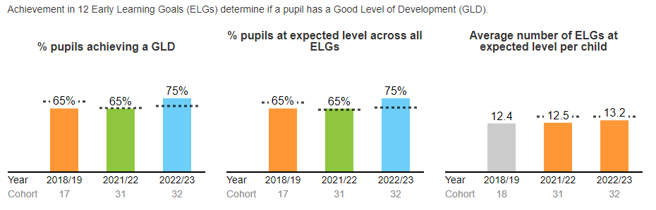

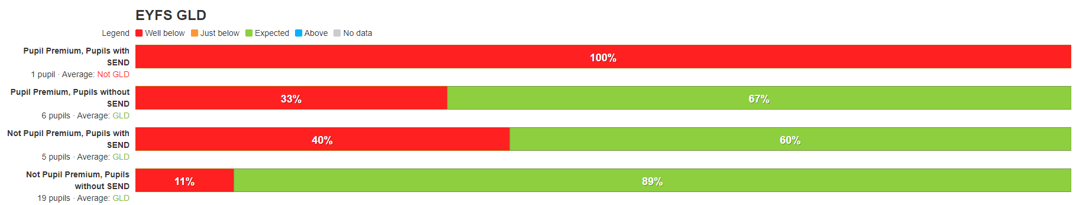

KS1:
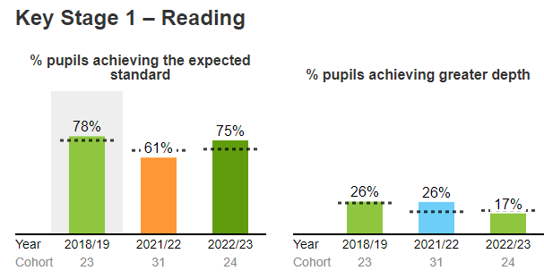
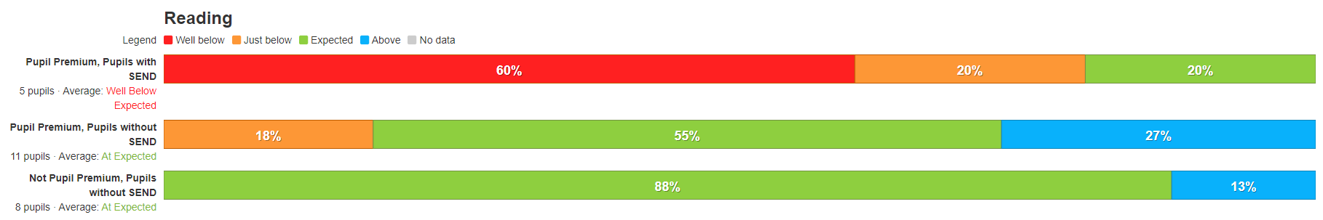
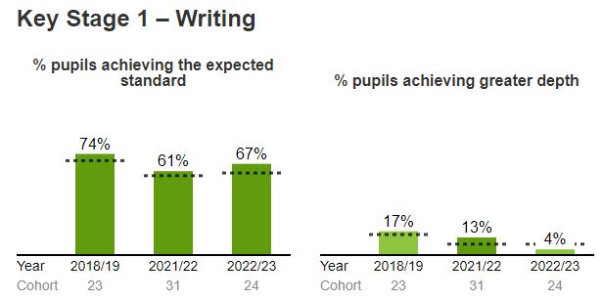

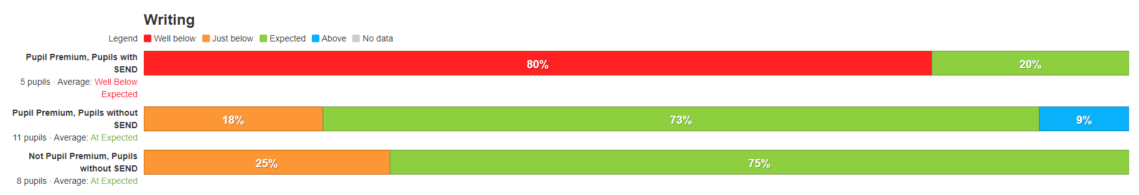
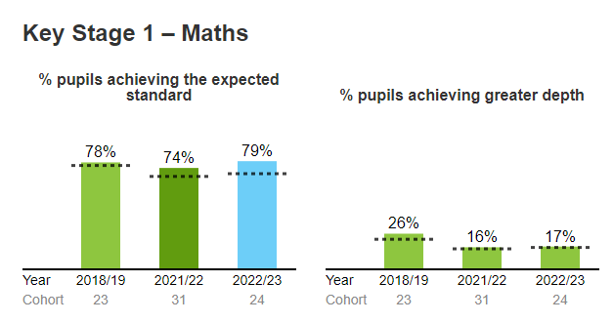
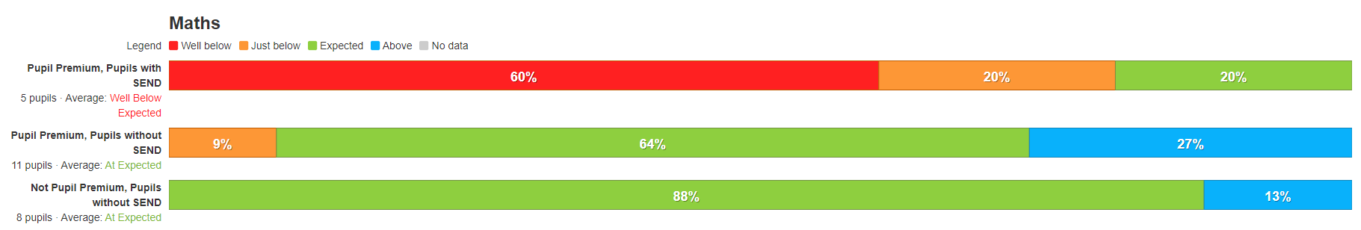
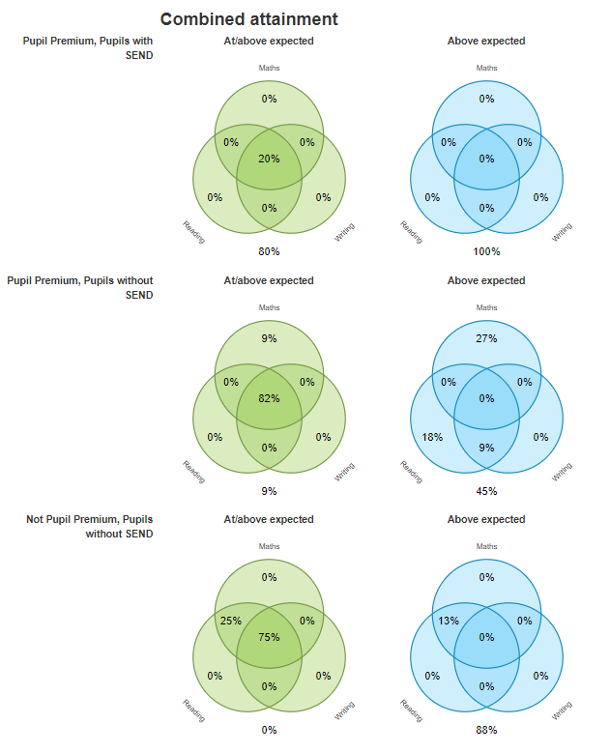
KS2:
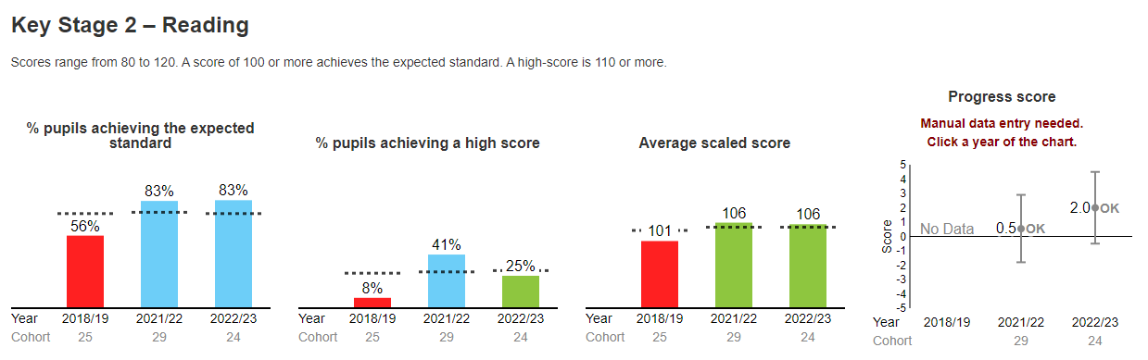
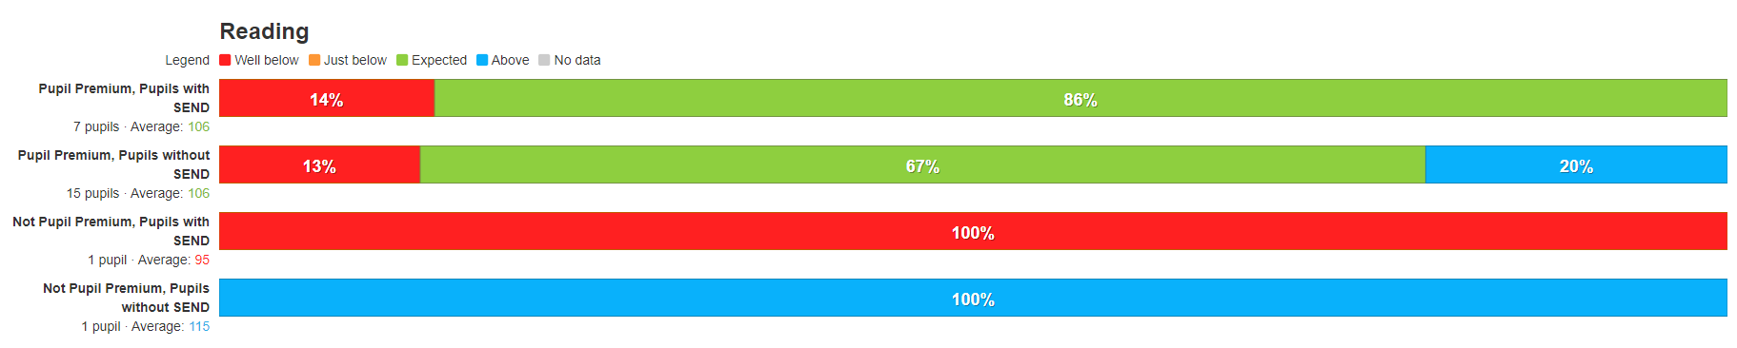
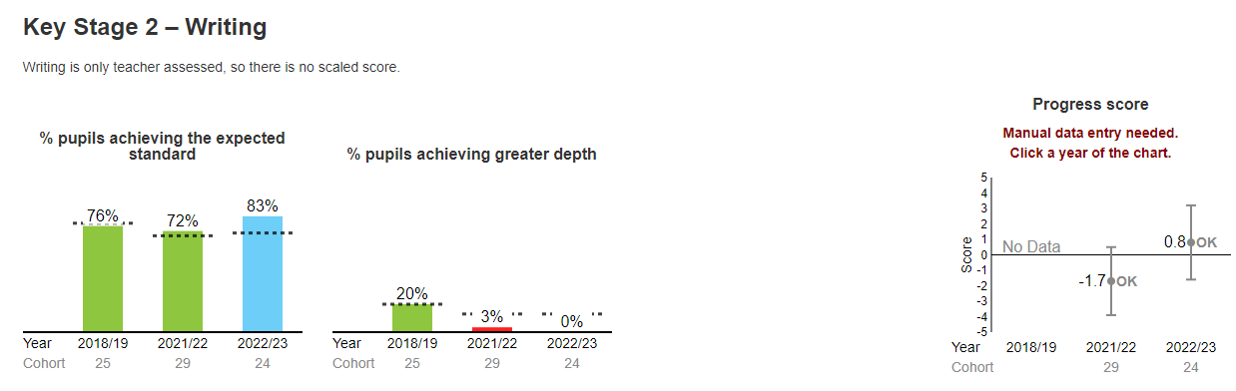
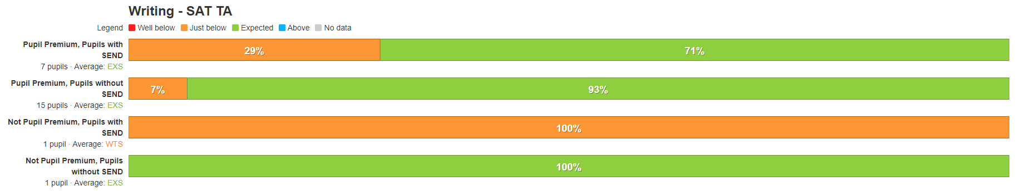
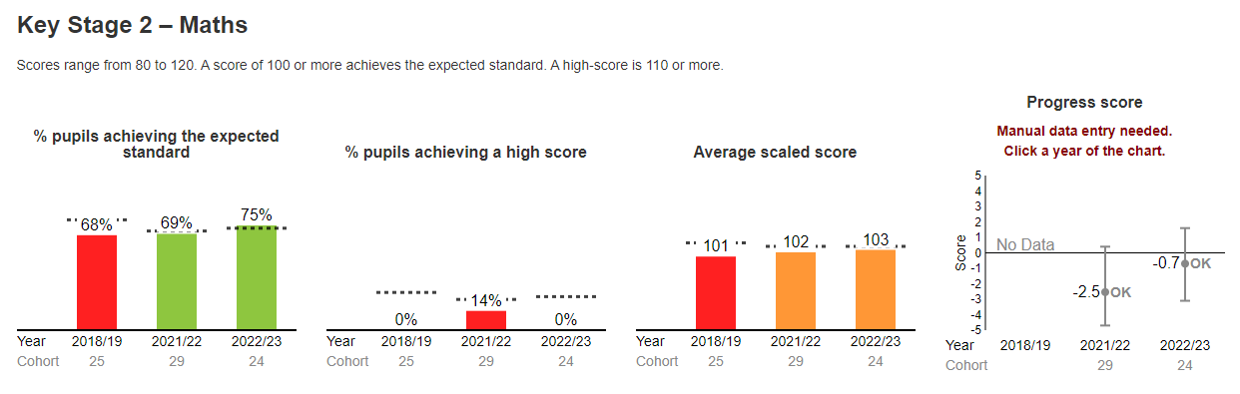
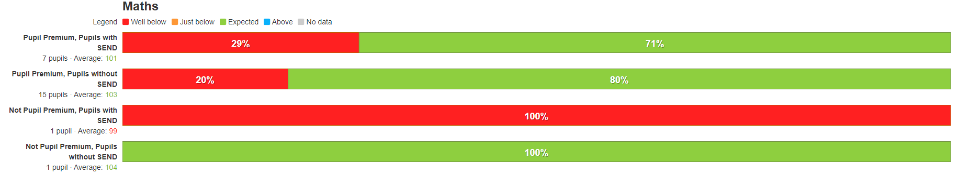

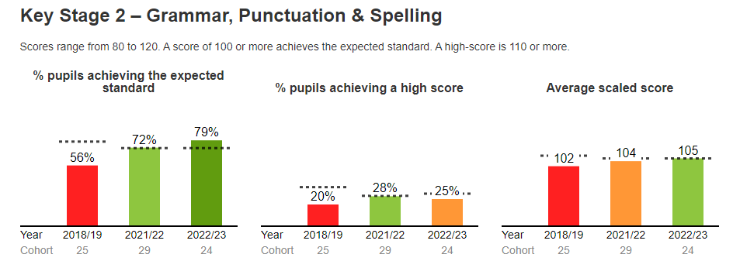

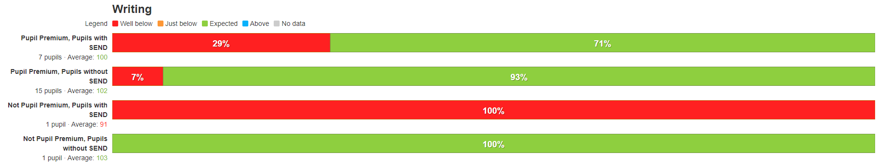
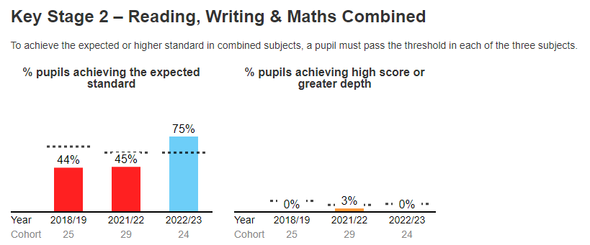

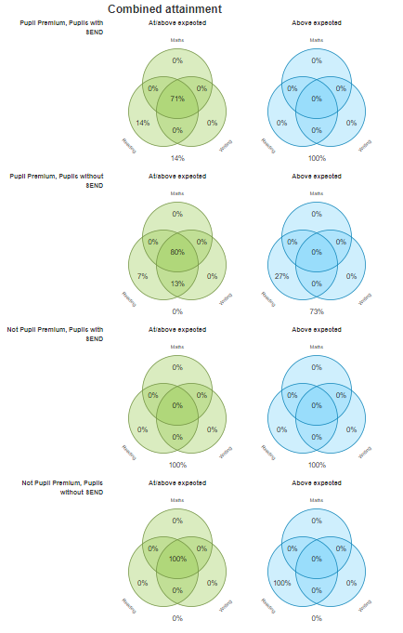

Externally provided programmes
Please include the names of any non-DfE programmes that you purchased in the previous academic year. This will help the Department for Education identify which ones are popular in England
Programme | Provider
Ready Steady Read | Literacy Counts
Ready Steady Write | Literacy Counts
White Rose Maths | White Rose Hub
Power Maths | Pearson
Kapow – Computing, Art, DT | Kapow
Early Years Training | Early Excellence
Curriculum CPD | School Improvement Liverpool, Literacy Counts, Hodder
Developing Experts - Science | Developing Experts
Rocket Phonics | Hodder
Language Angels - Spanish | Language Angels

