**Feedback & Marking Policy**

Written September 2024

Review September 2025

Signed – Mrs Kat Allen

(Headteacher)

Signed – Mr Frank Walsh

(Chair of Governors)

**Introduction**

This policy document sets out Roby Park’s principles and strategies for feedback throughout the school. This policy will be reviewed at regular intervals and updated as necessary by the SLT and subject leaders.

**Feedback**

Dylan Wiliam, “The main role of feedback, at least in schools, is to improve the learner, not the work.”

Meaningful feedback supports pupil progress, building learning, addressing misconceptions, and thereby closing the gap between where the pupil is and where the teacher wants them to be. Feedback is a crucial component of high-quality teaching across the curriculum. Based on professional judgement, feedback can be provided in a variety of different ways. It can:

* focus on different **content**;
* be delivered in different **methods**;
* be directed to different **people**; and
* be delivered at different **times**.

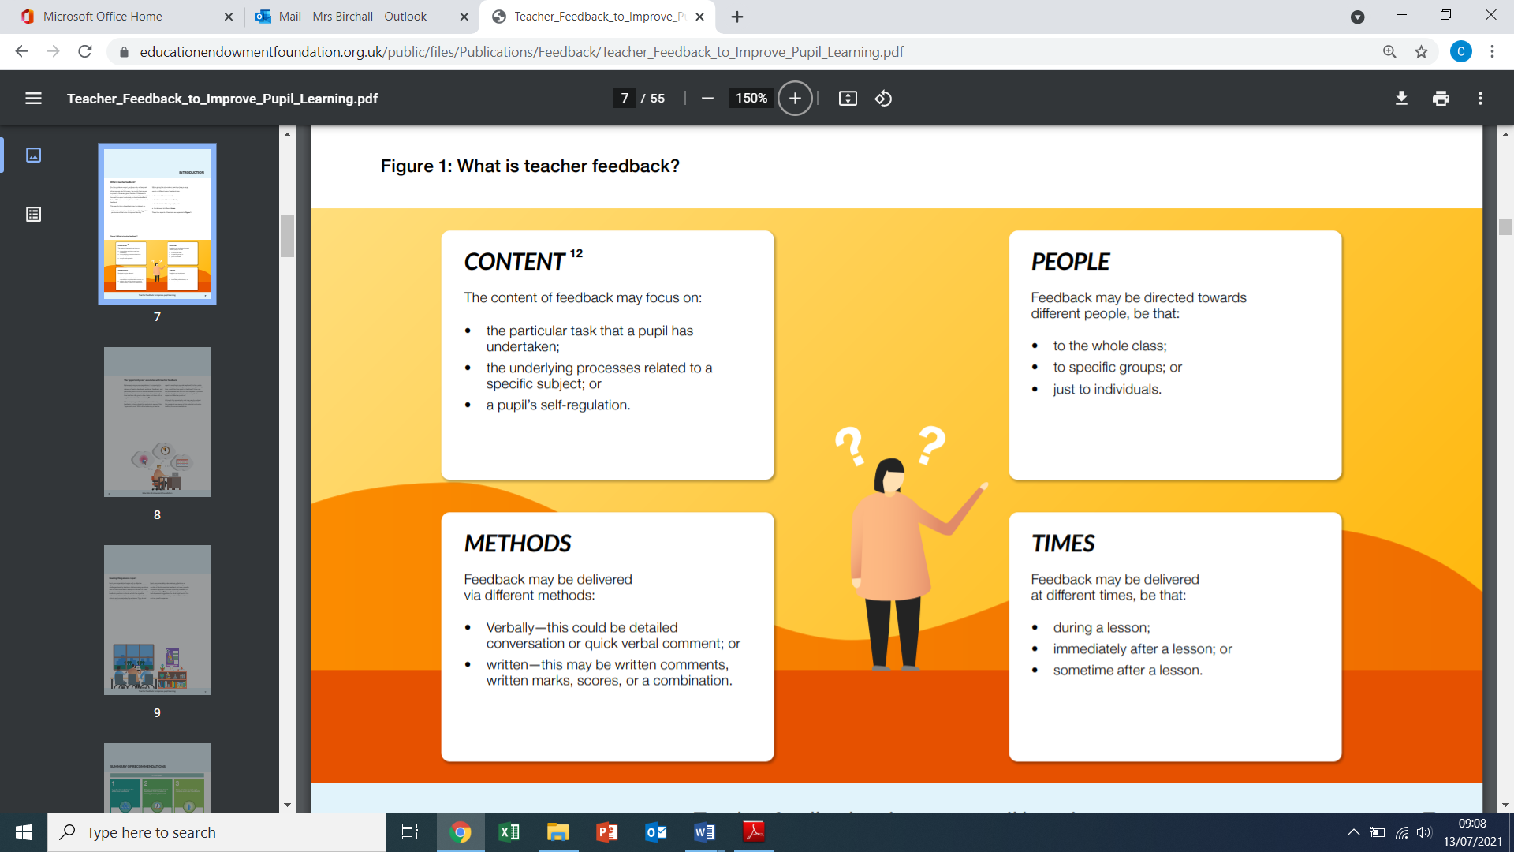

**Aims of this policy**

We aim to create a culture of effective feedback in order to maximise the impact on learning through the use of a wide range of approaches which research and evidence suggest are the most effective.

This policy recognises the significant time that written feedback can take and therefore seeks to make the most effective use of teacher time. This policy recognises that teachers are professionals

* Feedback forms an integral part of the process of responsive teaching which is evident in all lessons.
* Feedback is a two-way process: teachers will learn and be able to adapt their instruction from the feedback they receive from pupils within lessons; pupils will be able to learn from effective feedback they receive.
* It is primarily a verbal process that takes place between teachers and pupils.
* It is given where there is time and opportunity for pupils to respond to the feedback they have received.
* It will look different in different year groups and curriculum areas across school and be ‘age appropriate’ *e.g PE feedback would be wholly verbal.*
* It is based on a thorough understanding of individual pupils and their learning and may focus on the task, subject and self-regulations strategies.
* Feedback should ultimately aim to improve the pupils’ knowledge and understanding as opposed to simply improving the pupils’ work.

It is approached systemically, and specifically, by adopting three fundamental principles:

1. **Lay the foundations for effective feedback, with high-quality initial teaching that includes careful formative assessment**
2. **Deliver appropriately timed feedback, that focuses on moving learning forward**
3. **Plan for how pupils will receive and use feedback using strategies to ensure that pupils will act on the feedback offered.**
4. **Laying the foundations of effective learning**

* To offer effective feedback, teachers must first lay the foundations. Specifically, they will provide high quality instruction, including two formative assessment strategies:
* Set learning intentions (which feedback will aim towards), ensuring that learning intentions and success criteria are clarified, shared and understood.
* Assess learning gaps (which feedback will address) in order to target these weaknesses. This requires carefully designed tasks, activities and effective questioning.

1. **Deliver appropriately timed feedback that focuses on moving learning forward**

Timing of feedback can be categorised into the following three stages:

* ***Immediate feedback***: This takes place during a lesson and allows teachers to adapt their teaching and give feedback at the point of teaching.
* ***Summary feedback*:** This may take place at the end of a lesson. It may involve some form of self/peer assessment.
* ***Distance feedback*:** This takes place away from the lesson and provides feedback to the teacher about how well pupils have understood concepts. This, in turn, informs planning for future learning opportunities which includes the use of whole class feedback sheets to focus on the next steps for the whole class, groups or for individuals.

|  |  |
| --- | --- |
| **Type of feedback** | **What it might look like** |
| **Immediate** | ***Takes place within lessons as part of teaching.***  Includes teacher gathering feedback from verbal responses, ipads, book work, whiteboards, etc.  Takes place in lessons with individuals, small groups or the whole class.  Is given verbally so that the impact can be immediate.  May be given by teaching assistants, other adults or peers  May involve further support, challenge or a change of task  May re-direct the focus of teaching or the task. |
| **Summary** | ***Takes place at the end of a lesson or activity.***  Provides an opportunity for evaluation of learning in the lesson  May take the form of self- or peer- assessment against an agreed set of success criteria  In some cases, may guide a teacher’s further use of distance feedback, focusing on areas of need or particular interest. |
| **Distance** | ***Takes place away from the point of teaching***  Provides teachers with opportunities for assessment of understanding.  Adaptation of future lessons through planning, grouping etc– teachers may sort work into different groups to identify where ‘group feedback’ is required in the next session.  The use of teachers’ feedback books to organise feedback and support high quality teaching within the next lessons. |

Feedback will focus on moving learning forward, targeting the task, subject or self- regulation strategies.

1. **Plan for how pupils will receive and use feedback**

The following factors may influence a pupil’s use of feedback:

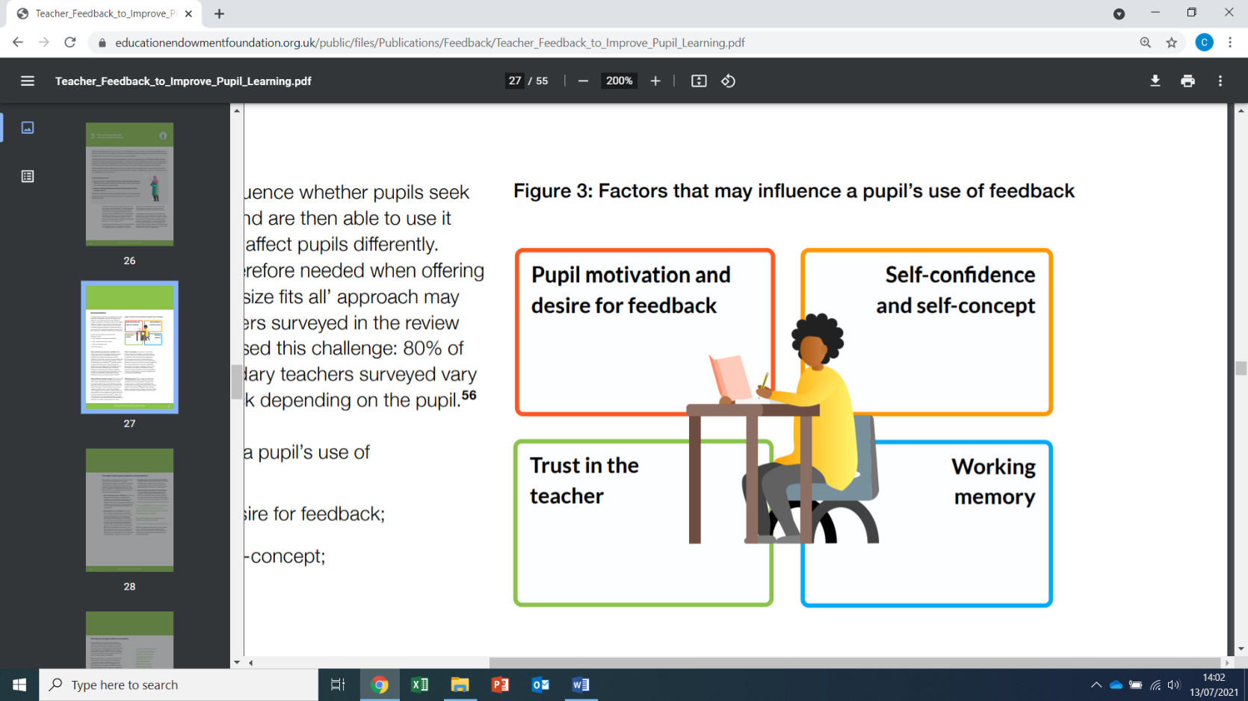

Using their knowledge of individuals, teachers will use a wide range of strategies to meet their needs. They will monitor whether their feedback is being used by pupils. If not, the approach will be adapted to support pupils welcoming and acting on feedback.

Teachers will ensure that pupils are given the time and opportunity to use feedback so that it moves learning forward, using a range of strategies, so that it becomes a ‘recipe for future action.’ This approach closes the feedback loop so that pupil learning can progress.

**Practical Guidance on the approach to distance feedback at Roby Park Primary.**

The teacher then reads each child’s work and analyses errors/ misconceptions being made.

During the book analysis, the teacher makes notes on their teacher’s feedback sheet using the template below. The analysis is used to assess learning gaps. These may be addressed in the next lesson during a short feedback session, giving children dedicated time to correct/ edit/ improve their work It also informs the next steps of the learning journey and may include reteaching. This approach ensures that feedback is timely and actionable. The time saved using this approach can then be used more effectively to plan in light of the feedback.

**Template:**

|  |  |
| --- | --- |
| **Praise and Share** | **Further support** |
|  |  |
| **Presentation** | **Basic Skills Errors** |
|  |  |
| **Misconceptions/ Next Steps** | |
|  | |

**What a ‘feedback session’ may look like –**

Teachers use the feedback sheet to feedback to a class on their previous lesson (this should take approximately 5-10 minutes in a typical lesson although can be significantly longer or shorter dependent on need). The feedback session typically has three layers - individual feedback, group feedback and feedback. A session might contain **some** of the following elements…

1. Share good work picking out the key features perhaps screen share.
2. Share feedback with individuals (teacher or TA)
3. Share feedback with groups (teacher or TA)
4. Share feedback with the whole class
5. Common basic errors may be shared and retaught – e.g. a teacher may write sentence/calculation containing the common mistake rather than using actual pupils’ work and ask pupils to identify the mistake and correct it. Pupils then get the chance for deliberate practice
6. Common misconceptions from previous lesson are shared and re-taught. Pupils may practise the skill on whiteboards etc.
7. Pupils may then respond to the feedback given. Where possible, feedback focuses on improving children’s knowledge and understanding not just improving their previous piece of work.
8. Specific spelling rules may need to be consolidated. Teachers may reteach any words or spelling rules that were spelled incorrectly by groups of pupils.
9. Specific handwriting issues may be addressed. Teachers may model age related joins for children to practise in their handwriting books.

**Symbols**

* on children’s work teachers use green pen
* children write in pencil/ handwriting pen
* children edit work in their ‘fix it time’ purple pen

Where appropriate and necessary by either adult or child:

|  |  |  |  |
| --- | --- | --- | --- |
| **✓** | correct | P | Punctuation error |
| **^** | omission | * | Grammatical error* |
| . | Incorrect |  |  |
| beleive | Spelling error** | believe | Handwriting*** |

*positioned by start of relevant section to support children in responding to feedback

e.g *In writing, a child has written a sentence in the wrong tense by using ‘is’ instead of ‘was’. The teacher models during feedback reading a sentence to check the tense (which was identified previously in success criteria). The child checks the sentence for tense, correcting as needed.*

*The importance here is that the teacher is not telling the child the exact error by underlining ‘is’ but is supporting the child to use the feedback and progress.*

**circle just the mistake – Spelling Corrections will reflect the children’s growing subject skill and knowledge from their phonics and spelling lessons. No more than 5 spelling errors to be highlighted in any one piece of work. Incorrect spellings must be identified from the following: common exception words, phonics and spelling rules taught, Y3/Y4 spelling list. Y5/Y6 spelling list and subject specific vocabulary for foundation subjects. The correct spelling is to be handwritten using age appropriate letter joins next to the margin. Children will then copy the correct spelling along to the end of the line in pencil (KS1) and purple pen (KS2) during fix it time.

*** Incorrect letter joins – where a child has used an incorrect letter join in their writing the error must be circled and an H written in the margin. As with spelling, the word with the age appropriate join is to be handwritten next to the margin. Children will then copy the correct handwriting along to the end of the line in pencil (KS1) and purple pen (KS2) during fix it time.

There should be no more than five spelling/handwriting errors identified in any one piece of writing regardless of how many mistakes are made. It is at the judgement of the teachers which words are corrected but they must reflect the year group and spelling age of the child.

**Highlighting during extended writing**

To indicate exemplary examples of children’s extended writing, two whole sentences will be highlighted in green. This should communicate to the child that they have achieved well in relation to their success criteria.

One whole sentence which needs to be redrafted and improved, should be highlighted in pink.

We want our children to:

* Become immersed in texts and language, speaking and listening and talk for writing before writing
* Be comfortable making mistakes and understand that this is part of the learning process
* Understand that writing takes time and that good writers edit and improve their writing

**Proofreading:** re-reading written work and looking for secretarial mistakes/ correcting. Children may benefit from doing this the next day rather than immediately after writing.

**Editing:** making significant changes to the structure/ content of writing in response to feedback. This may be done in the lesson or the next day.

**Teacher assessment**

When books across the whole curriculum are marked, work should be assessed using a number system:

* 1 = working towards ARE
* 2 = ARE
* 3 = Above ARE

Any discrete teaching e.g. grammar should be marked/ corrected.

Foundation subject work should be acknowledged in line with the marking of English. Verbal or written feedback should be used to correct mistakes/ direct learning.

**Success criteria**

Every piece of work should have the date and title glued in. The success criteria for achieving the learning intentions of the lesson should be in child friendly language which they can then assess themselves against at the end of the lesson.

Teachers will assess sing the number system above, measuring children’s learning against the success criteria.

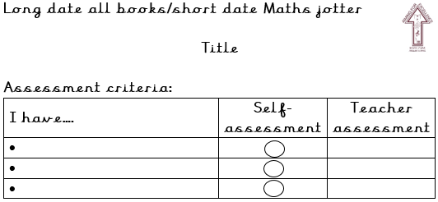

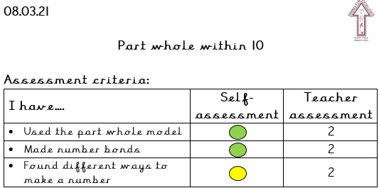

**Fix it time**

Children are to be given fix it time daily, to respond to marking.