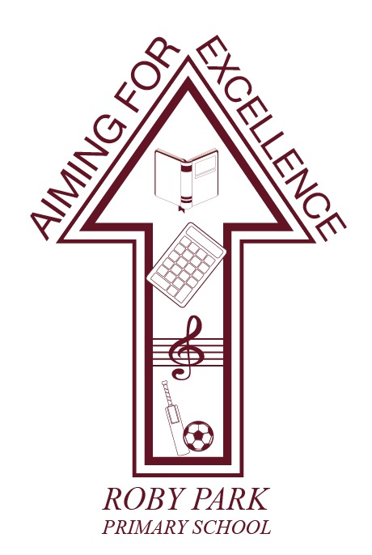

Asthma Policy

Written Sept 2024

Review Sept 2025

Signed – Mrs Kat Allen

(Headteacher)

Signed – Mr Frank Walsh

(Chair of Governors)

The Principles of our school Asthma Policy

Roby Park Primary School

- recognises that asthma is a condition affecting many school children and welcomes all pupils with asthma
- encourages children with asthma to achieve their potential in all aspects of school life by having a clear policy that is understood by school staff, their employers (the local education authority) and pupils. Supply teachers and new staff are ALSO MADE AWARE OF THE POLICY. All staff who come into contact with children with asthma are provided with training on asthma regularly.
- ensures that children with asthma participate fully in all aspects of school life including PE and outdoor learning
- recognises that immediate access to reliever inhalers is vital
- keeps records of children with asthma and the medication they take
- ensures the school environment is favourable to children with asthma
- ensures that other children understand asthma
- ensures all staff who come into contact with children with asthma know what to do in the event of an asthma attack
- will work in partnership with all interested parties including all school staff, parents, governors, doctors and nurses, and children to ensure the policy is implemented and maintained successfully

This policy has been written with advice from the Department for Education

Medication
Immediate access to reliever inhaler is vital. The reliever inhalers are kept in the classroom in the medical box. Each inhaler must have a pharmacy label with the child’s name on the box or on the reliever inhaler. Children under the age of 12 years should also have a spacer. Boxes are taken out on the playground and into the hall/playground during PE lessons.

School staff are not required to administer medication to children except in an emergency however many of our staff are happy to do this. School staff who agree to do this are insured by the local education authority when acting in accordance with this policy. All school staff will let children take their own medication when they need to.

Record Keeping
At the beginning of each school year, or when a child joins the school, parents are asked if their child has asthma. If medication changes in between times, parents are asked to inform the school. The school holds an inhaler and spacer for each child. Start and expiry dates are added to Medical Tracker. School Business Manager is responsible for sending Medical Tracker notifications for when inhalers are due to expire to ensure we are provided with a new inhaler in school. IT IS THE PARENTS’ RESPONSIBILITY TO PROVIDE A NEW INHALER OR SPACER AT THE REQUEST OF THE SCHOOL.

If a child has used their inhaler in school, the number of puffs and the time of administration will be recorded on Medical Tracker. A notification will then be sent to parents via Medical Tracker to the email address they have provided school. If a child is needing to use their inhaler more than once during the day, the school office staff will phone the parents to let them know.

Emergency Use Inhaler
Roby Park Primary School does now hold an emergency inhaler kit:
- A salbutamol metered dose inhaler
- At least one plastic spacers compatible with the inhaler
- Instructions on using the inhaler and spacer
- Instructions on cleaning and storing the inhaler
- A note of the arrangements for replacing the inhaler and spacers
- A list of children permitted to use the emergency inhaler
- A record of when the inhaler has been used

‘Guidance on the use of Emergency Salbutamol inhalers in schools’ September 2014. Parents will provide a signed consent to allow the school to provide use of the emergency inhaler and spacer when they feel that it is necessary.

This inhaler is kept in the School Office.

PE
Taking part in sports is an essential part of school life. Teachers are aware of which children have asthma from the class medical register. Children with asthma are encouraged to participate fully in PE. Each child’s inhalers will be labelled and kept in a box at the site of the lesson. If a child needs to use their inhaler during the lesson, they will be encouraged to do so. Staff will then record this on Medical Tracker immediately. A notification will be sent home via Medical Tracker to their provided email, informing the parents that the inhaler has been used.

The School Environment
The school does all that it can to ensure the school environment is favourable to children with asthma. The school does not keep furry and feathery pets indoors and has a non-smoking policy. As far as possible the school does not use chemicals in science and art lessons that are potential triggers for children with asthma.

Making the School Asthma Friendly
The school ensures that all children understand asthma. Asthma can be included in Key Stages 1 and 2 in the National Curriculum. Children with asthma and their friends are encouraged to learn about asthma; information for children and teens can be accessed from the following website www.asthma.org.uk.

Staff training
Staff will complete training provided by either the school nurse or online from www.educationforhealth.org and completing the Support Children’s Health Asthma Module. This will be done every two years.

When a Child is falling behind in lessons
If a child is missing a lot of time from school because of asthma or is tired in class because of disturbed sleep and falling behind in class, the class teacher will initially talk to the parents. If appropriate the teacher will then talk to the school nurse and/or SENDCo about the situation. The school recognises that it is possible for children with asthma to have special education needs because of asthma.

Asthma Attacks
All staff who come into contact with children with asthma know what to do in the event of an asthma attack.
- Encourage the child to sit up and slightly forward
- Help the child to take two separate puffs of his/her inhaler or the emergency salbutamol inhaler via the spacer
- If there is no immediate improvement, continue to give two puffs every two minutes up to a maximum of 10 puffs, or until their symptoms improve
- Stay calm and reassure the child
- Help the child to breathe by ensuring tight clothing is loosened.

After the attack
Minor attacks should not interrupt a child’s involvement in school. When they feel better they can return to school activities.

The child’s parents must be told about the attack straight away.

Emergency procedure

Call 999 using the child’s emergency contact details if:
- The reliever has no effect after five to ten minutes
- The child is either distressed or unable to talk
- The child is getting exhausted
- Has a blue/white tinge around his/her lips
- Is going blue
- Has collapsed
- You have any doubts at all about the child’s condition
- If for any reason the child stops breathing, an ambulance should be called immediately
- Parents will also be contacted

A child should always be taken to hospital in an ambulance.

