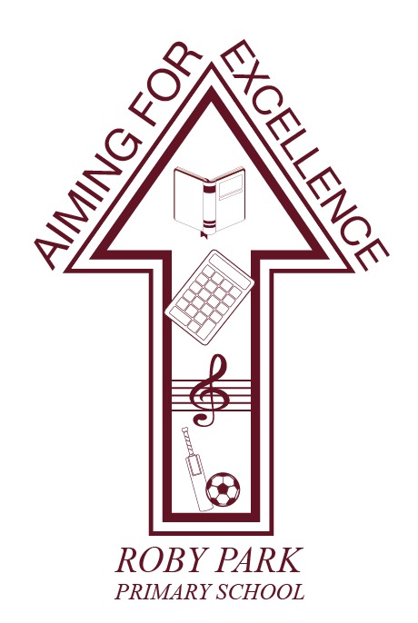

Assessment Policy

Written Sept 2024

Review Sept 2025

Signed – Mrs Kat Allen

Kat Allen (Headteacher)

Signed – Mr Frank Walsh

(Chair of Governors)

Aims
The assessment, recording and reporting policy of our school is based on a clear set of aims which reflect our educational philosophy and support the overall aims of the school, and which are expressed in terms of the intended educational outcomes.

The assessment, recording and reporting policy will help pupils to:
- recognise and celebrate a wide range of achievements
- identify their strengths and areas for reinforcement and development, to ensure mastery in their year of learning
- take responsibility for, and make informed judgements about, their future learning

Help teachers to:
- be aware of their pupils’ achievements in order to guide their future learning
- evaluate the effectiveness of teaching strategies and materials in their curriculum planning

Help the school to:
- make informed judgements relating to the way the school's curriculum, including the National Curriculum, is planned and resourced
- communicate effectively pupils’ achievements to parents, governors and other responsible parties
- inform school improvement planning to continuously strive for the best outcomes for pupils

Principles of Assessment
Assessment is consistent:
- Judgements are formed accordingly to common principles
- The results are readily understandable
- A school’s results are capable of comparison with other schools, both locally and nationally.

Assessment feedback should inspire greater effort and a belief that, through hard work and practice, more can be achieved. Measures of both progress and attainment are important for understanding school performance. Ongoing teacher-led assessment is a crucial part of effective teaching.

Effective assessment systems:
- involve children in all aspects of assessment so that they understand how to improve and become independent learners
- are built upon accurate and confident subject knowledge of age-related expectations and ways to evidence them
- help drive improvement for pupils and teachers
- are closely linked to improving the quality of teaching
- ensure feedback to pupils contributes to improved learning and is focused on specific and tangible objectives
- produce recordable measures which can demonstrate comparison against expected standards and reflect progress over time.
- to embrace and reflect academic, social, emotional, spiritual, cultural and moral development of children

Assessment
Teachers’ own formative assessments will be based on learning objectives and success criteria identified in their planning, and evaluation of lessons. In addition to informal methods of assessment used by teachers for continuous assessment in the context of their own classes, the following assessment tools will be used:

- Baseline Assessment - EYFSP
- EYFS Profile at end of Foundation Stage Development Matters tracking throughout Foundation Stage
- Wellcomm screening in Nursery, Reception and KS1
- Phonic screening test in Y1 and Y2
- Non-statutory SATs tests in Y2
- Statutory SATs tests in Y6
- Spelling assessment in Y1-6 – curriculum spelling lists
- Spelling age assessments – Y3-6
- Reading age assessments – Y2-6
- NFER Reading tests Y1-6
- Writing assessments Y1-6 through half termly internal moderations
- Power Maths End of Unit Tests Y1-6

EYFS
Observations are used to evidence children’s learning. Practitioners have a good understanding of individual children’s development. Observations will link to children’s stage of development, in line with the statutory framework. The purpose of these assessments is to further inform future planning to ensure all children are on track to reach the Early Learning Goals. This is also discussed at weekly band meetings to inform continuous provision planning.

Formal assessment will take place at the start of the year. The Reception Baseline Assessment (RBA) is a short assessment, taken in the first three weeks in which a child starts Reception and is reported to the local authority.

All assessments are recorded using Evidence Me. Practitioners monitor progression and evidence learning through the observations and data collected, which allows next steps to be identified. Evidence Me is used as a tool to communicate children’s outcomes with parents and also to encourage parents to provide school with a broader understanding of children’s abilities as some children display different behaviours and skills at home than in school. This then gives the whole picture of the child.

Evidence gathered will be internally moderated on a half termly basis and externally moderated by the early years support team. This data is used during pupil progress meetings to give an overview of individual children’s learning journeys and cohort attainment.

Individual next steps are displayed in the classroom to allow all practitioners to target children’s development. These will be used to focus observations and will be updated as children achieve.

Children will be observed three times over a fortnight in areas linked to their next steps and gaps in evidence or learning. These observations will be shared with parents on a fortnightly basis. Observations record the ‘remarkable’ where children demonstrate new skills.

In the final term of the year and no later than 30 June in that term, the EYFS Profile will be completed for each child. The Profile provides parents and carers, practitioners with a well-rounded picture of a child’s knowledge, understanding and abilities, their attainment against expected levels, and their readiness for year 1. The Profile will reflect practitioners’ own knowledge and professional judgement of a child to inform discussions with parents and carers.

Each child’s level of development must be assessed against the early learning goals. Practitioners must indicate whether children are meeting expected levels of development, or if they are not yet reaching expected levels (‘emerging’). Profiles are shared with parents and carers and a copy given to the Year 1 teacher. All EYFSP will be shared with LA

KS1/2 Formative Assessments

English
Formative assessment of writing is completed through teachers’ daily feedback to inform future planning. Teachers use the children’s every day writing, plus at least one piece of unaided writing each half term, to assess against INSIGHT objectives. INSIGHT objectives are used to ensure coverage and show next steps in learning across a range of writing. Half termly staff meetings are used to moderate assessment of unaided work against the exemplar materials for writing and the school’s agreed assessment criteria (non-negotiables) for each year group. Writing will also be externally moderated with other local schools.

Formative assessment in reading is to be recorded through weekly shared reading sessions, guided reading opportunities and other reading across the curriculum using the reading domains and INSIGHT statements. Gaps in learning will be identified and used to inform planning. Reading evidence will also be externally moderated with other local schools. Data will also be extracted from Reading Plus.

Summative assessments take place in Autumn, Spring and Summer using NFER materials.

Judgements for spelling, punctuation and grammar are supported from extended writing pieces.

Speaking and listening will be assessed using the INSIGHT objectives. This will be added each term.

Reading ages and spelling ages should be assessed termly and added to Insight.

Book bands should be updated half termly to demonstrate progress. Progress can also be monitored using Rising Stars Reading Planet online library with added assessment tool.

Teachers are equipped with Literacy Counts moderation resources to help support their judgements.

Mathematics
Formative assessment in mathematics is on-going and teachers use INSIGHT statements to show what children have achieved and identify gaps in learning. Maths jotters are used to show progress in mental maths and ARE Number basic skills, on a daily basis. Children’s understanding is assessed daily against the learning in their Power Maths practice books. This is based upon whether that learning is working towards expected, expected or above expected. This is an indication for the teacher to see where a child may need additionality to support and further their understanding.

Summative assessments take place at the end of each unit, using end of unit/end of term assessments from Power Maths.

Staff also have access to weekly arithmetic tests which track attainment and progress.

Science
Assessment in the sciences will focus on children and young people’s knowledge and understanding of key scientific concepts in the living, material and physical world and investigative skills, linked to Developing Experts’ planning objectives. In Key Stage 1 and 2, at the end of a unit of work, the teacher makes a summary judgement about the work and progress of each pupil. Class teachers will use INSIGHT to report half termly progress and attainment.

Beginning and end of unit Knowledge Organiser quizzes and end of unit tests are used to assess ‘sticky knowledge’ gained over the unit.

Foundation Subjects
Foundation subject objectives will be assessed half termly and a termly judgement will be based on whether a child is working towards expected, expected or above expected. Class teachers will use INSIGHT to report termly progress and attainment.

MFL is assessed on Language Angels and PE is assessed on Get Set 4 PE.

Physical Education
P.E. is continually tracked and monitored over the half term using Get Set 4 PE planning and assessment tool. Each unit taught is assessed by the Sports Coach and uploaded to Get Set 4 PE. Objectives are assessed half termly and a termly judgement will be based on whether a child is working towards expected, expected or above expected. Class teachers will use Get Set 4 PE to report termly progress and attainment.

Reporting
Reporting to parents will take place through Parents’ Evenings in the Autumn and Spring terms, written reports in the Summer term, and the opportunity to discuss the content of written reports at the end of the school year. End of year reports will inform parents if their child is working: well below, just below, at or above ARE.

Special Educational Needs
Further assessments will be completed during the year in order to identify children with SEN. Many children may experience special needs at some time during their school life. The nature of these needs may be:
• short or long term
• applied to the very able or the low attainer
• academic, behavioural, social or health
• mixture of the above
• Parental partnership is vital if we are to ensure that these children’s needs are met.

Further details may be found in our SEND Policy.

Children working below their age related curriculum are assessed using PIVATs – see SEND Policy.

Tracking
In Maths, Reading, Writing, Speaking and Listening and Science, half termly assessments will be recorded on our tracking system (INSIGHT) and progress monitored. Children not making sufficient progress and/or children not meeting ARE will be highlighted in half termly PPRs and appropriate intervention provided. Children are given a target for the end of the year based on prior attainment groups and teachers will monitor children’s progress towards this through half termly pupil progress meetings.
Appendix 1

EYFS Assessment
Expected Progress
 | Autumn 1 | Autumn 2 | Spring 1 | Spring 2 | Summer 1 | Summer 2
Nursery | 3-4 E | 3-4 E | 3-4 D | 3-4 D | 3-4 S | 3-4S
Reception | Rec E | Rec E | Rec D | Rec D | Rec S | Rec S  ELG

Assessment Guidance
