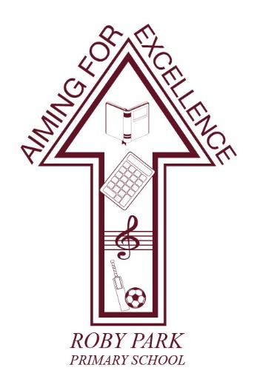

**Roby Park Primary School**

Easton Road

Huyton

Knowsley

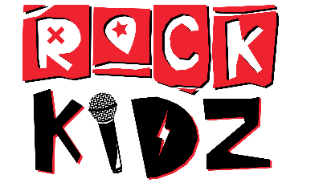L36 4NY

Tel: 0151 477 8340

Website: [www.robyparkprimary.co.uk](http://www.robyparkprimary.co.uk)

E-mail: [robypark@knowsley.gov.uk](mailto:robypark@knowsley.gov.uk)

**Headteacher: Mrs K Allen**

Date: Thursday 5th September 2024

**A Message from Rock Kidz**

Dear Parents/Carers,

Have you heard the news? Rock Kidz is officially coming to your child’s school on Tuesday 10th September to deliver the most exciting rock ‘n’ roll workshops in the UK!

Throughout the school day we’ll be transforming the whole school into Rockstars and inspiring them to be the best they can be. Our experienced team will be teaching one of our key messages such as self-esteem, anti-bullying, aspirations and inclusion through our unique Rock Kidz songs.

**Merchandise: Wear the message, live the message!**

We believe that it is more important than ever for young people to immerse themselves in positive experiences that leave a lasting effect on their wellbeing.   
  
At the end of the workshop day our team will be outside conducting a **‘Meet & Greet’** for the school community where there will be an opportunity to meet the team and purchase the **official Rock Kidz Merchandise** for your child. The merchandise features a positive message of the value we’ve covered in the workshop and aims to serve as an inspirational reminder of the Rock Kidz experience. All purchases can be made with **cash** or **card**. Here is what we will have on sale with prices:  
  
T-Shirts - £12

Caps - £15

Hoodies - £20  
  
Thank you in advance for your support of Rock Kidz. Your purchase helps us to continue our mission to inspire children nationwide.

If you’d like to learn more about our organisation and the work we do visit **www.rockkidzonline.com/ontour**  
  
We look forward to seeing you soon!

Kindest Regards,  
  
Rock Kidz