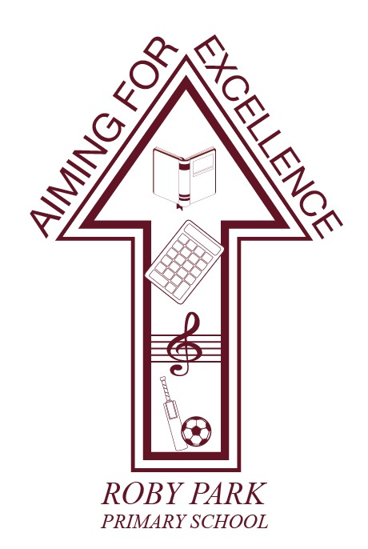

**Whistleblowing Policy**

Written Sept 2024

Review Sept 2025

Signed – Mrs Kat Allen

(Headteacher)

Signed – Mr Frank Walsh

(Chair of Governors)

**WHISTLEBLOWING POLICY**

scope and purpose

At Roby Park Primary School, our **School** is committed to conducting itself with honesty and integrity, and it expects all staff to maintain high standards. However, all organisations face the risk of things going wrong from time to time, or of unknowingly harbouring illegal or unethical conduct. A culture of openness and accountability is essential in order to prevent such situations occurring or to address them when they do occur.

The aims of this policy are:

* To encourage staff to report suspected wrongdoing as soon as possible, in the knowledge that their concerns will be taken seriously and investigated as appropriate, and that their confidentiality will be respected;
* To provide staff with guidance as to how to raise those concerns; and
* To reassure staff that they should be able to raise genuine concerns in good faith without fear of reprisals, even if they turn out to be mistaken.

This policy does not form part of any employee's contract of employment and it may be amended at any time.

Who is covered by this policy?

This policy applies to all individuals working at all levels of the **School**, including officers, directors,

employees, consultants, contractors, trainees, homeworkers, part-time and fixed-term workers,

casual and agency staff and volunteers (collectively referred to as **staff** in this policy).

Who is responsible for the policy?

The **Governing Body** has overall responsibility for this policy, and for reviewing the effectiveness of actions taken in response to concerns raised under this policy.

The Whistleblowing Officer has day-to-day operational responsibility for this policy, and must ensure that all managers and other staff who may deal with concerns or investigations under this policy receive regular and appropriate training.

All staff are responsible for the success of this policy and should ensure that they use it to disclose any suspected danger or wrongdoing.

What is whistleblowing?

**Whistleblowing** is the disclosure of information which relates to suspected wrongdoing or dangers at work. This may include:

* + - criminal activity;
    - miscarriages of justice;
    - danger to health and safety;
    - damage to the environment;
    - failure to comply with any legal or professional obligation or regulatory requirements;
    - bribery;
    - financial fraud or mismanagement;
    - negligence;
    - breach of the **School**’s internal policies and procedures;
    - conduct likely to damage the [**Academy/School**]’s reputation;
    - unauthorised disclosure of confidential information;
    - concerns about the harm or risk of harm to children;
    - the deliberate concealment of any of the above matters.

A **whistleblower** is a person who raises a genuine concern relating to any of the above. If a member of staff has any genuine concerns related to suspected wrongdoing or danger affecting any of the **School**’s activities (a **whistleblowing concern**) they should report it under this policy.

This policy should not be used for complaints relating to a member of staff’s own personal circumstances, such as the way they have been treated at work. In those cases the member of staff should use the **School**’s Grievance Procedure or Anti-harassment and Bullying Policy as appropriate.

If a member of staff is uncertain whether something is within the scope of this policy they should seek advice from the Whistleblowing Officer, whose contact details are at the end of this policy.

Raising a whistleblowing concern

Roby Park Primary School hopes that in many cases staff will be able to raise any concerns with their line manager or **Head Teacher**. A member of staff may tell them in person or put the matter in writing if they prefer. They may be able to agree a way of resolving the member of staff’s concern quickly and effectively. In some cases they may refer the matter to the Whistleblowing Officer.

However, where the matter is more serious, or the member of staff feels that their line manager or the **Head Teacher** has not addressed the concern, or they prefer not to raise it with them for any reason, they should contact the Whistleblowing Officer. At Roby Park Primary that would be Kirstie Carroll, Business Manager. Contact details are set out at the end of this policy.

Whistle Blowing Manager will liaise with our HR advisor on the appropriate actions and steps that should be taken to ensure that the whistle blowing procedure is managed correctly. That may involve senior staff or governors being directed towards appropriate actions and steps.

If the concern is about the head teacher that should be referred to the Governing Body and if required Local Authority Designated Officer if it raises safeguarding concerns.

Confidentiality

Roby Park Primary School hope that staff will feel able to voice whistleblowing concerns openly under this policy. However, if a member of staff wants to raise a concern confidentially, Roby Park Primary School will make every effort to keep their identity secret. If it is necessary for anyone investigating the concern to know the member of staff’s identity, the Roby Park Primary School will discuss this with them.

Roby Park Primary School does not encourage staff to make disclosures anonymously. Proper investigation may be more difficult or impossible if it cannot obtain further information from the member of staff raising the concern. It is also more difficult to establish whether any allegations are credible. Whistleblowers who are concerned about possible reprisals if their identity is revealed should come forward to the Whistleblowing Officer and appropriate measures can then be taken to preserve confidentiality. **If a member of staff is in any doubt they can seek advice from Public Concern at Work, the independent whistleblowing charity, who offer a confidential helpline. T**heir contact details are at the end of this policy.

Investigation and outcome

Once a member of staff has raised a concern, Roby Park Primary School will arrange a meeting with them as soon as possible to discuss their concern. A member of staff may bring a colleague or union representative to any meetings under this policy. The companion must respect the confidentiality of the disclosure and any subsequent investigation.

Roby Park Primary School will take down a written summary of the member of staff’s concern and provide them with a copy after the meeting. The Roby Park Primary School will also aim to provide an indication of how it proposes to deal with the matter.

Roby Park Primary School will carry out an initial assessment to determine the scope of any investigation. The Governing Body will inform the member of staff of the outcome of its assessment. The member of staff may be required to attend additional meetings in order to provide further information.

In some cases the **Governing Body** may appoint an investigator or team of investigators including staff with relevant experience of investigations or specialist knowledge of the subject matter. The investigator(s) may make recommendations for change to enable the Roby Park Primary School to minimise the risk of future wrongdoing.

Roby Park Primary School will aim to keep the member of staff who raised the concern informed of the progress of the investigation and its likely timescale. However, sometimes the need for confidentiality may prevent the **Governing Body** giving the member of staff specific details of the investigation or any disciplinary action taken as a result. Any information about the investigation should be treated as confidential.

If the **Governing Body** concludes that a whistleblower has made false allegations maliciously or with a view to personal gain, the whistleblower will be subject to disciplinary action.

If A Member of Staff is not satisfied

While Roby Park Primary School cannot always guarantee the outcome the member of staff raising the complaint may be seeking, it will try to deal with the concern fairly and in an appropriate way. By using this policy staff can help the Roby Park Primary School to achieve this.

If a member of staff is not happy with the way in which their concern has been handled, they can raise it with one of the Chair of Governors. If the concern directly involves the Chair of Governors another senior governor will be designated as the link governor role.

External disclosures

The aim of this policy is to provide an internal mechanism for reporting, investigating and remedying any wrongdoing in the workplace. In most cases staff should not find it necessary to alert anyone externally.

The law recognises that in some circumstances it may be appropriate for staff to report their concerns to an external body such as a regulator. It will very rarely if ever be appropriate to alert the media. The Roby Park Primary School strongly encourage staff to seek advice before reporting a concern to anyone external. The independent whistleblowing charity, Public Concern at Work, operates a confidential helpline. They also have a list of prescribed regulators for reporting certain types of concern. Their contact details are at the end of this policy.

Whistleblowing concerns usually relate to the conduct of the **School**’s staff, but they may sometimes relate to the actions of a third party, such as a supplier or service provider. In some circumstances the law will protect staff if they raise the matter with the third party directly. However, the Roby Park Primary School encourages staff to report such concerns internally first. Staff should contact their line manager, the Senior Leadership Team or the Whistleblowing Officer for guidance.

Protection and support for whistleblowers

It is understandable that whistleblowers are sometimes worried about possible repercussions. Roby Park Primary School aims to encourage openness and will support staff who raise genuine concerns in good faith under this policy, even if they turn out to be mistaken.

Staff must not suffer any detrimental treatment as a result of raising a concern in good faith. Detrimental treatment includes dismissal, disciplinary action, threats or other unfavourable treatment connected with raising a concern. If a member of staff believes that they have suffered any such treatment, they should inform the Whistleblowing Officer immediately. If the matter is not remedied they should raise it formally using the school’s Grievance Procedure.

Staff must not threaten or retaliate against whistleblowers in any way. Anyone involved in such conduct will be subject to disciplinary action.

Contacts

|  |  |
| --- | --- |
| **Head Teacher**  **Mrs Allen** | **0151 477 8340**  **Kathryn.Allen@knowsley.gov.uk** |
| **Whistleblowing Officer**  **Kirstie Carroll**  **Business Manager**  **Roby Park Primary School** | **0151 477 8340**  **Kirstie.Carroll@knowsley.gov.uk** |
| **Chair of Governors** | **chairofgovernors@robyparkprimary.co.uk** |
| **Public Concern at Work**  (Independent whistleblowing charity) | **Helpline: (020) 7404 6609**  **E-mail: whistle@pcaw.co.uk**  **Website:** [**www.pcaw.co.uk**](http://www.pcaw.co.uk) |