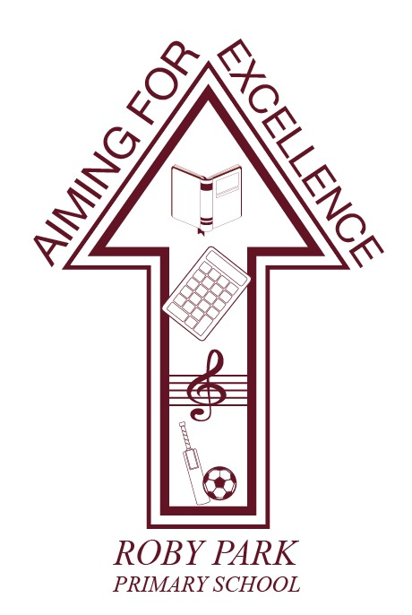

**Handwriting & Presentation Policy**

Written Sept 2024

Review Sept 2025

Signed – Mrs Kat Allen

(Headteacher)

Signed – Mr Frank Walsh

(Chair of Governors)

Rationale:

A consistently high standard of presentation and handwriting is promoted across the whole

school which all children and staff recognise, understand and follow. For children and

teachers this aims to foster a sense of pride and respect in their work. Self-esteem is

raised when children are able to communicate meaning accurately.

**Presentation across the school:**

* All books are named with the school labels and logo. Names are typed on the front of books.
* All books have handwriting lines in to encourage neat presentation and handwriting.
* A4 worksheets are added into books, using treasury tags.
* Every piece of work has a long date (except in Maths), title and success criteria stuck in.
* Modelled examples are used to introduce new skills and reinforce expectations.
* Children use guidelines if they are writing on plain paper (from Y2 onwards).
* All drawings and diagrams are in pencil, using appropriate templates which may be scaffolded where needed.
* Pencil crayons, not felt pens, are used in exercise books.
* A purple pen is used for specific reasons by children e.g. self-correcting, editing or peer assessment.
* One single line is used to cross out mistakes or edit writing.
* Books are well kept with no writing or doodling on the outside or inside of covers.
* Children underline the last piece of work and start a new piece of work underneath
* Poor presentation is challenged through verbal feedback and marking.
* Rubbers, tippex and correction pens are not to be used by children except for drawings.
* Rubbers are only to be given to correct drawings, mathematical diagrams etc.

**Maths:**

* Every piece of work has a short date, title and success criteria stuck in.
* should be linked to learning objective (skills focused)
* Each page has a 2 square margin
* One numeral in each square
* Rulers used for drawing lines
* Rubbers are only to be given out to correct mathematical drawings which need to be accurate (not jottings).

**Handwriting across the school:**

* Children use a continuous cursive handwriting style, using letterjoin to teach, model and support. See handwriting policy.
* They are encouraged to maintain a correct posture and pencil grip.
* Handwriting is discretely taught daily in all year groups.
* Opportunities for linking phonics and spelling are used.
* Additional handwriting sessions are given to those children whose letter formation, joining or speed require improvement.
* Children write in pencil until the end of year 3. From year 4, onwards pupils write in blue pen.

**Specific Progression:**

**Foundation Stage**

* Children are taught correct letter and number formation in a cursive style, moving from single letters to words and sentences.
* Children are free to select a writing implement of their choice in child-initiated learning.
* Correct sitting and pencil grip is taught.
* They are encouraged to write in a straight line from left to right.
* Use of rulers for labelling is modelled by teachers and rulers are available for child-initiated learning.
* Some children are taught how to write ‘on the line’ and begin to join letters.

**Years 1 and 2**

* Children are taught how to join letters, maintain regular size and shape of letters and regular spaces between words.
* They develop the fluency of their joined handwriting at word and sentence level.
* Children are all taught to write ‘on the line’.
* They are taught how to underline and label neatly with a ruler.

**Years 3 and 4**

* They work on securing joins, improving fluency and continuing spelling links.
* Children are expected and taught how to use a ruler to draw lines, including underlining, diagrams, labelling and crossing out.
* Children write in paragraphs around a theme.
* Children are taught to adapt the layout of their written work to fit the intended purpose, i.e. letter presentation, play script, etc.

**Years 5 and 6**

* Children write in blue pen when they have achieved a pen licence.
* They are expected to use a ruler to draw lines, including underlining, diagrams, labelling and crossing out.
* Teaching of handwriting continues to develop an efficient writing speed and aids spelling.
* Children learn to select the most appropriate presentation style for different writing genres.
* They begin to understand the balance between speed and legibility which is dependent on the purpose of the writing: the product or the final draft of a piece of writing.

**Inclusion:**

These expectations apply to the vast majority of children in our school. Occasionally a

decision will be made to personalise expectations for a child who has such specific needs

that these expectations could be a barrier to their progress (e.g. a child with physical

difficulties writing). Difficulties are addressed through appropriate interventions or specific

equipment.

**Celebration and Motivation:**

All staff ensure that presentation and handwriting is promoted by:

* Celebrating work of a high standard, including homework, in whole class situations.
* Ensuring good presentation and handwriting is rewarded in line with the whole school behaviour policy (Star of the Week, Governor Award, Headteacher Awards).
* Sharing good work in whole school assemblies.
* Displaying written work
* Using joined, legible and consistently formed handwriting on boards, in books, on flip charts and displays.
* Providing modelled examples and reviewing expectations with children.

**Home Learning:**

Parents are encouraged to support their children to produce quality work following the policy

guidelines. Children are expected to take the same care with homework as they do in their

class books.

**Monitoring:**

Presentation is monitored by the Senior Leadership Team on a regular basis through monitoring cycle. Feedback will be shared with the class teacher and at Leadership meetings. This will ensure that the policy leads to good practice