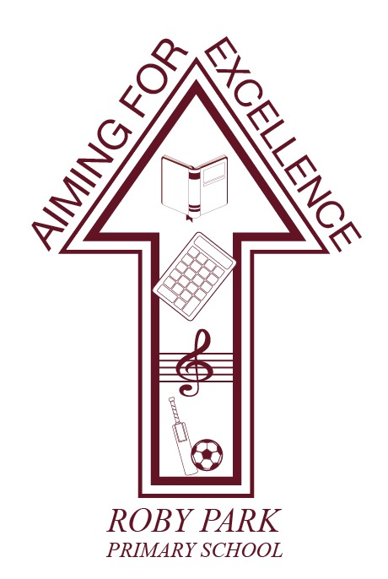

Food Policy

Written Sept 2024

Review Sept 2025

Signed – Mrs Kat Allen

(Headteacher)

Signed – Mr Frank Walsh

(Chair of Governors)

INTRODUCTION
At Roby Park Primary School we understand the importance of healthy eating, oral health and the pupils’ education.
Named member of staff leading on healthy food: Miss Ellie Beggs

FOOD POLICY AIM(S)
Food and sharing food are an important part of what we do as a school.

Across Year 1 to Year 6, tables of pupils are supported by an adult who works with the children to help them serve their food, encourage them to eat and help them learn to assist with clearing up after their meal.

The menu, which is healthy and nutritionally balanced, is decided and occasionally changed by the School Council. We will of course cater for vegetarians, have a Halal option and for medical dietary needs or allergies. We are also very happy to work with you and your child to make sure that they are able to eat the food on offer. We know that some children can be fussy, but we are committed to working with you to help your child enjoy a wider range of foods.

We believe eating is more than just ‘refuelling’ but should be an informal social situation where children work together, share responsibilities, and make new friends across the school. We are committed to working with you to make lunchtime better for your child, but at Roby Park lunch time will always be more to us than just food.

1. FOOD & DRINK PROVISION THROUGHOUT THE DAY.
As part of the School Food Plan, a new set of standards for all food served in schools was launched by the Department for Education. They become mandatory in all maintained schools, and new academies and free schools from January 2015.
These school food standards are intended to help children develop healthy eating habits and ensure they obtain the energy and nutrition they need across the whole school day, which includes food provided for breakfasts, mid-morning snacks, lunches, tuck shops and after school clubs.
For more information please refer to: http://www.schoolfoodplan.com

- Breakfast
Breakfast is an important meal and should make up a 1/4 of a child’s energy requirements and can provide essential vitamins and minerals.

Healthy breakfast options:
  - We offer a variety of different fruits and vegetables every day, e.g. fresh fruit, fresh fruit, dried fruit, canned fruit in natural juices and juice;
  - A selection of cereals including low sugar, low salt, high fibre alternatives. Mix plain cereal with wholegrain varieties to reduce overall sugar content.
  - A variety of different types of bread for sandwiches, toast and toasties, including wholegrain varieties.
  - Porridge
  - Provide different toppings for toast and bread e.g. low fat spread, reduced sugar jam, low fat soft cheese
  - Semi-skimmed milk for drinking, with cereal or in smoothies and low fat yoghurt.

- Snacks
At Roby Park. we understand that snacks can play an important part of the diet of young people and can contribute positively towards a balanced diet.

The Governments school fruit and vegetable scheme entitles all children in KS1 to one piece of fruit and/ or vegetable per day.

Snacks provided for children and staff are always tooth friendly and any food containing sugar is restricted to mealtimes only and will be provided on a limited basis.

- School lunches
Food prepared by the school catering team meets the national school food based standards and we ensure that the quality of the ingredients and that the choice of meals are appealing by regular checks and asking the pupils and staff for feedback. The school council make suggestions regularly, ensuring that the meals reflect on the needs of the pupils.

In September 2014 the Government introduced universal free school meals for all children from reception to year 2, the school encourages parents/carers to opt for school lunches for their children by regularly promoting our service, as it can be an easier way of ensuring they get a nutritionally balanced meal.

2. FOOD & DRINKS BROUGHT INTO SCHOOL

- Packed lunches
Parents are encouraged to provide healthy well balanced packed lunches and have been sent advice on how to ensure they are.

Preparing a balanced child's lunchbox, include:
- starchy foods – these are bread, rice, potatoes, pasta and others
- protein foods – including meat, fish, eggs, beans and others
- a dairy item – this could be cheese or a yoghurt
- vegetables or salad and a portion of fruit
- a healthy drink such as water, milk or 100% fruit juice.

 | INCLUDE:
- | Minimum of 1 portion of fruit and 1 portion of vegetables everyday
- | Meat/ fish eggs and non-dairy protein e.g. pulses everyday
- | Oily fish at least once every few weeks
- | Starchy food such as bread, pasta, rice, potatoes
- | A dairy product milk, cheese and yoghurt
- | Water or milk (semi-skimmed or skimmed).
 | LIMIT:
- | Meat products sausage rolls, pies, sausages etc
- | Cakes and biscuits to be enjoyed as part of a meal occasionally not as a snack
- | Fruit juice 150mls per day

 | DO NOT INCLUDE
- | Salty snacks such as crisps nuts etc
- | Sweets and chocolate
- | Sugary soft drinks

For more information: www.childrensfoodtrust.org.uk
- Drinks
The school food plan states:
Water is available for all pupils throughout the day, free of charge. Milk is available for children at least once a day in addition to before and after school clubs
- School events
Pupils who have school meals are provided with a nutritious packed lunch if not on the school site for lunch.

- Birthdays and other special celebrations
If parents wish to bring in birthday cakes, providing they are individually portioned up and wrapped up in advance this is fine. Birthday cake will always be sent home for parents to decide if they wish for their child to eat it or not.

3. Cooking and Food Education in the Curriculum
As of September 2014 food, cooking and nutrition education is a compulsory part of the school curriculum for KS1 to KS3.
- Ensure food and nutrition is taught at an appropriate level throughout each key stage.
- Identify food and nutrition links to different subject areas.
- Addressed through different teaching methods; leading by example, staff training, visitors to the classroom, resources etc.
- Monitoring of the pupils learning.
- EYFS pupils are taught about healthy eating daily and fruit is available for them in the classrooms. The school nurse delivers sessions on living a healthy lifestyle and the dentist visits annually to talk about oral health.

Extra-curricular activities
- We offer clubs that provide continued learning around leading a healthy lifestyle for example gardening club, multi-sports club and dance club.

4. SPECIAL DIETARY REQUIREMENTS
- Religious and ethnic groups
- Vegetarians and vegans
- Food allergy and intolerance
Roby Park is aware of all food allergies/intolerances and other dietary requirements of the children. We offer a vegetarian and Halal option for every meal.

- FOOD SAFETY
Roby Park has adequate facilities, suitable equipment, all food handlers appropriately trained and all possible hazards are identified.

SHARING THE POLICY

This policy is available to all staff via a shared drive and to parents through the school website.

