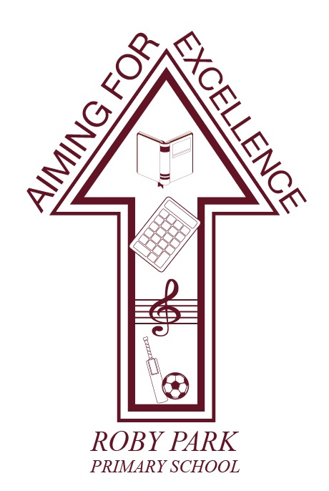

ENGLISH AS AN ADDITIONAL LANGUAGE (EAL) POLICY

Written Sept 2024

Review Sept 2025

Signed – Mrs Kat Allen

(Headteacher)

Signed – Mr Frank Walsh

(Chair of Governors)

INTRODUCTION
As a school, we recognise that EAL Status is dependent on which language was learned first by a child.

In our school the teaching and learning, achievements, attitudes and well-being of all our children are valued. We encourage and support all our children to achieve the highest possible standards. We do this through taking account of each child’s life experiences and needs.

Children who are learning English as an additional language have skills and knowledge about language similar to monolingual English-speaking children. As a school, we recognise and understand the difference between communication skills and language proficiency for all children. For example, a child’s ability to participate in the full curriculum may be in advance of their ability to communicate in English.

AIMS AND OBJECTIVES
The National Curriculum secures entitlement for all children to a number of areas of learning and gives them the opportunity to develop the knowledge, understanding, skills and attitudes that are necessary for their self-fulfillment and development as responsible citizens. We promote the principles of respect for all through the education that we provide in our school.

The aim of this policy is to help ensure that we meet the full range of needs of those children who are learning English as an additional language. This is in line with the requirements of the Equality Act 2010.

Staff at Roby Park Primary School aim to follow the guidelines issued by the DfE for the Autumn Census (2016) by striving to ensure that all children with EAL have been assessed using the EAL Proficiency Codes.

TEACHING AND LEARNING STYLE
In our school teachers take action to help children who are learning English as an additional language in the following ways:

Developing their spoken, understanding and written English by:
• ensuring that vocabulary work covers the technical as well as the everyday meaning of key words, metaphors and idioms;
• explaining how speaking and writing in English are structured for different purposes across a range of subjects;
• providing a range of reading materials that highlight the different ways in which English is used;
• ensuring that there are effective opportunities for talking, and that talking is used to support writing;
• endeavour to build on children’s experiences of language at home and in the wider community, so that their developing uses of English and other languages support one another;

Ensuring access to the curriculum and to assessment by:
• using accessible texts and materials that suit children’s ages and levels of learning;
• providing support through ICT, audio visual materials and dictionaries

CURRICULUM ACCESS
All children in our school follow the curricular requirements of the Foundation Stage and the
National Curriculum. Children with English as an additional language do not produce separate work.

In the Foundation Stage we plan opportunities for children to develop their English, and we provide support to help them take part in activities as needed.

The Foundation Stage helps children learning English as an additional language by:
• building on children’s experiences of language at home and in the wider community, so that their developing uses of English and of other languages support one another;
• providing a range of opportunities for children to engage in speaking and listening activities in English with peers and adults;

ASSESSMENT
We closely monitor and track the progress of these children and if necessary, seek advice from MEAS.

KNOWSLEY EAL TEAM
Referrals can be made to the Knowsley EAL team to seek further support for pupils. A pre-referral guide is available to ensure all strategies are in place. Karen Foley is the EAL Support Manager and can be contacted at Karen.Foley@knowsley.gov.uk

