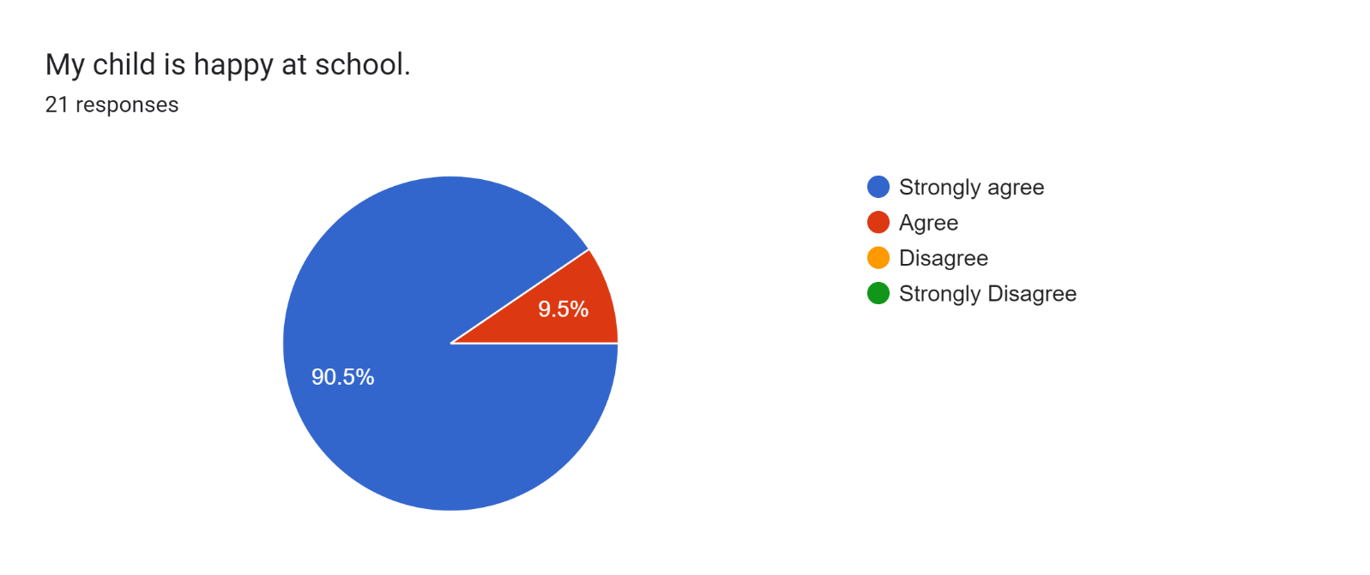

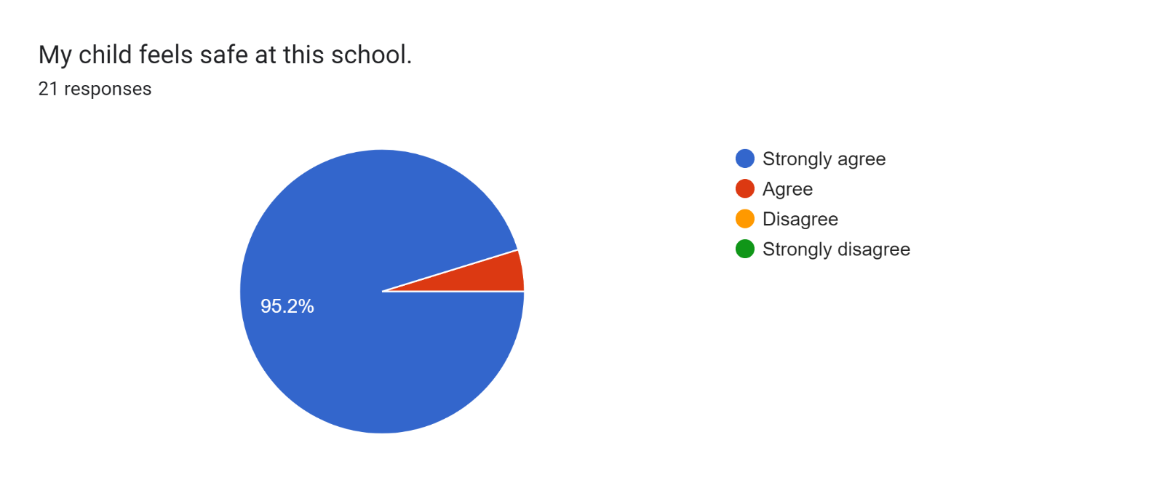

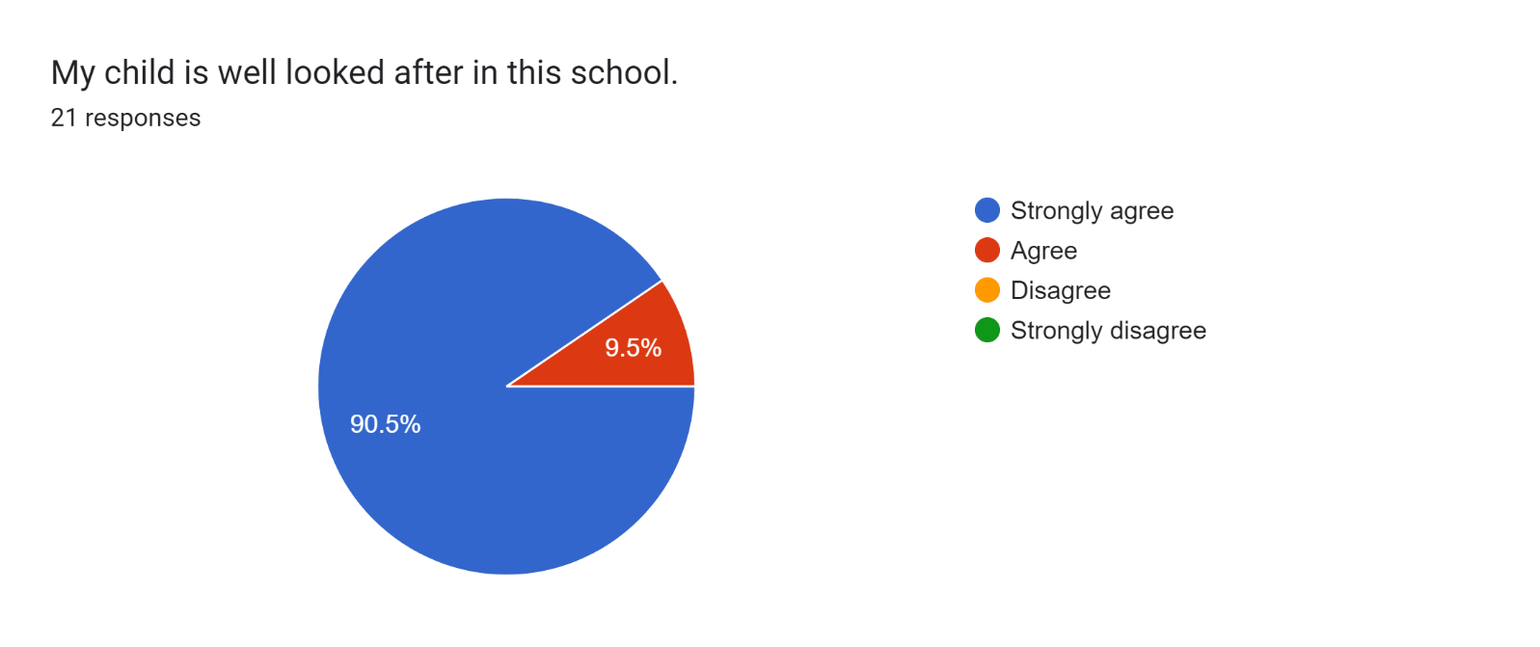

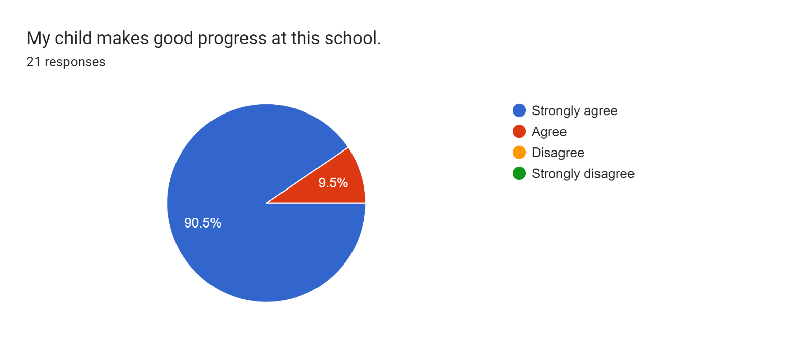

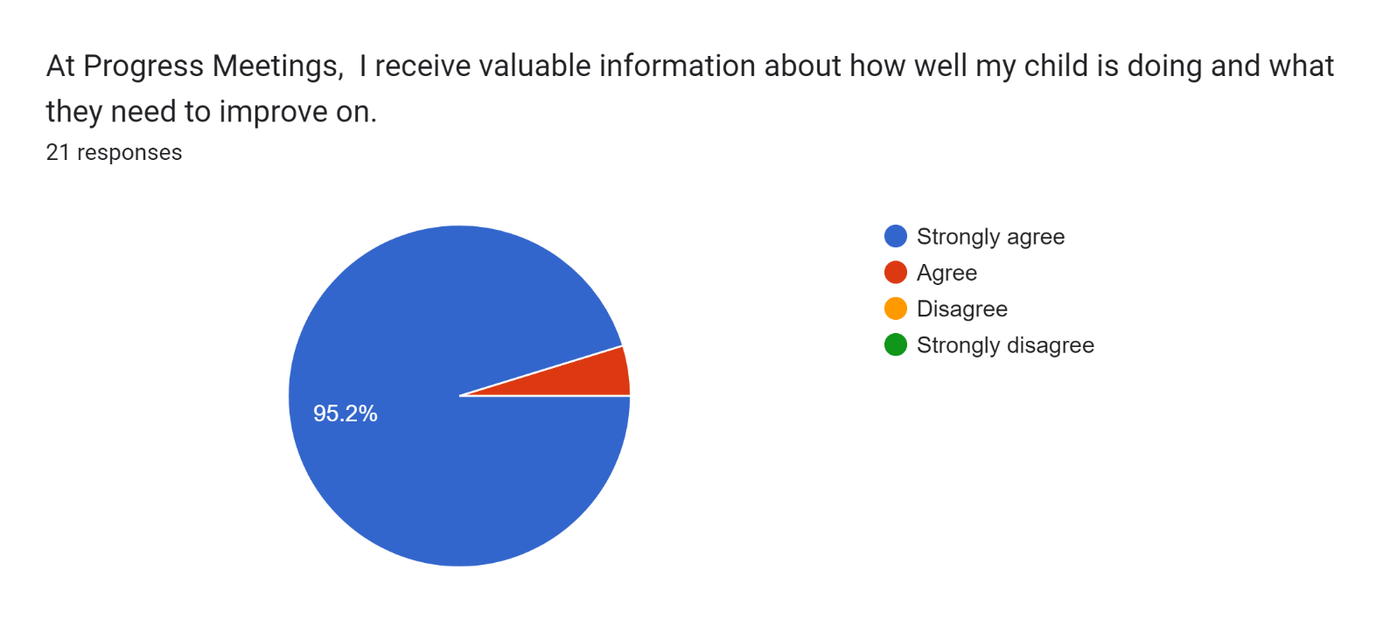

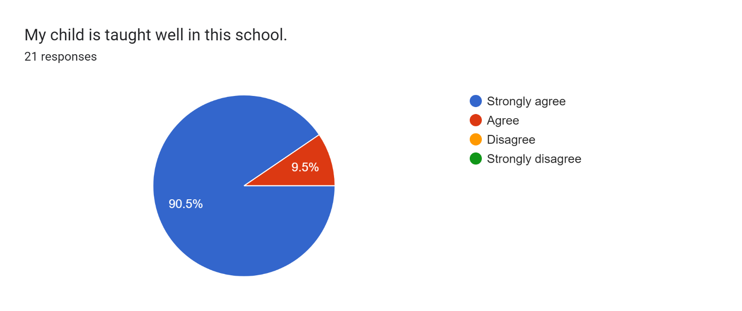

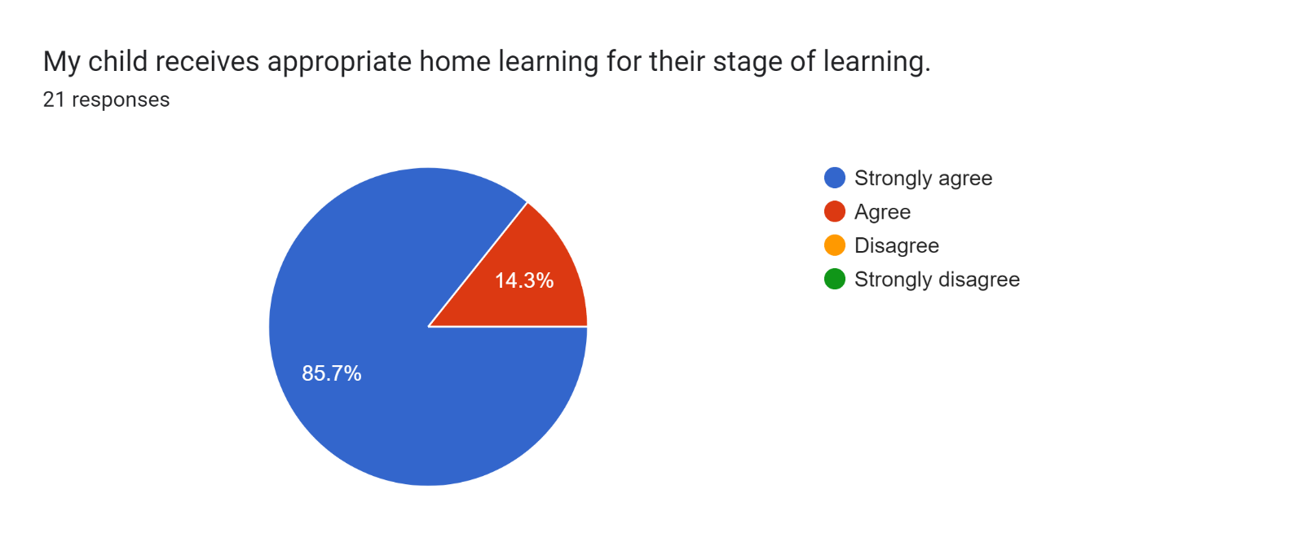

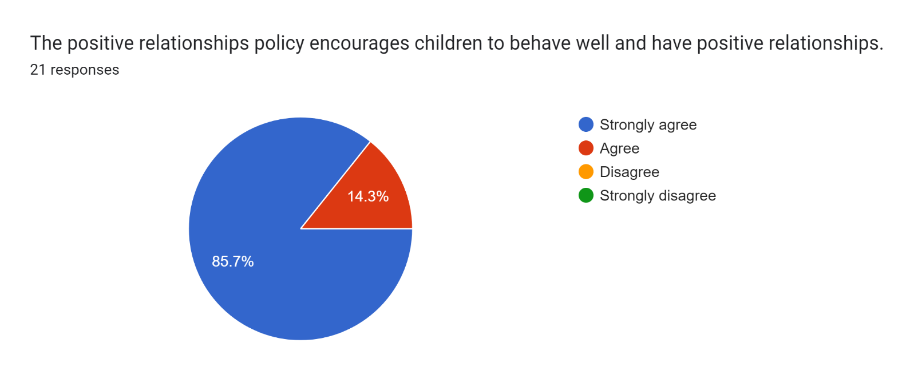

Forms response chart. Question title: This school deals effectively with bullying
. Number of responses: 21 responses.

Forms response chart. Question title: This school is well led and managed
. Number of responses: 21 responses.

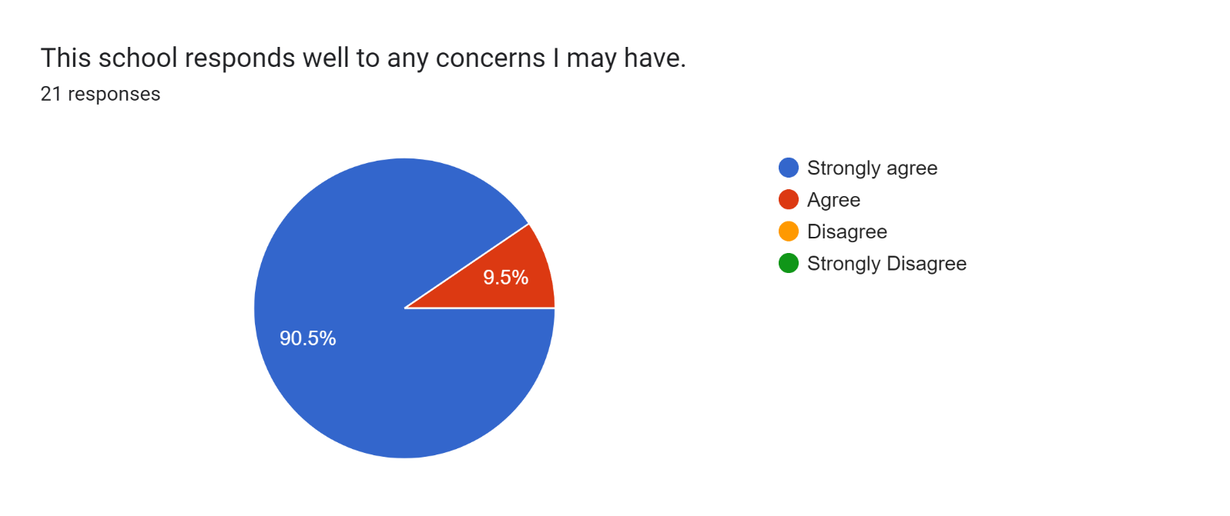

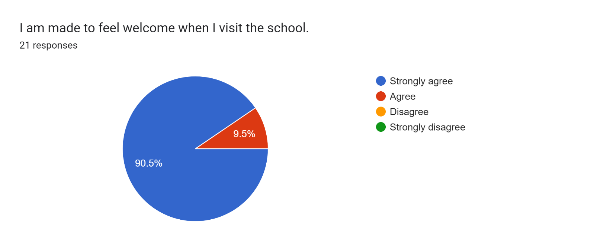

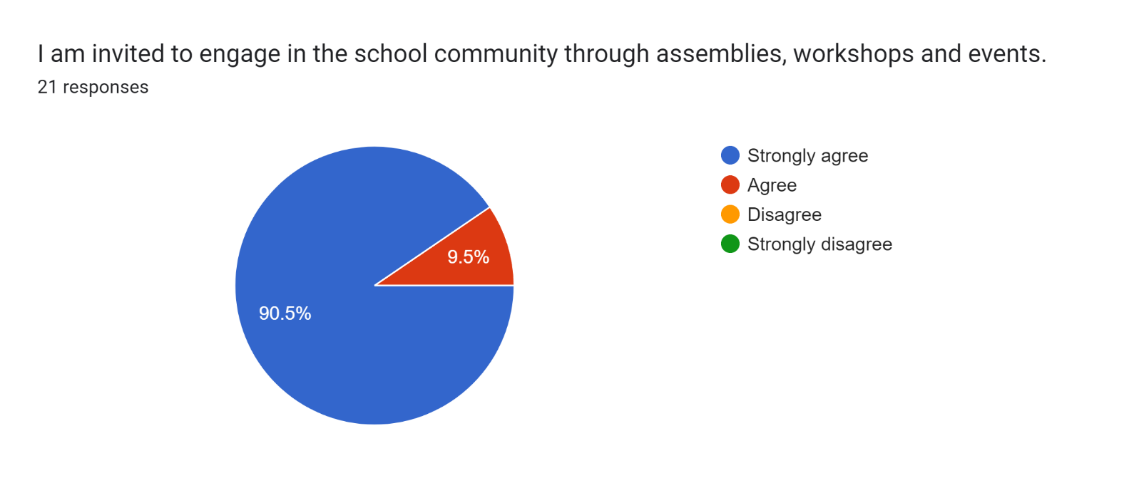

Forms response chart. Question title: The school uses a range of platforms to communicate with parents and carers - Class Charts, website, newsletters etc.
. Number of responses: 21 responses.

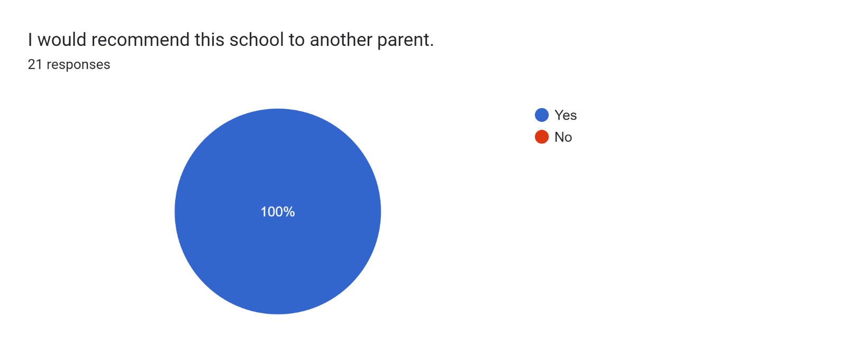

If there are any other comments you would like to make, please add below:

* I am really happy with my son’s progress.
* EYFS teachers are amazing!
* My son has settled in well and I feel that is due to the teachers. It always feel like you are listened to by Mrs. Lyons and she has provided feedback for areas our son needs to improve on.
* Fantastic, helpful and supportive.
* Always friendly, welcoming and helpful.
* Friendly and helpful.
* Brilliant!
* Thank you very much for all you do for my daughter.
* My son has made great progress since being here and he is very happy here.
* Thank you for all your hard work. Our daughter is doing so amazing at this school.
* Fabulous, inspiring and motivating staff - thank you.
* Mrs Lyons is lovely!
* Thanks for all of your hard work.
* Our son is making amazing progress and we are so proud of him. We are very grateful for the hard work of the staff.
* Keep up the good work.
* We just love this school and our son is happy. Thank you all.
* My daughter absolutely loves coming to school. Thank you so much for all your help.
* Fabulous school!
* Amazing!
* Thank you for everything that you do!