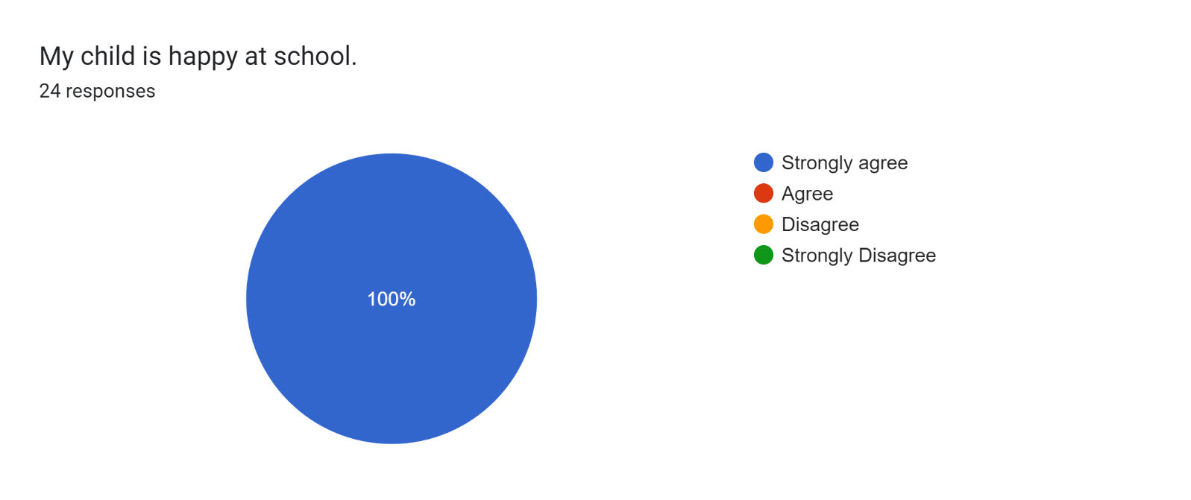

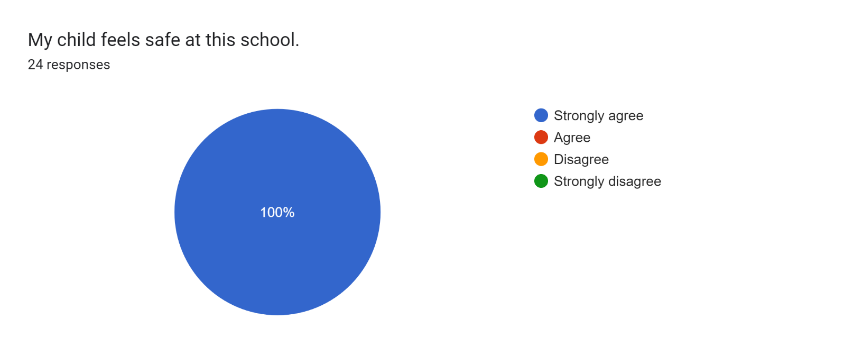

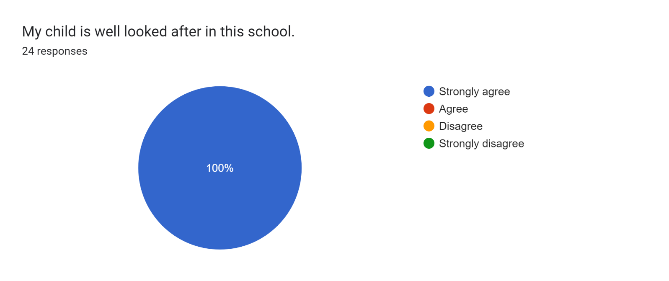

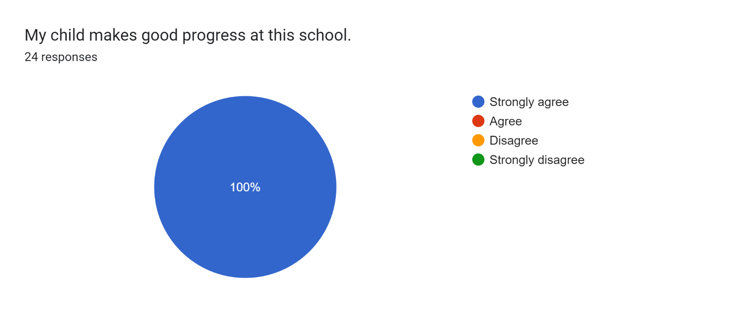

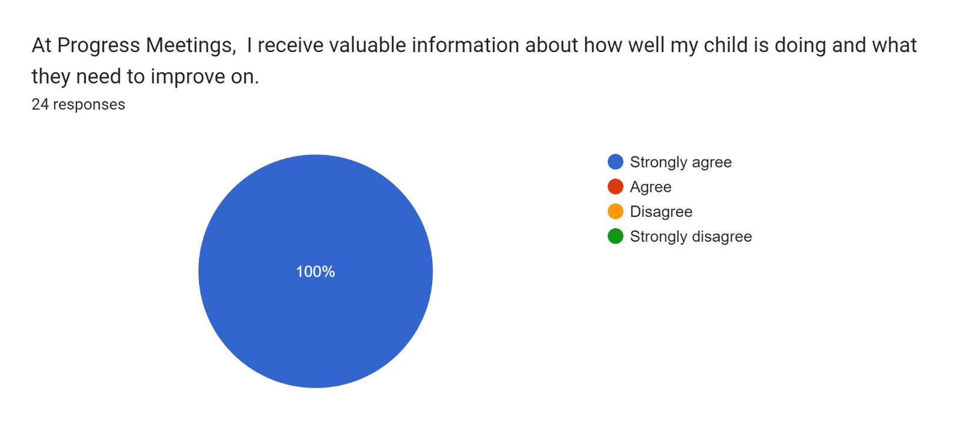

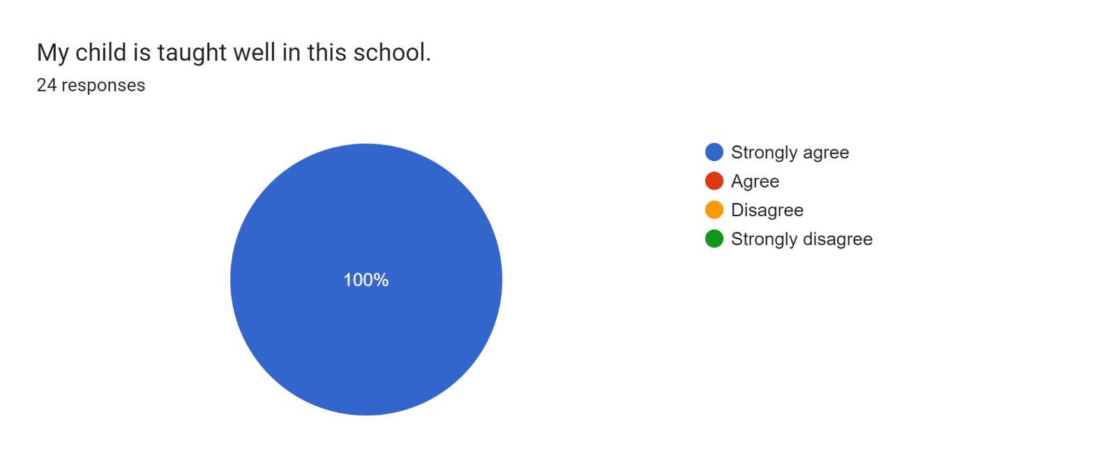

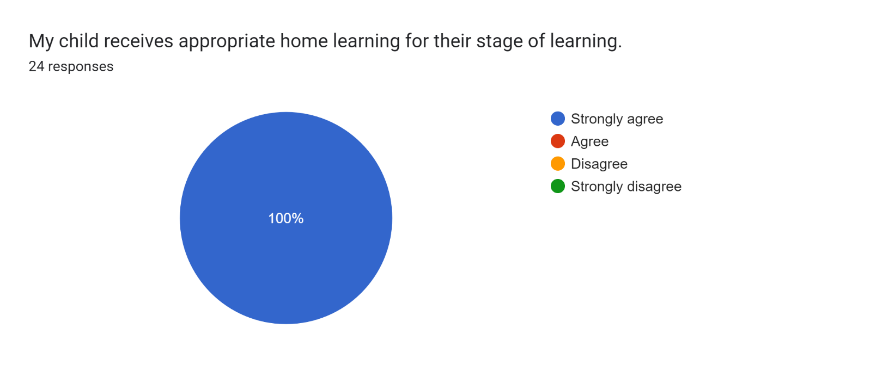

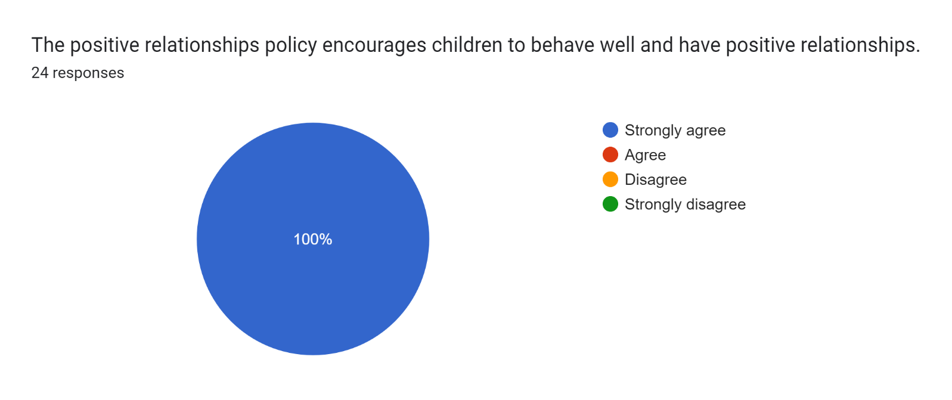

Forms response chart. Question title: This school deals effectively with bullying
. Number of responses: 24 responses.

Forms response chart. Question title: This school is well led and managed
. Number of responses: 24 responses.

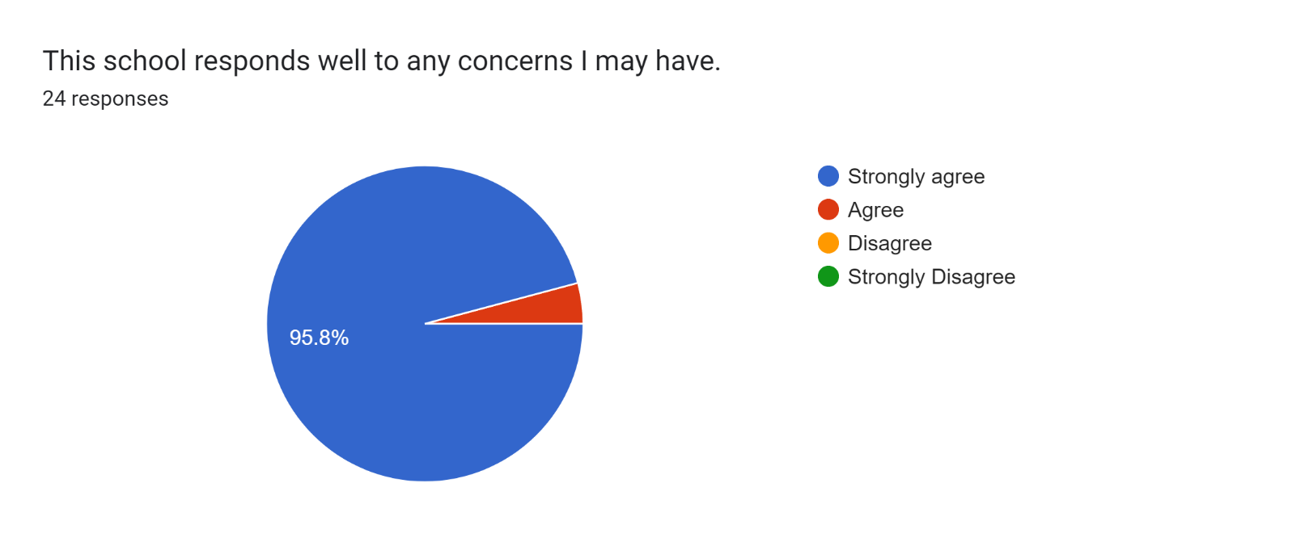

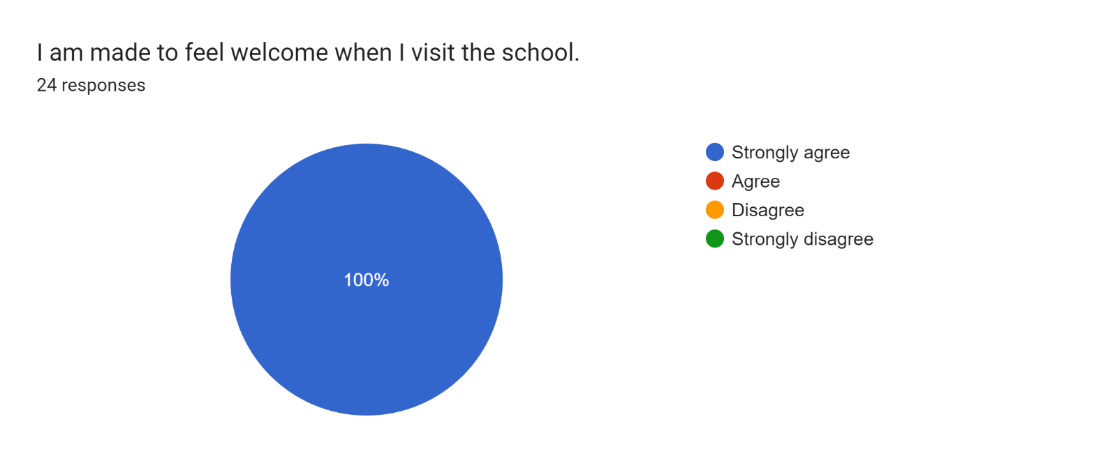

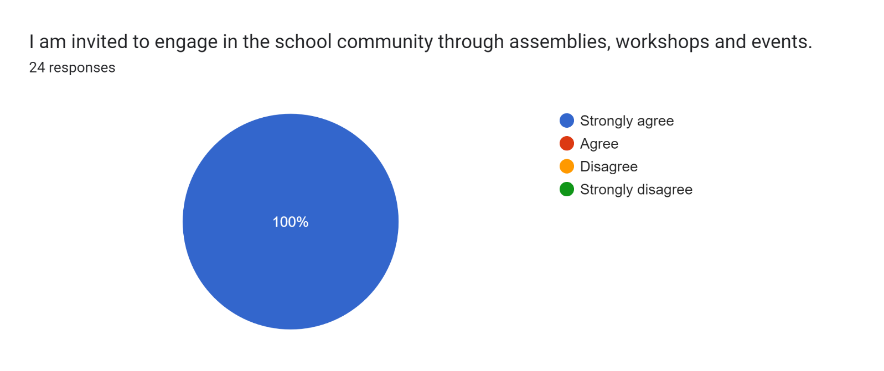

Forms response chart. Question title: The school uses a range of platforms to communicate with parents and carers - Class Charts, website, newsletters etc.
. Number of responses: 24 responses.

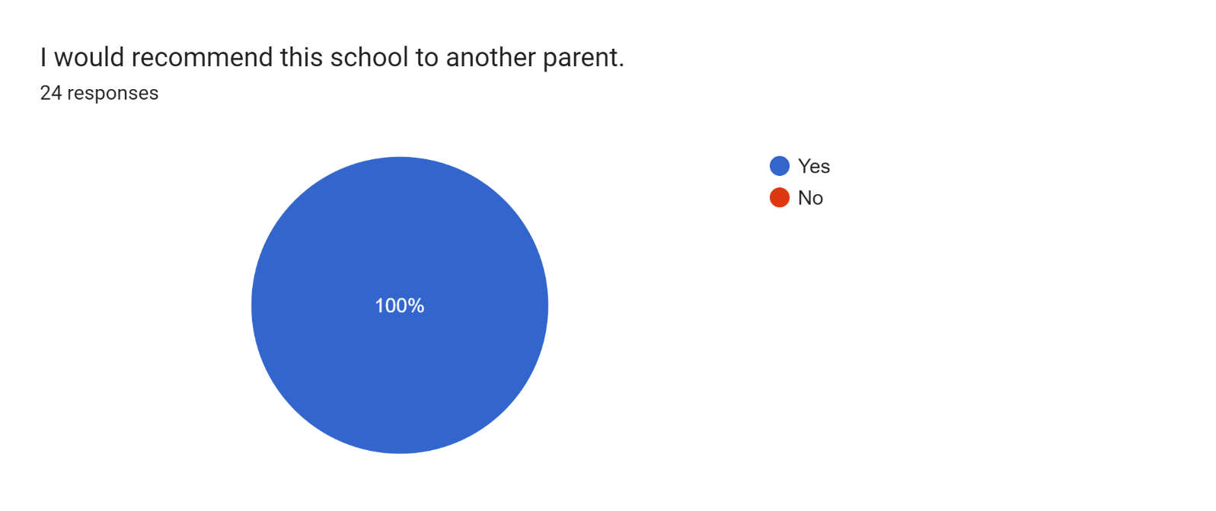

If there are any other comments you would like to make, please add below:

* "I like playing in the builders"

"I couldn't pick a better place for my son" - Mummy

* Brilliant job!
* Brilliant!
* Well done.
* Thank you to all your support.
* My son loves school and he’s excited to come in everyday.
* My daughter has settled in well and is making great progress.
* We are really happy with our daughter’s progress.
* Thank you for everything you do!
* Amazing for my little boy!
* I am really happy with our progress meeting. Thank you!
* A fantastic school! Miss Murphy has been incredible for our son’s development.
* Roby Park is amazing for my children who are constantly improving and progressing. My children and I have unbelievable relationships with all staff who are all so kind and ALWAYS willing to help or talk to me if needed. I feel like they have such amazing opportunities that not a lot of other local schools have and for that I'm grateful.
* Great school!
* Thank you so much for looking after our daughter and helping her learn. We could not ask for better teachers to look after her. She loves it here.
* Brillant staff!
* Fantastic support and our son loves coming to school.
* Excellent!
* All your efforts are very much appreciated.
* My child is happy here.