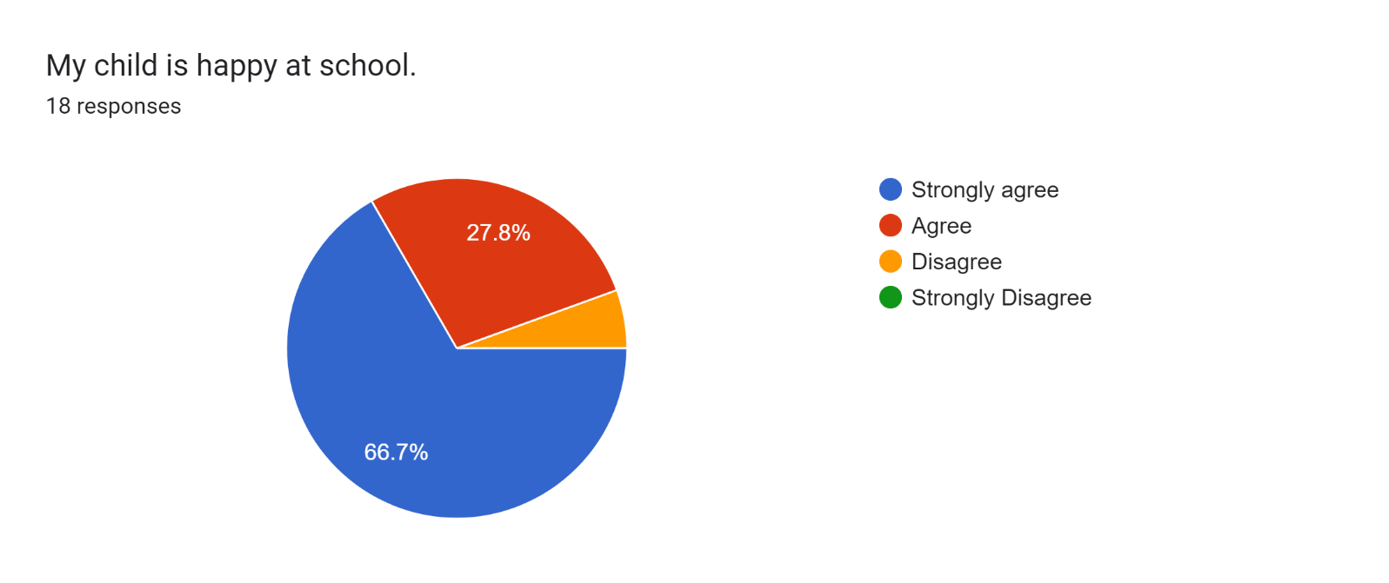\*1 parent

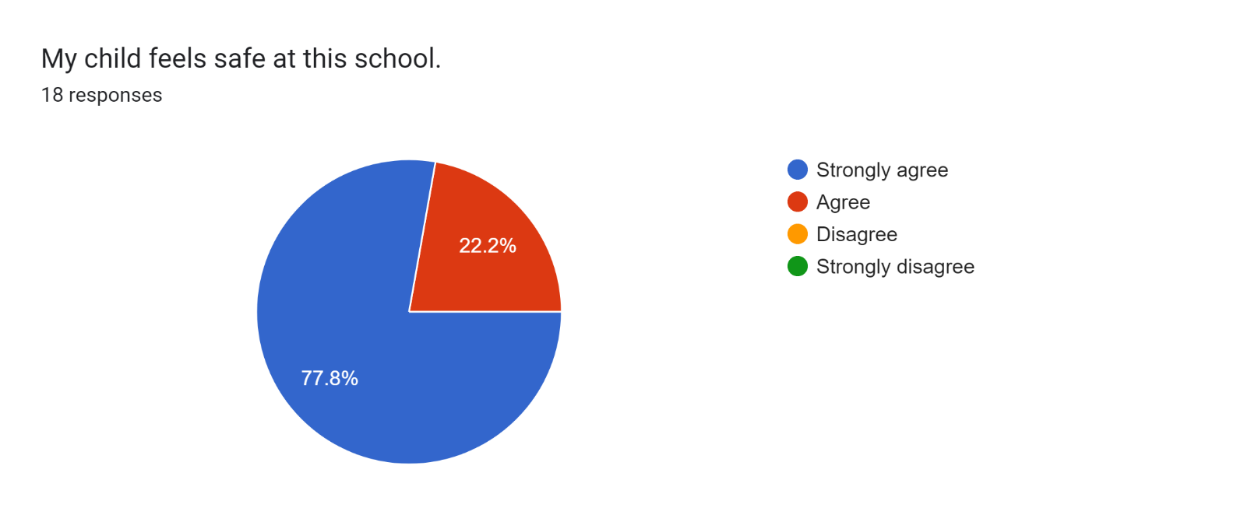

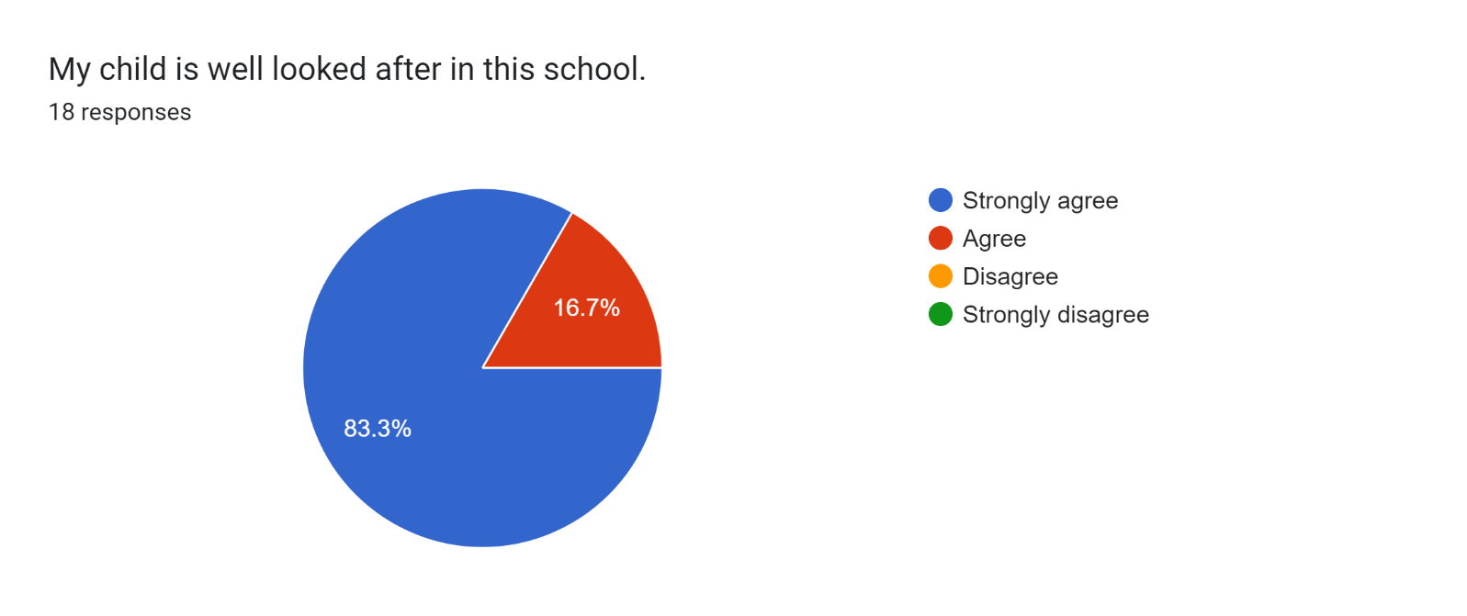

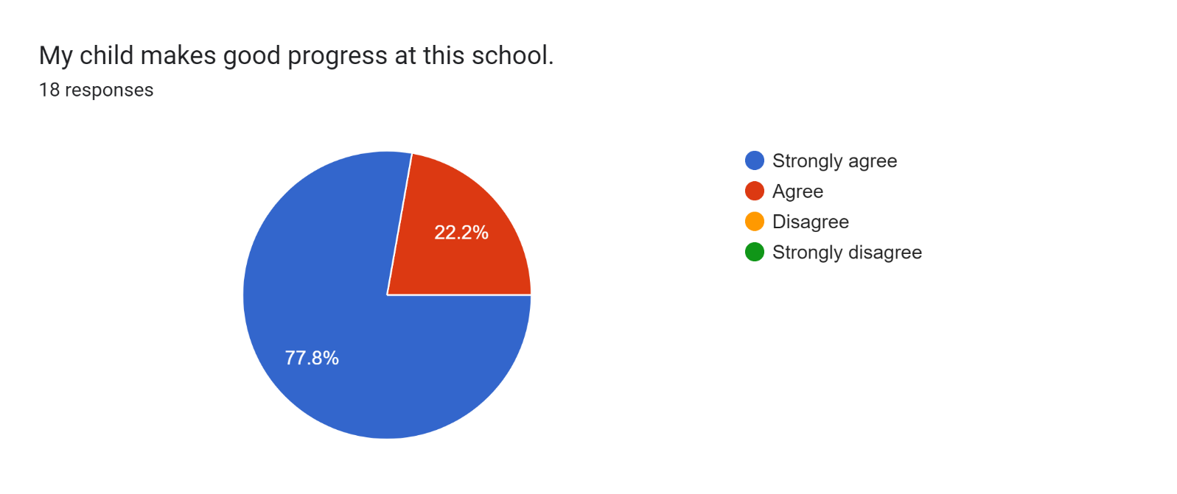

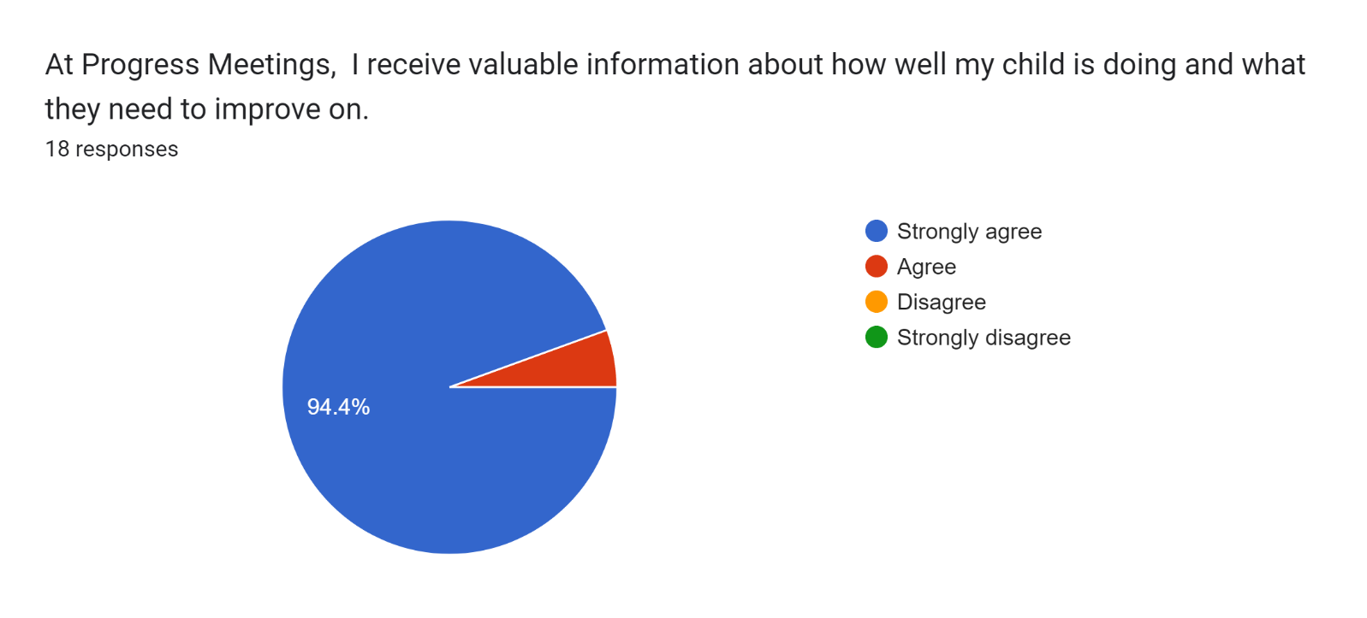

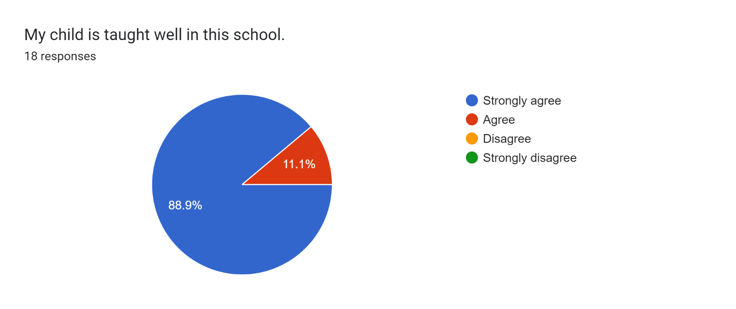

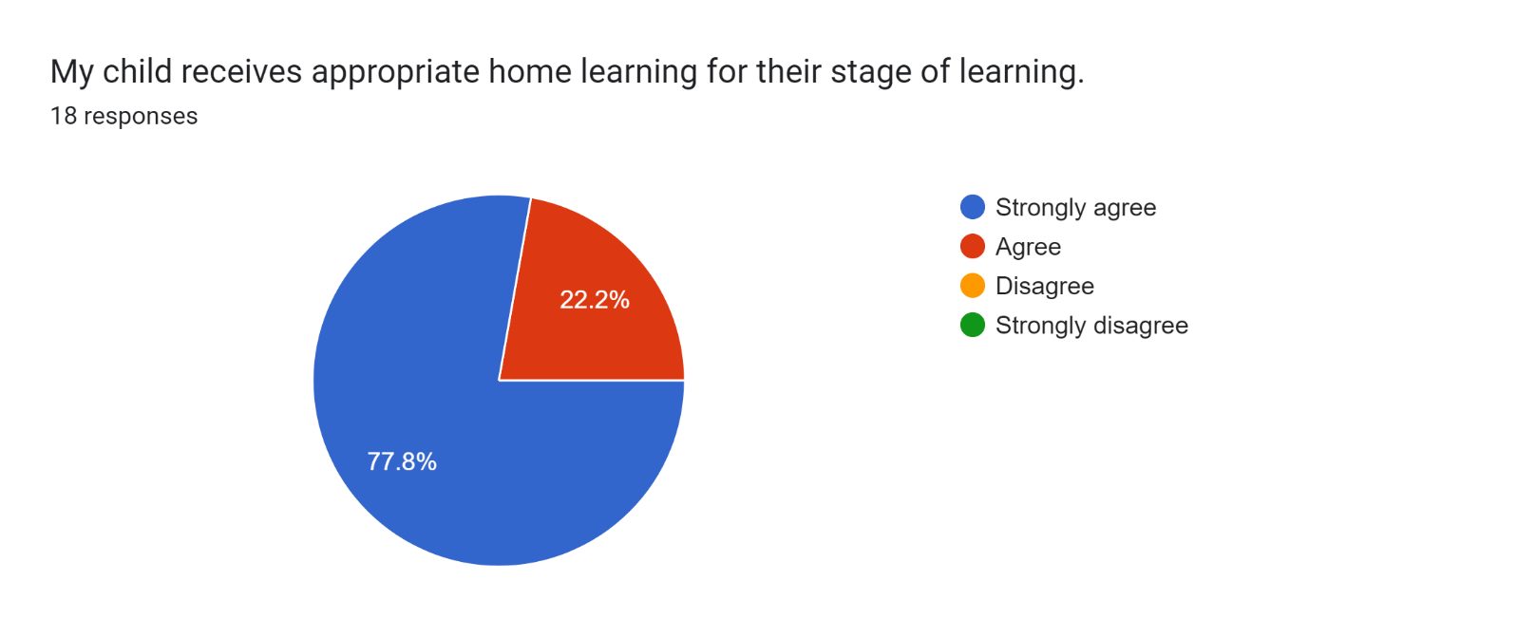

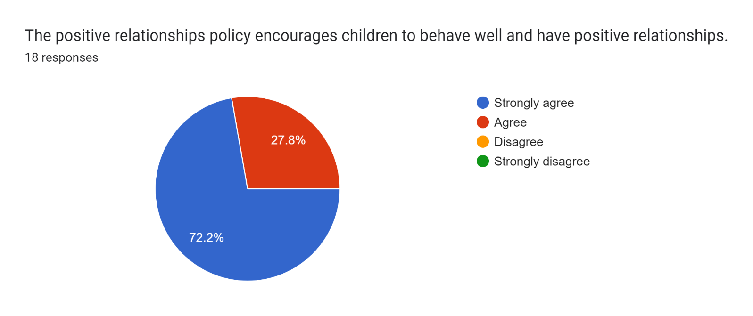

Forms response chart. Question title: This school deals effectively with bullying
. Number of responses: 18 responses.Forms response chart. Question title: This school is well led and managed
. Number of responses: 18 responses.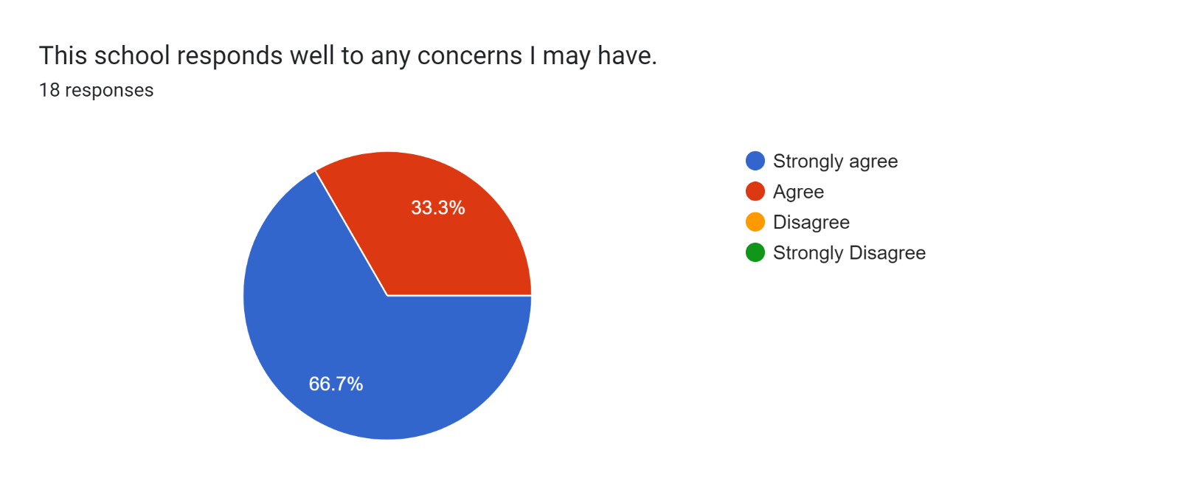

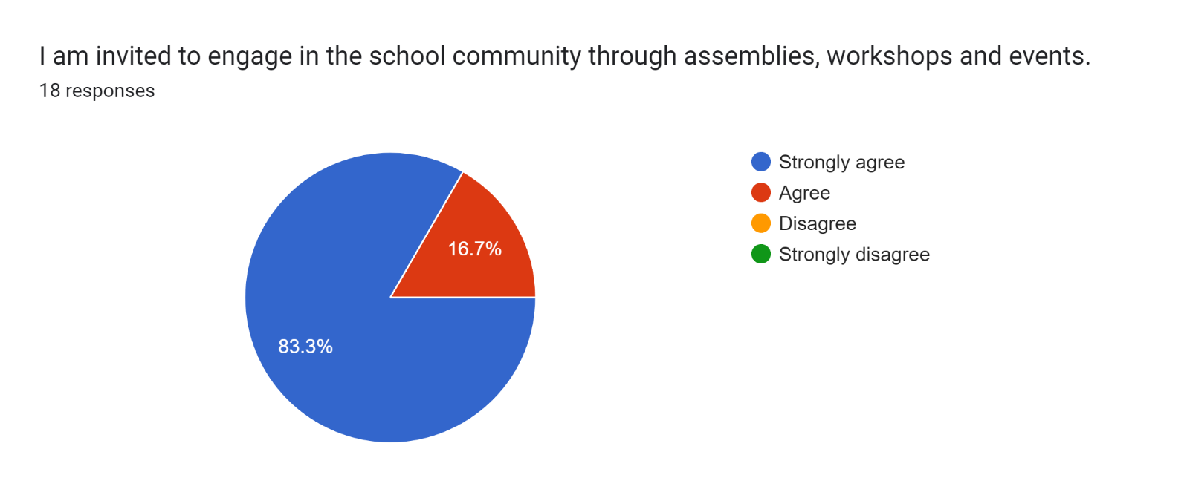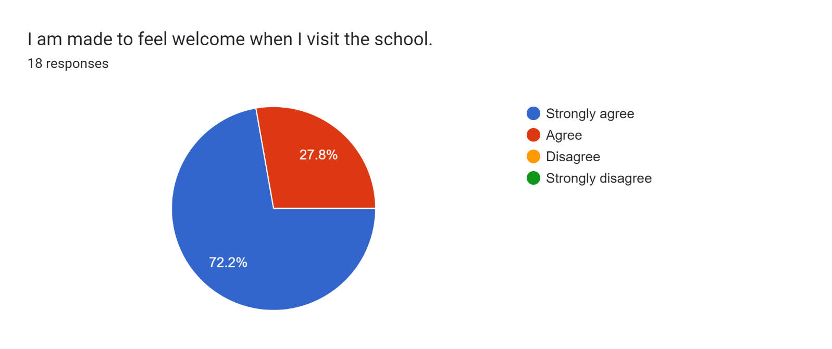

Forms response chart. Question title: The school uses a range of platforms to communicate with parents and carers - Class Charts, website, newsletters etc.
. Number of responses: 18 responses.

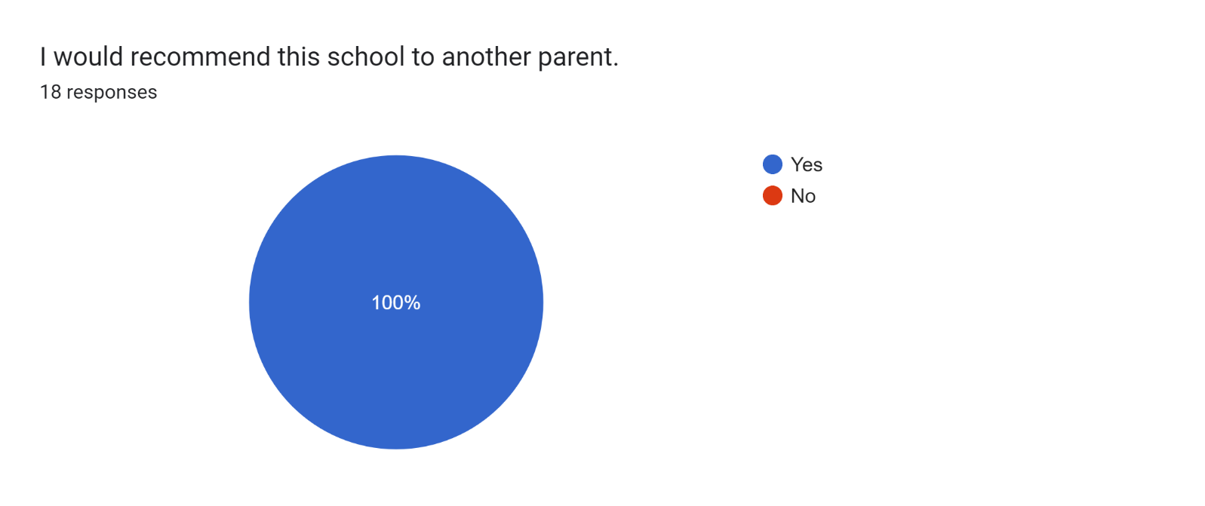

If there are any other comments you would like to make, please add below:

* Thank you for your support.
* Keep the good work and keep pushing the kids more.
* Thanks for teaching my boys. It has been nice to hear that they are doing well.
* Amazing school!
* We believe that our daughter has progressed really well throughout her time at Roby Park and we are happy with the support and guidance that the school provides for her.
* Can not speak highly enough about the help my son has received from this school and his teachers.
* My child learns very well at this school.
* Keep up good job.
* Any concerns I may have are always dealt with effectively. Our teachers are always glad to help and will go the extra mile to support any concerns I have which I am very grateful for.
* Wonderful school and staffing. Sorry this is my son’s last year at the school.
* It was lovely meeting my son’s teacher. She was very welcoming.
* Friendly and welcoming.
* Fabulous teachers.