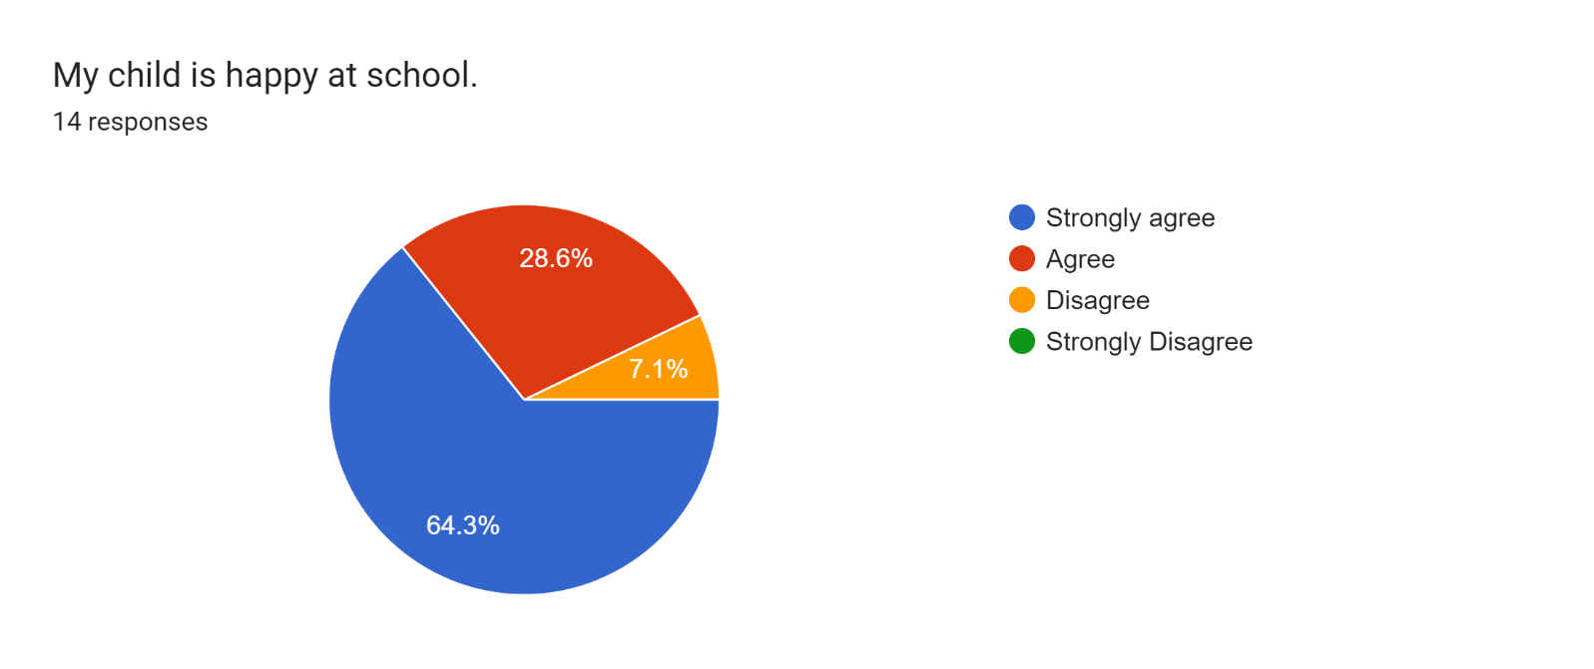

\*1 parent

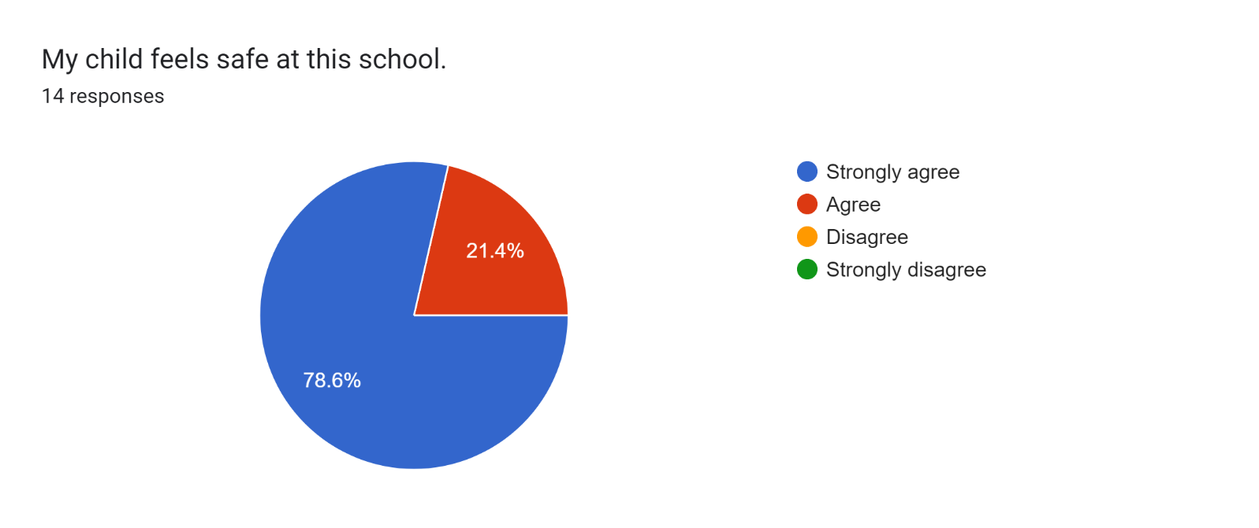

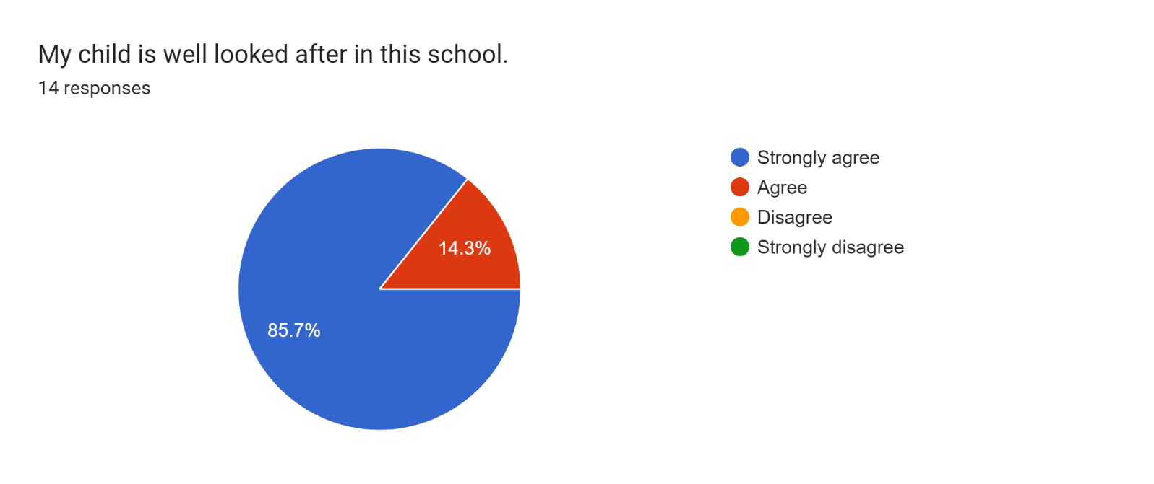

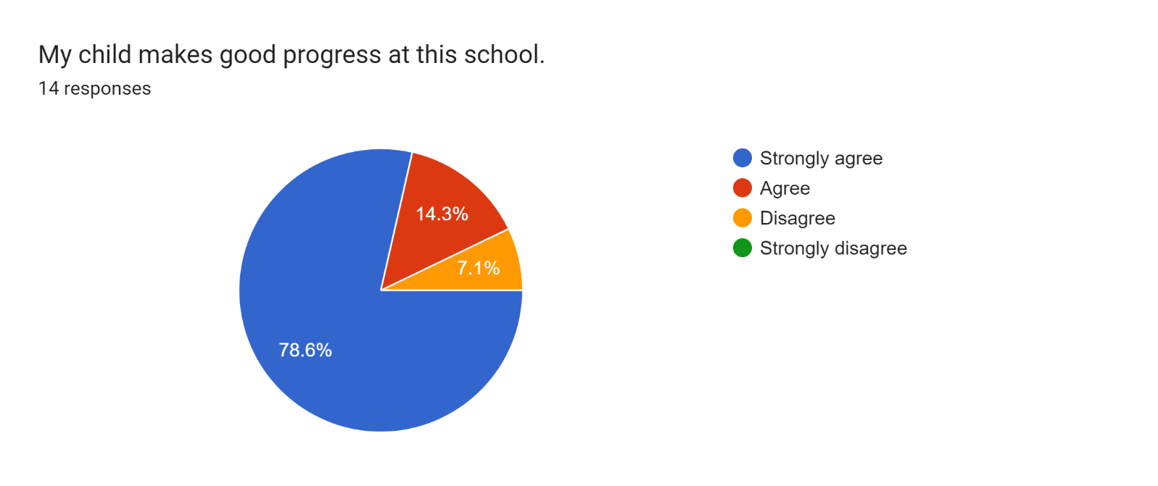

\*1 parent

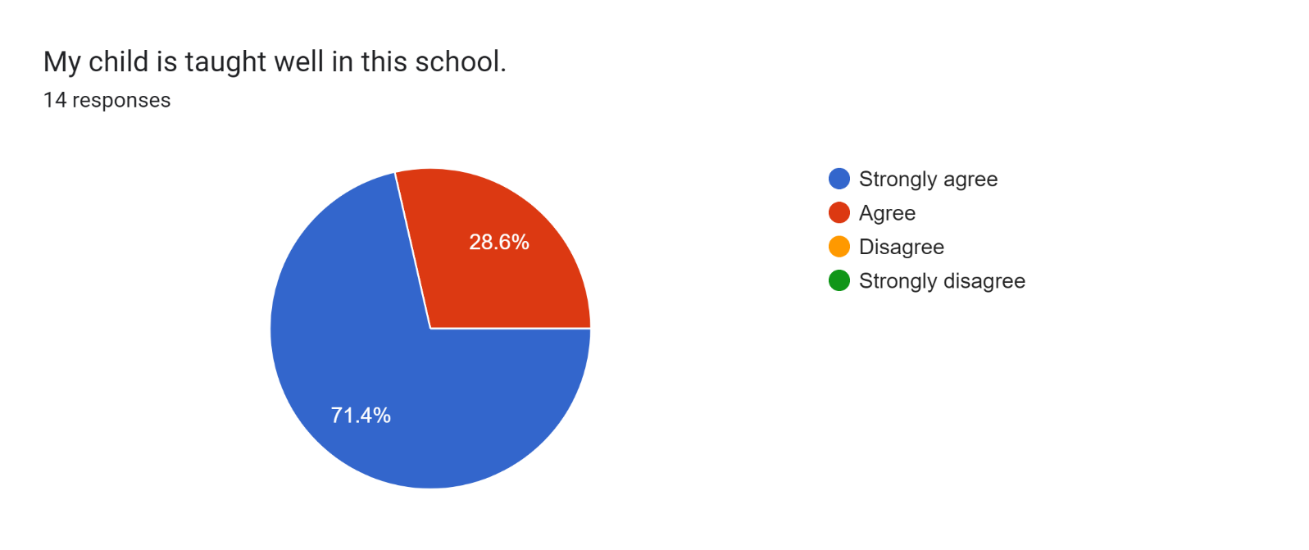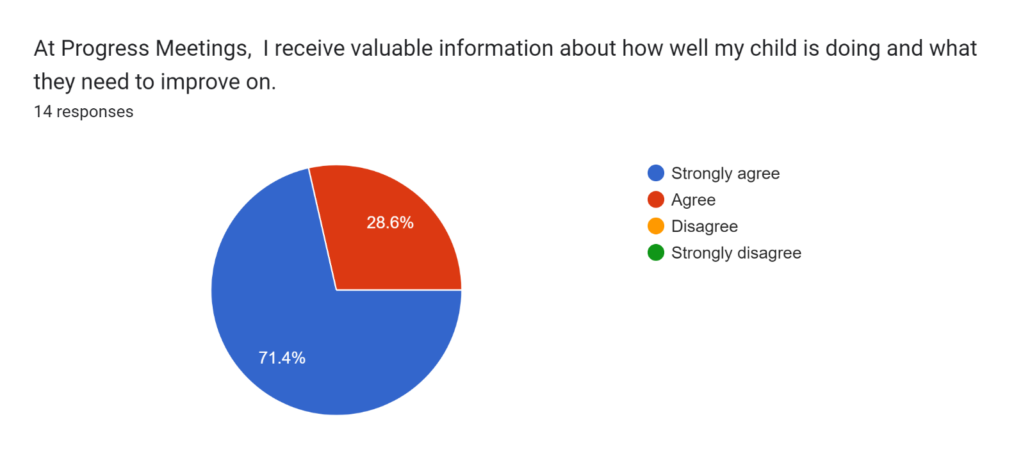

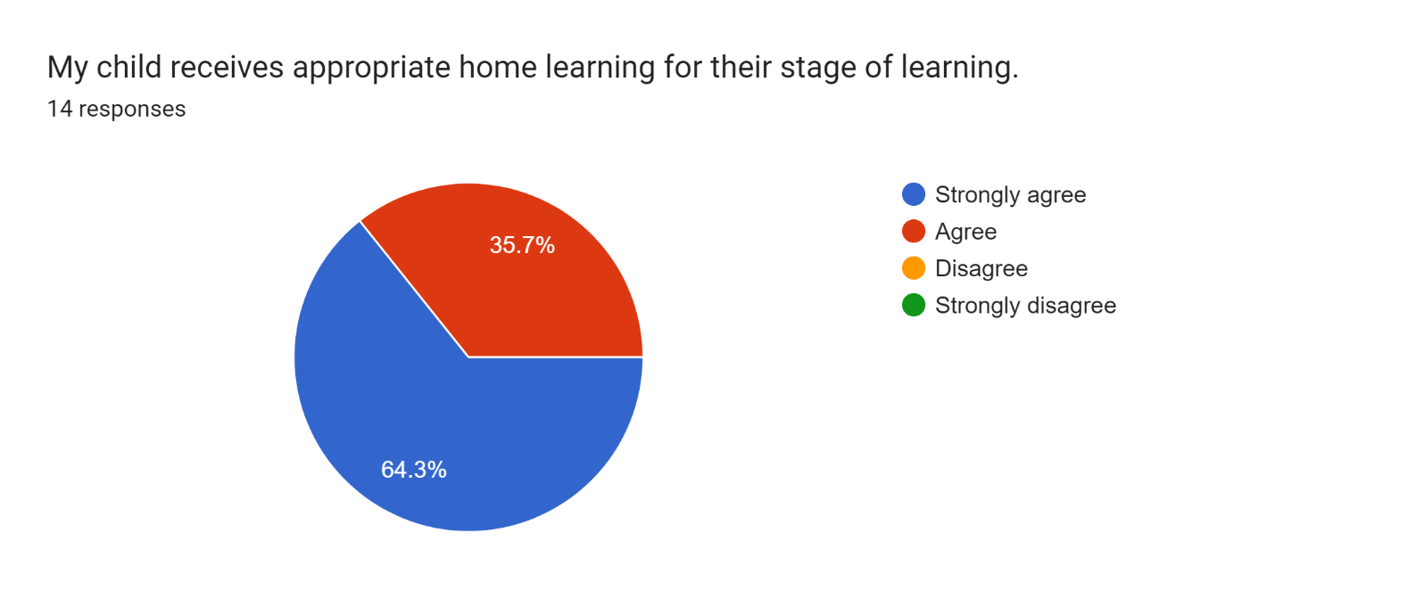

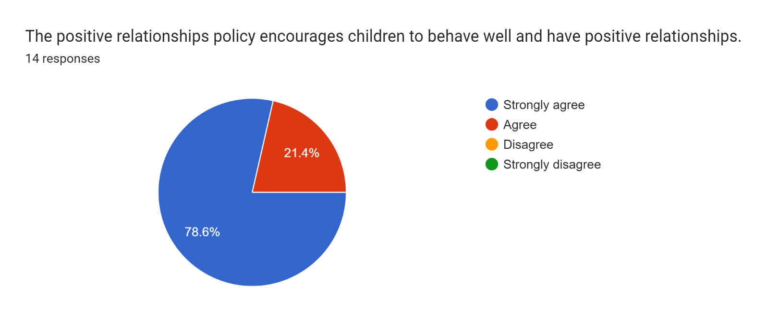

Forms response chart. Question title: This school deals effectively with bullying
. Number of responses: 14 responses.

\*1 parent

Forms response chart. Question title: This school is well led and managed
. Number of responses: 14 responses.

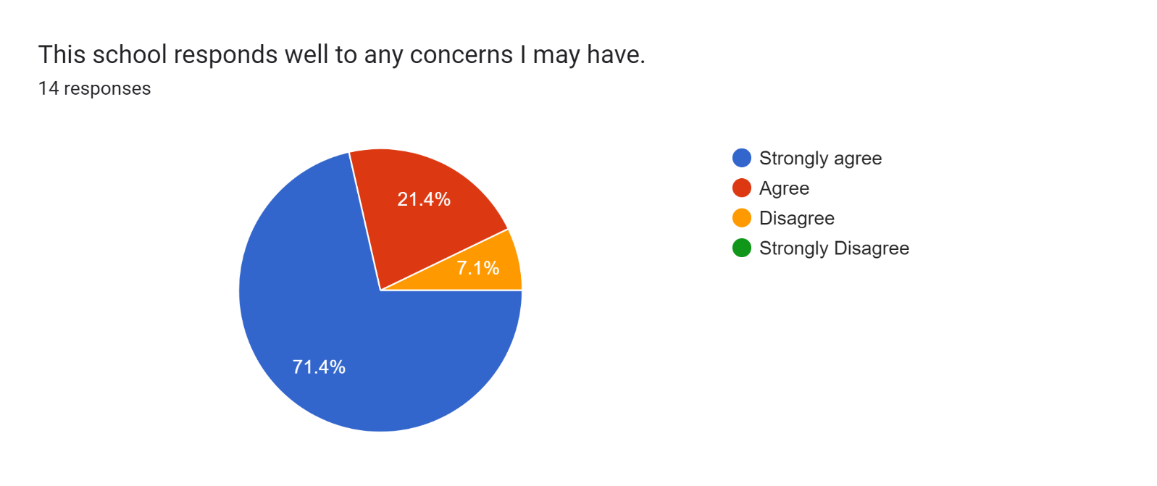

\*1 parent

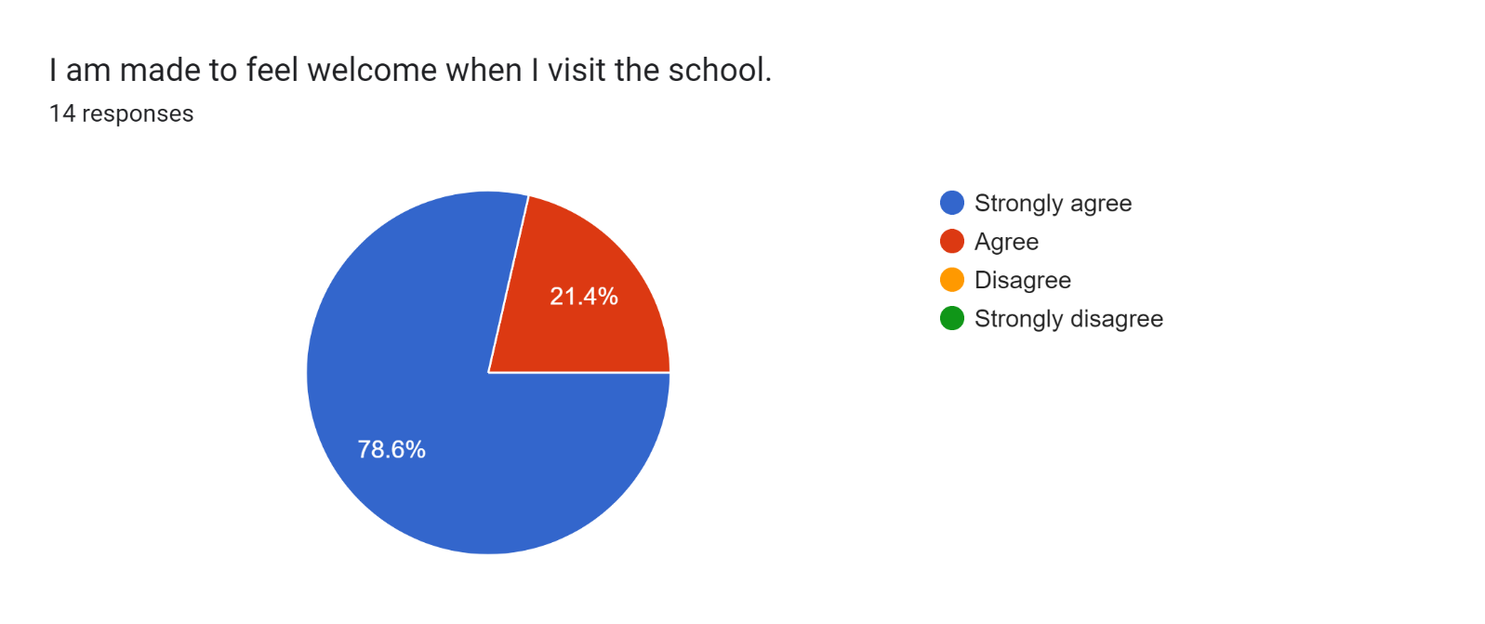

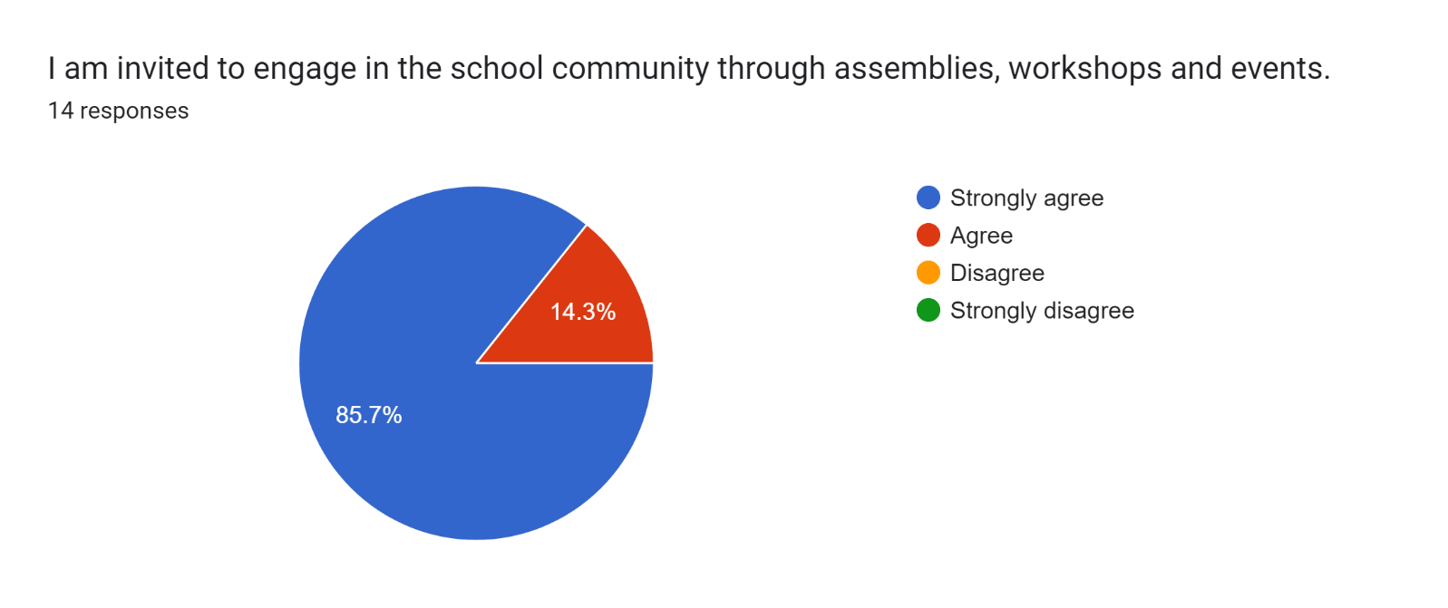

Forms response chart. Question title: The school uses a range of platforms to communicate with parents and carers - Class Charts, website, newsletters etc.
. Number of responses: 14 responses.

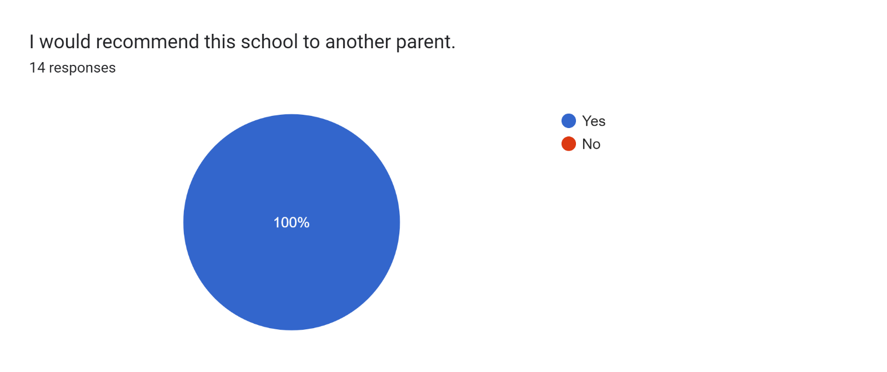

If there are any other comments you would like to make, please add below:

* Amazing work - thank you.
* I was happy to hear about my son’s progress in school.
* Thank you for all you do for my child.
* Very welcoming.
* Thank you for helping and listening. Nice to see progress made.
* Miss Worthington has made our son feel settled and welcome since starting. He has progressed well and his confidence has increased.
* Very happy.
* Thank you.
* Keep going :)
* It is a lovely school and I am thankful for all that the teachers do for my son.
* Thanks to ALL staff. You are amazing!
* Brillant all round.