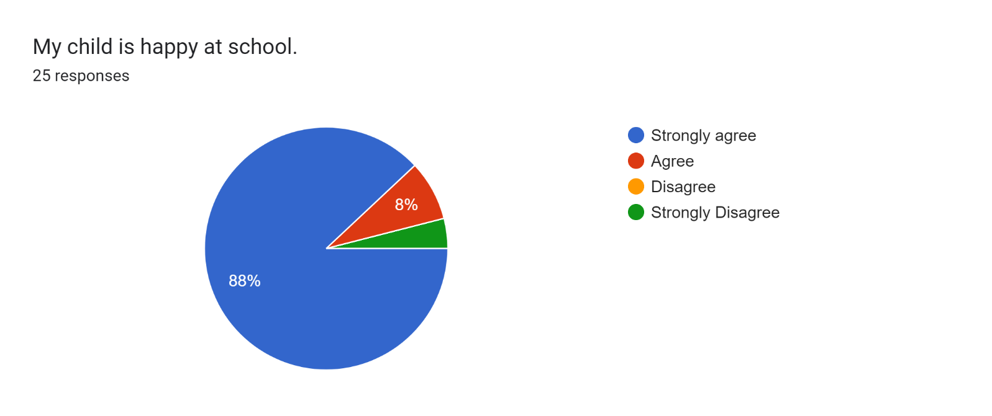

\*1 parent

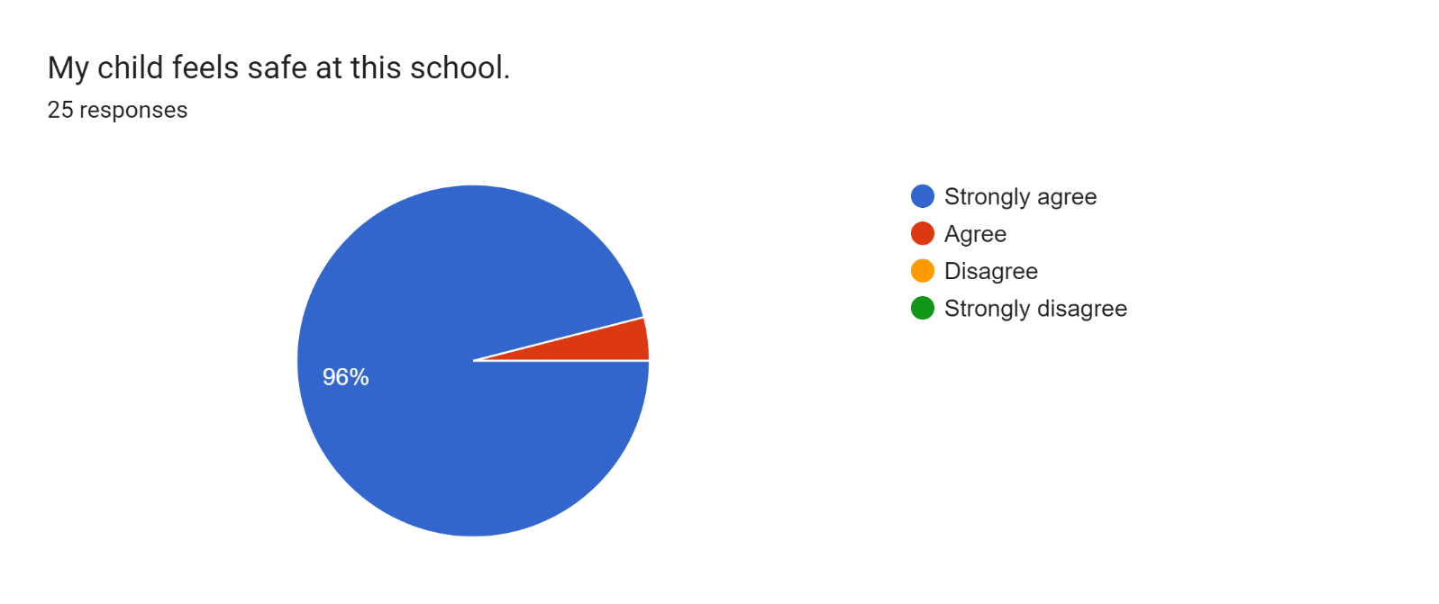

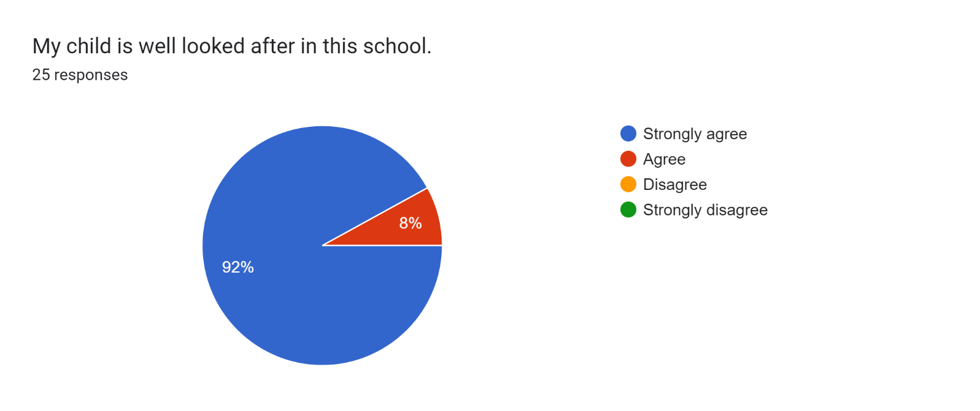

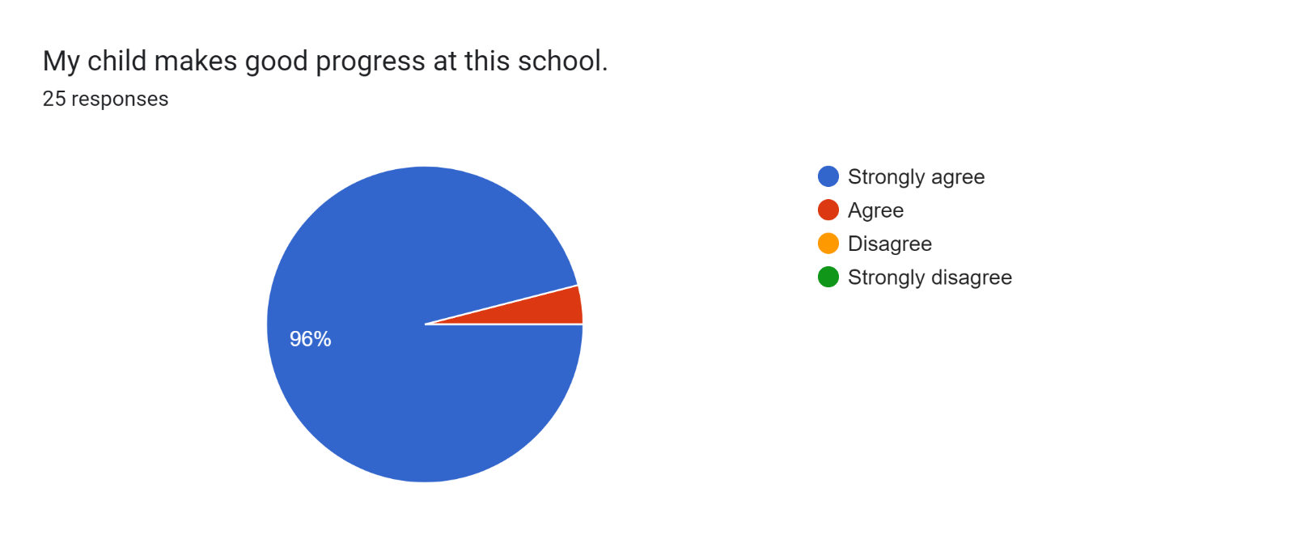

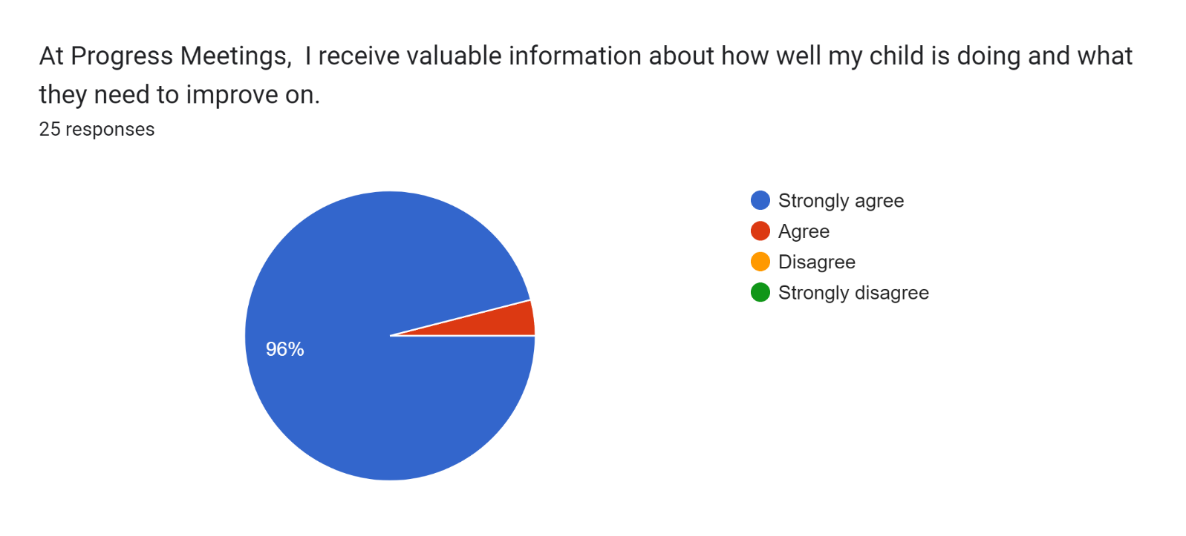

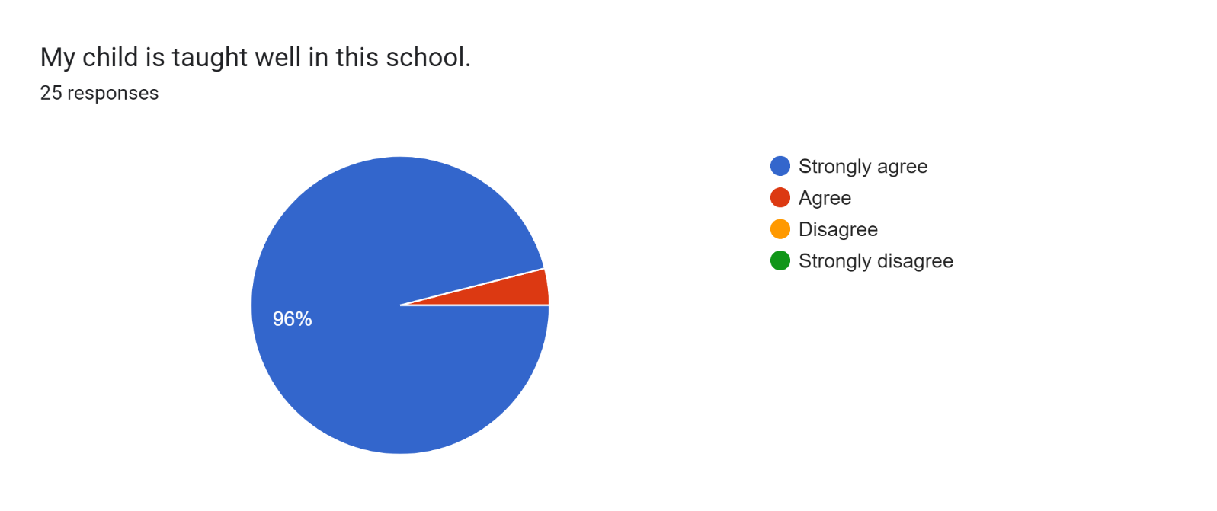

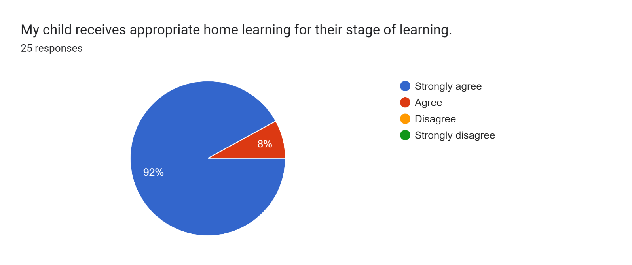

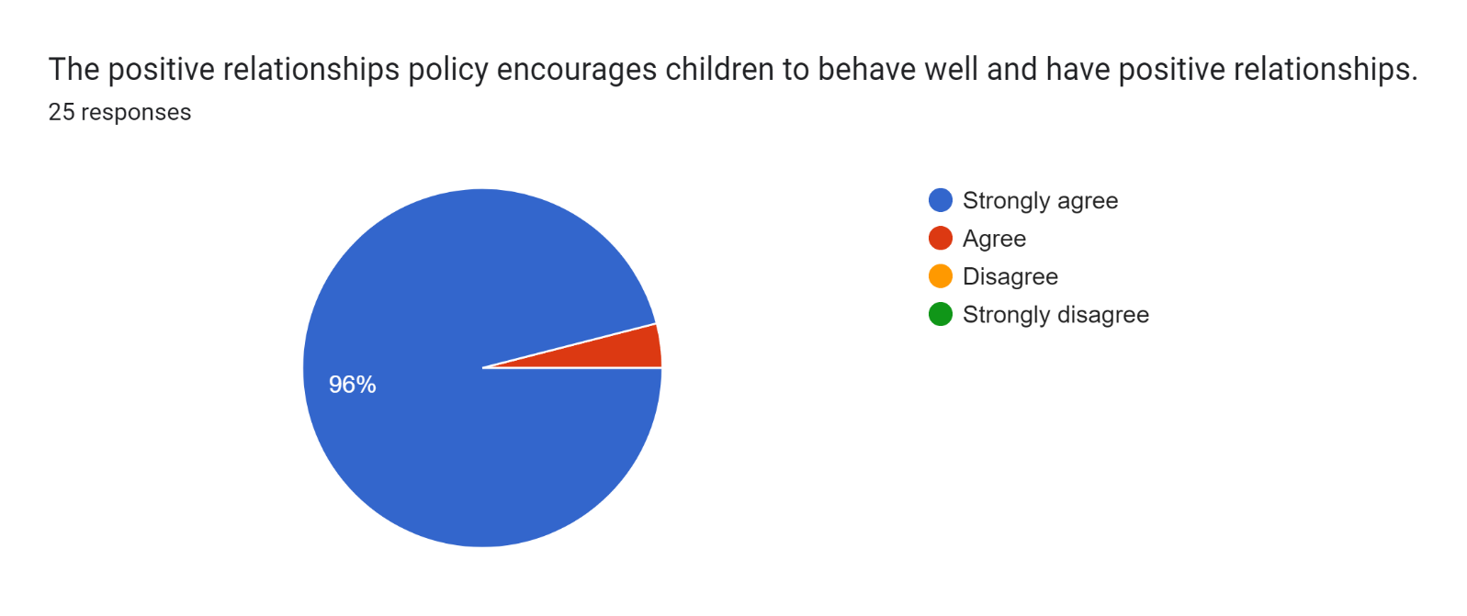

Forms response chart. Question title: This school deals effectively with bullying
. Number of responses: 25 responses.

Forms response chart. Question title: This school is well led and managed
. Number of responses: 25 responses.

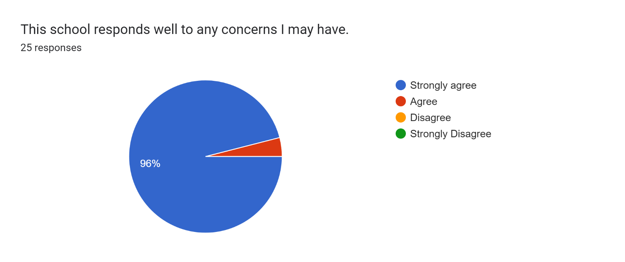

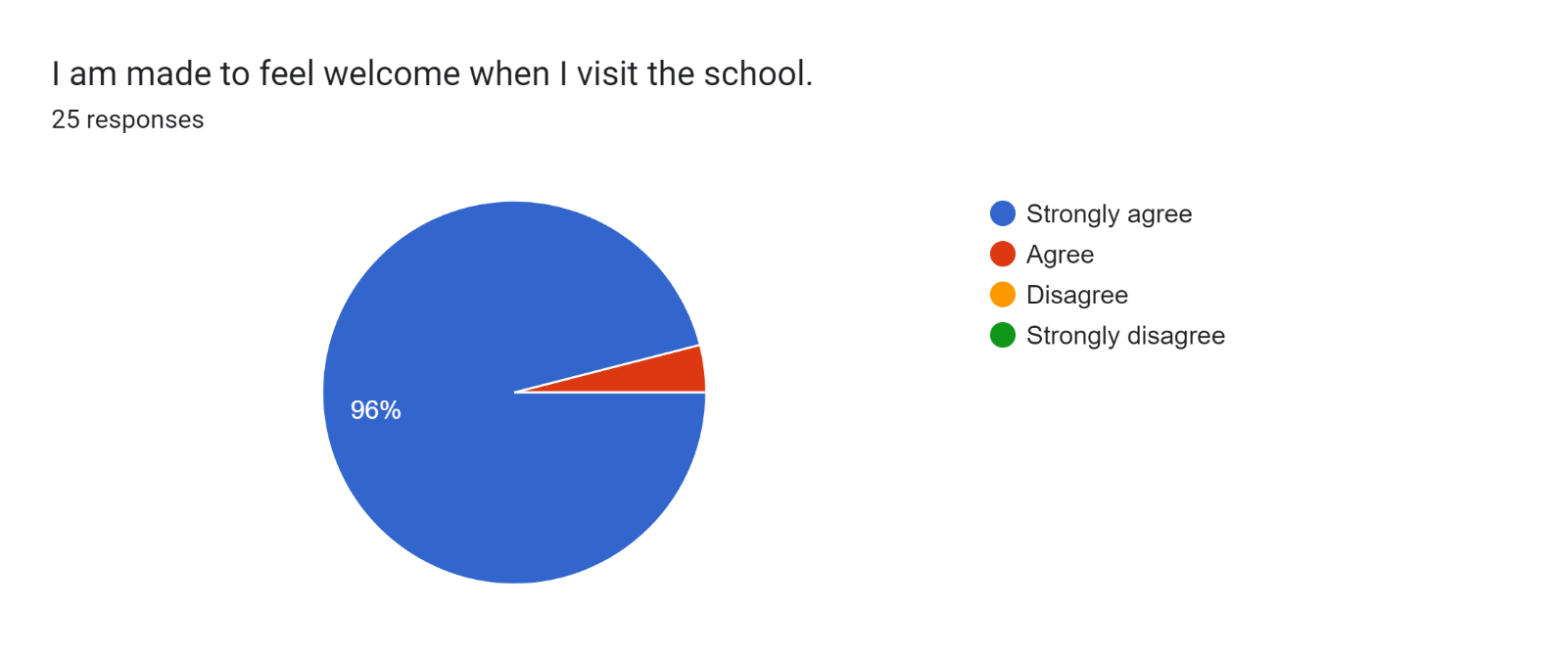

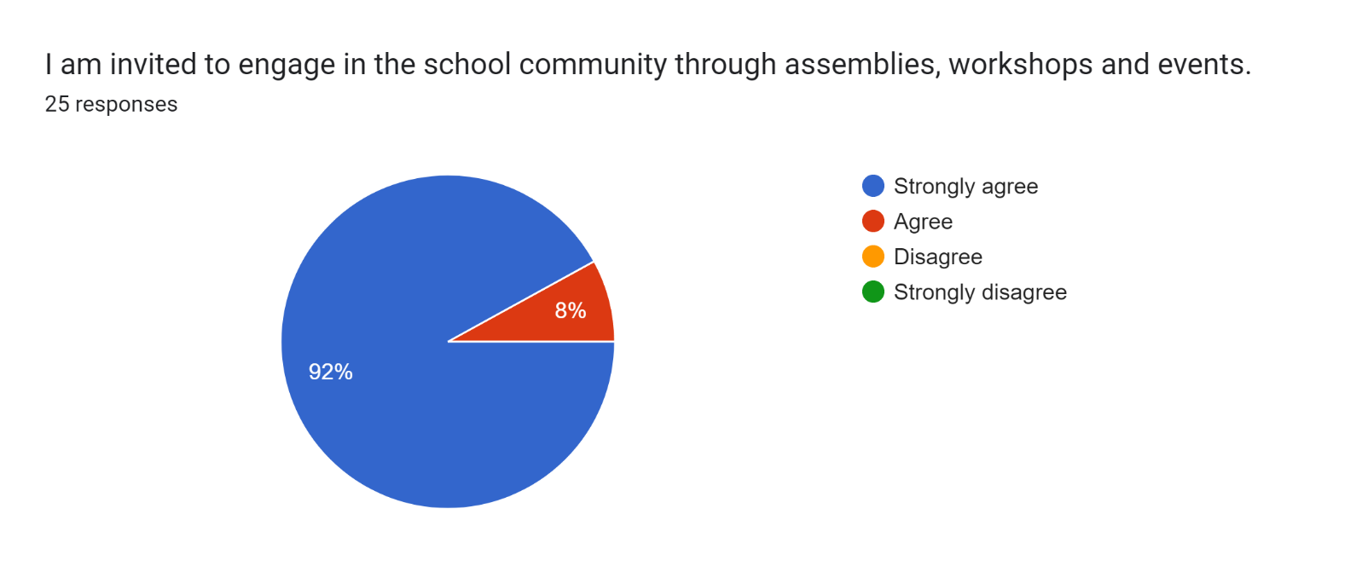

Forms response chart. Question title: The school uses a range of platforms to communicate with parents and carers - Class Charts, website, newsletters etc.
. Number of responses: 25 responses.

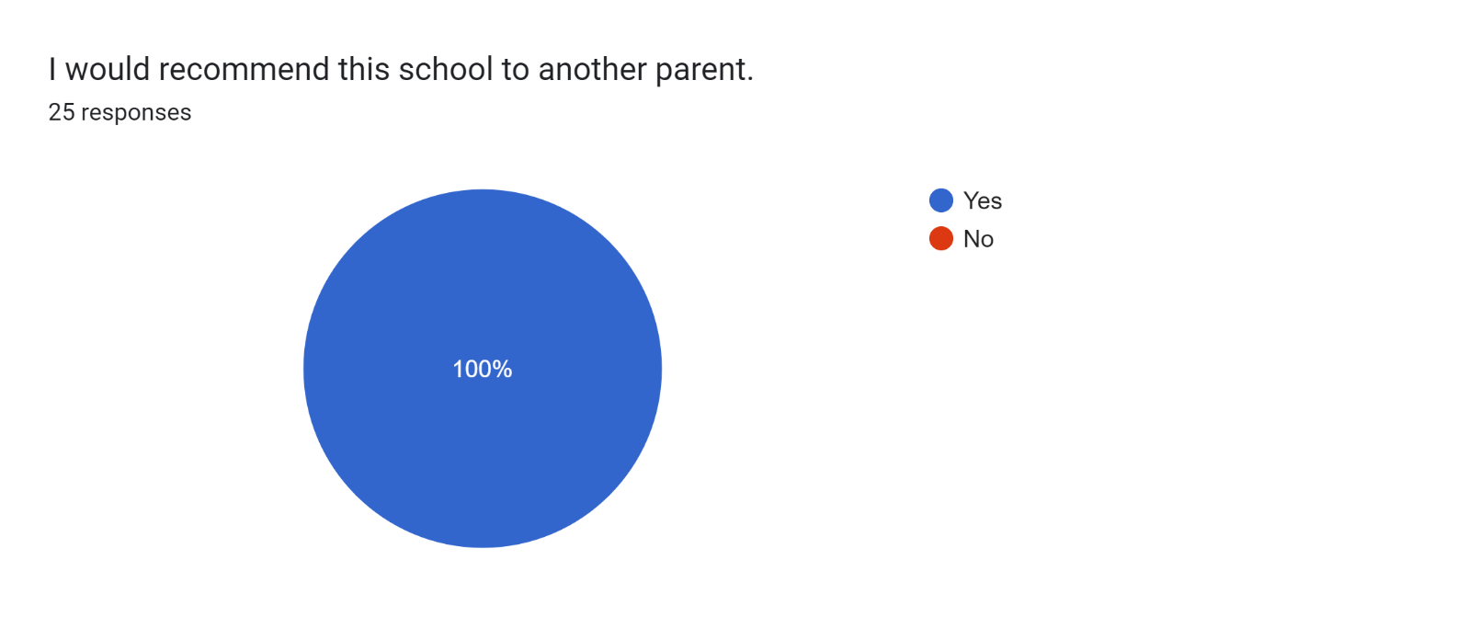

If there are any other comments you would like to make, please add below:

* I am happy about hearing the progress my daughter is making in school.
* I couldn’t fault this school.
* Thank you for all you do for my child.
* Amazing!
* Keep up the good work with the children.
* Brilliant!
* Great class teacher.
* Excellent staff.
* Lovely and caring - thank you so much.
* Lovely staff.
* They're brilliant.
* Great staff and we are made to feel welcome.
* You are all wonderful - thank you.
* Great report. I am really pleased with our child's progress in school.
* Brilliant staff - thank you for supporting my son this year.
* Best school in the borough!
* Welcoming and friendly.
* Staff are great - my daughter loves coming to school.
* Happy with my child’s progress at this school. Thank you, Mr Couling, for all of your hard work.
* Brilliant school.
* Amazing teachers.