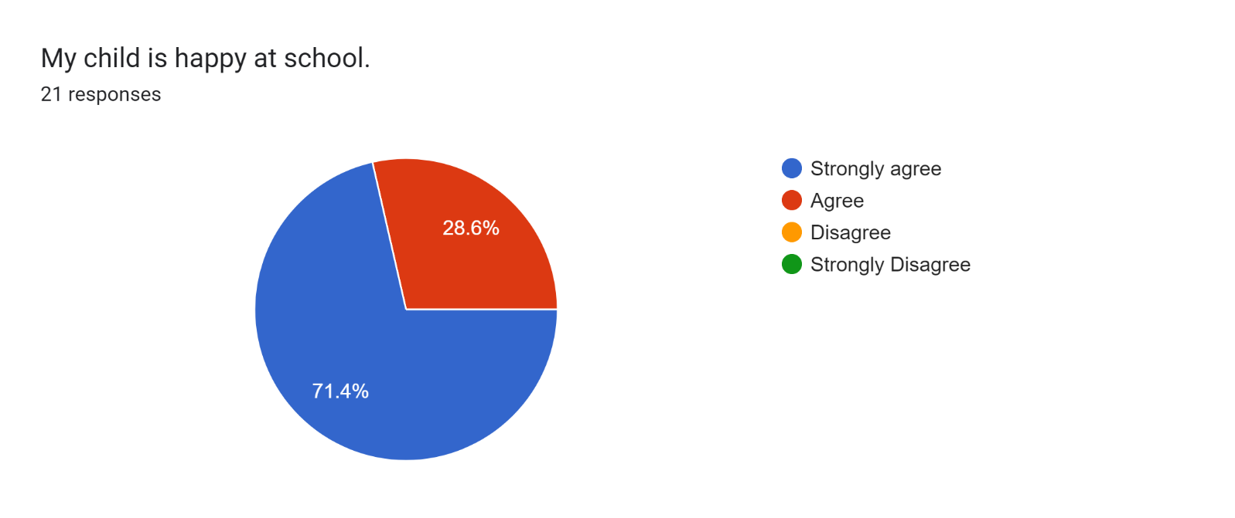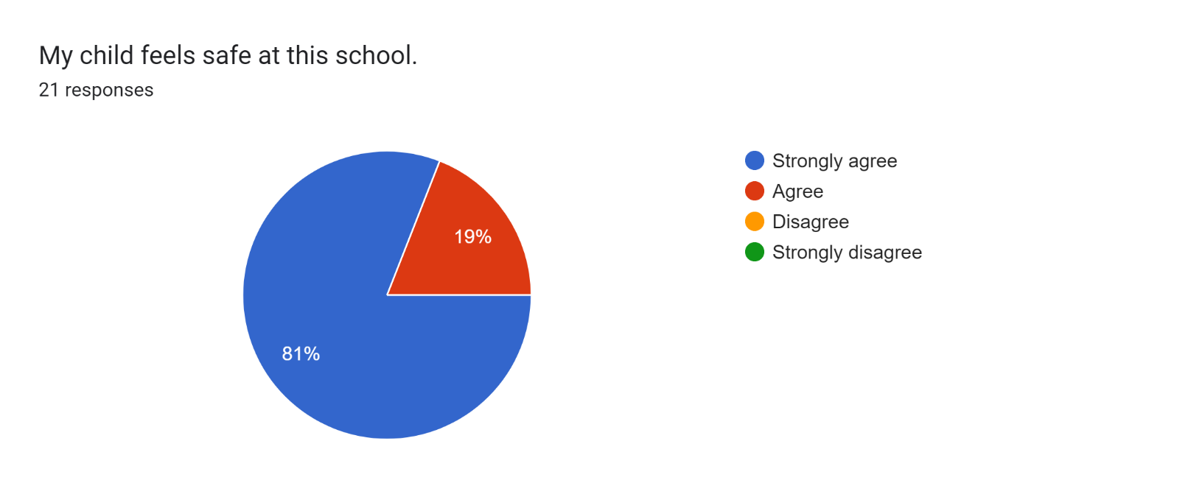

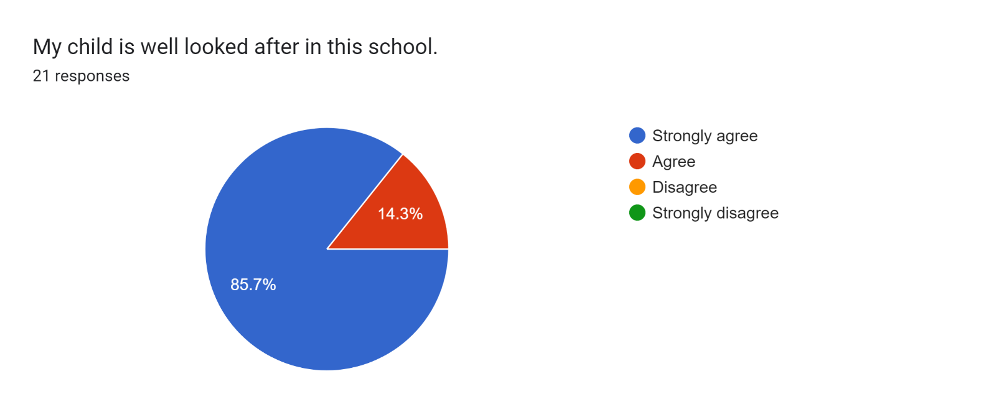

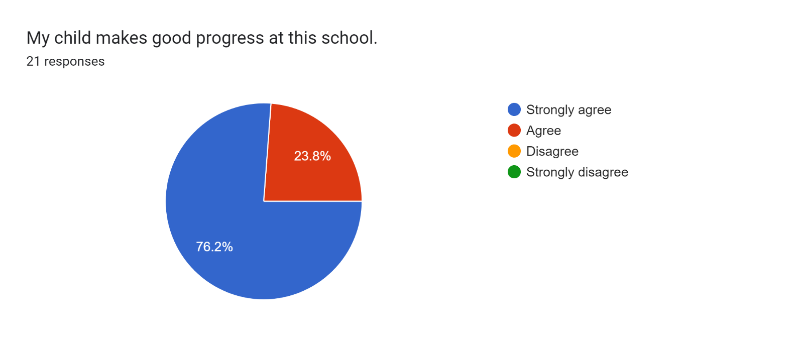

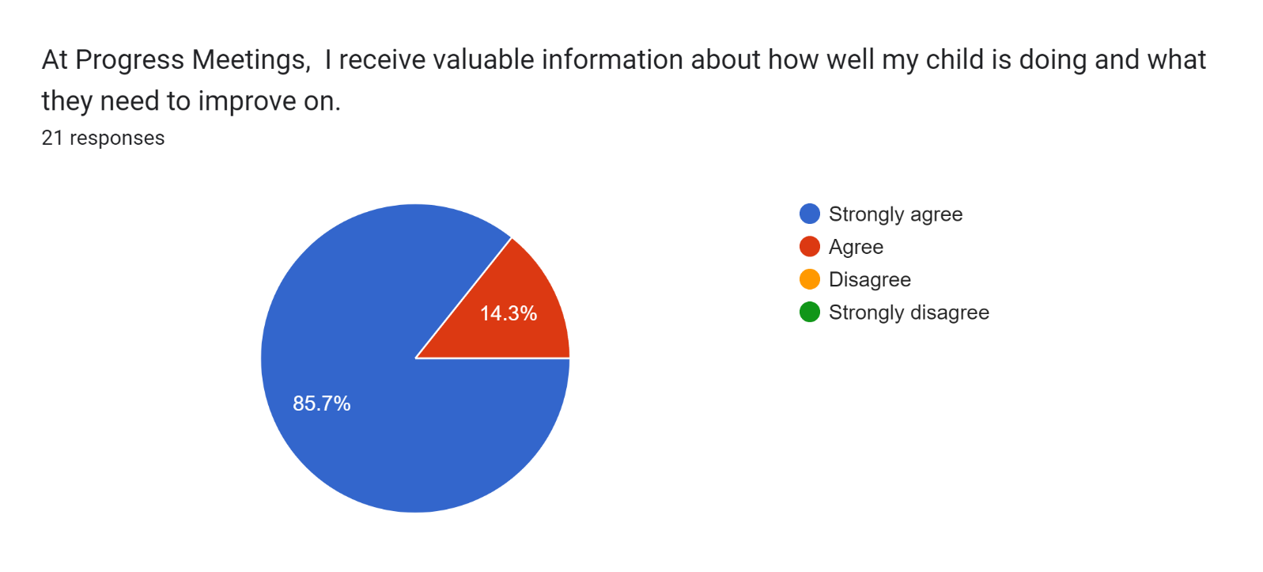

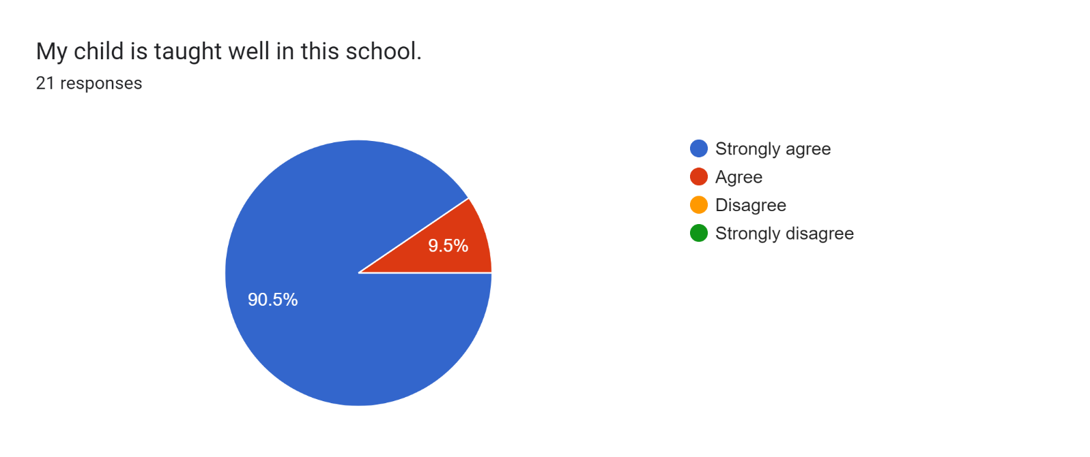

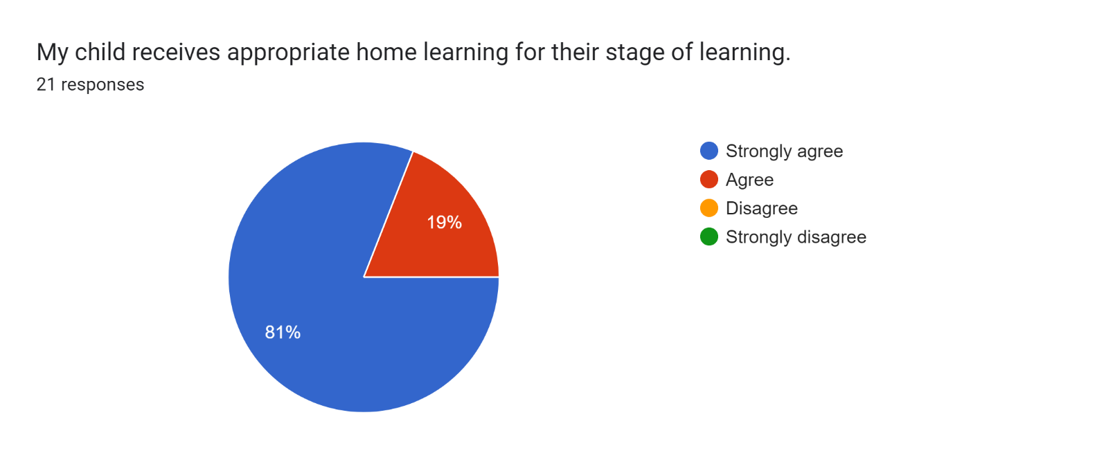

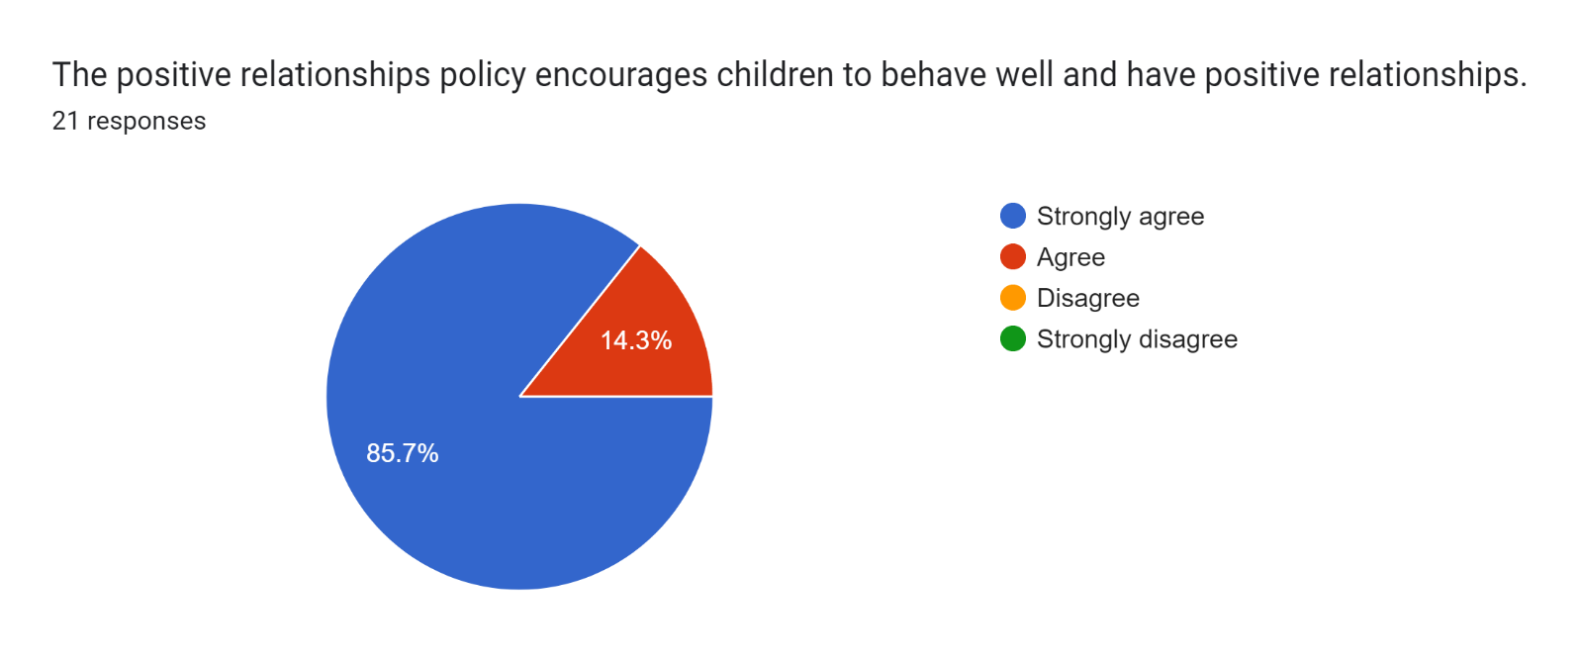

Forms response chart. Question title: This school deals effectively with bullying
. Number of responses: 21 responses.

Forms response chart. Question title: This school is well led and managed
. Number of responses: 21 responses.

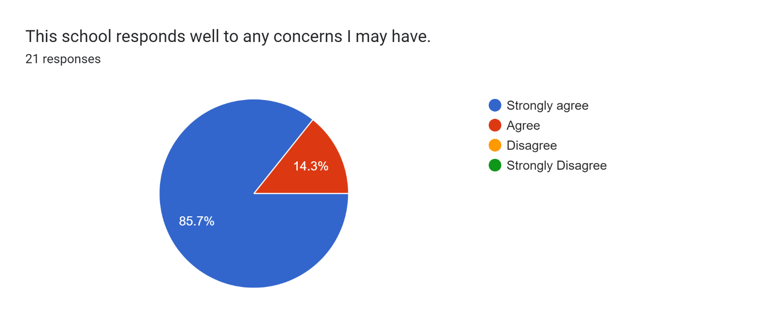

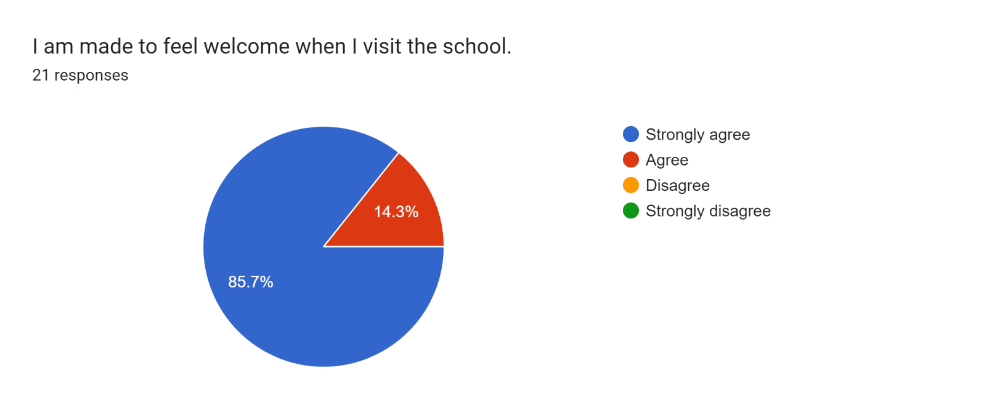

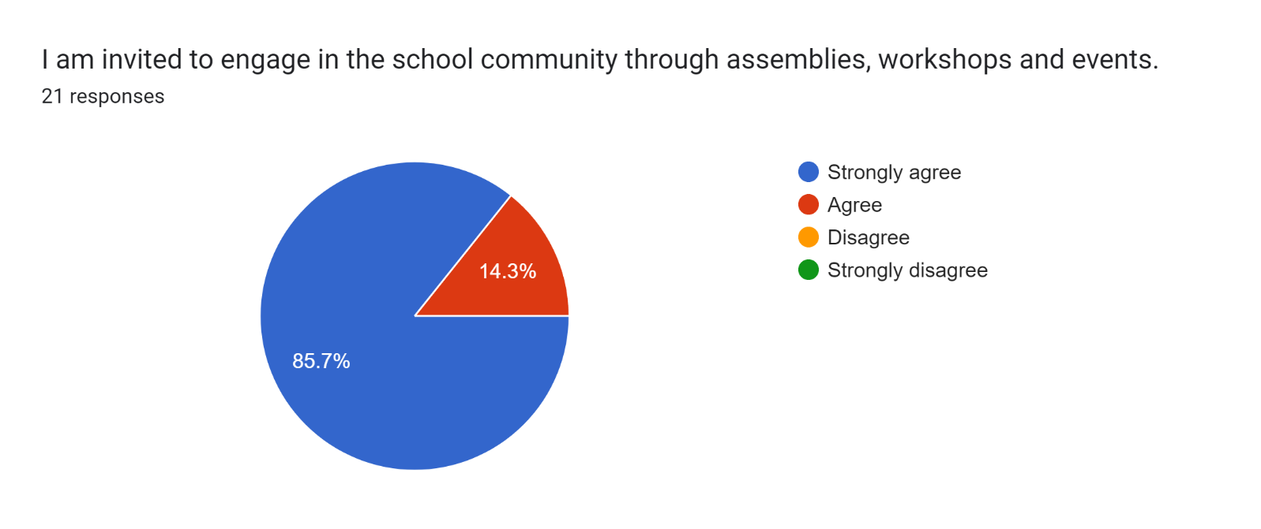

Forms response chart. Question title: The school uses a range of platforms to communicate with parents and carers - Class Charts, website, newsletters etc.
. Number of responses: 21 responses.

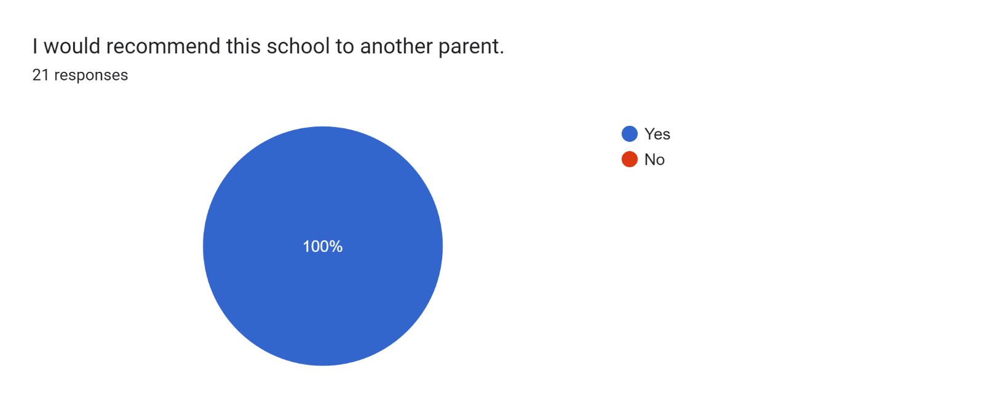

If there are any other comments you would like to make, please add below:

* I am so pleased to hear how much my son has come on this last term. His confidence is improving so much and I thank all the teachers for all the extra things they do to support him.
* Brilliant!
* Keep up the hard work.
* Thank you for all your support.
* Kind, friendly and helpful staff.
* Great school!
* Keep up the good work.
* Fantastic school.
* We are very happy with how much our son has settled into his class.
* The teacher is so lovely and great with our son.
* Thanks for everything you have done for my children.
* Amazing parents evening. I am so happy with how my daughter has settled in.
* Well done!
* I am very happy with the support my son receives.
* Amazing school and class teacher.
* My son loves school - thank you so much.
* Doing a fab job!