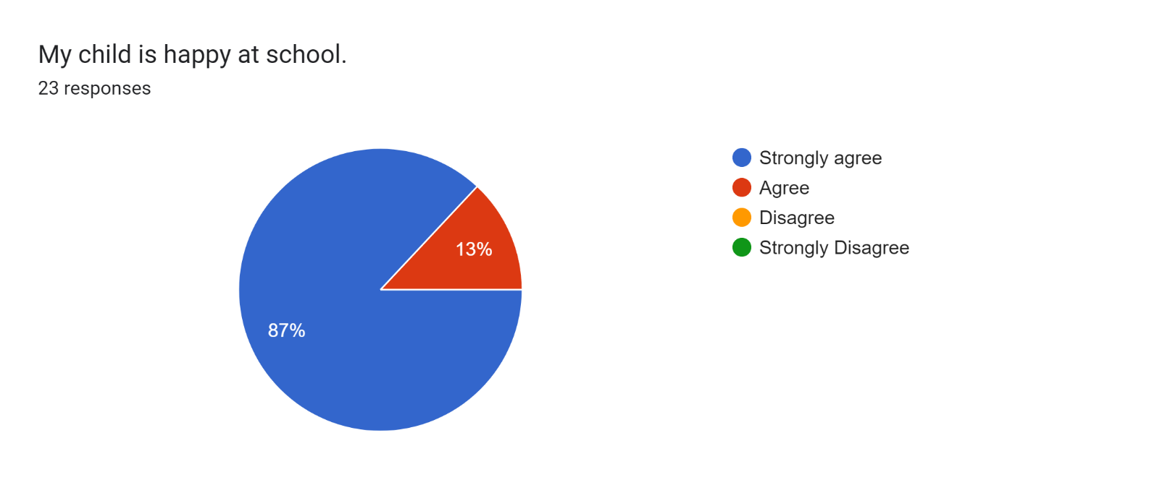

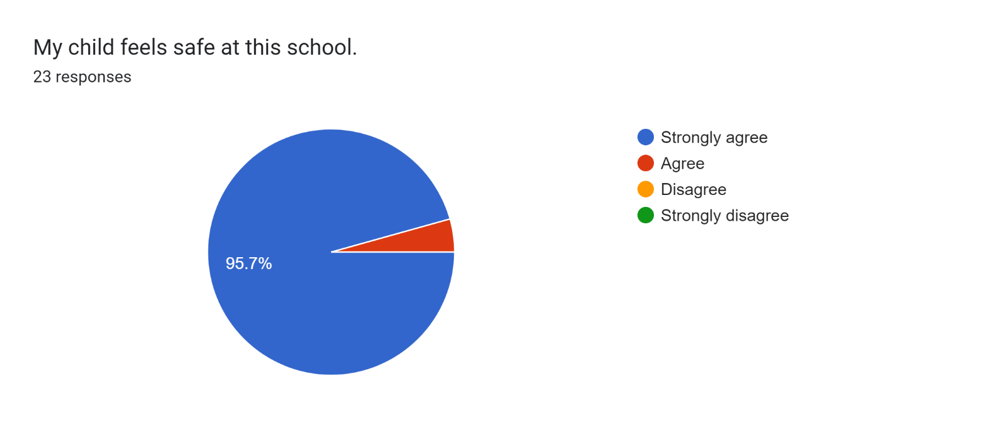

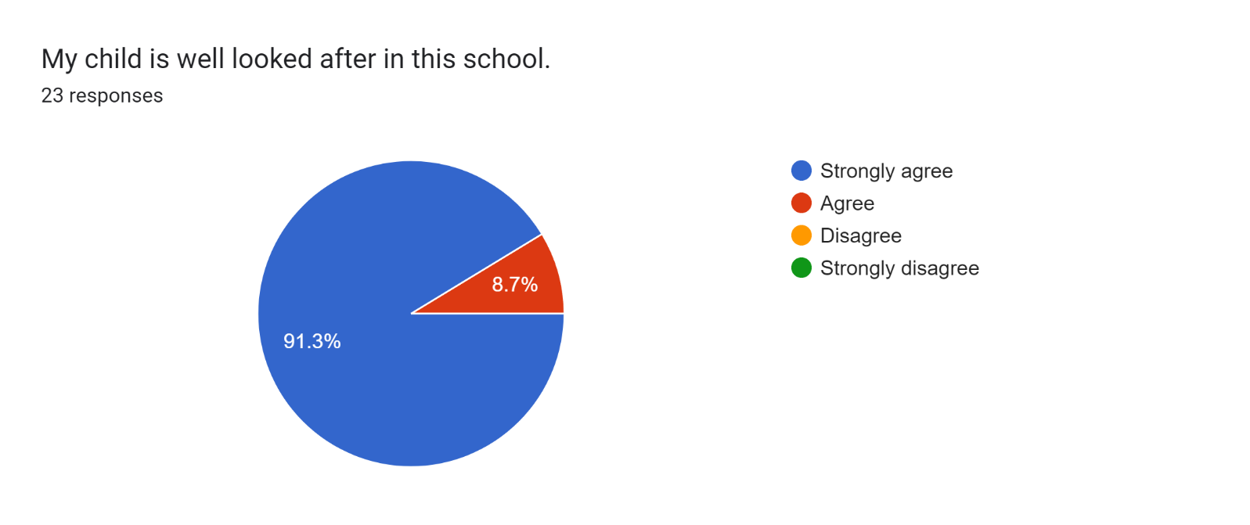

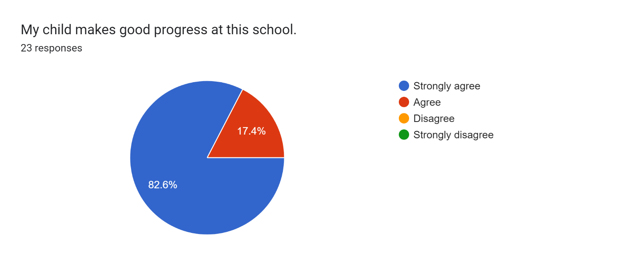

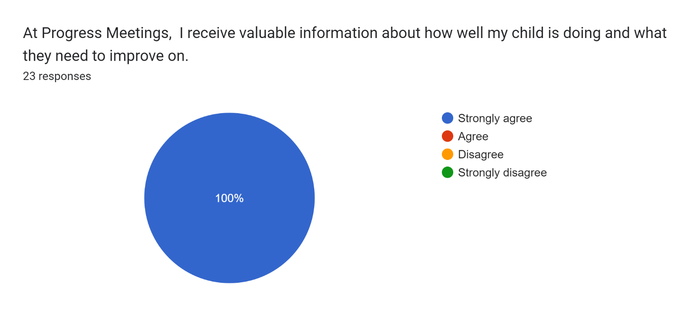

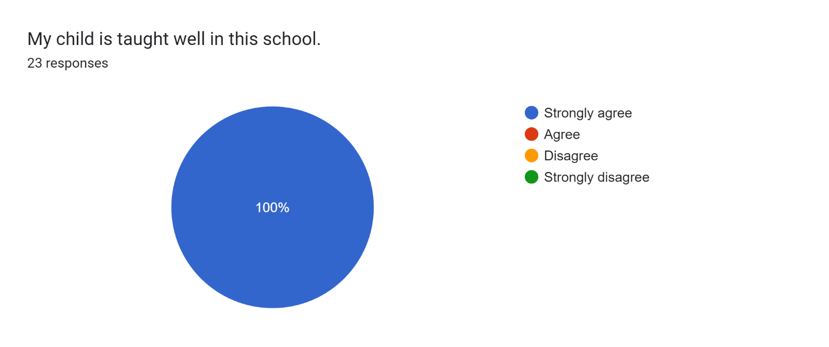

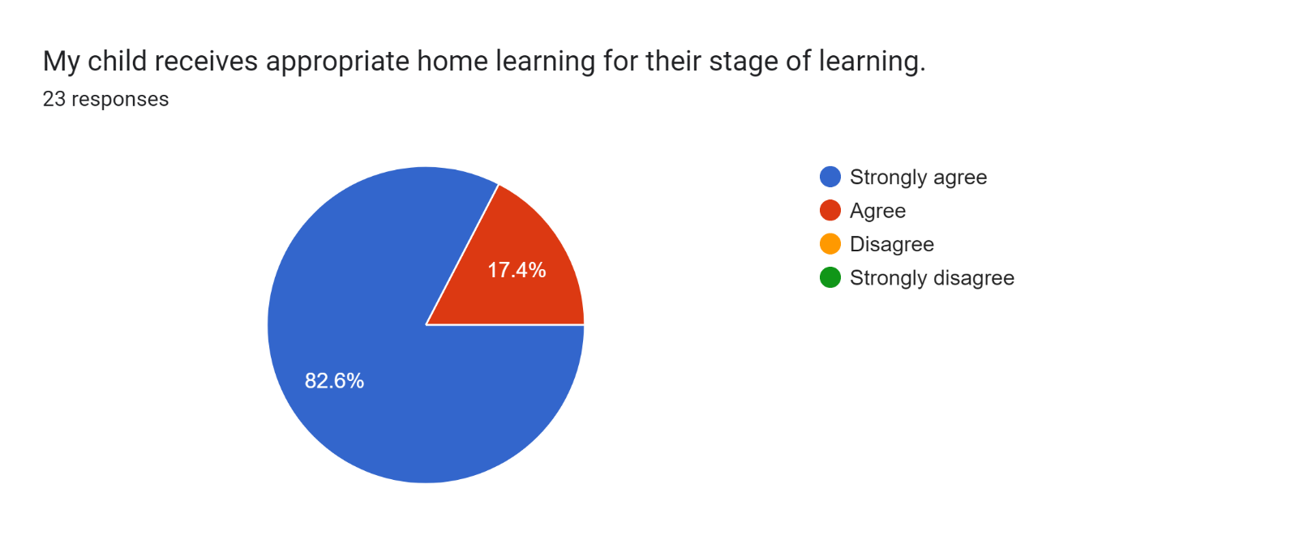

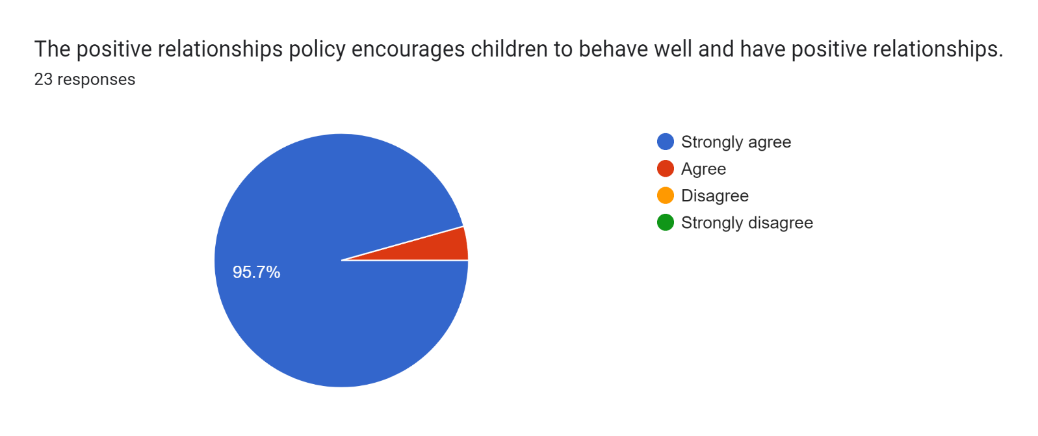

Forms response chart. Question title: This school deals effectively with bullying
. Number of responses: 23 responses.

Forms response chart. Question title: This school is well led and managed
. Number of responses: 23 responses.

\*1 parent

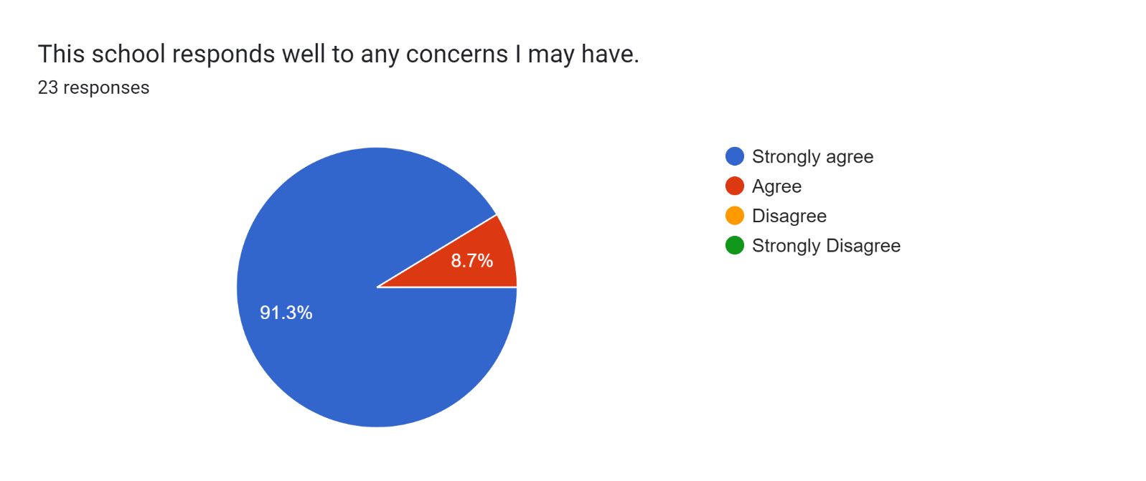

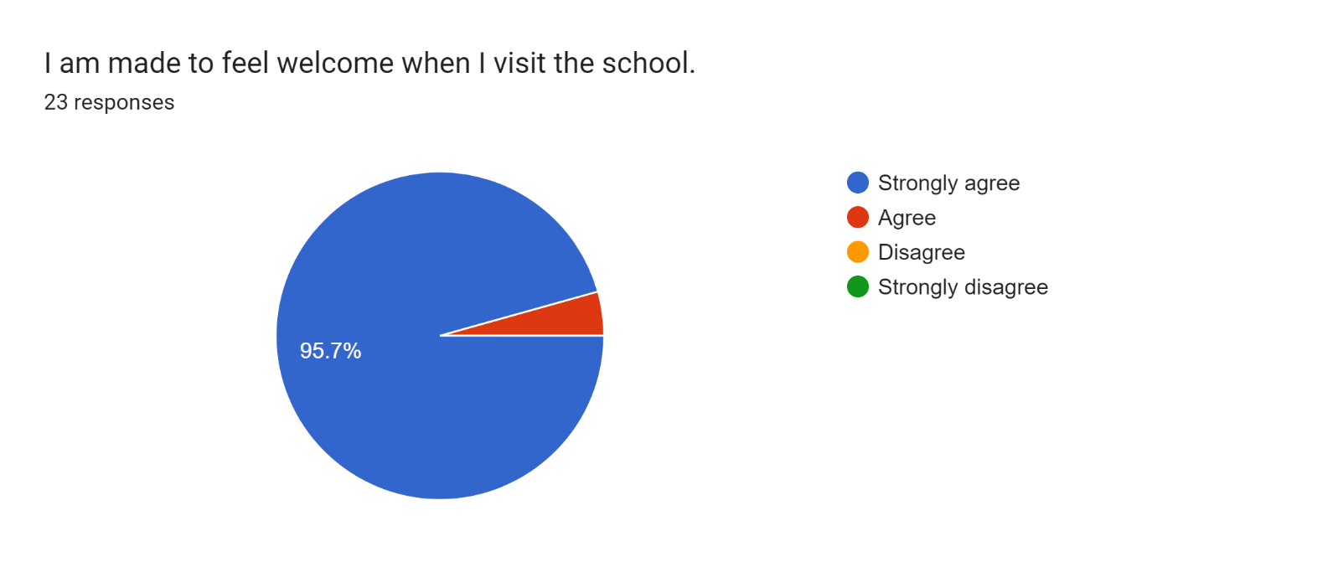

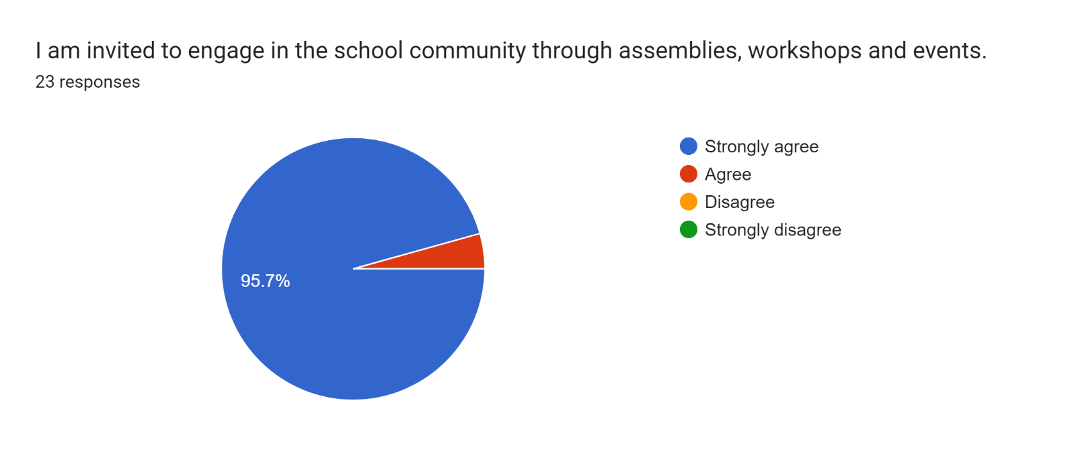

Forms response chart. Question title: The school uses a range of platforms to communicate with parents and carers - Class Charts, website, newsletters etc.
. Number of responses: 23 responses.

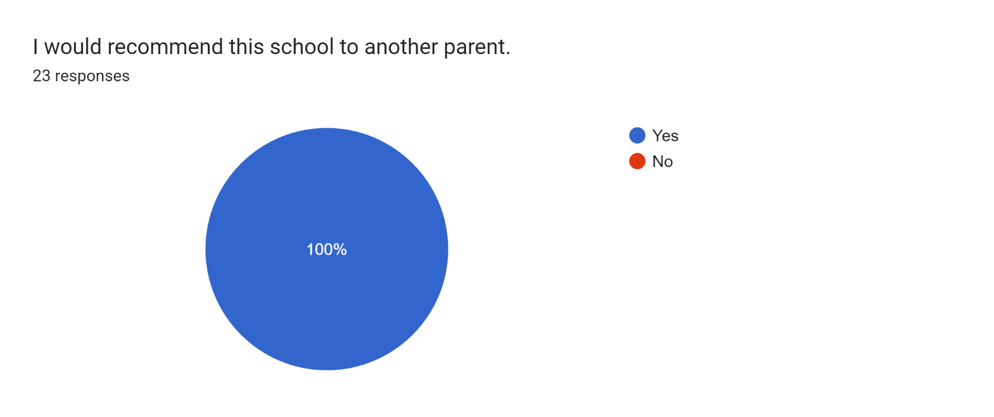

If there are any other comments you would like to make, please add below:

* Overall, I am really happy with my daughter’s progress. She is truly thriving.
* Happy with the staff looking after our child.
* My daughter’s improvement in the school has been great.
* Very welcoming and understanding.
* All the staff are very friendly.
* I’m happy with my child’s progress and happy with the plan made going forward.
* Thanks for the effort that’s clearly being put into my son’s education and happiness at this school.
* We love how happy and well our daughter is doing at school and how any troubles have been managed.
* Thank you for all that you do!
* I am so delighted with my daughter’s progress. I couldn't ask for anything more. Thank you so much.
* Great school!
* All the staff do an amazing job and they work really hard to make this school a safe environment for the children.
* Our daughter’s reading has come on so much this year and she is getting more confident.
* My son enjoys learning here at Roby Park.
* Our daughter has come on so much. Her handwriting has improved massively.
* Thank you for helping my son in Year 2.
* Mr Swatman has really brought the best out of my daughter. She has really grown in confidence and absolutely loves coming to school. Thank you.
* Lovely staff. My daughter loves coming here.
* We couldn't be happier with the progress our daughter is making. She has come on leaps and bounds especially with her reading. Her teacher is exceptional and deserves great credit with how she is progressing. Roby Park is an amazing school and we're lucky that she’s a pupil.
* Thank you so much, Mr Swatman.
* Mr Swatman is such a nice teacher.