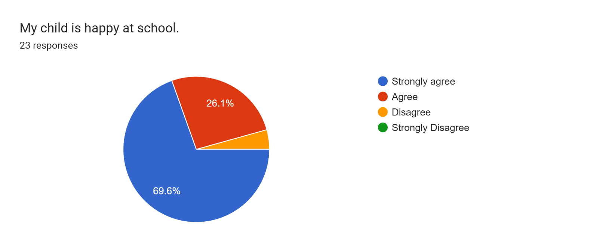

\*1 parent

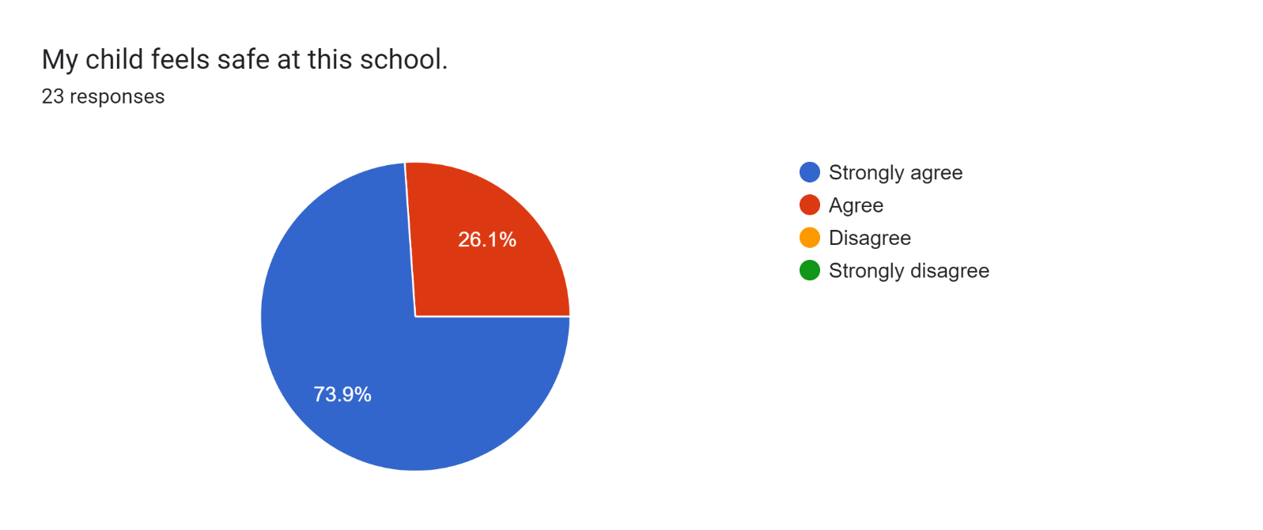

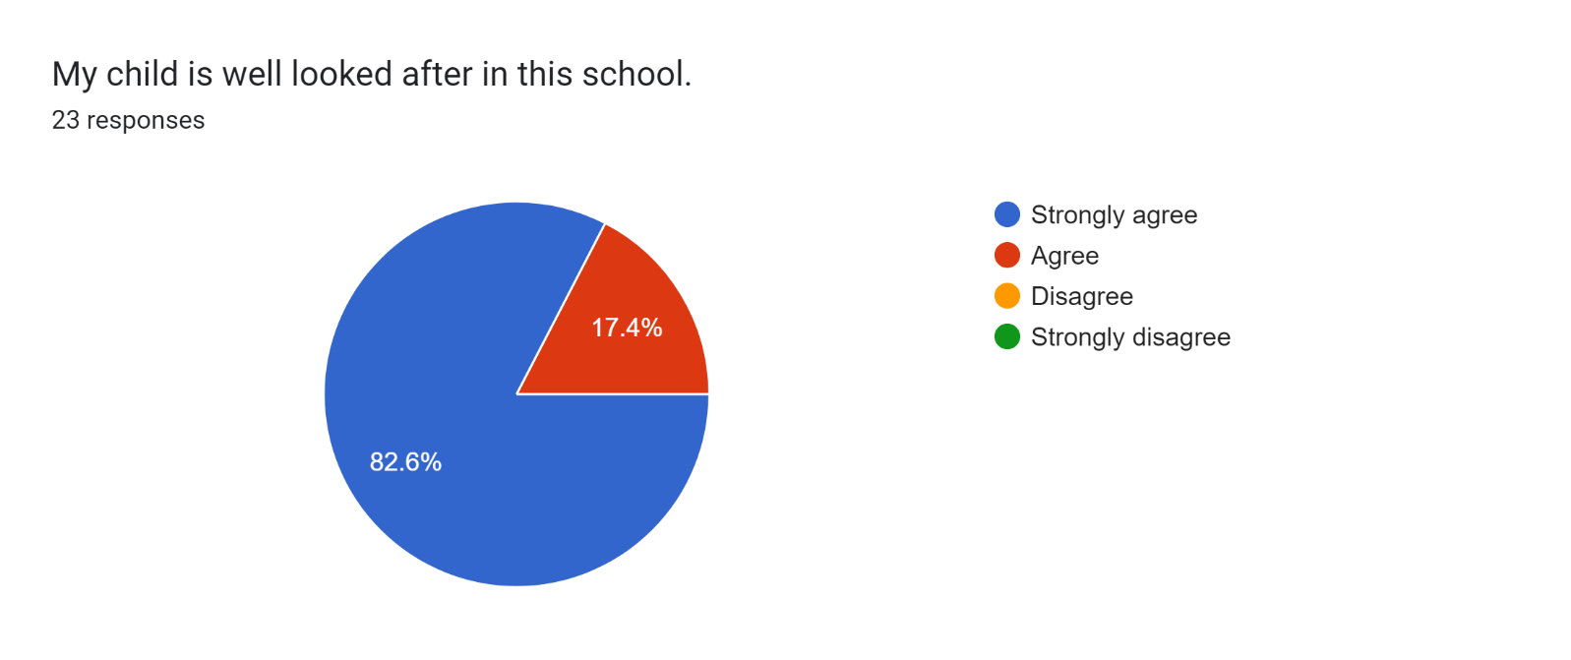

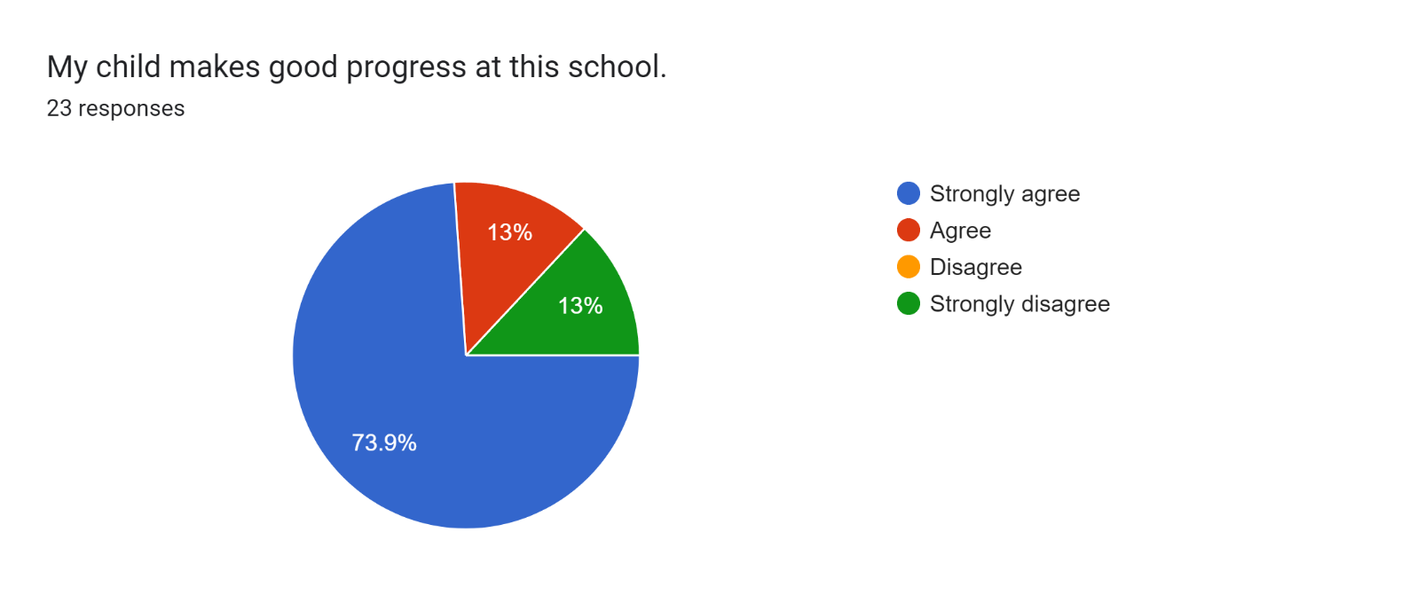

\*2 parents

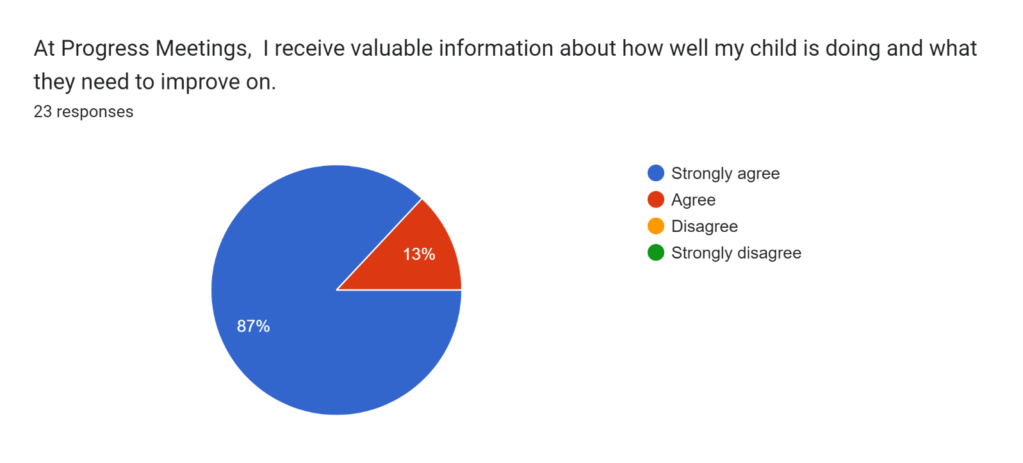

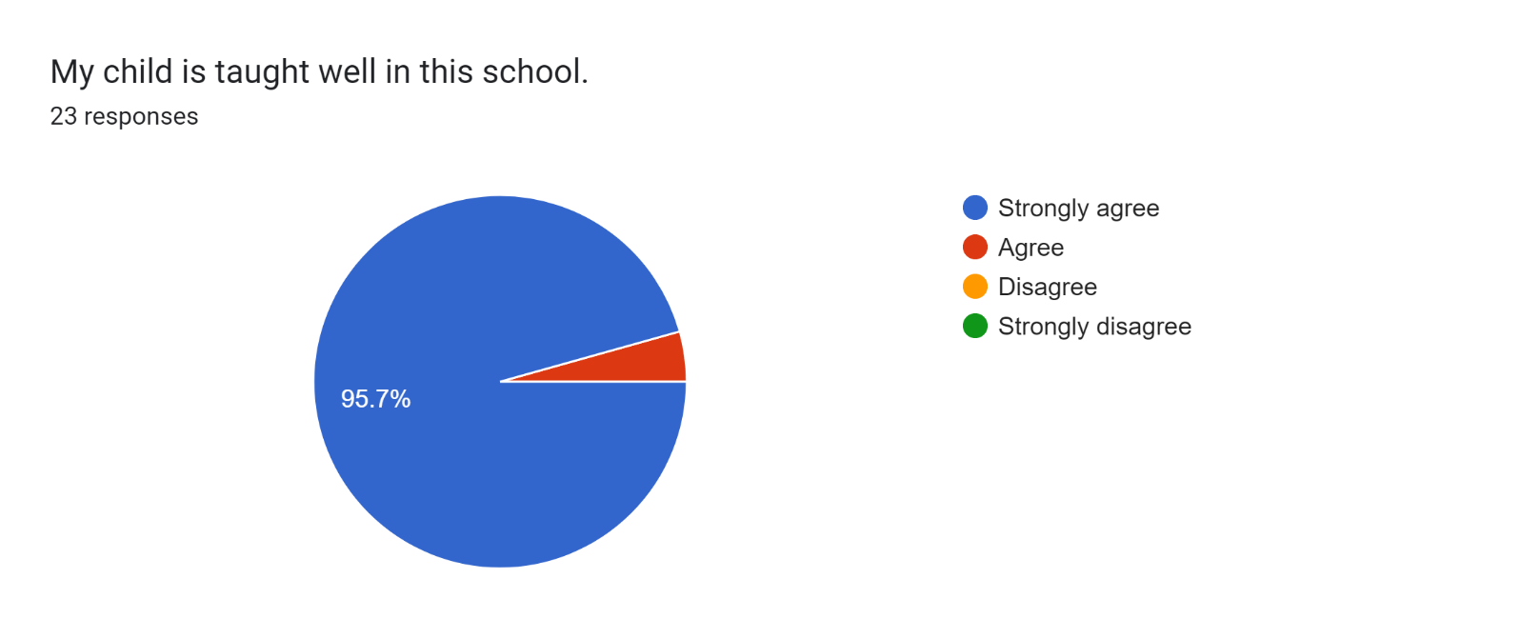

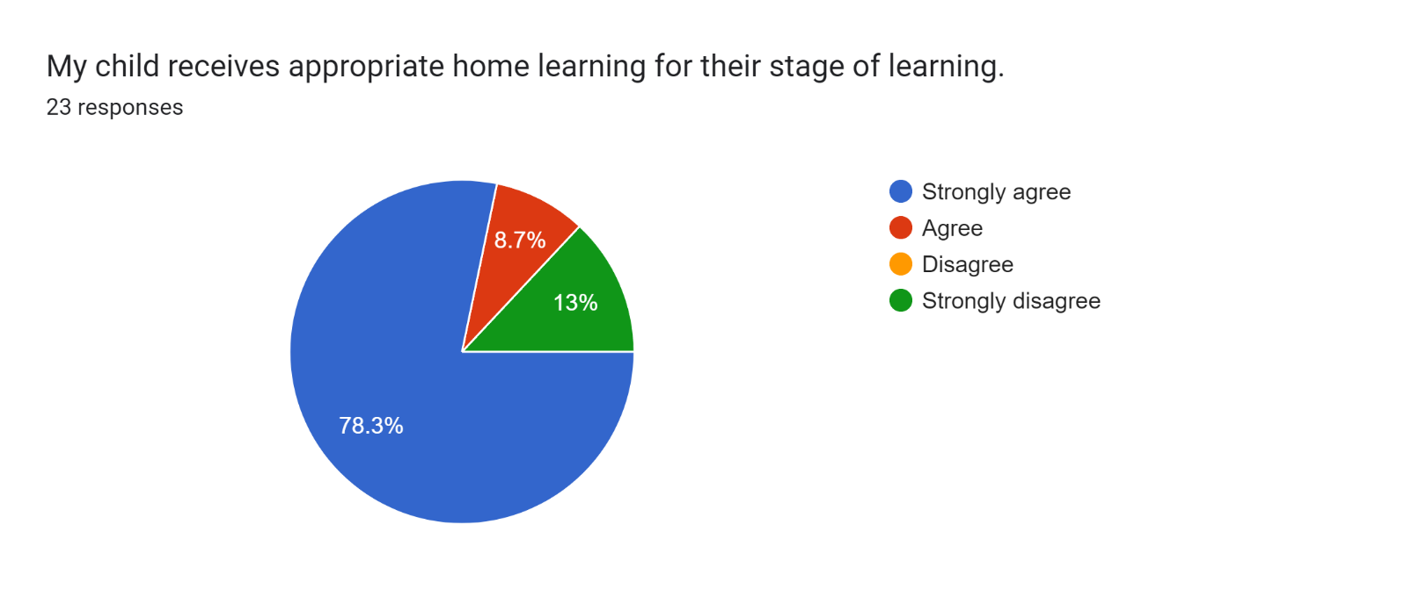

\*2 parents

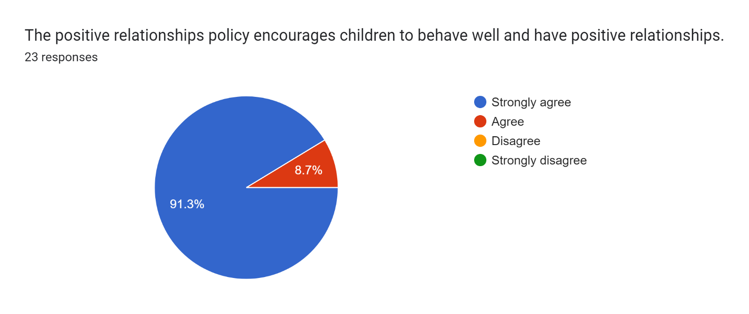

Forms response chart. Question title: This school deals effectively with bullying
. Number of responses: 23 responses.

Forms response chart. Question title: This school is well led and managed
. Number of responses: 23 responses.

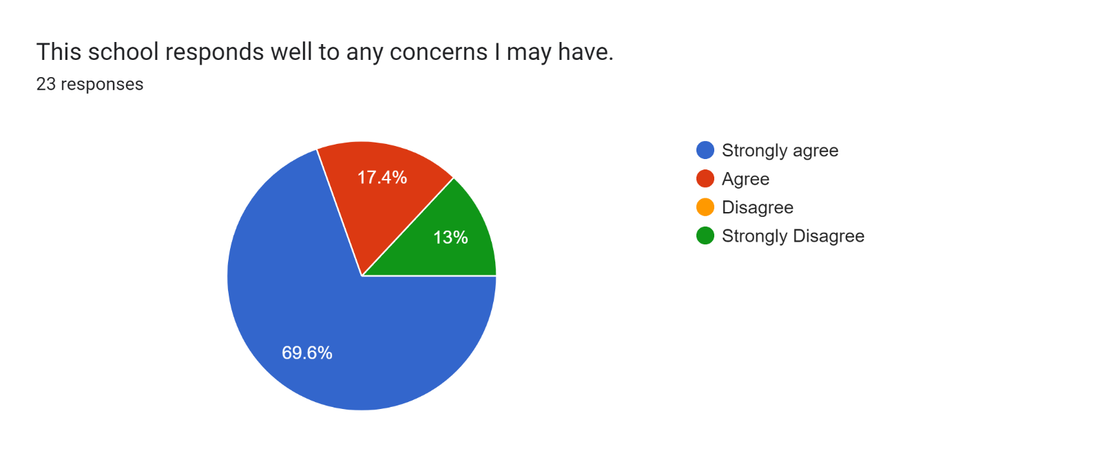

\*2 parents

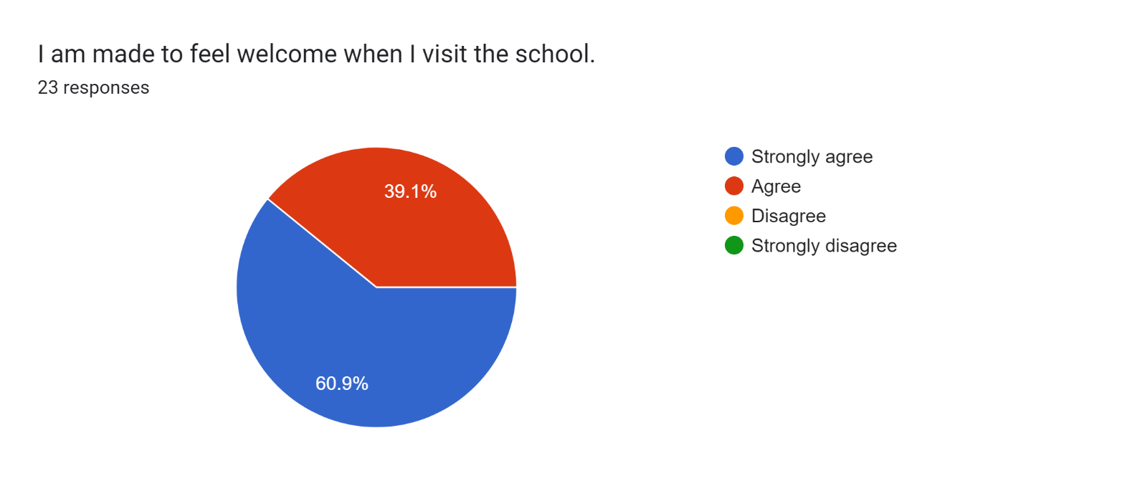



Forms response chart. Question title: The school uses a range of platforms to communicate with parents and carers - Class Charts, website, newsletters etc.
. Number of responses: 23 responses.

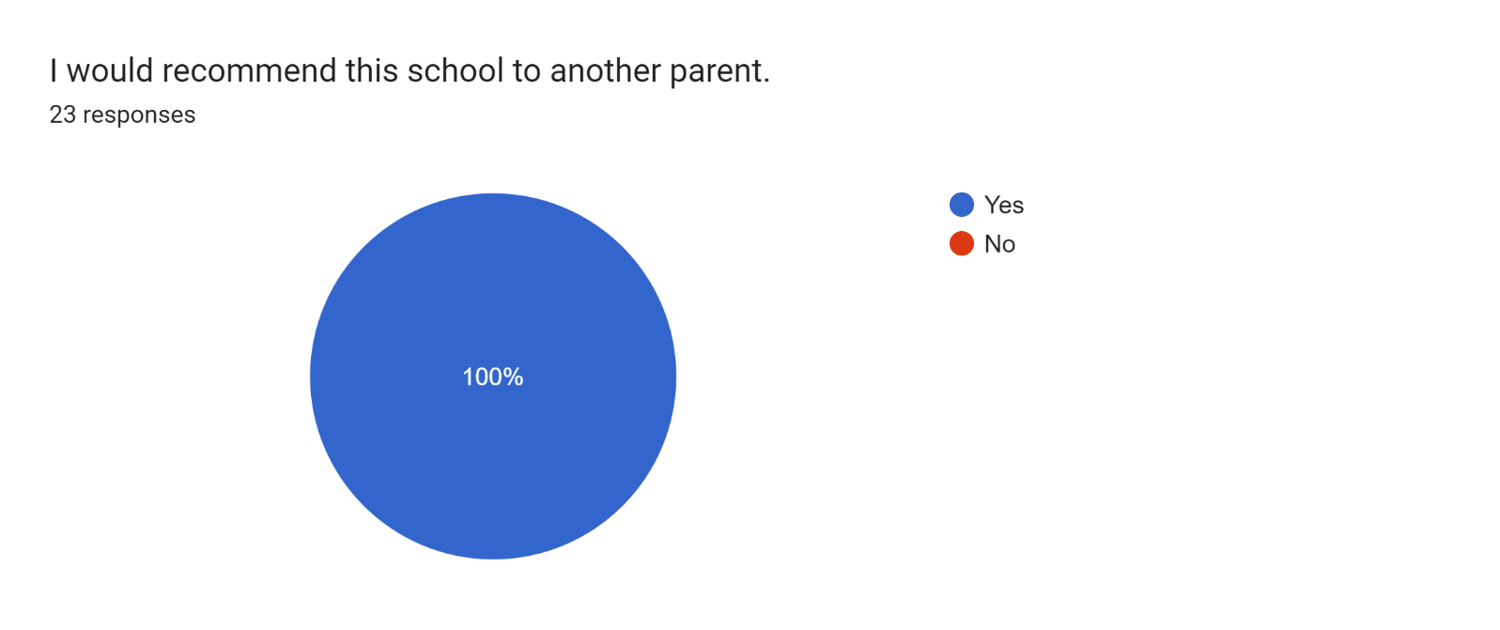

If there are any other comments you would like to make, please add below:

* I am happy with my son’s improvements.
* Thank you for doing such an amazing job.
* Staff are great and my son is really happy here.
* My son loves Miss Clarkson and he enjoys coming to school.
* My daughter loves coming to school everyday. She enjoys learning new things and telling me everything she has learned at school.
* Nice clean & tidy school.
* 👍
* Brilliant staff!
* Lovely, caring, supportive and approachable.
* Fabulous!
* School and support is always brilliant!
* Support is great!
* All very happy to help.
* Staff are wonderful and are always doing their best for the children.
* Excellent staff - thank you.
* Lovely school!
* Thank you for all that you do for our daughter. Thank you for recognising her needs and putting strategies in place to support her. Thank you for supporting her through her struggles. We are so pleased with the academic progress she has made - her reading is so impressive. Her confidence has grown so much. Thank you - you work exceptionally hard and it shows.