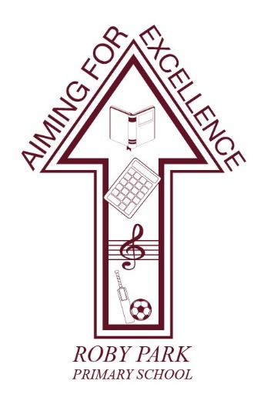

**Roby Park Primary School**

Easton Road

Huyton

Knowsley

L36 4NY

Tel: 0151 477 8340

Website: [www.robyparkprimary.co.uk](http://www.robyparkprimary.co.uk)

E-mail: [robypark@knowsley.gov.uk](mailto:robypark@knowsley.gov.uk)

**Headteacher: Mrs K Allen**

Friday 22nd January 2024

**Easter Disco – Wednesday 27th March**

Dear Parents/Carers

On Wednesday, we will be holding our Easter discos.

We will end the day, with our fabulous Easter discos with Nursery and Reception enjoying their party from 2.00-3.00pm during the school day. Y1 & Y2 will have their disco at 3-4pm with Y3 – Y6 having their disco 4.15 – 5.15pm.

All children can come to school in their party clothes. If children do not want to dress up, they can come to school in their uniform if they would prefer.

**Nursery children who do not attend school in the afternoons but wish to come to the disco, can return to school for 2pm. Please bring them to the office.**

The cost of the disco for Nursery – Y2 children is £3.00 and includes a small packet of sweets, crisps and a drink. The cost of the disco for Y3 – Y6 is £3.00 and children get a chip cone and they can bring extra money to buy sweets, drinks and crisps. The disco must be paid for on **Parent Pay by 9.00am on Wednesday.** **Tickets are available now on Parent Pay.**

All children in Nursery – Y2 should be picked up from their classroom door at the end of their discos as normal. KS2 children should be collected from the main playground by an adult at 5.15pm. KS2 children must be brought to school for the disco by an adult and the adult must wait for children to have gone through the double red doors before leaving then collecting them at 5.15pm. Parents/carers are responsible for KS2 children until they have entered the disco itself.

Yours faithfully

Mrs Kat Allen

Headteacher