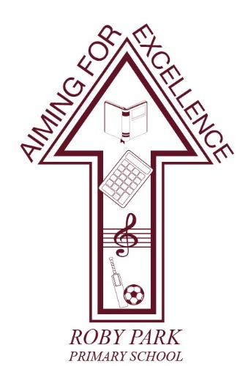

**Roby Park Primary School**

Easton Road

Huyton

Knowsley

L36 4NY

Tel: 0151 477 8340

Website: [www.robyparkprimary.co.uk](http://www.robyparkprimary.co.uk)

E-mail: [robypark@knowsley.gov.uk](mailto:robypark@knowsley.gov.uk)

**Headteacher: Mrs K Allen**

Date: Monday 11th March 2024

**Summer Uniform**

Dear Parents/Carers,

We are aware lots of families want to get organised for the next term, when the weather gets warmer. With this in mind, we are sharing with you the uniform expectations for Roby Park for April onwards.

The purpose of the uniform is to ensure children wear practical and appropriate clothes for the range of activities they need to take part in at school; to provide uniformity and to give the children a sense of belonging to our community.

We rely on parents and carers to co-operate with governors and staff by following the uniform policy and sending their children to school wearing appropriate clothing. We encourage parents and carers to contact the school if they are unsure about any aspect of the policy. If children do not attend school in the correct uniform or PE kit, including black footwear, the school may provide correct uniform items at a cost to parents.

Our uniform policy is:

|  |  |  |
| --- | --- | --- |
|  | **Nursery & Reception** | **Y1 – Y6** |
| **School Uniform** | Burgundy school book bag with logo  White polo shirt  Burgundy school jumper/cardigan with logo  Grey trousers/shorts or skirt/pinafore  Black shoes/pumps**with Velcro (no laces)**  Grey socks  Soft hair bobbles only – burgundy, black or white  **Wellies to keep in school** | Burgundy school book bag with logo  White polo shirt  Burgundy school jumper/cardigan with logo  Grey trousers/shorts or skirt/pinafore  Black shoes (**no trainers)**  Grey socks  Soft hair bobbles only – Burgundy, black or white  **Wellies to keep in school** |
| **Summer Alternatives** | Grey shorts  Pink and white Summer dresses | |
| **P.E. Kits** | Roby Park white tshirt with logo  Burgundy shorts  Roby Park navy blue tracksuit jacket with logo  Roby Park navy blue tracksuit bottoms  Trainers | |

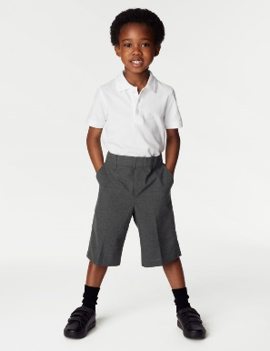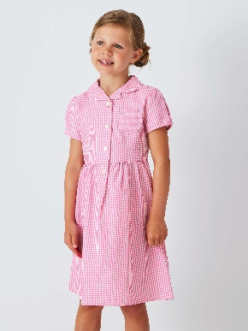During the Summer term, after Easter, children may choose to wear grey shorts instead of trousers or a pink and white Summer dress. Summer dresses should be pink and white only – not other colours. Playsuits are not allowed. They look cute but unfortunately they do not promote independence for children going the bathroom and children too often struggle to get out of them. Often, they are also ill-fitting causing children discomfort. Fashion trends like burgundy tank tops or gingham jackets (for replacing cardigans or jumpers) are also not part of our uniform policy so please do not invest in such items.

School shoes should remain black. **Sandals, trainers, jelly shoes and white shoes are not permitted**.

Summer uniform can be worn from after Easter until the Autumn half term in October as the months are warmer.

If any parents are facing financial hardship and need support with uniform, please contact the office to see what support we can possibly offer. School will also be offering a uniform swap shop, providing pre-loved school uniform.

If you have any pre-loved Summer uniform you would like to donate to school for other children to benefit from, it would be greatly appreciated.

Warmest regards,

Mrs Kat Allen

Headteacher