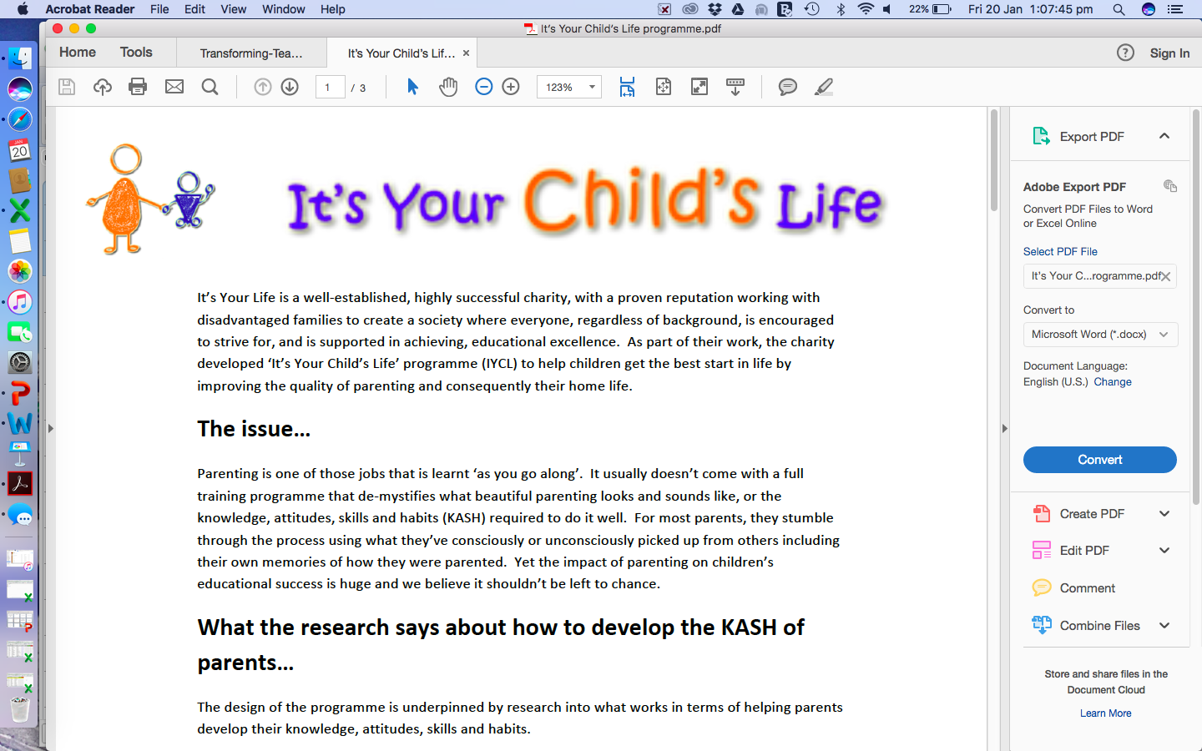

Dear Parent/Carer,

The ‘It’s Your Child’s Life’ programme is coming to Roby Park Primary School on Monday 19th February to help you help your child thrive at school. This 5-session course runs for an hour or so as soon as you’ve dropped your child off at the start of the day. We’ll have the kettle on in school just before 8.50 am!

The course gives you a real insight into what your child will be learning at school and ways you can support learning at home. Each week you’ll receive lots of practical tips and ideas as to how to help your child continue to develop skills in communication and language, personal development, physical development, reading, writing, maths, confidence and resilience. You will be given a booklet full of resources and ideas for games to play with your child at home which helps them embed what they have learnt in school.

The course is really relaxed and open to all parents/grandparents/carers of Reception/Y1. However, places are limited at this time to 10 parents so be quick to respond!

If you’d like to sign up for the course, please click on the link: <https://forms.gle/2bFFC4X1kTVa6up18>

We look forward to seeing you!

Parents/carers will be notified via Class Charts if they have a place by **Wednesday 14th February.**

What parents have said about the course……..

“My child’s confidence and handwriting has come on leaps and bounds”

“I had no confidence helping my child with maths. Now I know lots of ways to make maths fun for my son “

“I finally understand how to support my child with phonics”

“I’d 100% recommend this course to anyone with children in their care”