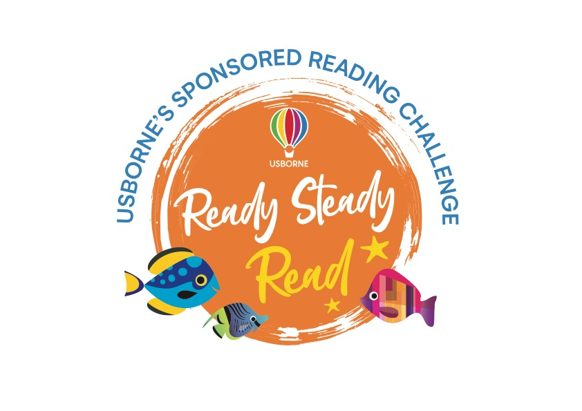

Dear Parent/Guardian,

To celebrate and encourage a lifelong love of reading at home and school, we are running a sponsored read between **4th – 8th March**.

The project is being organised in conjunction with our local Usborne Partner, **Emma Evans** and all the money raised will go towards brand new books for our school. In addition to the sponsorship money, Usborne will also donate up to 60% of the total raised in **EXTRA FREE BOOKS** to the school. So, for every £600 raised, we will get an extra £360 in FREE Usborne books!

Please help us to enhance our reading resources for pupils by encouraging your child to spend a small amount of time each day either reading to themselves, to others, or being read to. They can read books, comics, magazines, newspapers, menus, websites, recipes, poems, leaflets, instructions – anything with words!

If you are able to support our sponsored read, please find enclosed a sponsorship form. We would like all sponsor money to be back with the school by **15th March**. Any cheques need to be made payable to **Emma Evans.**

We look forward to having lots more books for your child to read, share and enjoy.



**Reading Log**

Pupil name: Class:

|  |  |  |
| --- | --- | --- |
| Day | Number of minutes spent reading | Total |
|  |  |  |
|  |  |  |
|  |  |  |
|  |  |  |
|  |  |  |
|  |  |  |
|  |  |  |
|  |  |  |
|  |  |  |
|  |  |  |
|  |  |  |