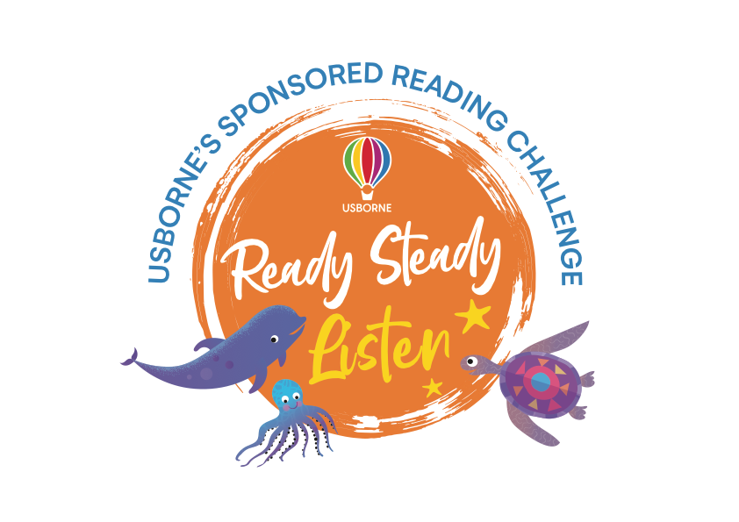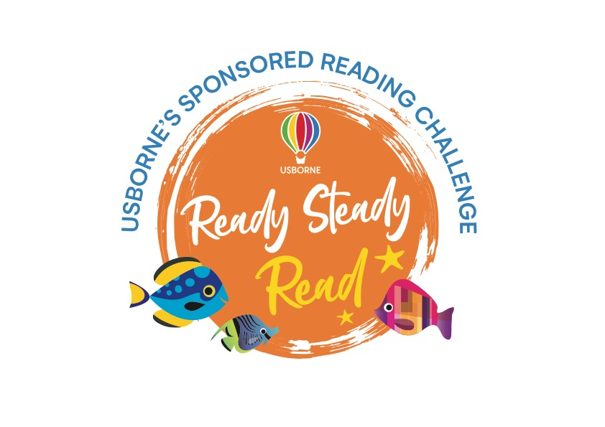

Dear Parent/Guardian,

To encourage a lifelong love of reading at home and in school, we will be running a **SPONSORED LISTEN** between **4th – 8th March**.

The project is being organised in conjunction with our local Usborne Partner, **Emma Evans** and all the money raised will go towards brand new books for our school. In addition to the sponsorship money, Usborne will also donate up to 60% of the total raised in **EXTRA FREE BOOKS** to the school.

Please help us to enhance our reading resources by encouraging your child to spend a small amount of time each day listening to stories being read aloud.

If you are able to support our sponsored listen, please find enclosed a sponsorship form for your child. We would like all sponsor money to be back with the school by **15th March**. Any cheques need to be made payable to **Emma Evans.**

We look forward to having lots more books for your child to read, share and enjoy.





**Sponsorship Form**

Childs name: Class:

|  |  |  |
| --- | --- | --- |
| Name | Sponsorship  (per minute/per book or total donation) | Amount collected |
|  |  |  |
|  |  |  |
|  |  |  |
|  |  |  |
|  |  |  |
|  |  |  |
|  |  |  |
|  |  |  |
|  |  |  |
|  |  |  |
|  |  |  |
|  |  |  |
|  |  |  |
|  |  |  |
|  |  |  |

Please return this form along with your sponsorship money and listening log to the nursery by **15th March.**

**Total amount:**