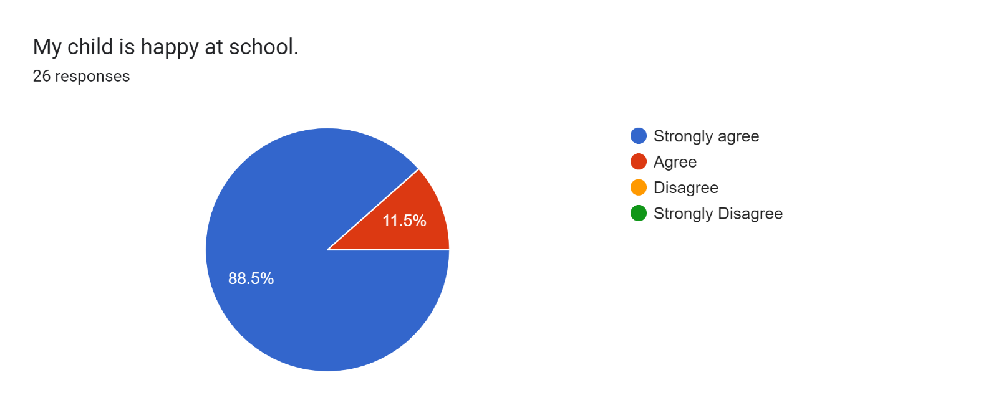

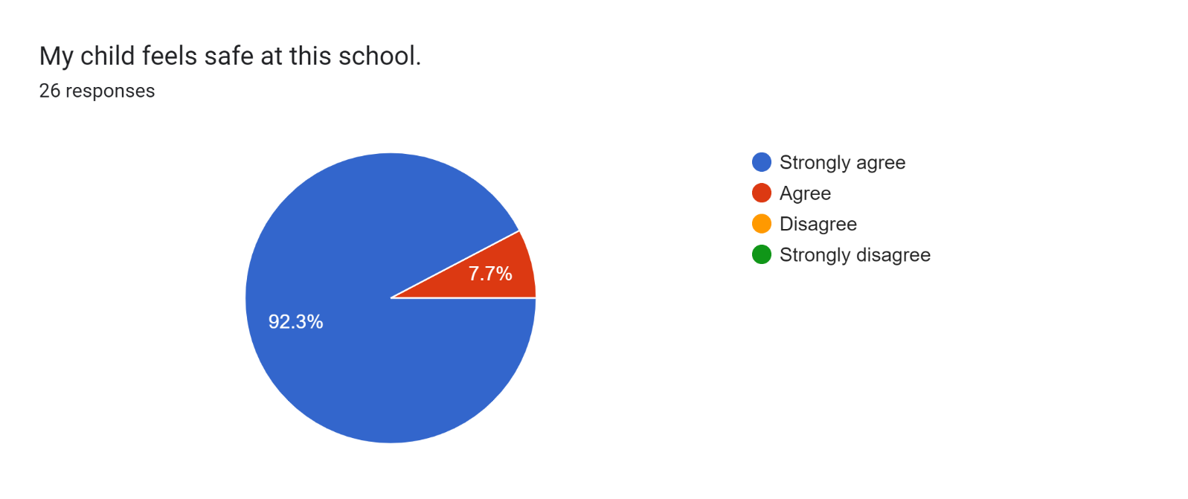

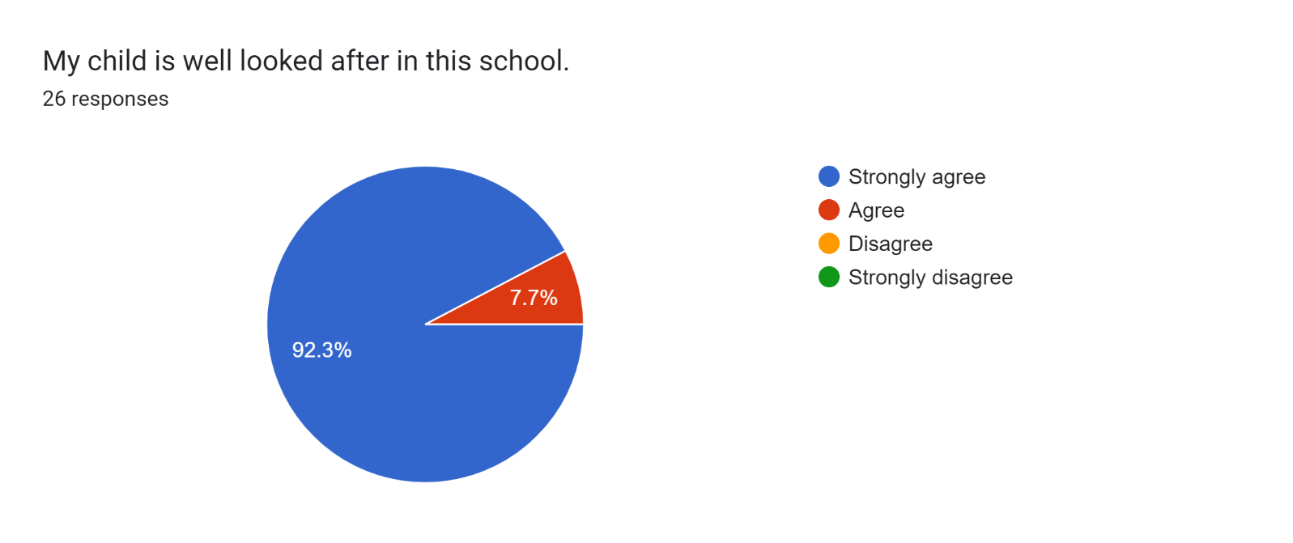

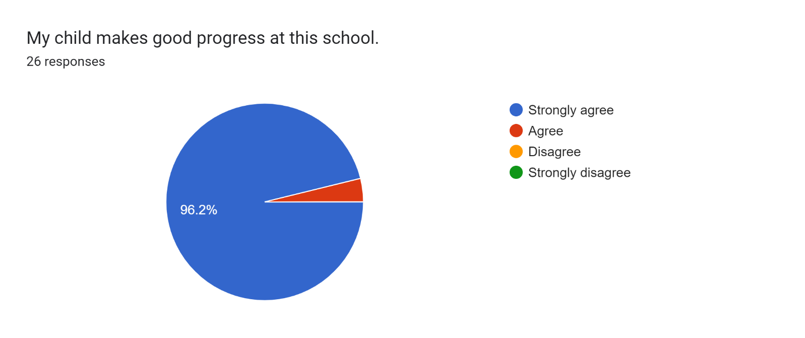

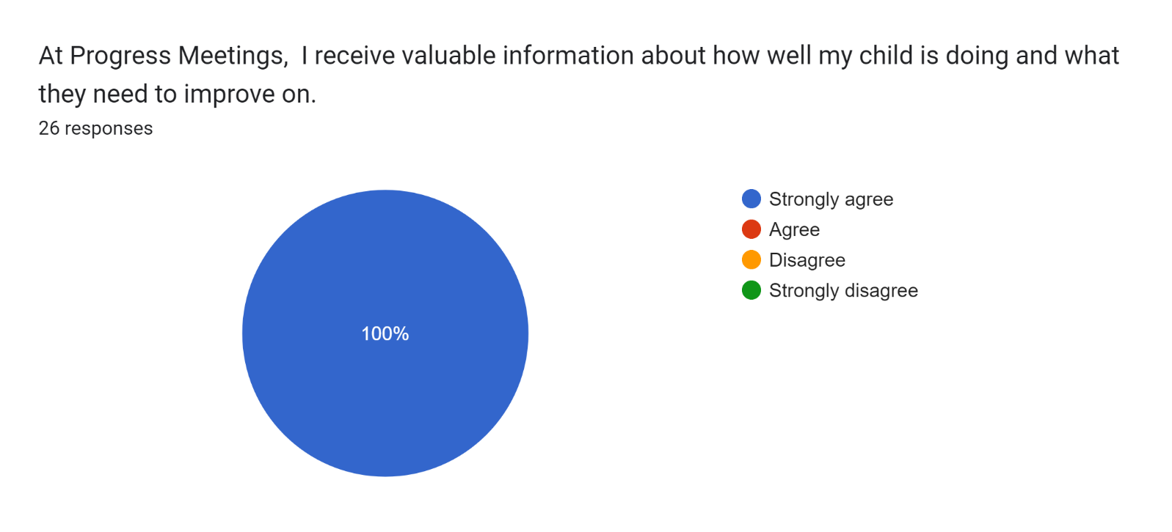

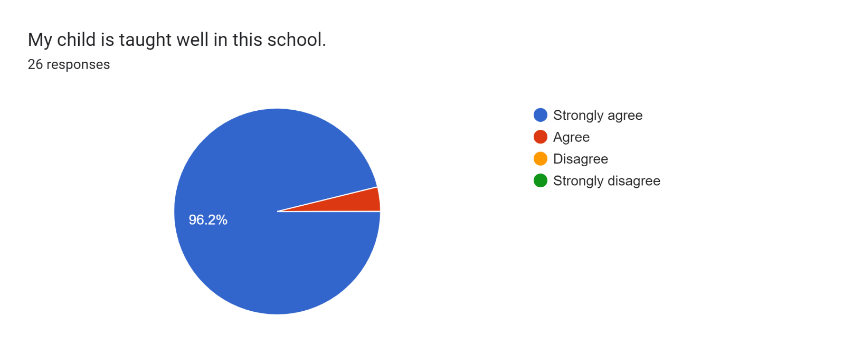

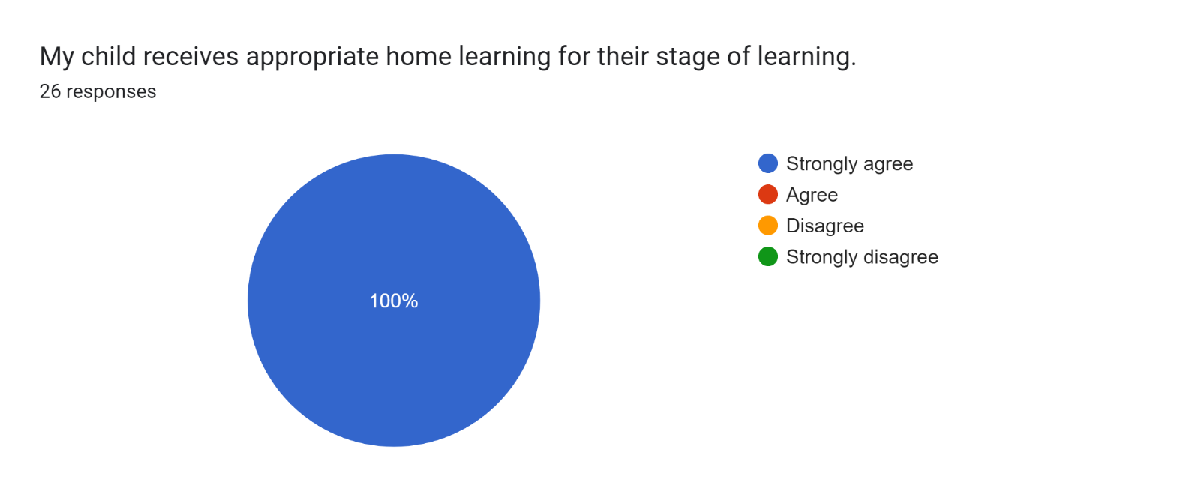

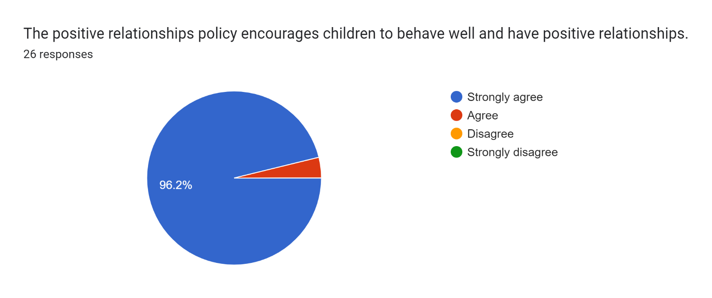

Forms response chart. Question title: This school deals effectively with bullying
. Number of responses: 26 responses.

Forms response chart. Question title: This school is well led and managed
. Number of responses: 26 responses.

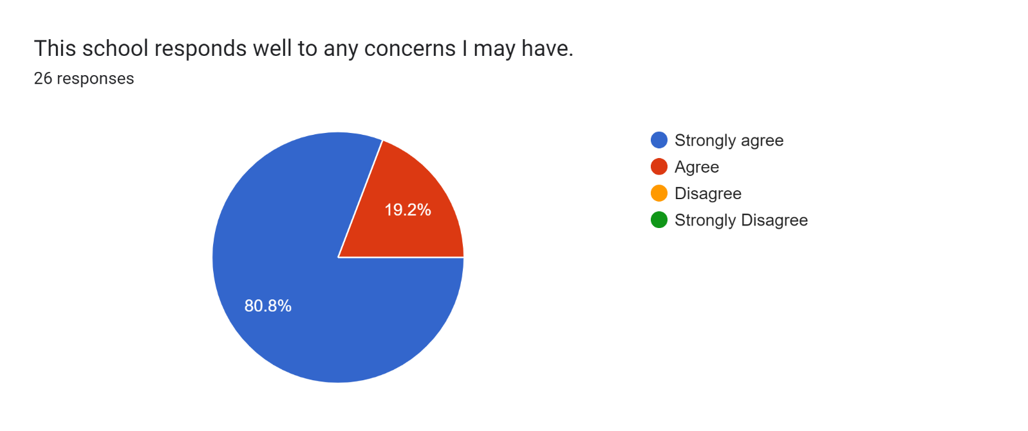

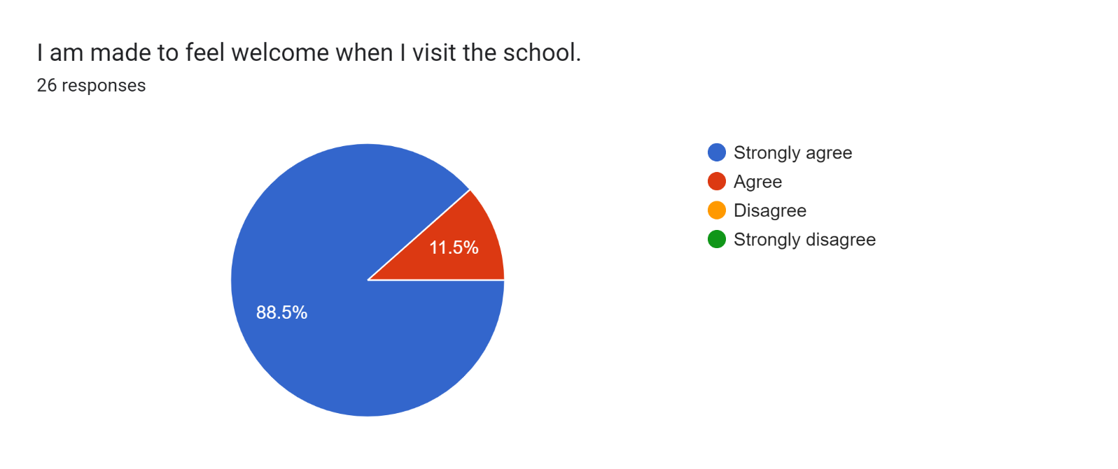

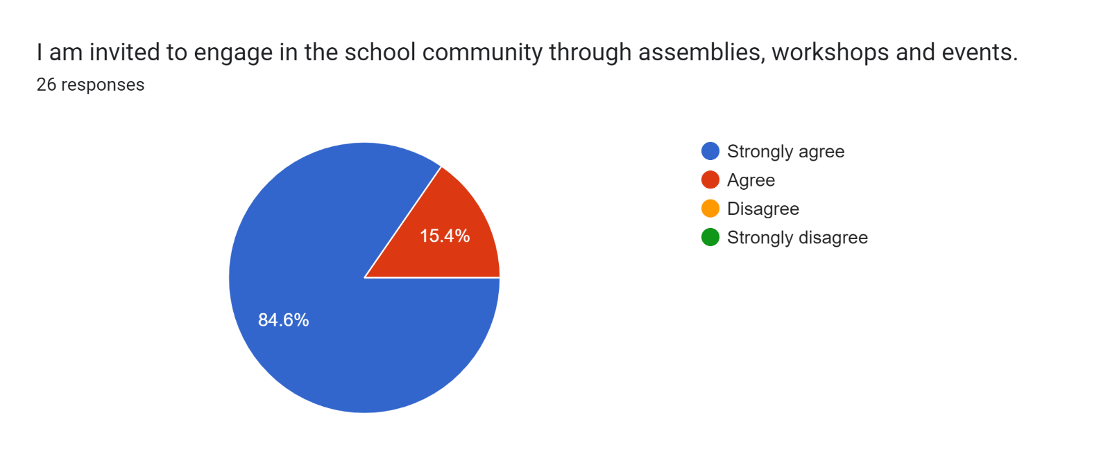

Forms response chart. Question title: The school uses a range of platforms to communicate with parents and carers - Class Charts, website, newsletters etc.
. Number of responses: 26 responses.

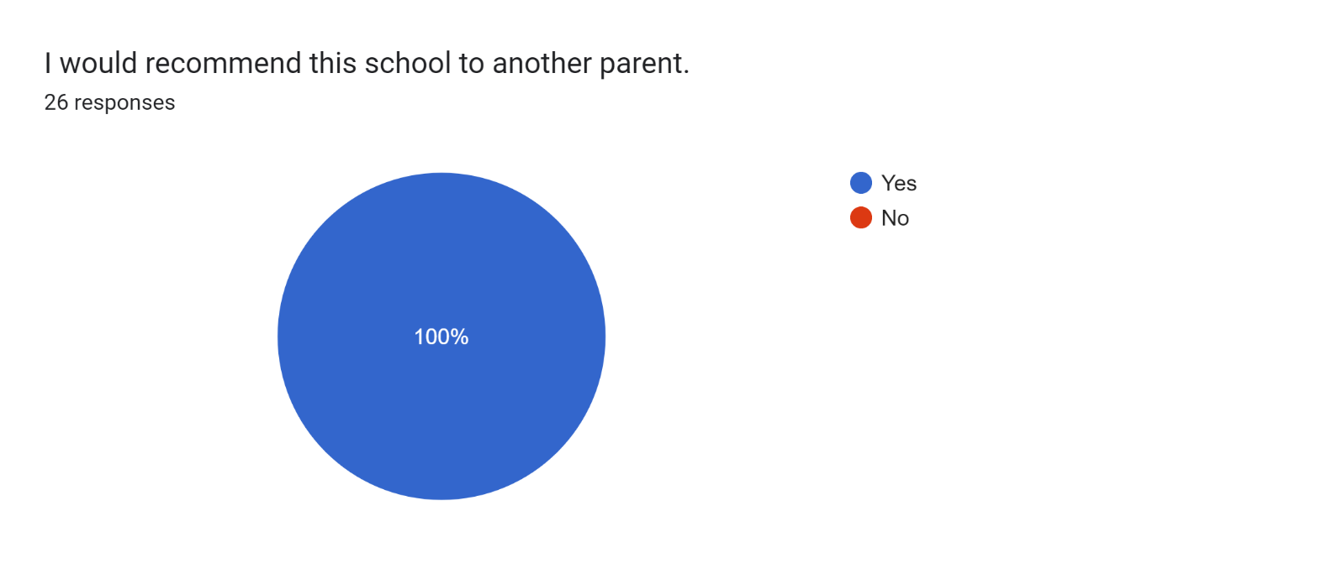

If there are any other comments you would like to make, please add below:

* This school is amazing and I always talk about how great it is.
* My son has settled in better than I could have imagined. He has, and still is, enjoying his time here and he is excelling so well.
* Our daughter is enjoying her time with you all.
* The school is fun and exciting - never boring! My kids absolutely love it here because the teachers are amazing.
* Fabulous staff - keep up the amazing work for our kids.
* You are all doing an amazing job.
* My daughter loves Mrs. Williams and all the staff.
* All of the staff are always happy and friendly.
* Thank you for everything you’re doing for our son!
* The teachers are amazing!
* Thanks for everything.
* Lovely staff. They are approachable and always there if you need a quick chat.
* My daughter loves coming to school and is clearly happy here. I am very pleased with her progress so far.
* Thanks for being so supportive and helping our son settle in so well.
* Thanks for your support with our son so far. We really appreciate it.
* Thank you for providing a safe, inclusive and supportive environment.
* Our son loves this school and so do I.
* Amazing school!
* Amazing!
* Thank you for everything you do for our daughter - she loves coming to school.
* Mrs Lyons is a brilliant teacher and my son has come on so much since he has started Reception.
* You’re doing fantastic!
* Thanks for all of your hard work.