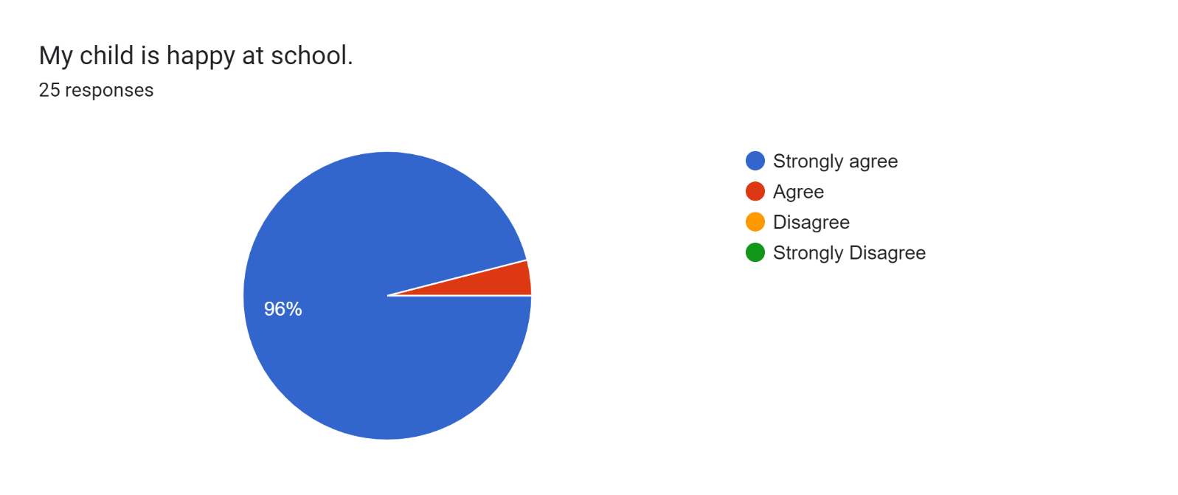

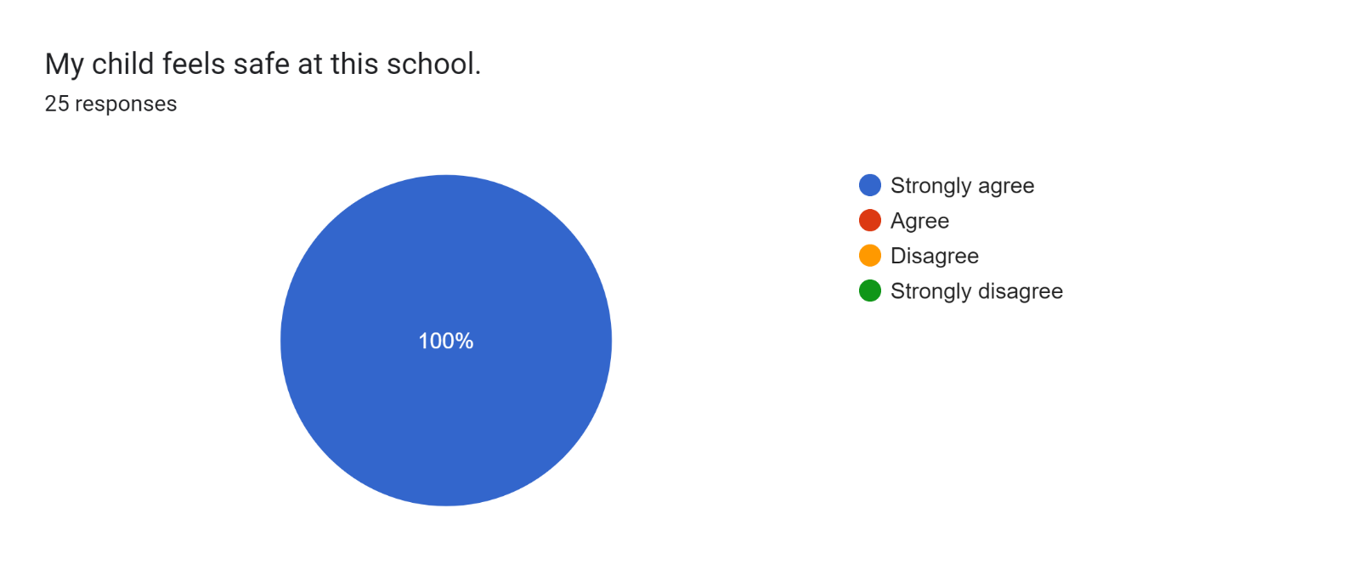

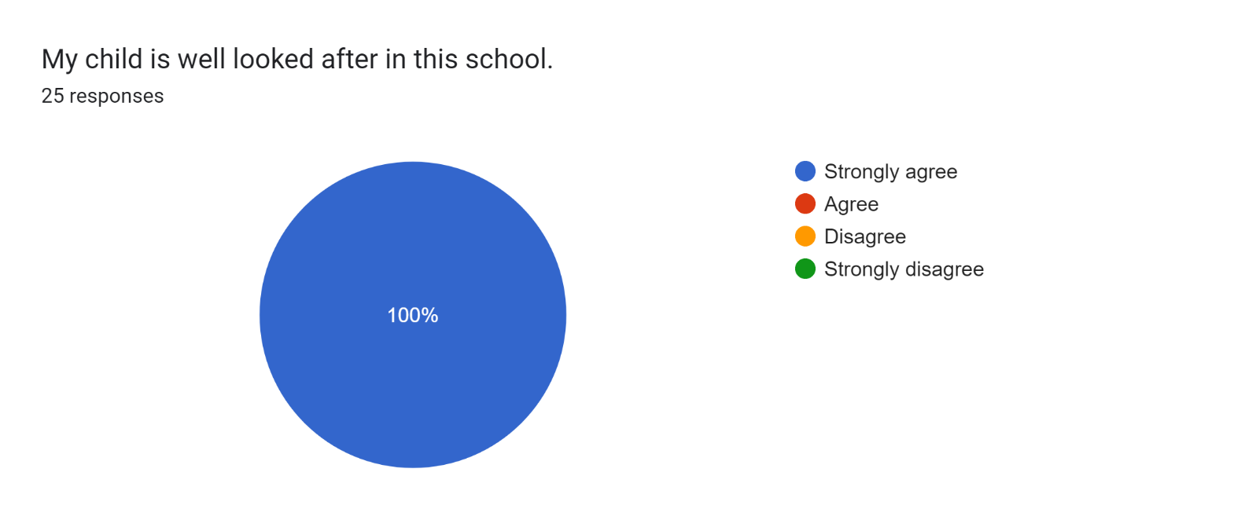

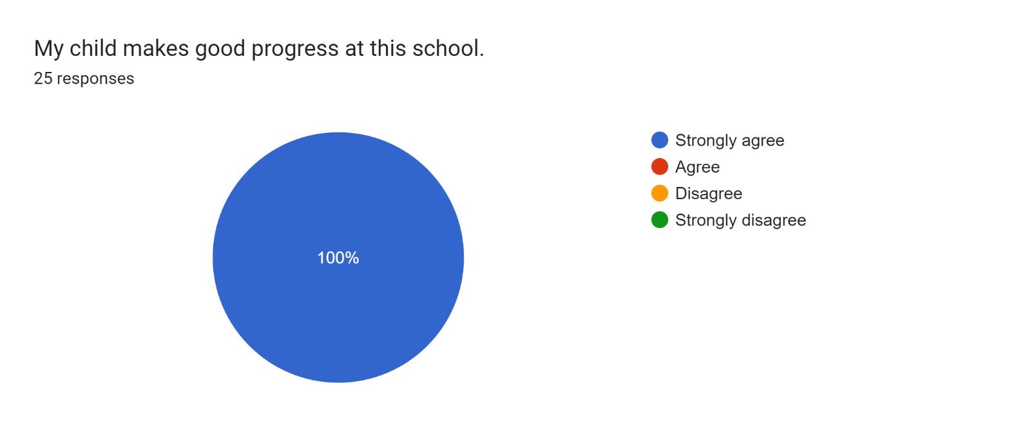

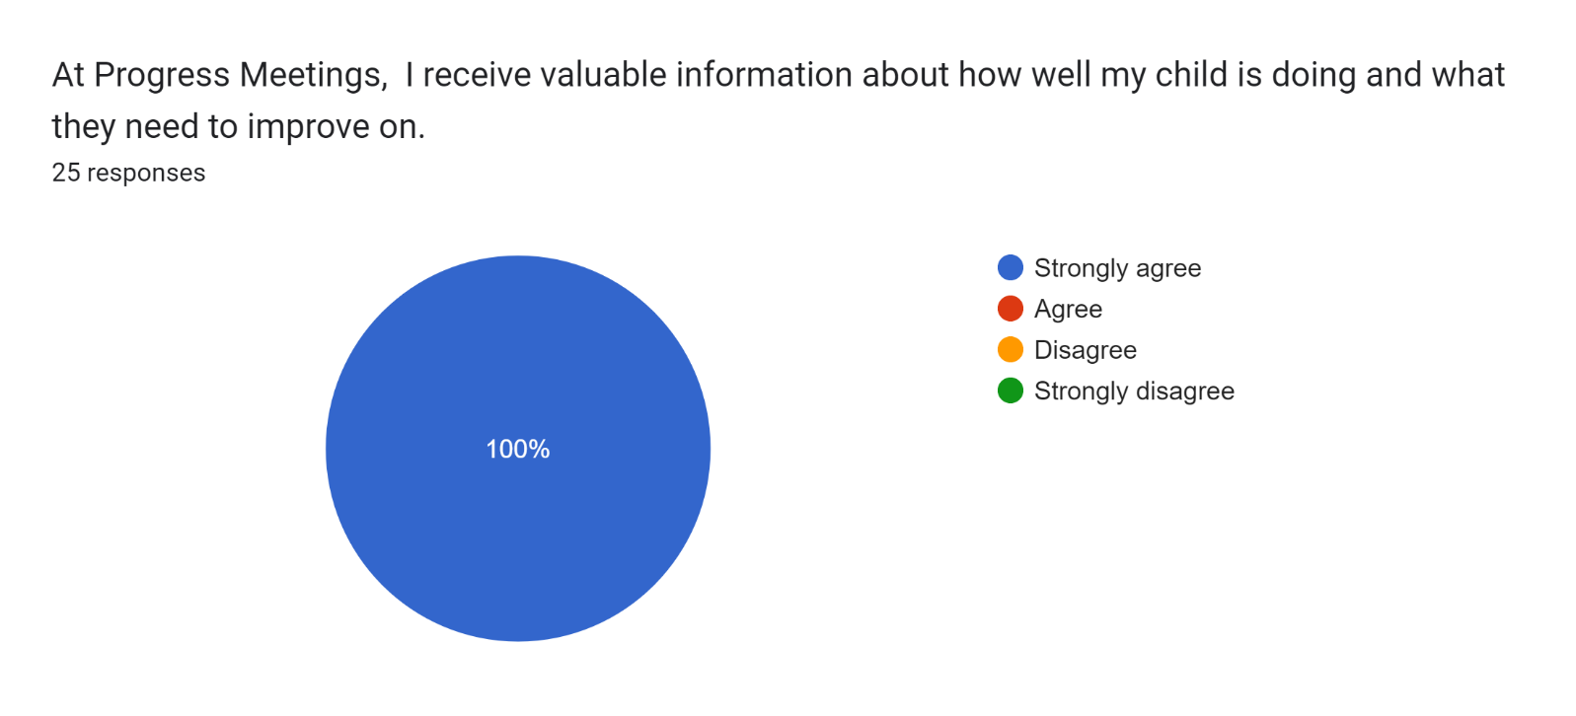

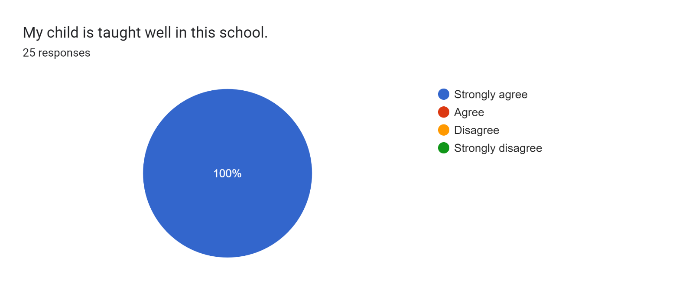

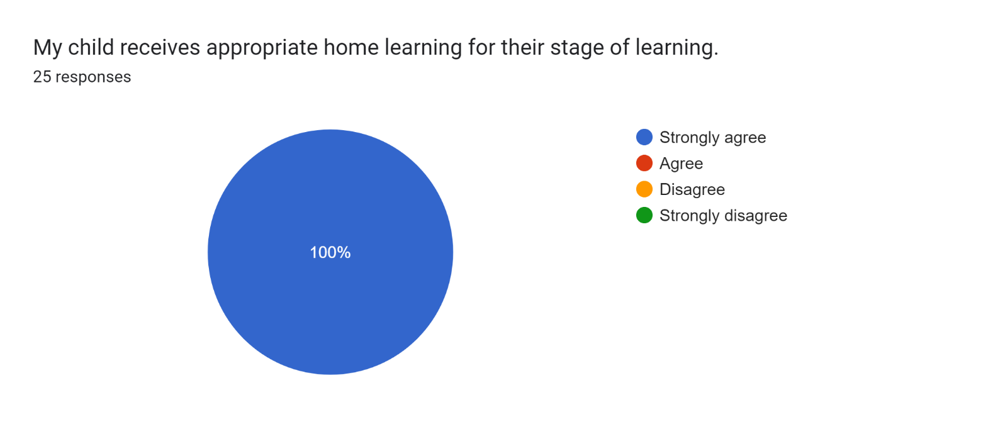

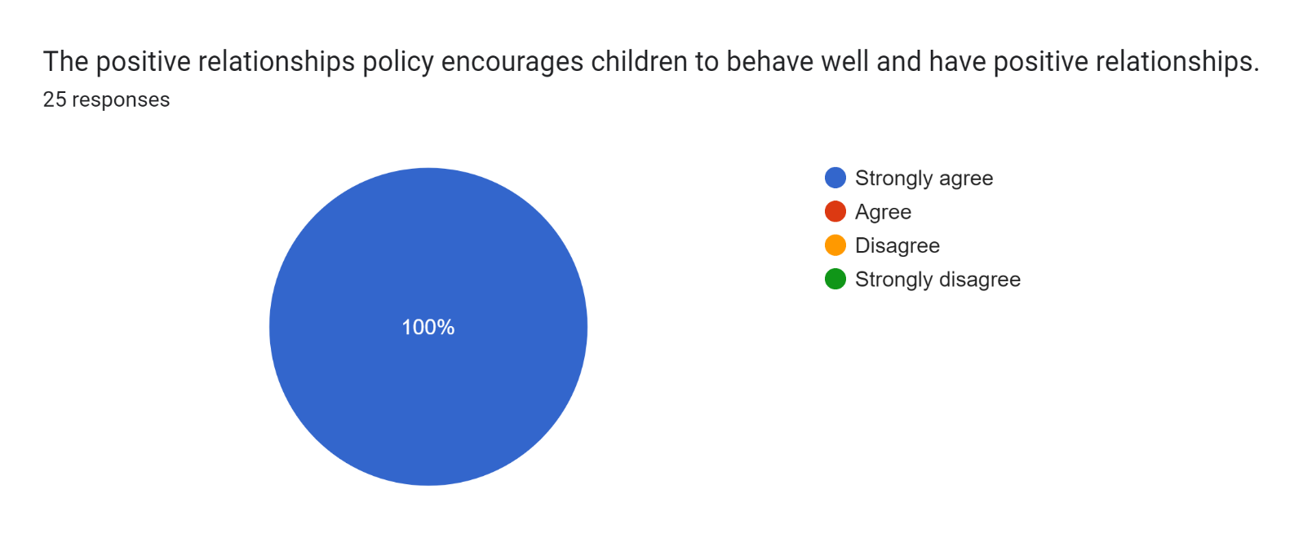

Forms response chart. Question title: This school deals effectively with bullying
. Number of responses: 25 responses.

Forms response chart. Question title: This school is well led and managed
. Number of responses: 25 responses.

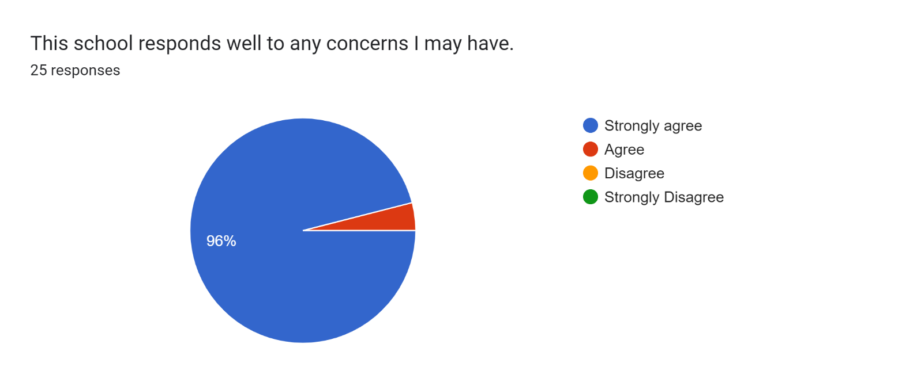

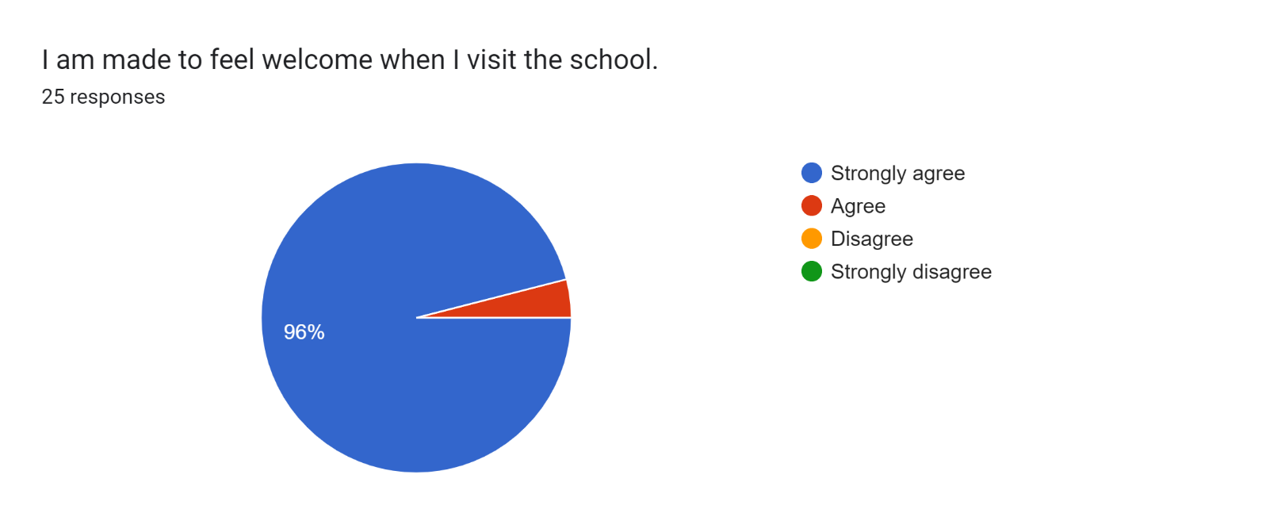

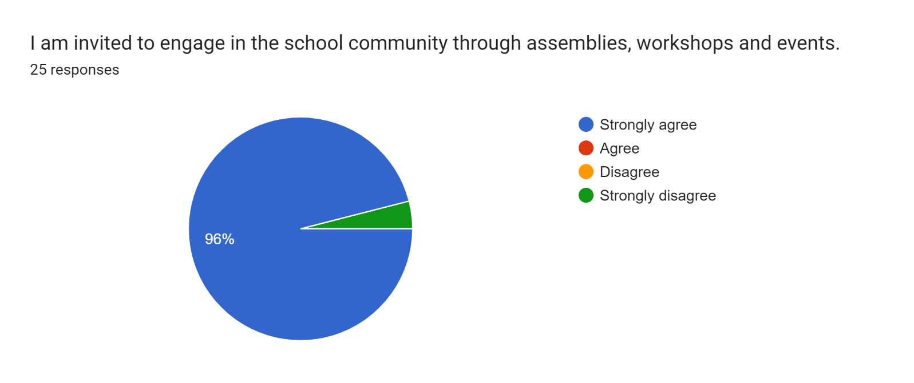

Forms response chart. Question title: The school uses a range of platforms to communicate with parents and carers - Class Charts, website, newsletters etc.
. Number of responses: 25 responses.

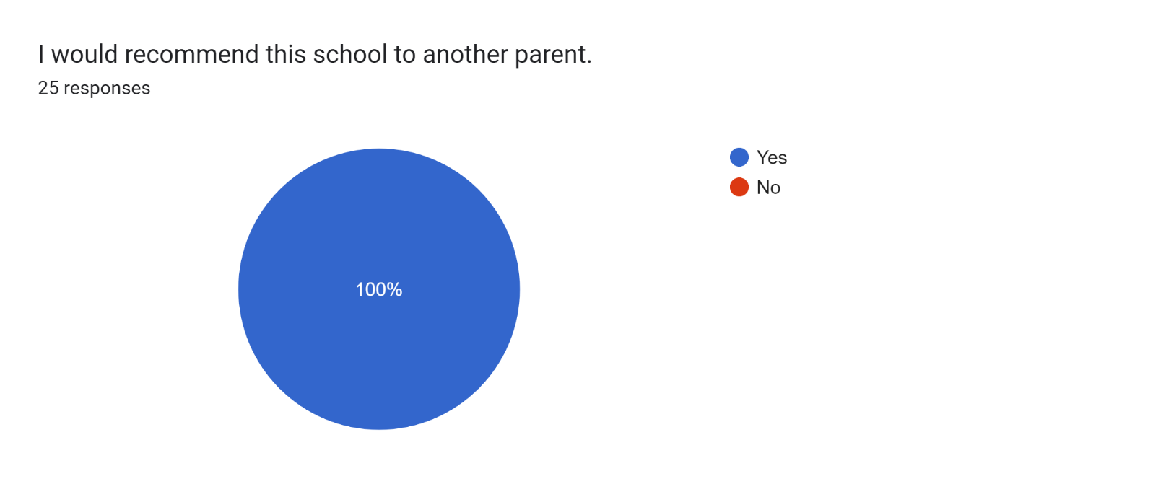

If there are any other comments you would like to make, please add below:

* Couldn't ask for a better school for my son, loving staff and wonderful environment.
* Really positive approach to children and families.
* Thank you for making my son’s first couple of months in his new school very welcoming. He is really enjoying school and making lots of new friends.
* Amazing school – I could not fault.
* Thank you.
* I am very grateful to all the staff for helping my daughter learn and making sure she’s happy and content at school.
* An amazing school and teacher, Miss Murphy. Thank you.
* Staff have been excellent.
* I am absolutely amazed at the facilities and opportunities available at Roby Park. Miss Murphy has been incredible at helping my son progress and we could not be happier.
* Brilliant staff.
* Thank you 😉
* This is a fantastic school - we hope our daughter continues learning here.
* Our son has really settled in. He’s very happy.
* We are happy with everything.
* Thank you for everything you’re doing for my son.
* A fantastic school and lovely staff.
* I am really happy with the school as a whole.
* I am so please how our son has settled in and I couldn't ask for more.
* Amazing!