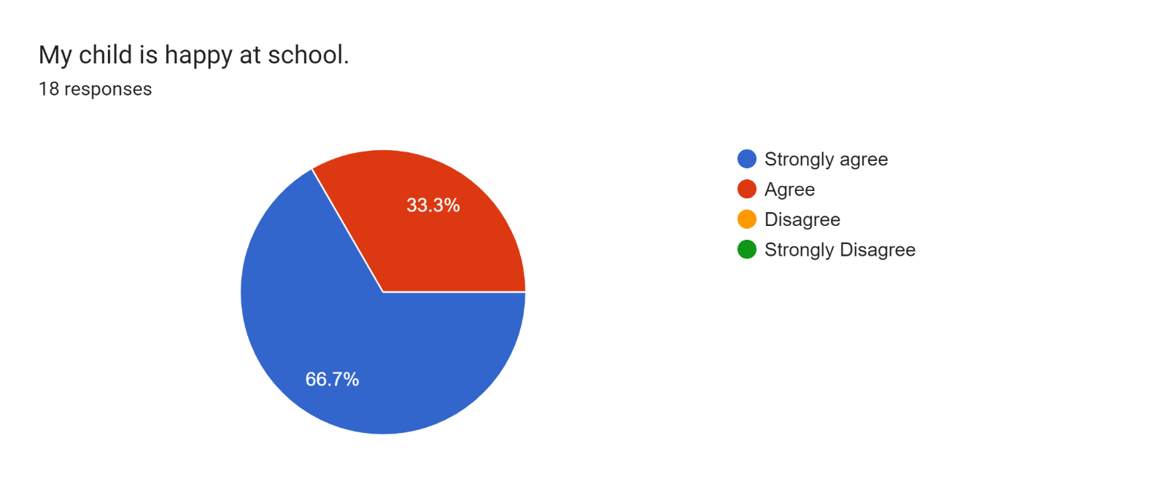

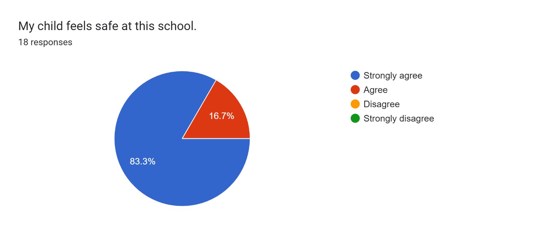

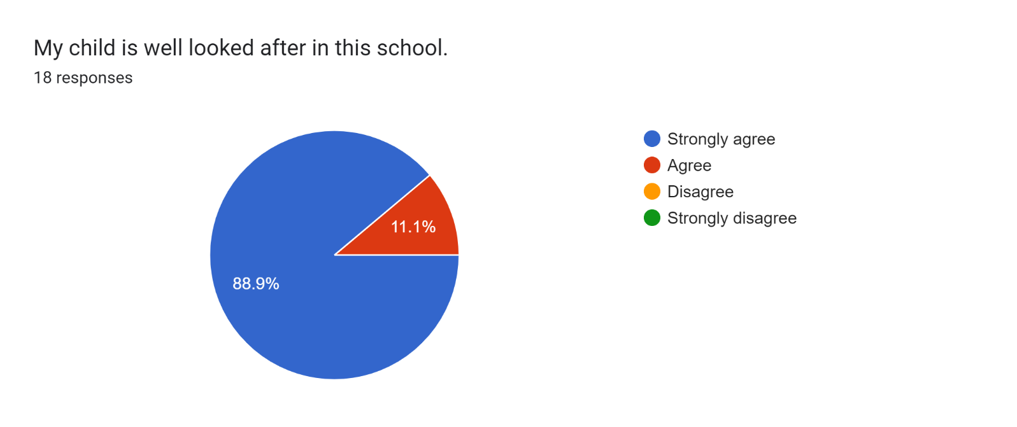

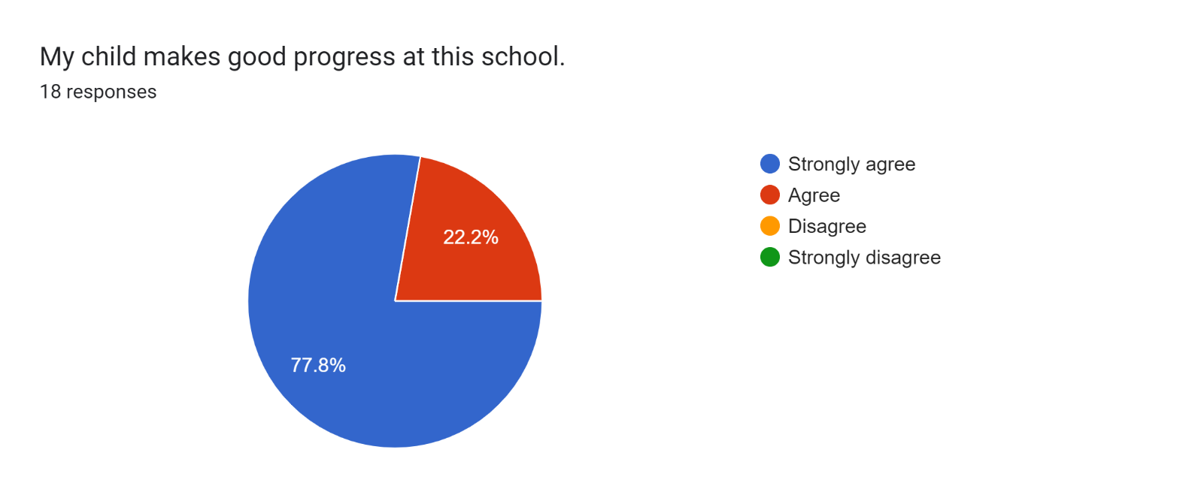

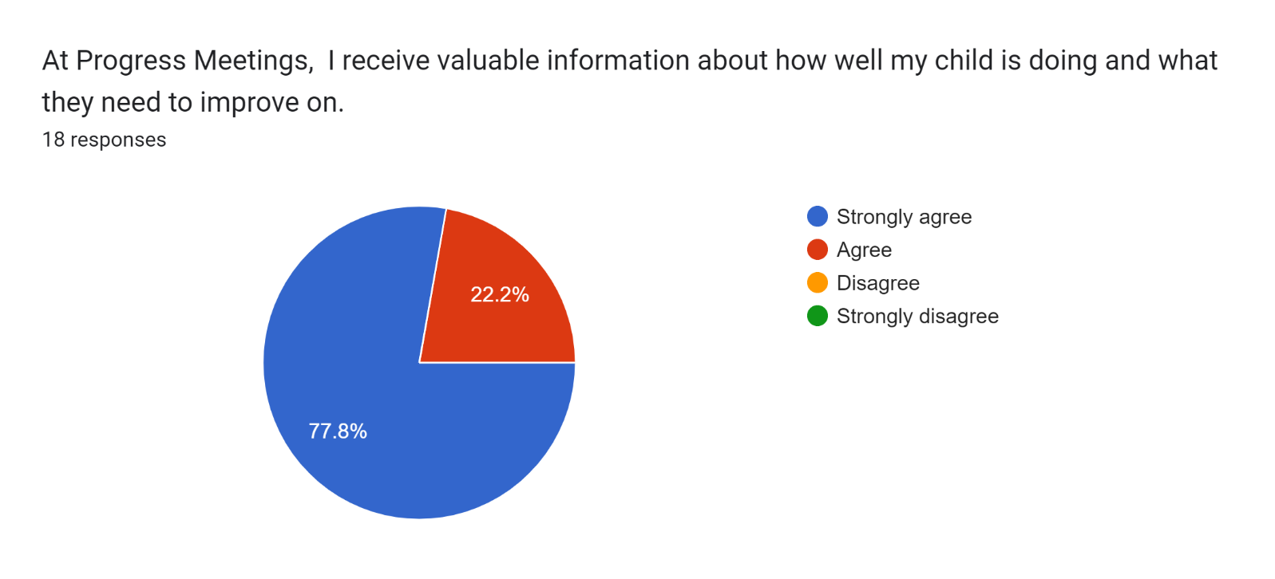

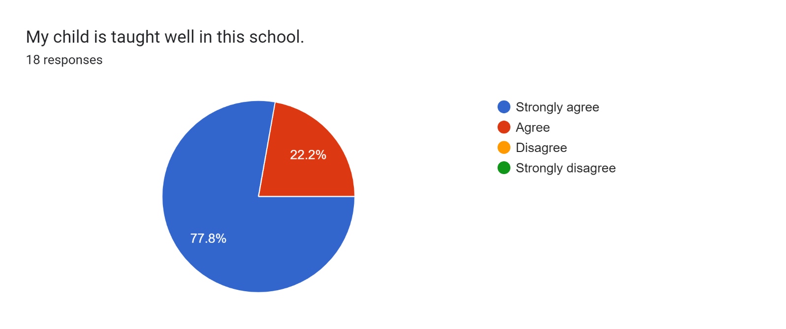

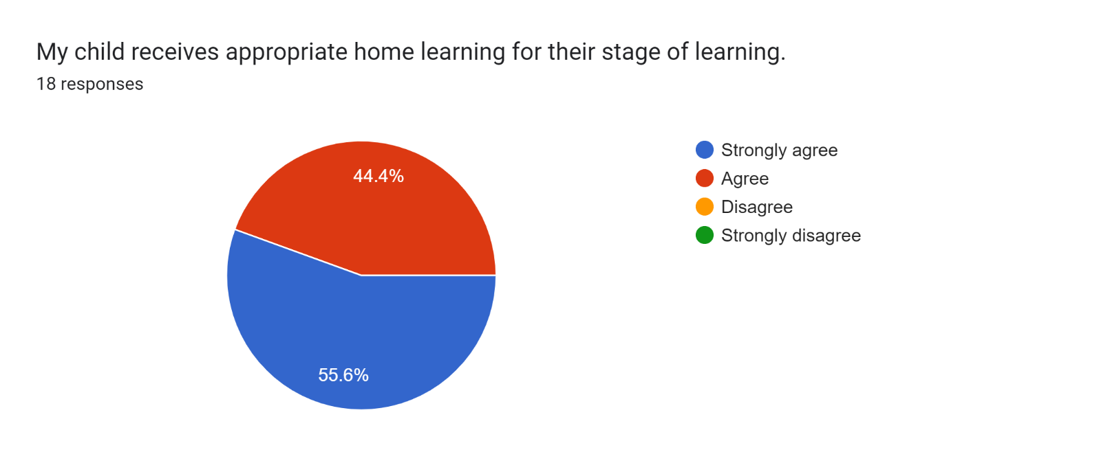

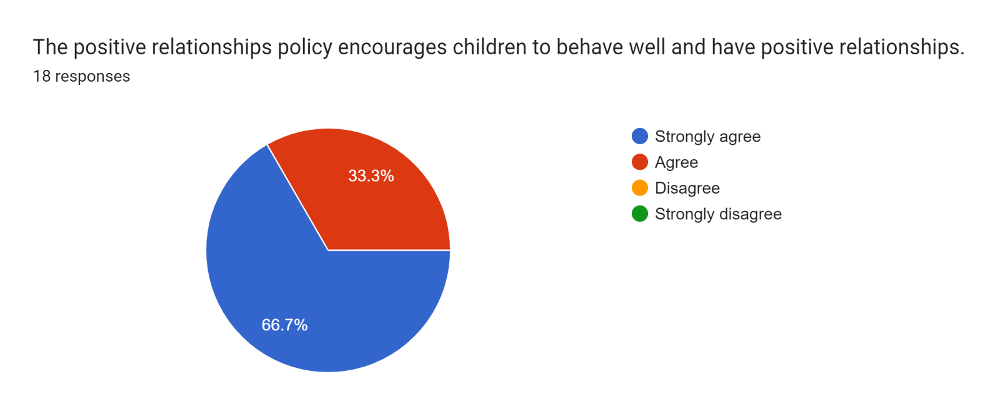

Forms response chart. Question title: This school deals effectively with bullying
. Number of responses: 18 responses.

Forms response chart. Question title: This school is well led and managed
. Number of responses: 18 responses.

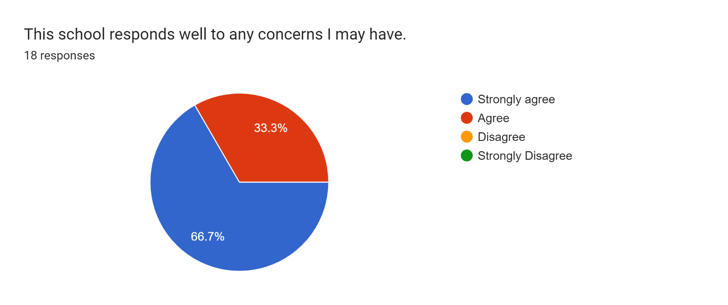

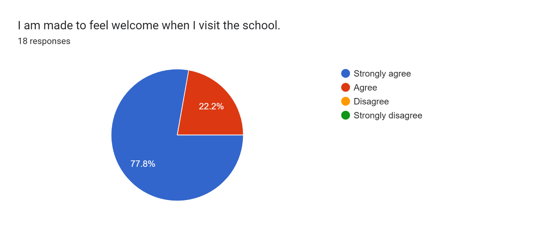

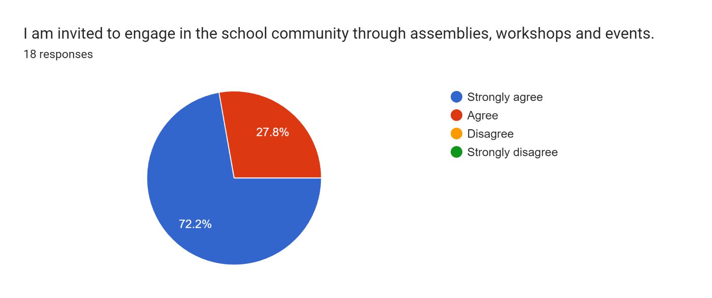

Forms response chart. Question title: The school uses a range of platforms to communicate with parents and carers - Class Charts, website, newsletters etc.
. Number of responses: 18 responses.

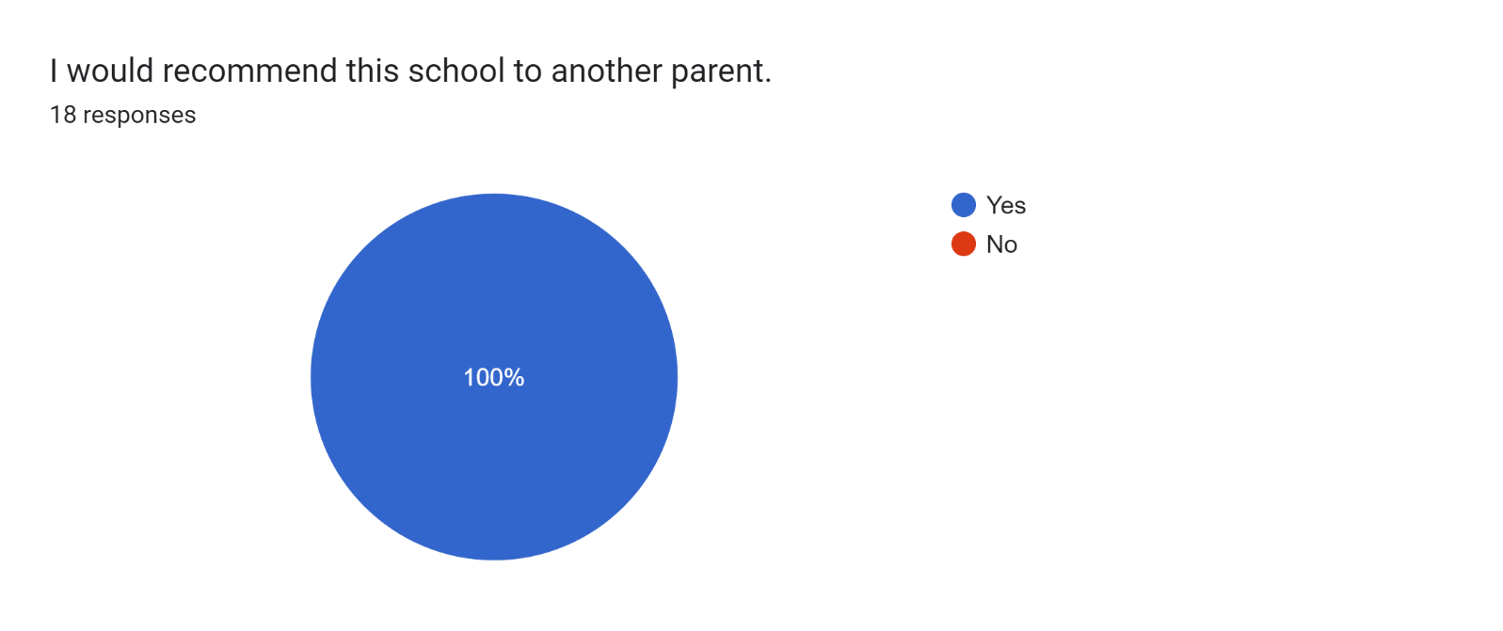

If there are any other comments you would like to make, please add below:

* Keep up doing a great job.
* You’re doing a great job!
* Keep up the good work - this school has become amazing!
* Thanks for all your help.
* School is amazing!!!!!!!!
* Thanks!
* Excellent start to the year. Staff are helpful.
* Thank you for the support shown to my son.
* My son is really happy at school.
* They are all just amazing, so friendly but professional at the same time.
* Great to hear feedback about how my child is doing at school.
* Really happy with my daughter’s teacher.
* A wonderful school and staff. I can't recommend highly enough!
* Miss Beggs has brought my son on leaps and bounds and built his confidence up so much which we appreciate so much.
* Thank you for helping my daughter.