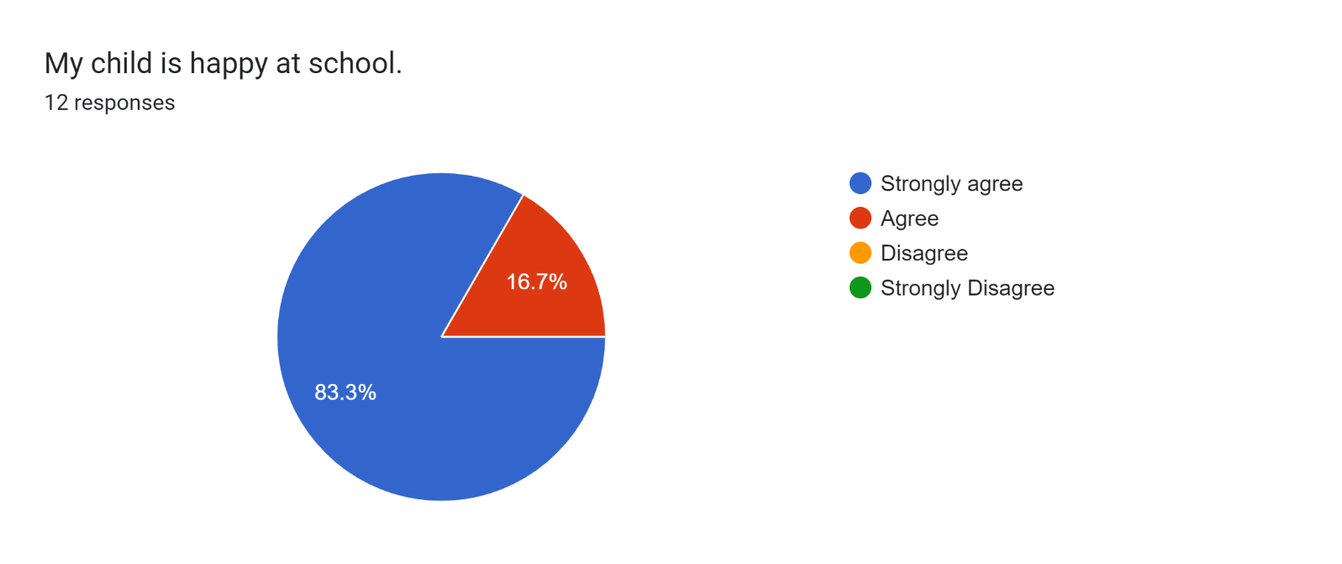

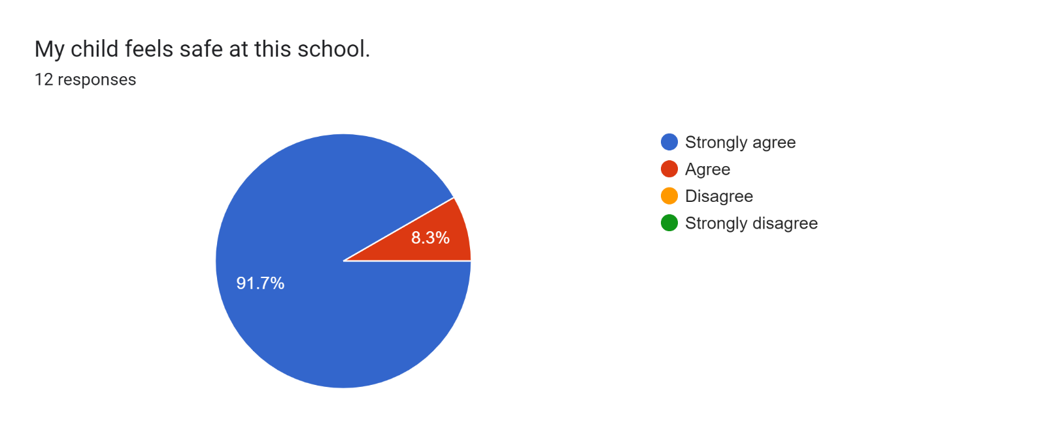

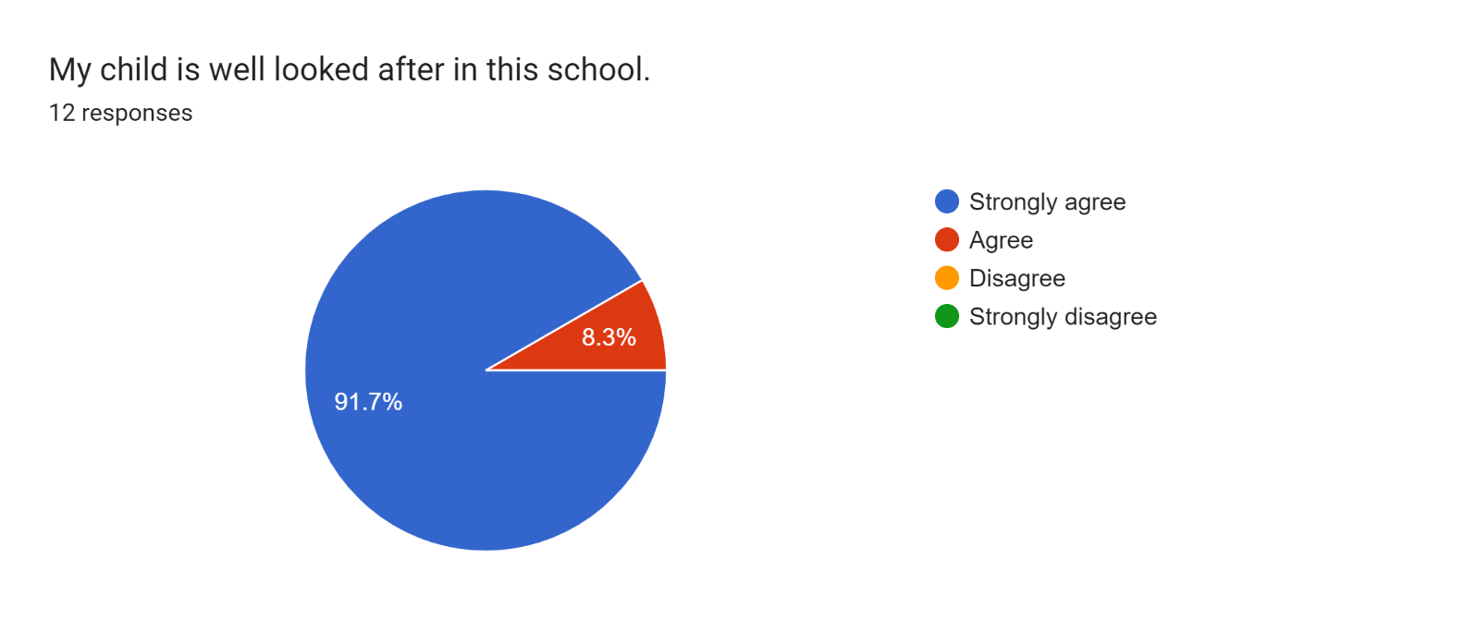

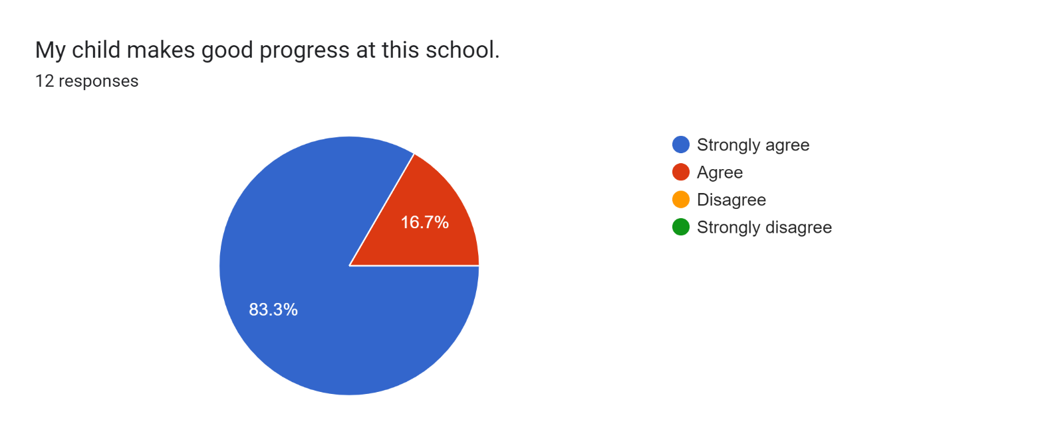

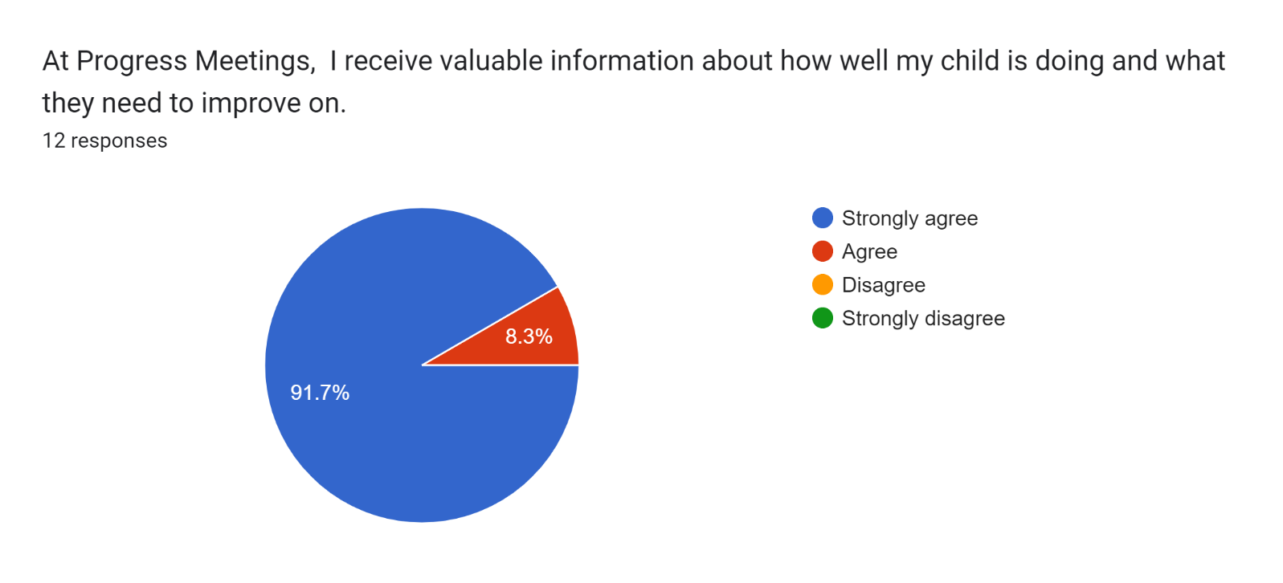

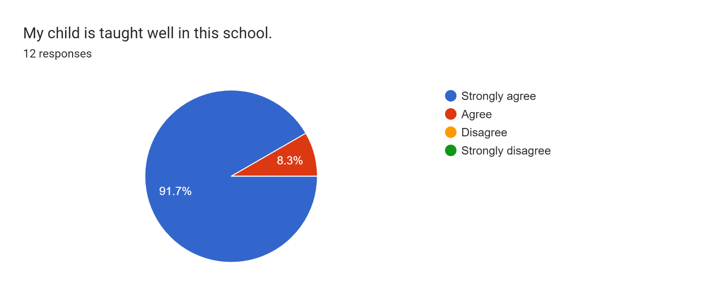

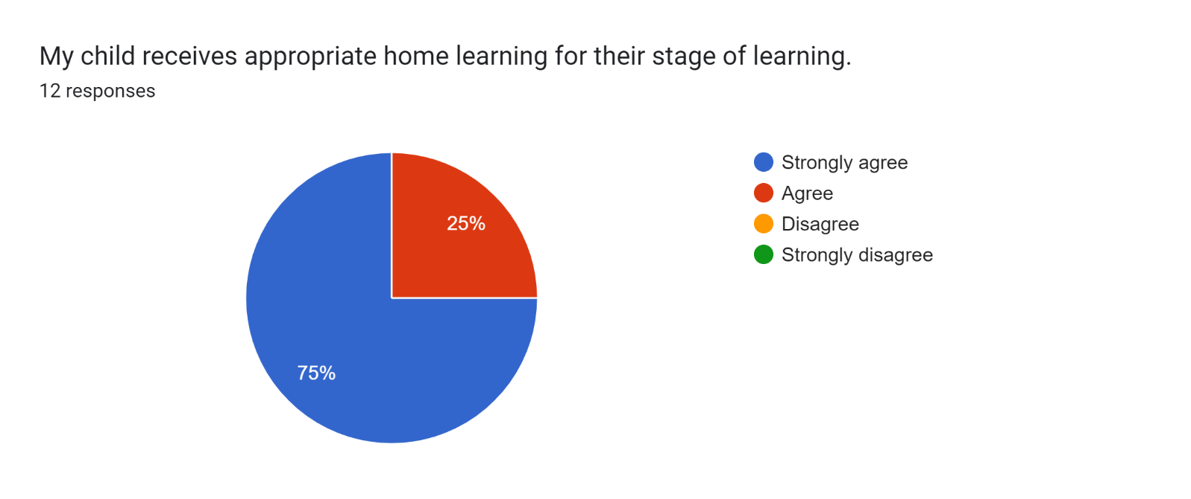

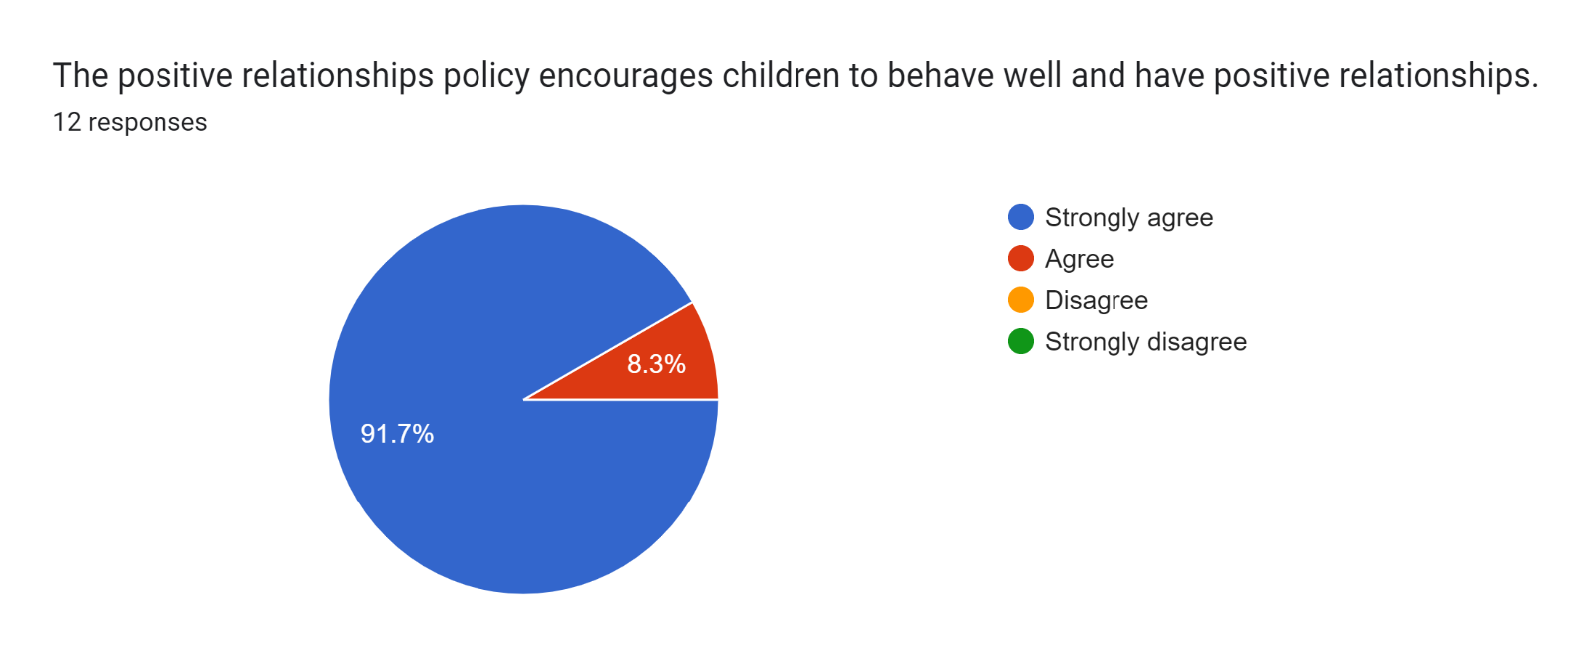

Forms response chart. Question title: This school deals effectively with bullying
. Number of responses: 12 responses.

Forms response chart. Question title: This school is well led and managed
. Number of responses: 12 responses.

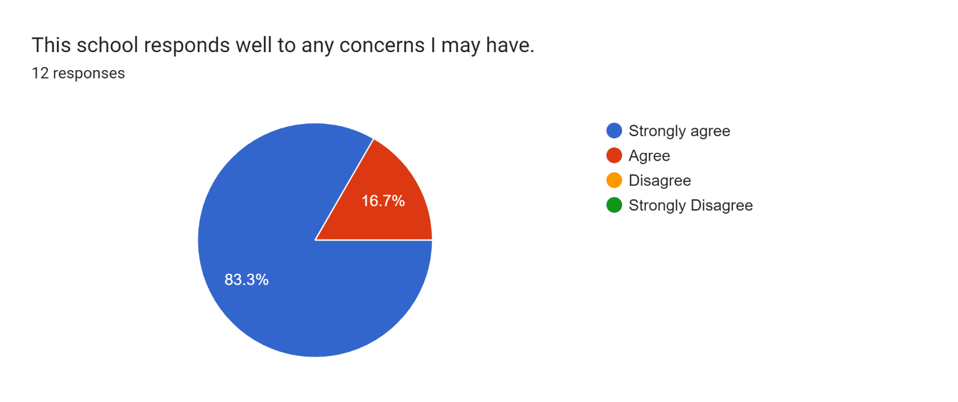

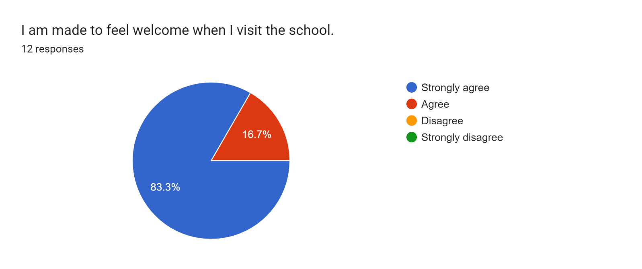

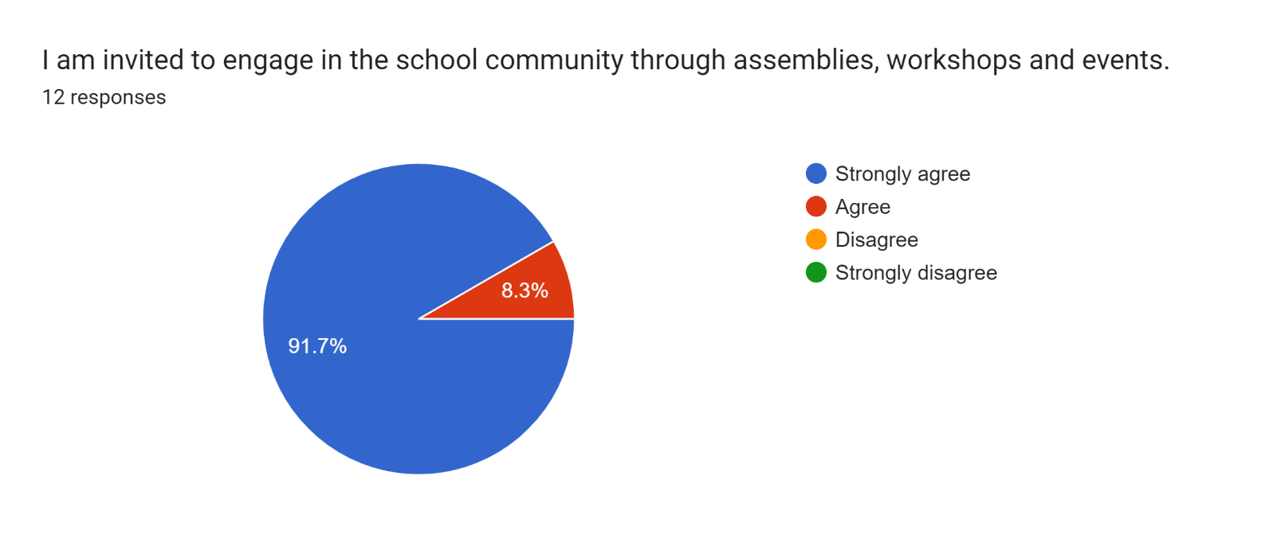

Forms response chart. Question title: The school uses a range of platforms to communicate with parents and carers - Class Charts, website, newsletters etc.
. Number of responses: 12 responses.

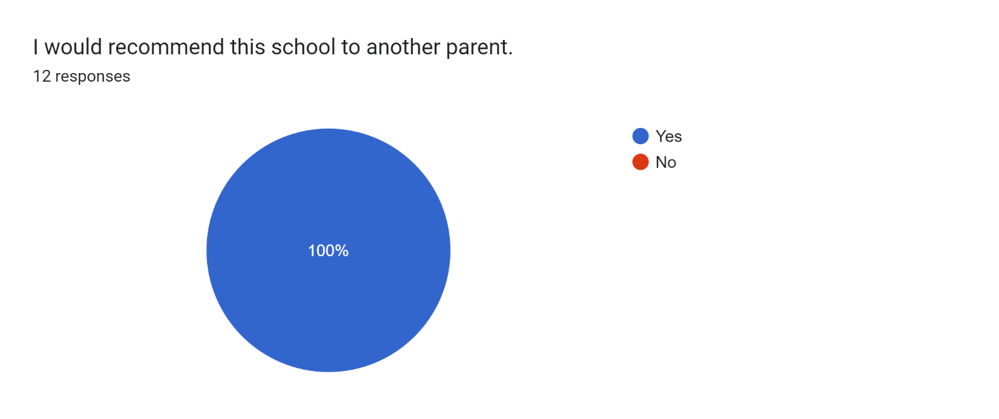

If there are any other comments you would like to make, please add below:

* Amazing school. Once again it has been a lovely progress meeting and it is lovely to hear how far my son has come on since Year 4.
* Thank you all.
* I am very pleased with the support from my daughter’s teacher.
* Keep up with all the hard work as it shows through the children.
* I am always made to feel very welcome.
* Thank you for helping my son to learn and being a great school with lots of fun things and lots to do.
* Keep up all of your hard work.
* Brillant!
* My son loves this new school - he has settled in great.