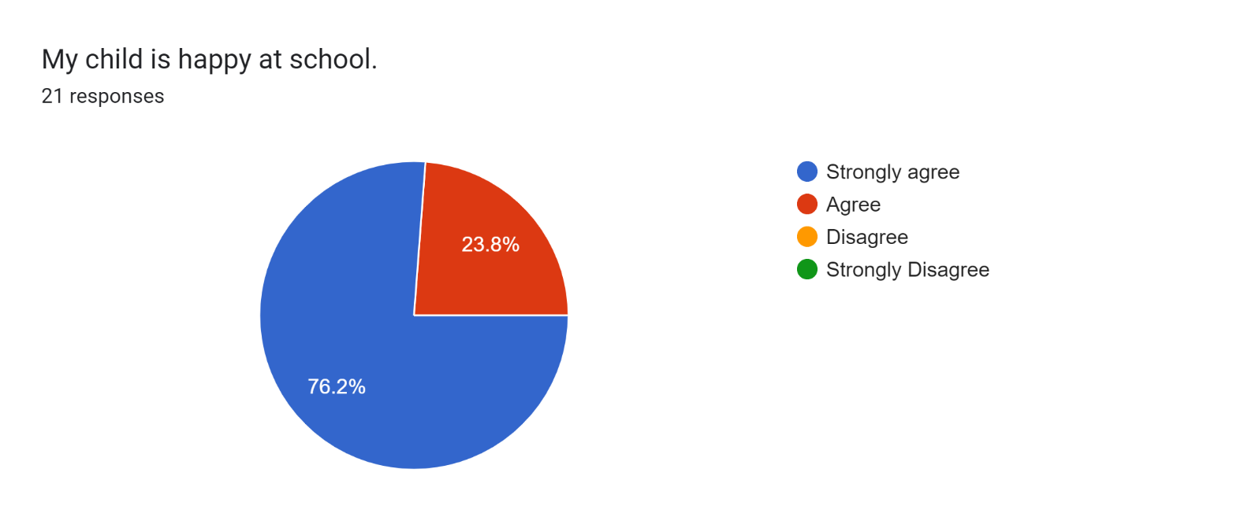

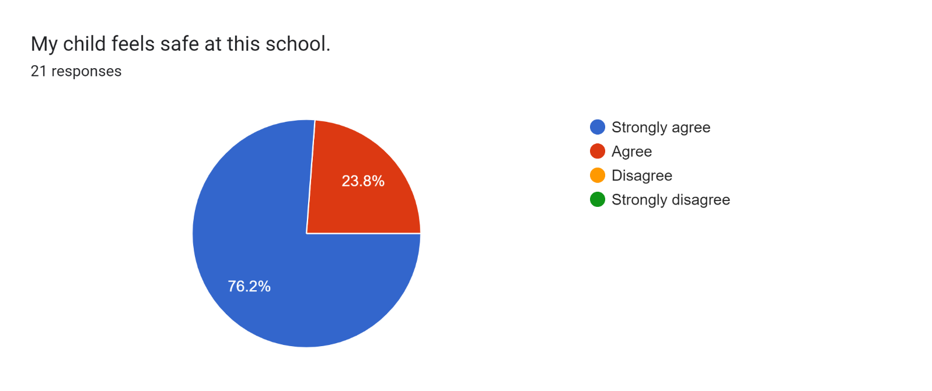

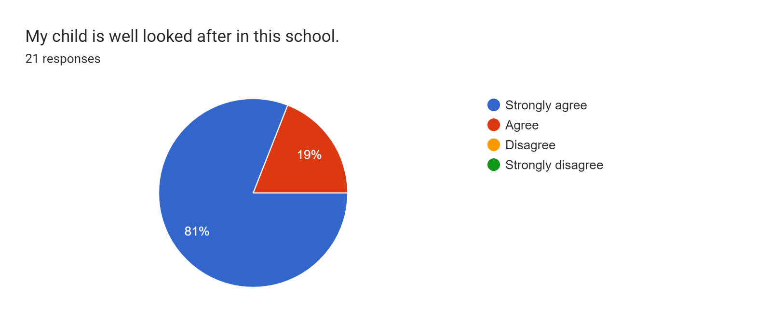

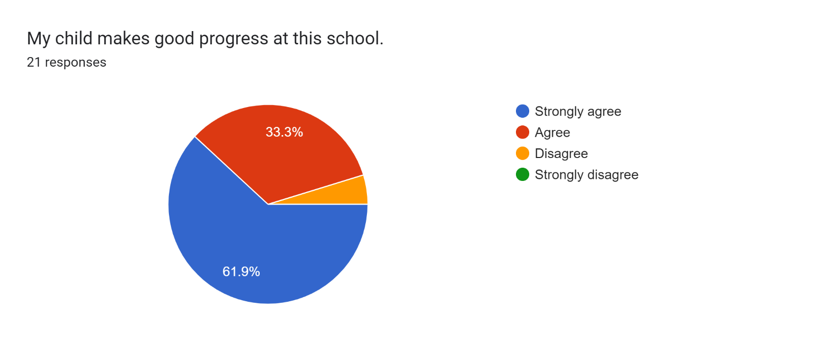

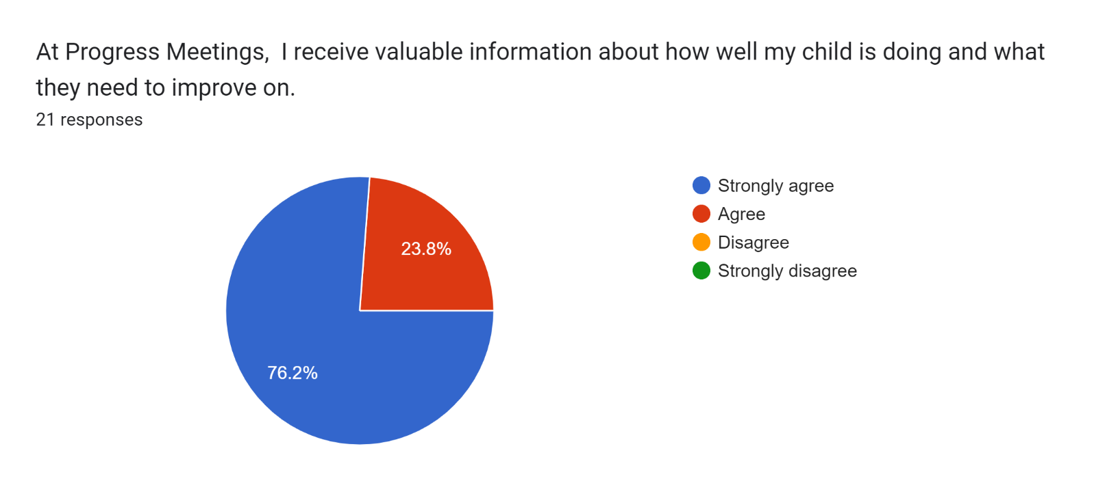

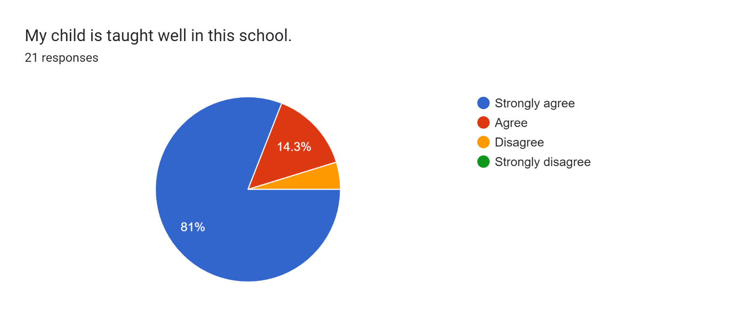

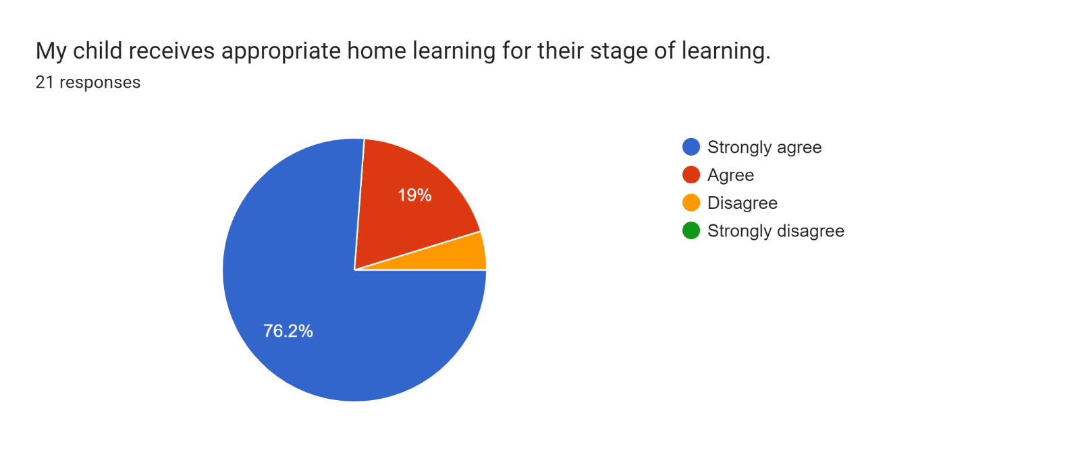

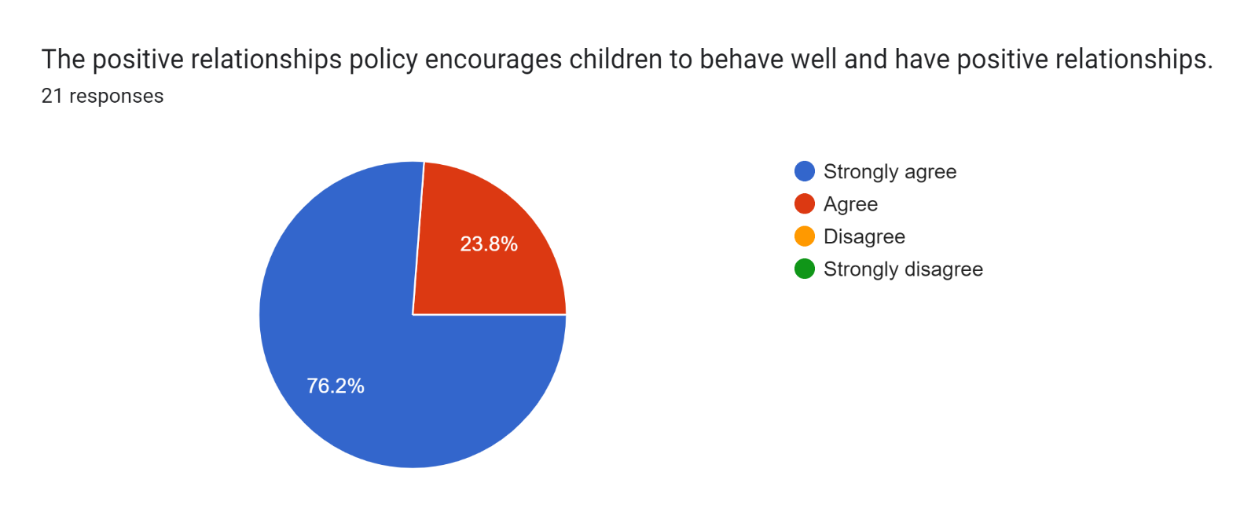

Forms response chart. Question title: This school deals effectively with bullying
. Number of responses: 21 responses.

Forms response chart. Question title: This school is well led and managed
. Number of responses: 21 responses.

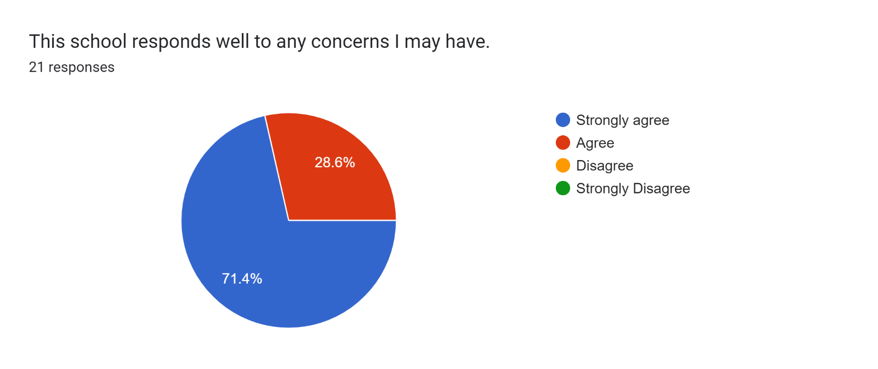

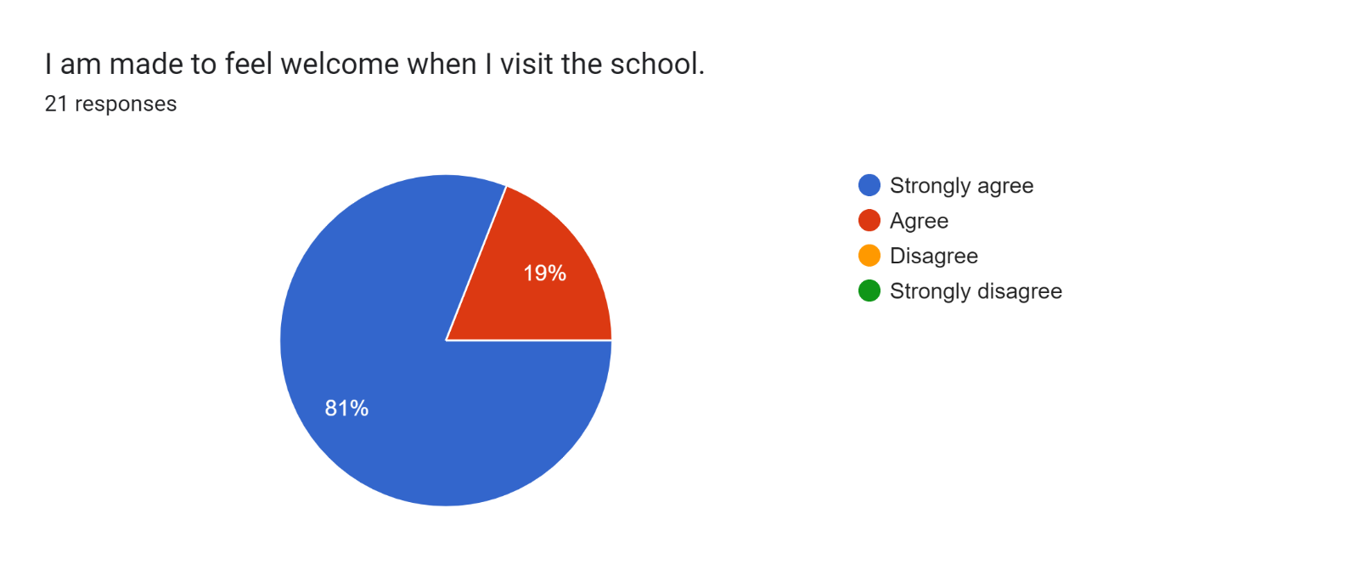

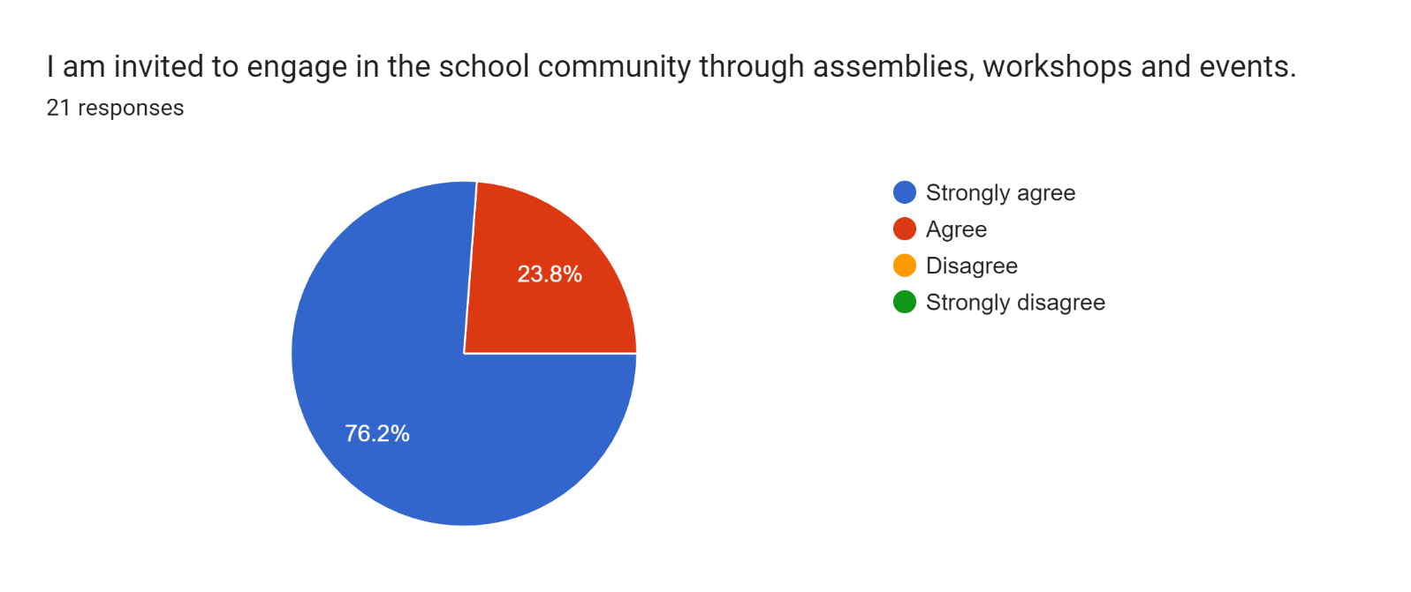

Forms response chart. Question title: The school uses a range of platforms to communicate with parents and carers - Class Charts, website, newsletters etc.
. Number of responses: 21 responses.

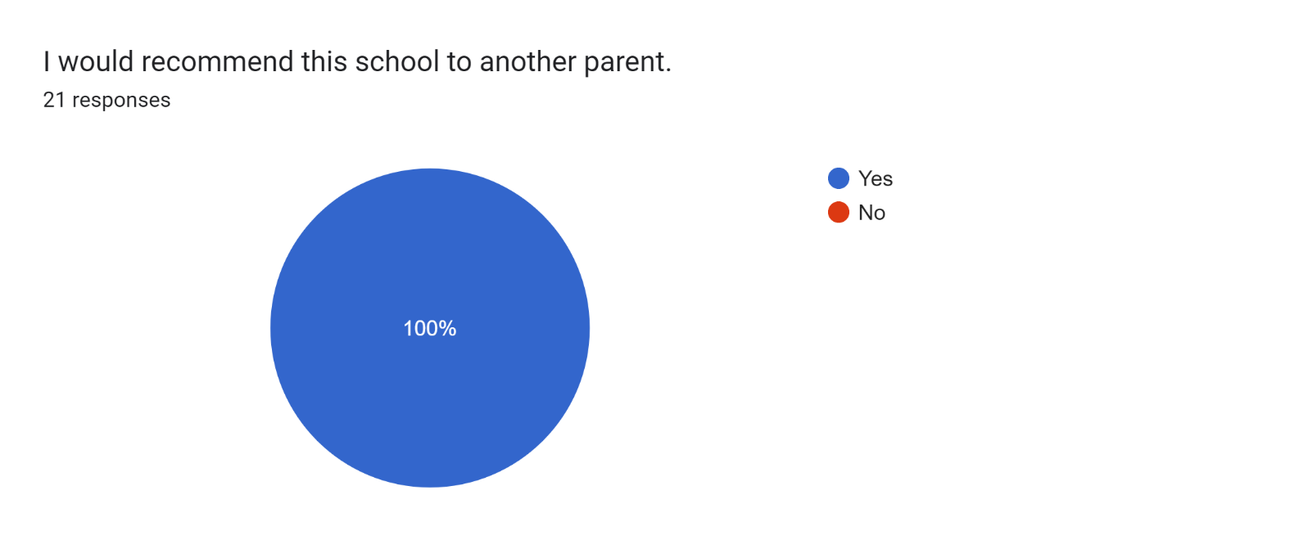

If there are any other comments you would like to make, please add below:

* Amazing school!
* My daughter really enjoys school.
* They have helped my son a lot.
* You are all amazing – thank you.
* Fabulous!
* Thanks for all of your help.
* We are happy with everything. Keep it up, Mr Couling ☺️
* An amazing school! All of the teachers are helpful and great to speak to about concerns I may have.
* The staff go above and beyond for the children.
* Thank you for always being there for both of my children and my family as a whole... what you do is incredible, and you should be proud of what you have all done for this school.
* A lovely progress meeting. It was lovely hearing about my daughter’s progress.
* The class teacher is great!
* Brilliant school!
* Great work.
* Great!
* Brilliant school!
* Thank you so much for all of your hard work.
* Thank you for supporting my son.