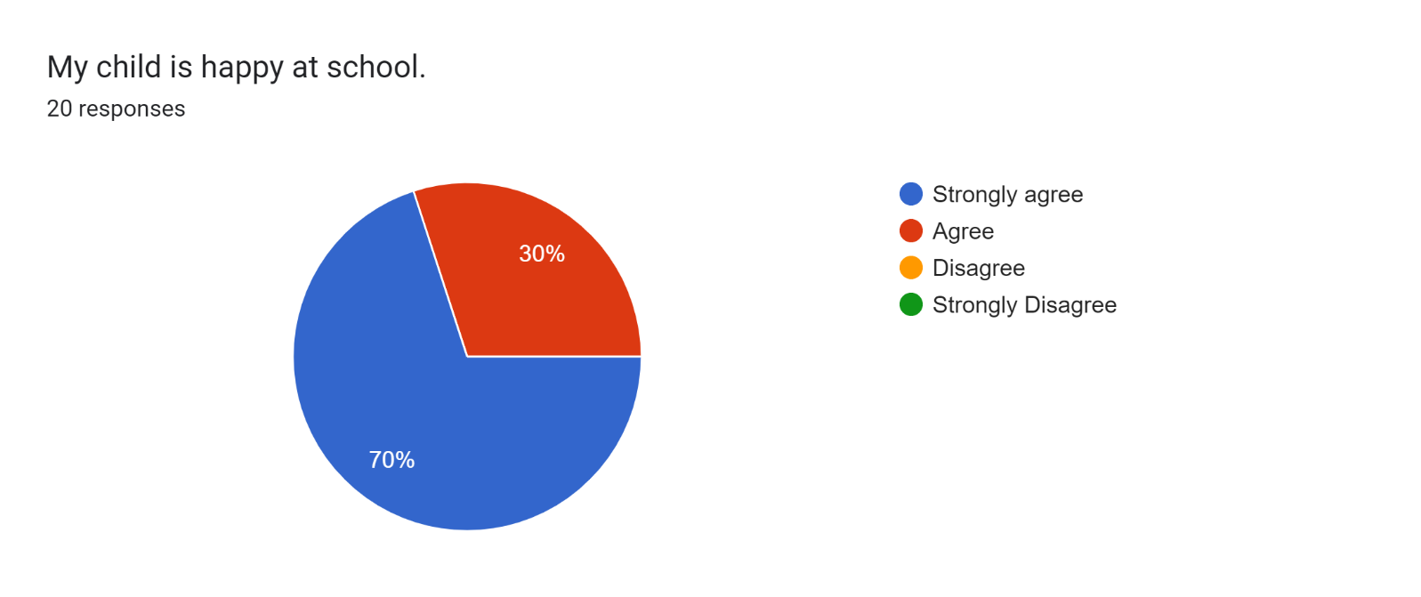

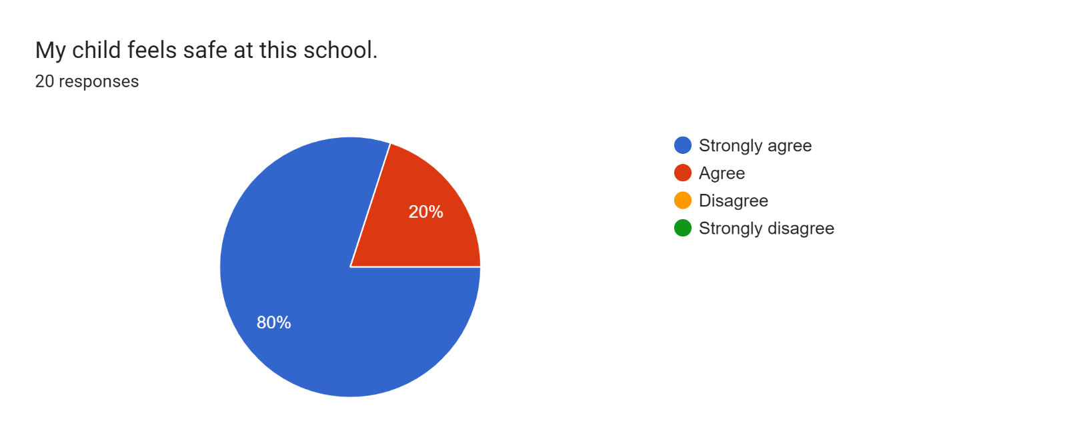

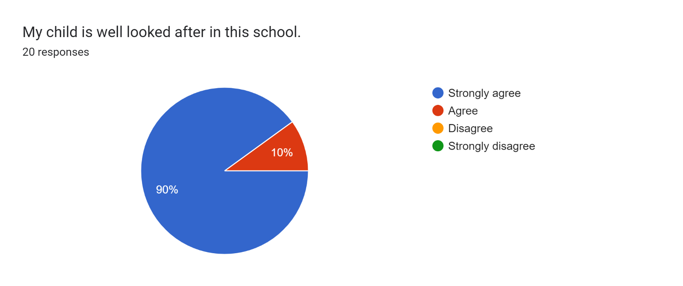

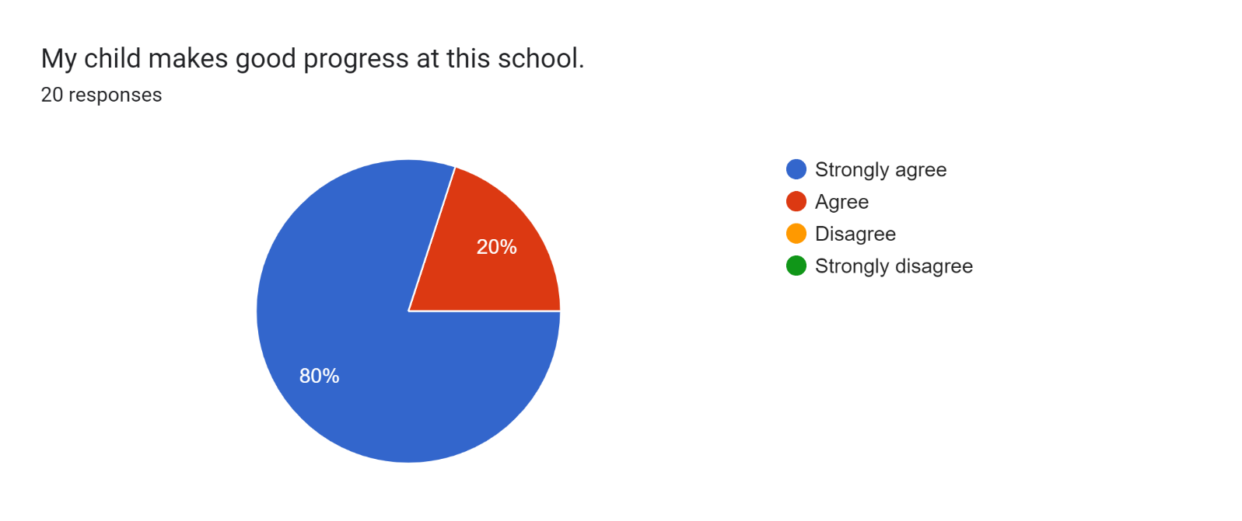

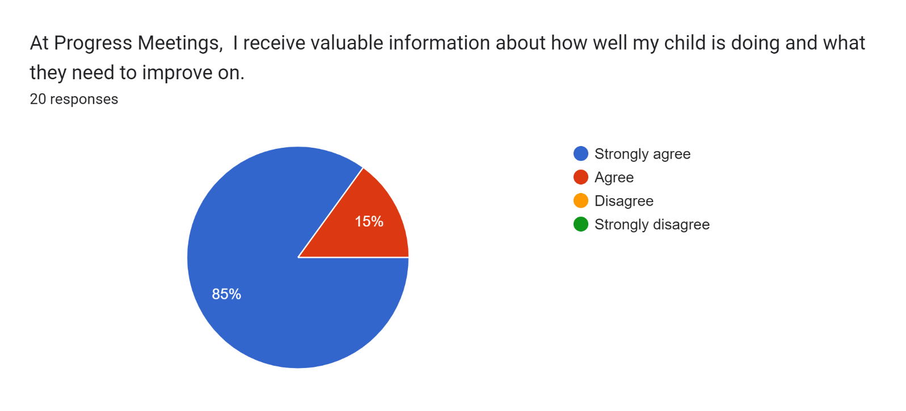

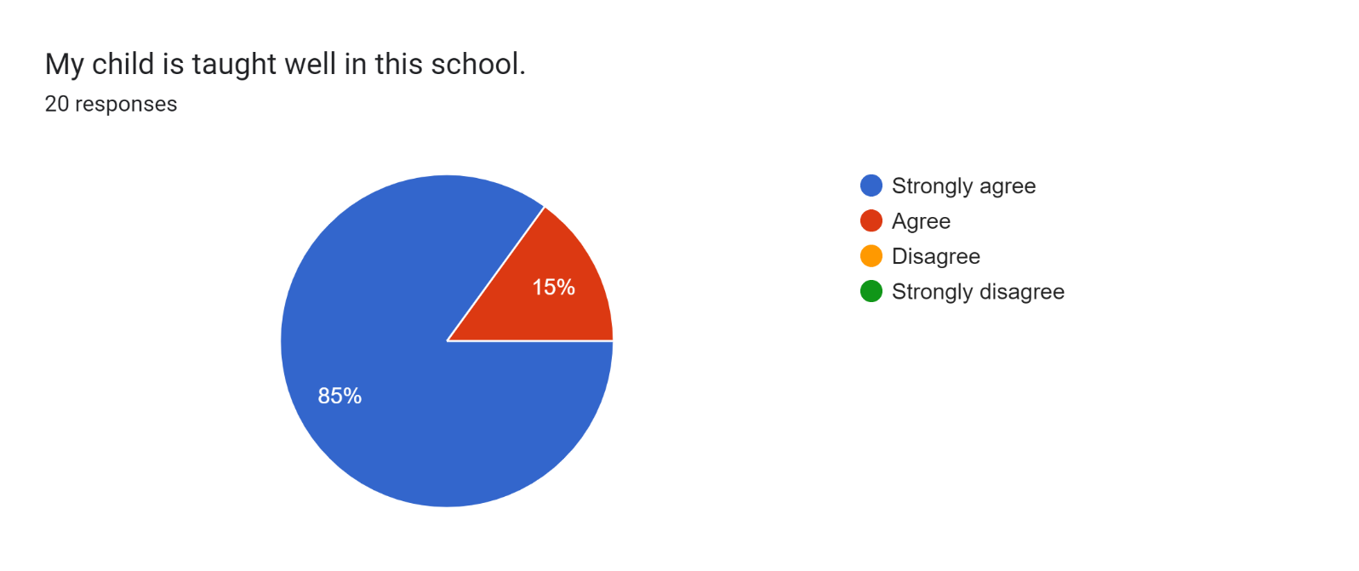

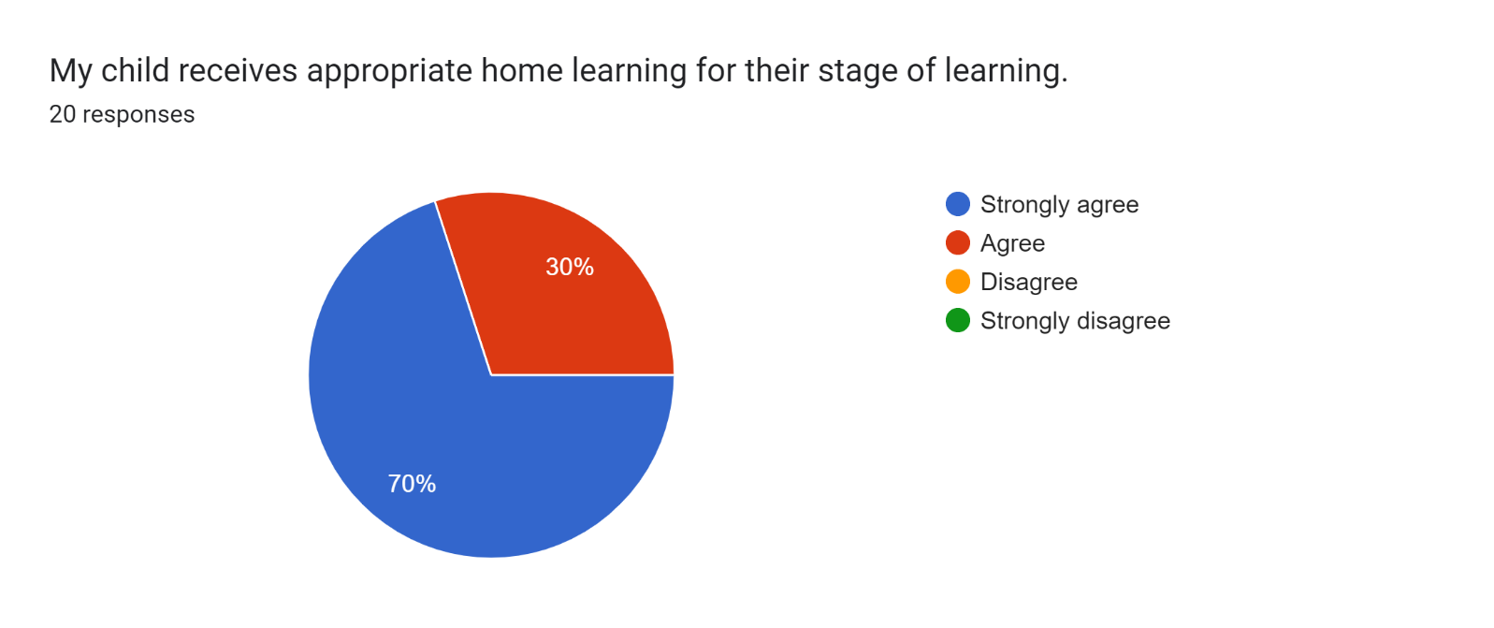

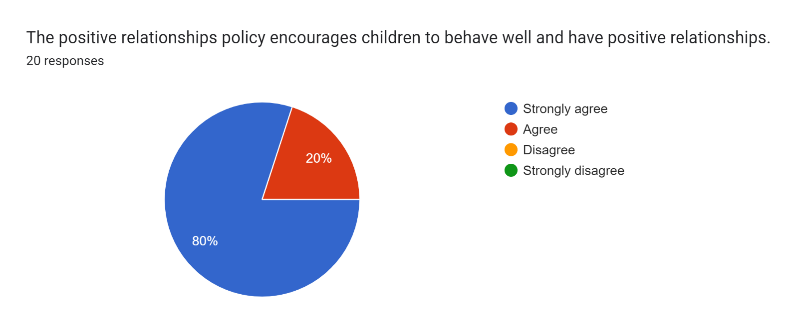

Forms response chart. Question title: This school deals effectively with bullying
. Number of responses: 20 responses.

Forms response chart. Question title: This school is well led and managed
. Number of responses: 20 responses.

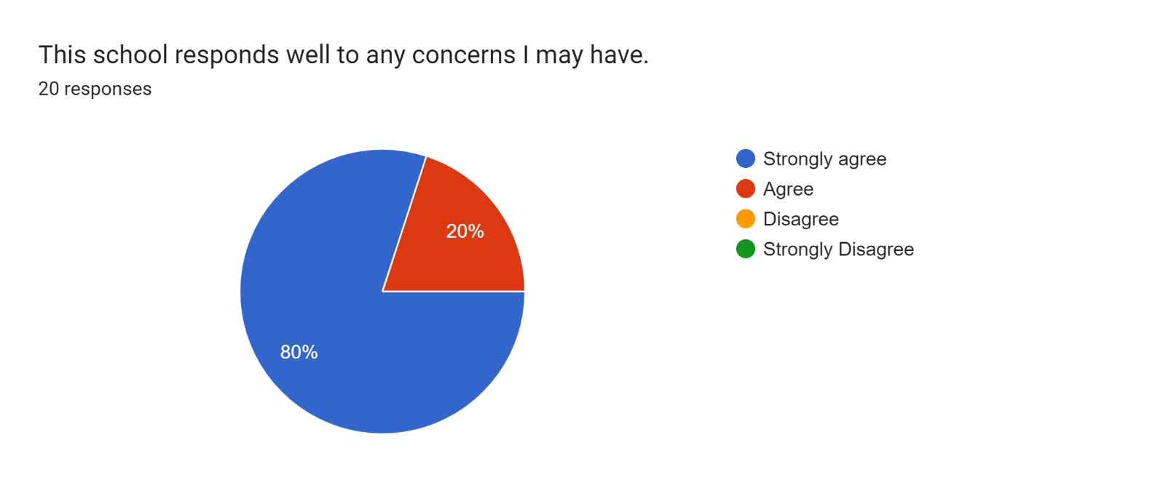

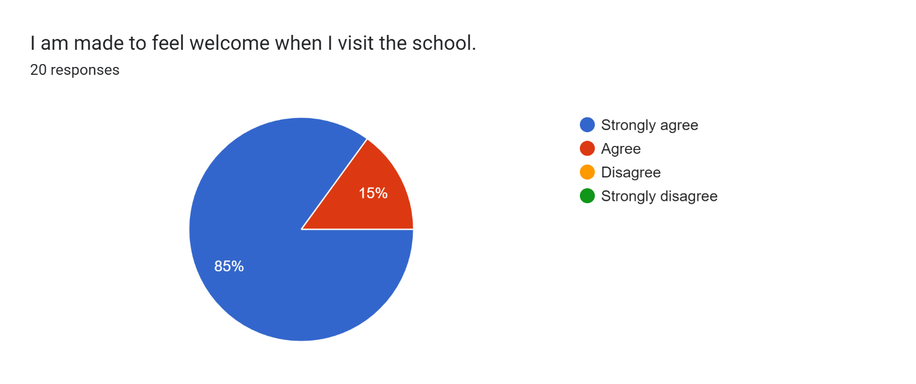

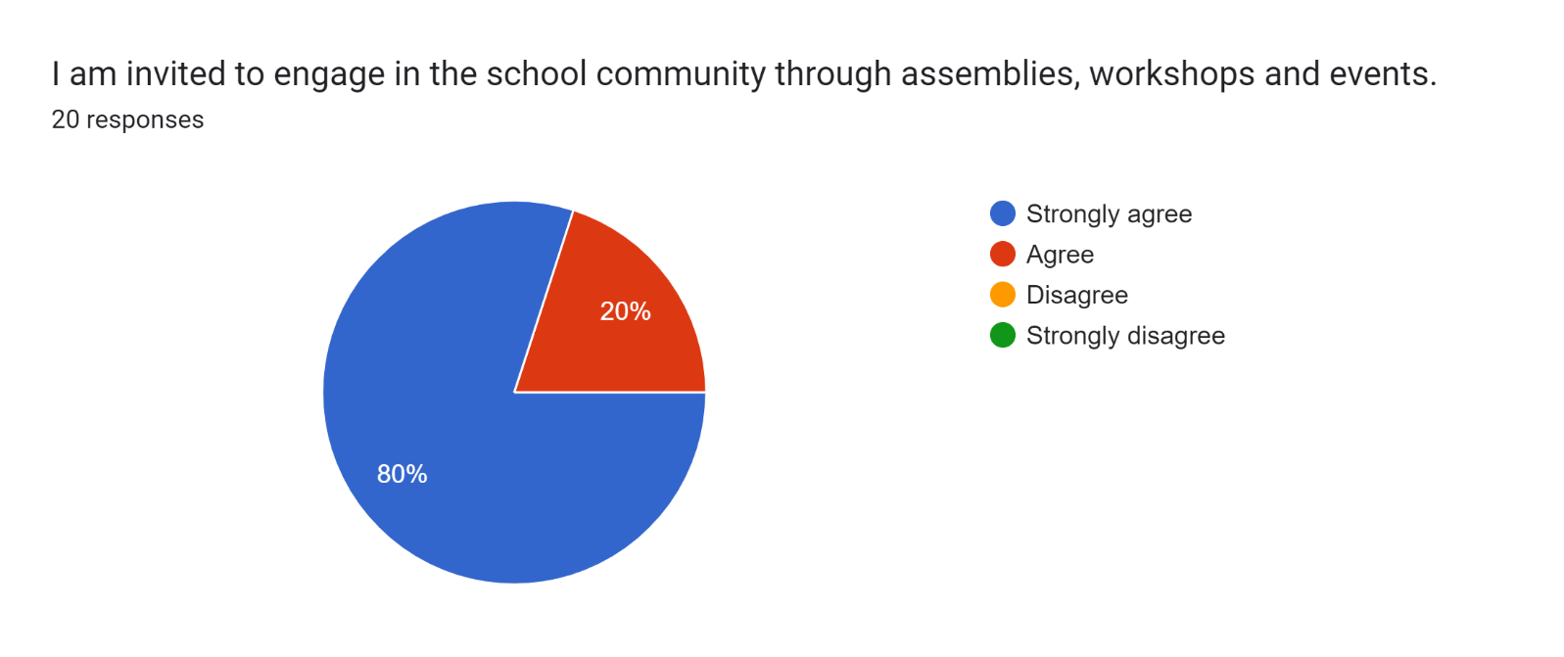

Forms response chart. Question title: The school uses a range of platforms to communicate with parents and carers - Class Charts, website, newsletters etc.
. Number of responses: 20 responses.

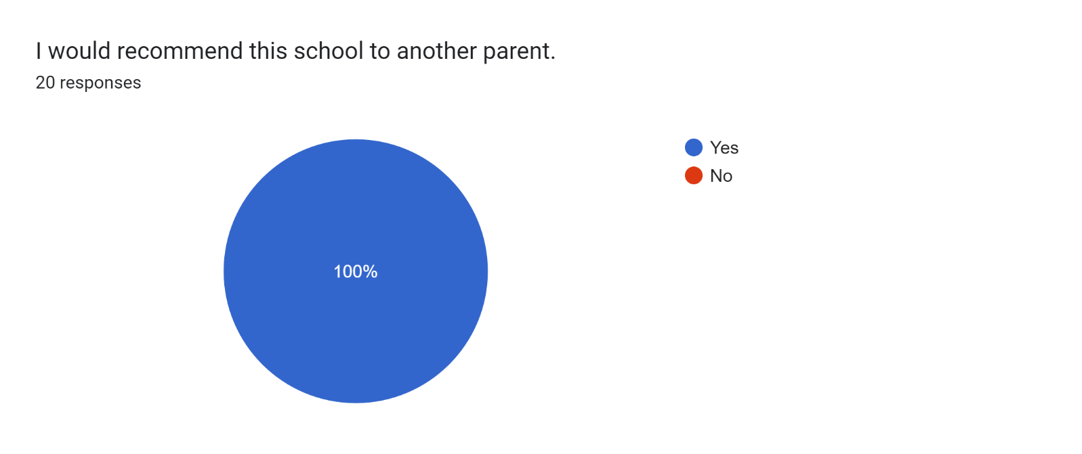

If there are any other comments you would like to make, please add below:

* It’s lovely to see that my son is getting more confident in Year 3 and thank you for all your help and support for myself and my child.
* Thank you.
* No other comments needed. I’m very happy with the school and my son’s progress.
* Friendly staff.
* My child is happy and feels safe at this school. The staff are always happy to help.
* Keep up the excellent work.
* The school and teachers are amazing!
* Great school!
* Good.
* All the staff are lovely.
* All lovely.
* Fantastic school.
* You are doing amazing!