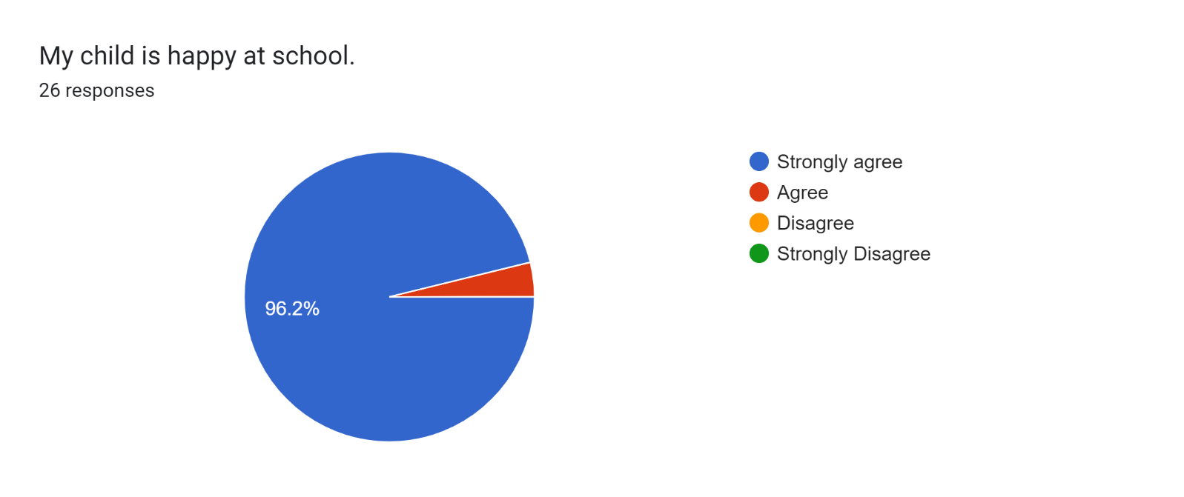

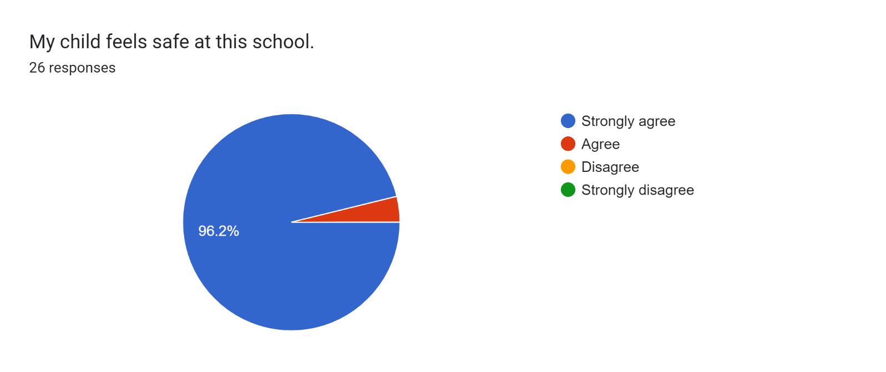

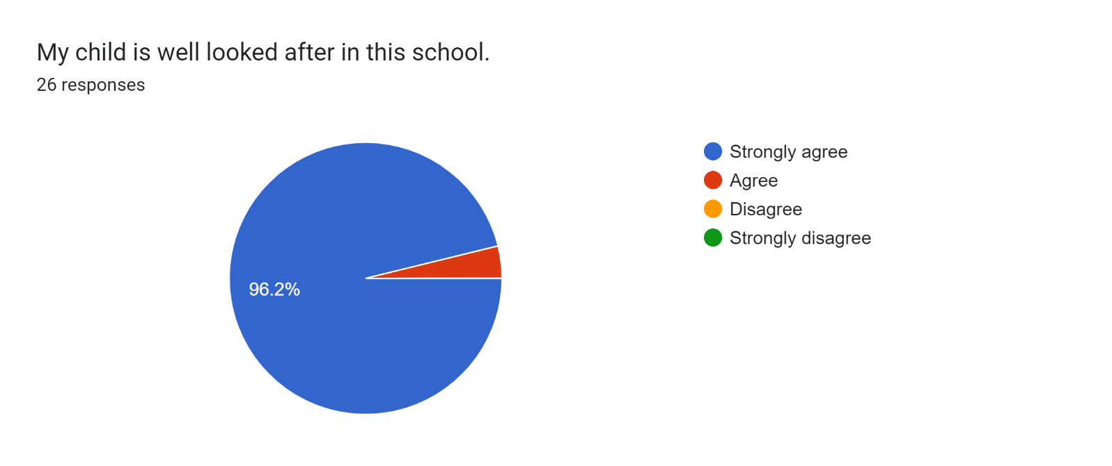

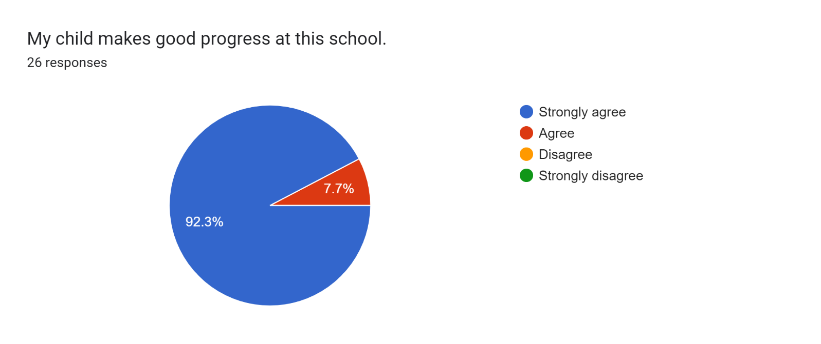

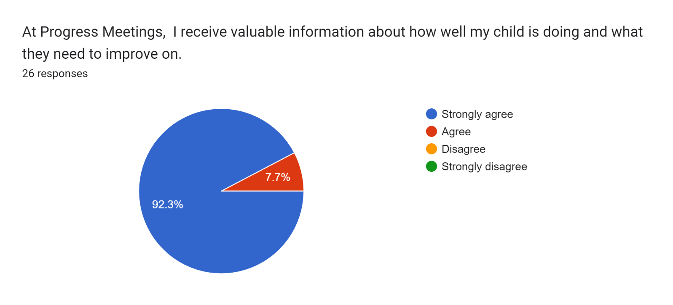

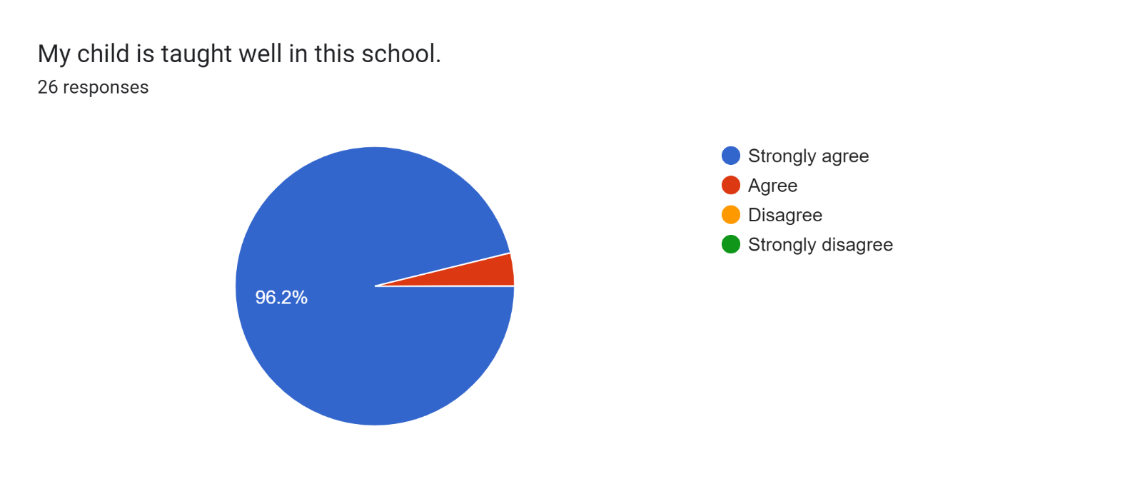

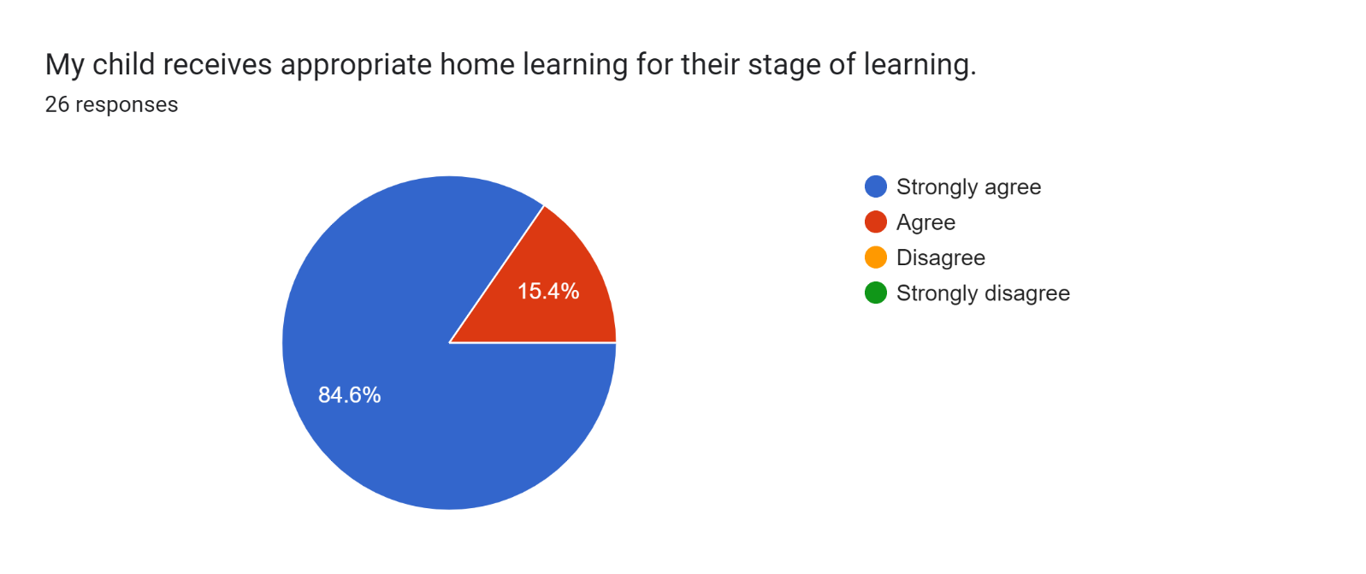

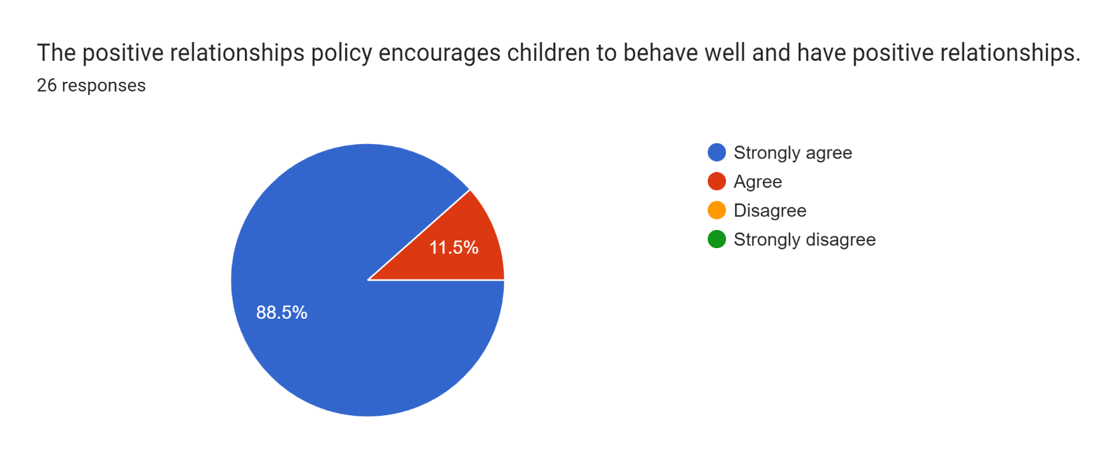Forms response chart. Question title: This school deals effectively with bullying
. Number of responses: 26 responses.

Forms response chart. Question title: This school is well led and managed
. Number of responses: 26 responses.

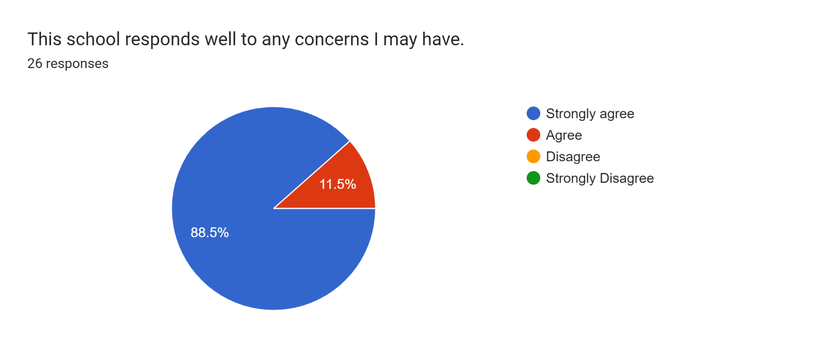

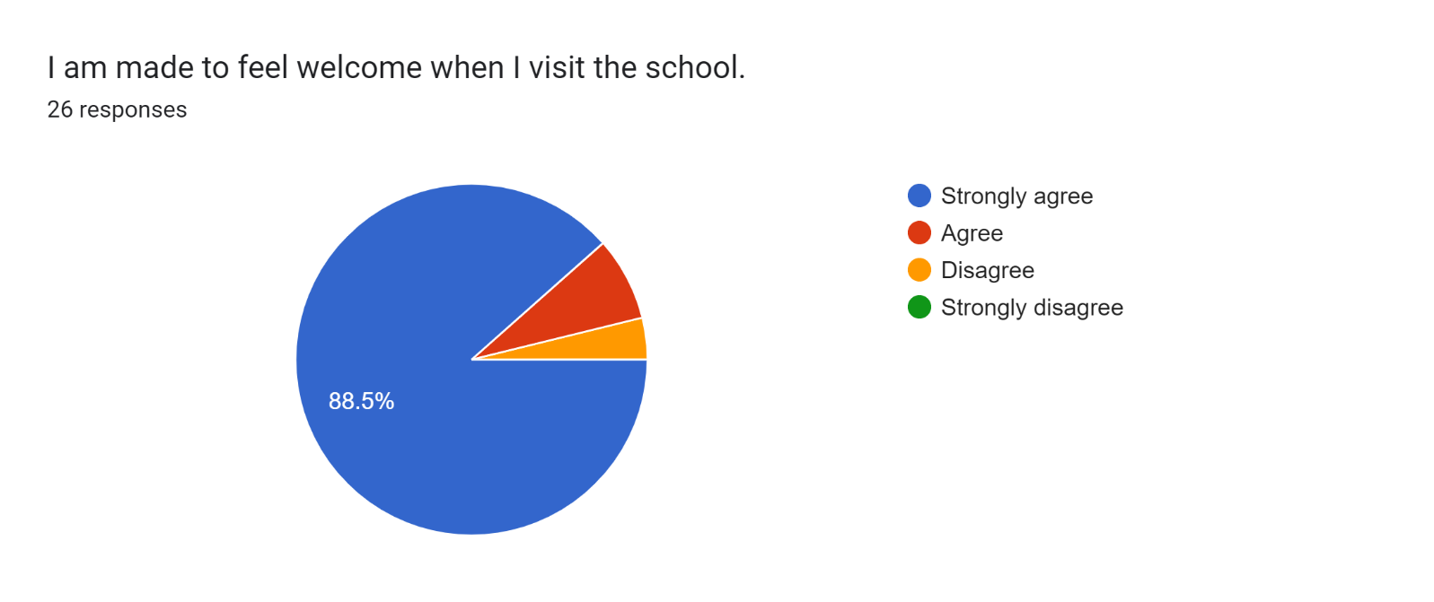

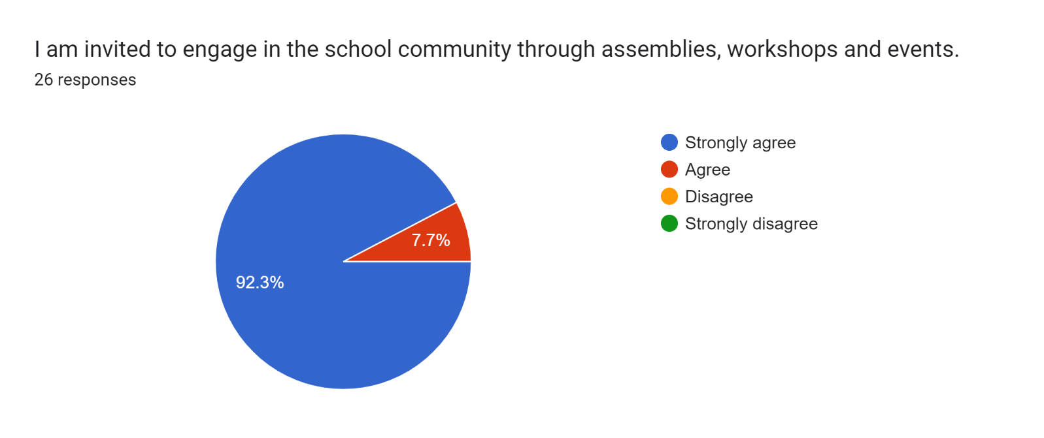

Forms response chart. Question title: The school uses a range of platforms to communicate with parents and carers - Class Charts, website, newsletters etc.
. Number of responses: 26 responses.

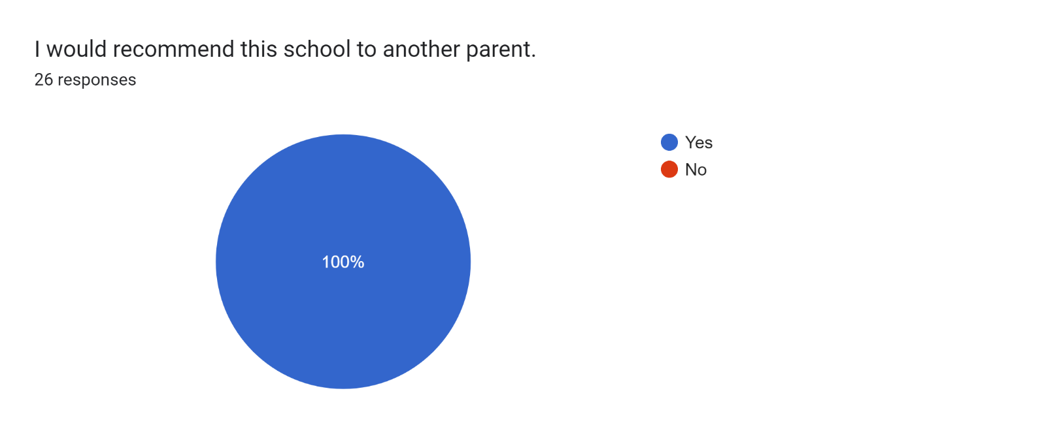

If there are any other comments you would like to make, please add below:

* Thank you for all that you and your team do for the children. You do an excellent job and our children are lucky to be part of such a fantastic community
* Lovely staff.
* The teachers do a fantastic job.
* I am so happy with everything.
* Amazing and friendly staff.
* You are all doing an amazing job.
* Thank you so much for all the support you have given to my son.
* Amazing staff who are making a difference to all of the children, their families and local community.
* Thanks for looking after the kids so well.
* Excellent staff.
* All the staff are really supportive and approachable. Amazing teaching!
* Pleased with how my son is coming along this year, considering he’s finding the work hard.
* Just thank you for everything you do for my child. You go above and beyond to help with everything to enhance her education.
* The staff are great, friendly and approachable.
* Thanks so much for all your help with my daughter.
* Thank you.
* My daughter really enjoys school. I am really pleased with the progress she has made.
* I am very happy with all of the staff I have dealt with.
* A fantastic school. My son really loves coming here and I would recommend to anyone.
* You're all doing amazing!
* Best school!