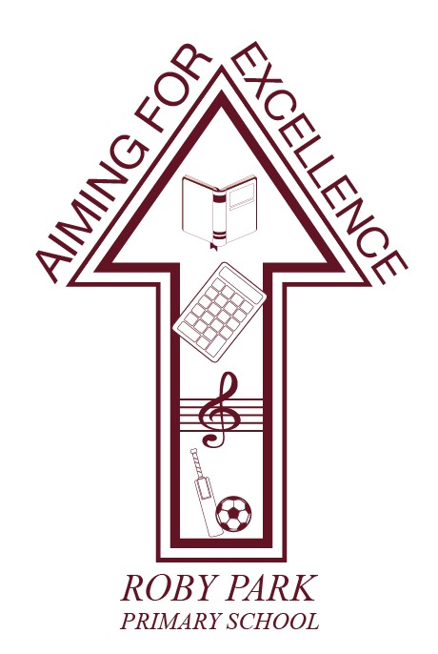

Roby Park Primary School

Easton Road

Huyton

Knowsley

L36 4NY

Tel: 0151 477 8340

Website: www.robyparkprimary.co.uk

E-mail: robypark@knowsley.gov.uk

Headteacher: Mrs K Allen
Date: Thursday 26th October

Y1 & Y2 Swimming Lessons

Dear parents/carers,

We are very excited to be welcoming Elite Swimming UK to Roby Park from 6th November – 1st December.

ELITE Swimming UK will deliver their very own bespoke ‘Pools to Schools’ to our Roby Park site, meaning every child from Nursery up to Y6 will be able to access weekly swimming lessons completely free of charge, as part of our Curriculum offer.

Swimming lessons are delivered by a level 2 swimming instructor and qualified lifeguard, in a swimming pool with an average temperature of 30.5°. All teaching aids are provided including pool noodles, body belts and kick boards. Children will enjoy a weekly 40-minute lesson and will be assessed against national curriculum guidelines.

Teaching groups will vary in size, dependent on age and need. Groups will have child:adult ratios of no more than 12:2. Please note, groups will not change.

All children must come to school in their PE kit and trainers, on their swimming day. This means it will be easier for children to undress and dress themselves. Children in EYFS & KS1 may need support getting dressed and our intimate care policy covers this – our policy can be found on our website. Children will be supported to achieve the highest level of possible given their age and abilities. Staff will encourage each child to do as much for him/herself as they can. Please use the half term to give children the opportunity to practise getting themselves undressed, dried and dressed.

For swimming lessons, all children will need:
- Swimming shorts (with netting), bikini, swimming costume/swimsuit
- Towel
- Swimming cap
- Flip flops/sliders/crocs (for going to and from the pool – not trainers)

Children need to bring their swim kit in a waterproof, named bag – not a backpack. Children’s names must be on all uniform items including swimwear, underwear, towels.

Children with long hair are strongly encouraged to wear a swimming cap due to the colder temperature and possibly having wet hair all day. However, if children do not have a swimming cap for their lesson, they will join in without it. Please ensure long hair is tied back and platted, if possible.

Staff will upload photographs and videos of children’s progress on our social media platforms – check out your child’s class Twitter/X page for all the latest updates.

Children will be in single sex changing rooms.

Please see details below for your child’s swimming day.

Your child’s class will have swimming lessons on: Monday/Tuesday/Wednesday/Thursday/Friday

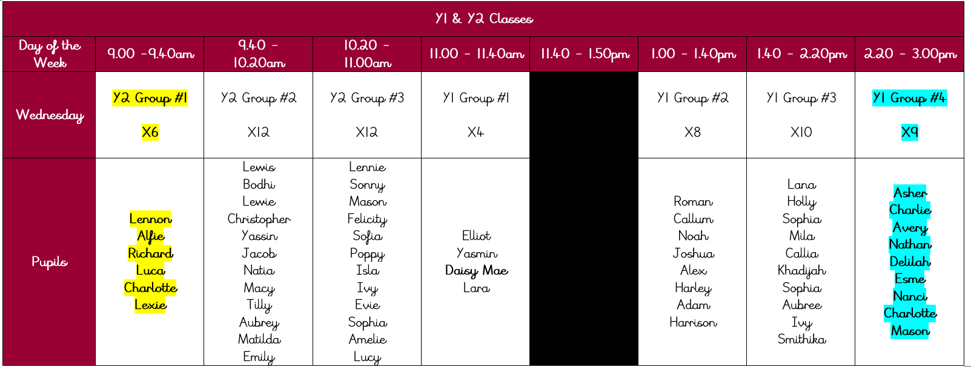

If your child is in the first group of the day, please ensure they come to school with their swimwear already under their PE kit so they can quickly change for a prompt start.

If your child is in the final group of the day, as their lesson finishes at 3.00pm please collect from school at 3.15pm, giving them time to get dried and dressed.

Warm regards,
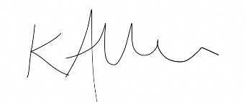
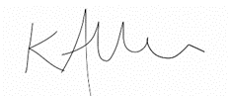
Kat Allen
Headteacher

