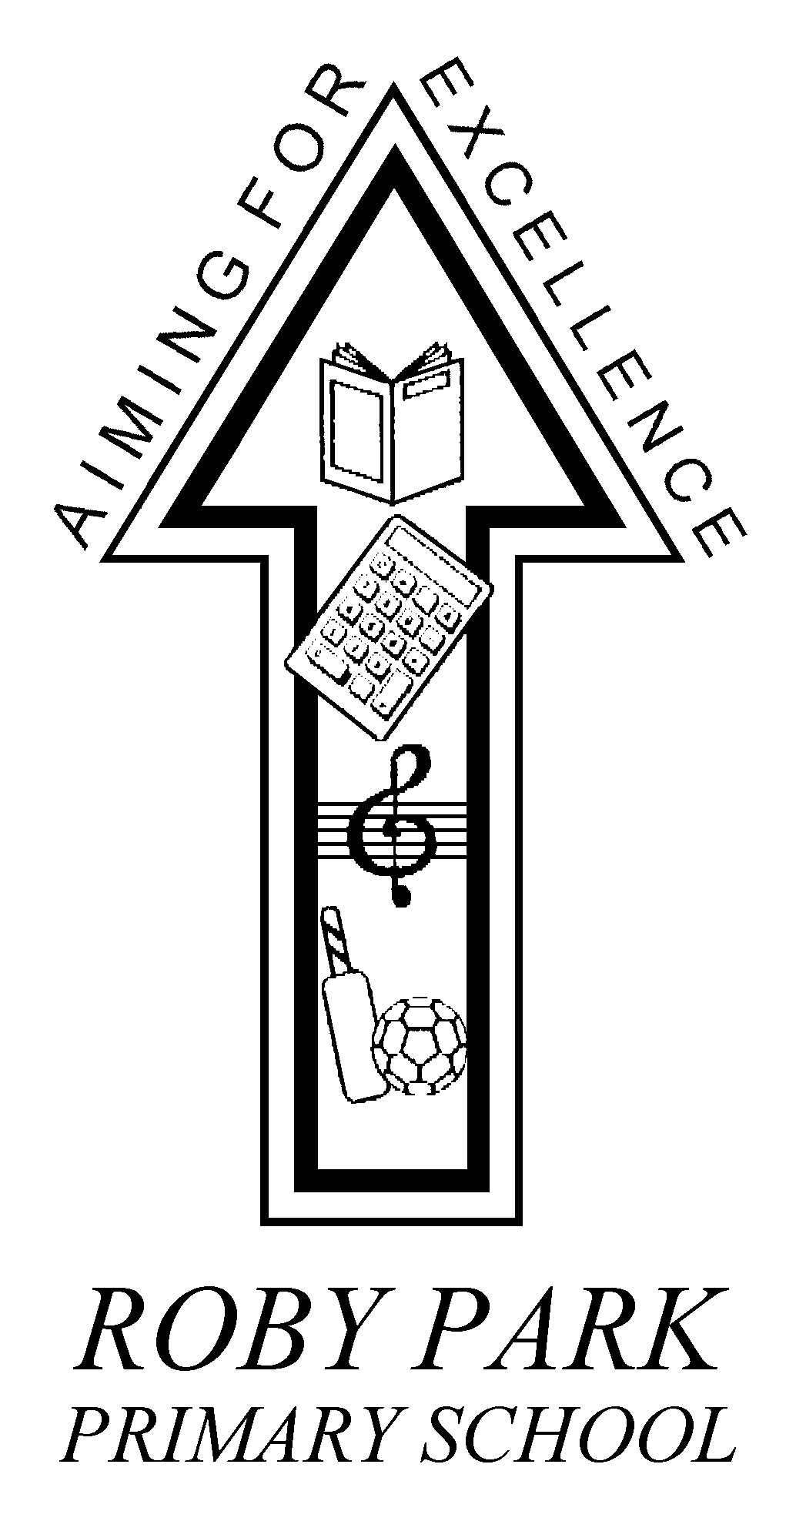

Roby Park Primary School

Easton Road

Huyton

Knowsley

L36 4NY

Tel: 0151 477 8340

Website: www.robyparkprimary.co.uk

E-mail: robypark@knowsley.gov.uk

Headteacher: Mrs K Allen
8th September 2023

Dear Parents/Carers,

Year 1 Museum Trip

We have arranged a visit to the ‘Museum of Liverpool - Toys Workshop’ on Monday 18th September. We will travel to and from the Museum by school minibus. We will return to school in time for the end of the school day.

Full school uniform must be worn. Please ensure that your child has a waterproof coat or jacket with a hood.

Please provide your child with a healthy packed lunch in a named carrier bag that can be thrown away after eating. (No cans or fizzy drinks please).

If you would like to order a school packed lunch then please let the office know by Friday 15th.

The cost is £3.00 per child payable by parent pay only. Paying by parent pay will also act as consent that you give your permission for your child to attend the trip.

Yours faithfully,

Mrs Allen
Headteacher

