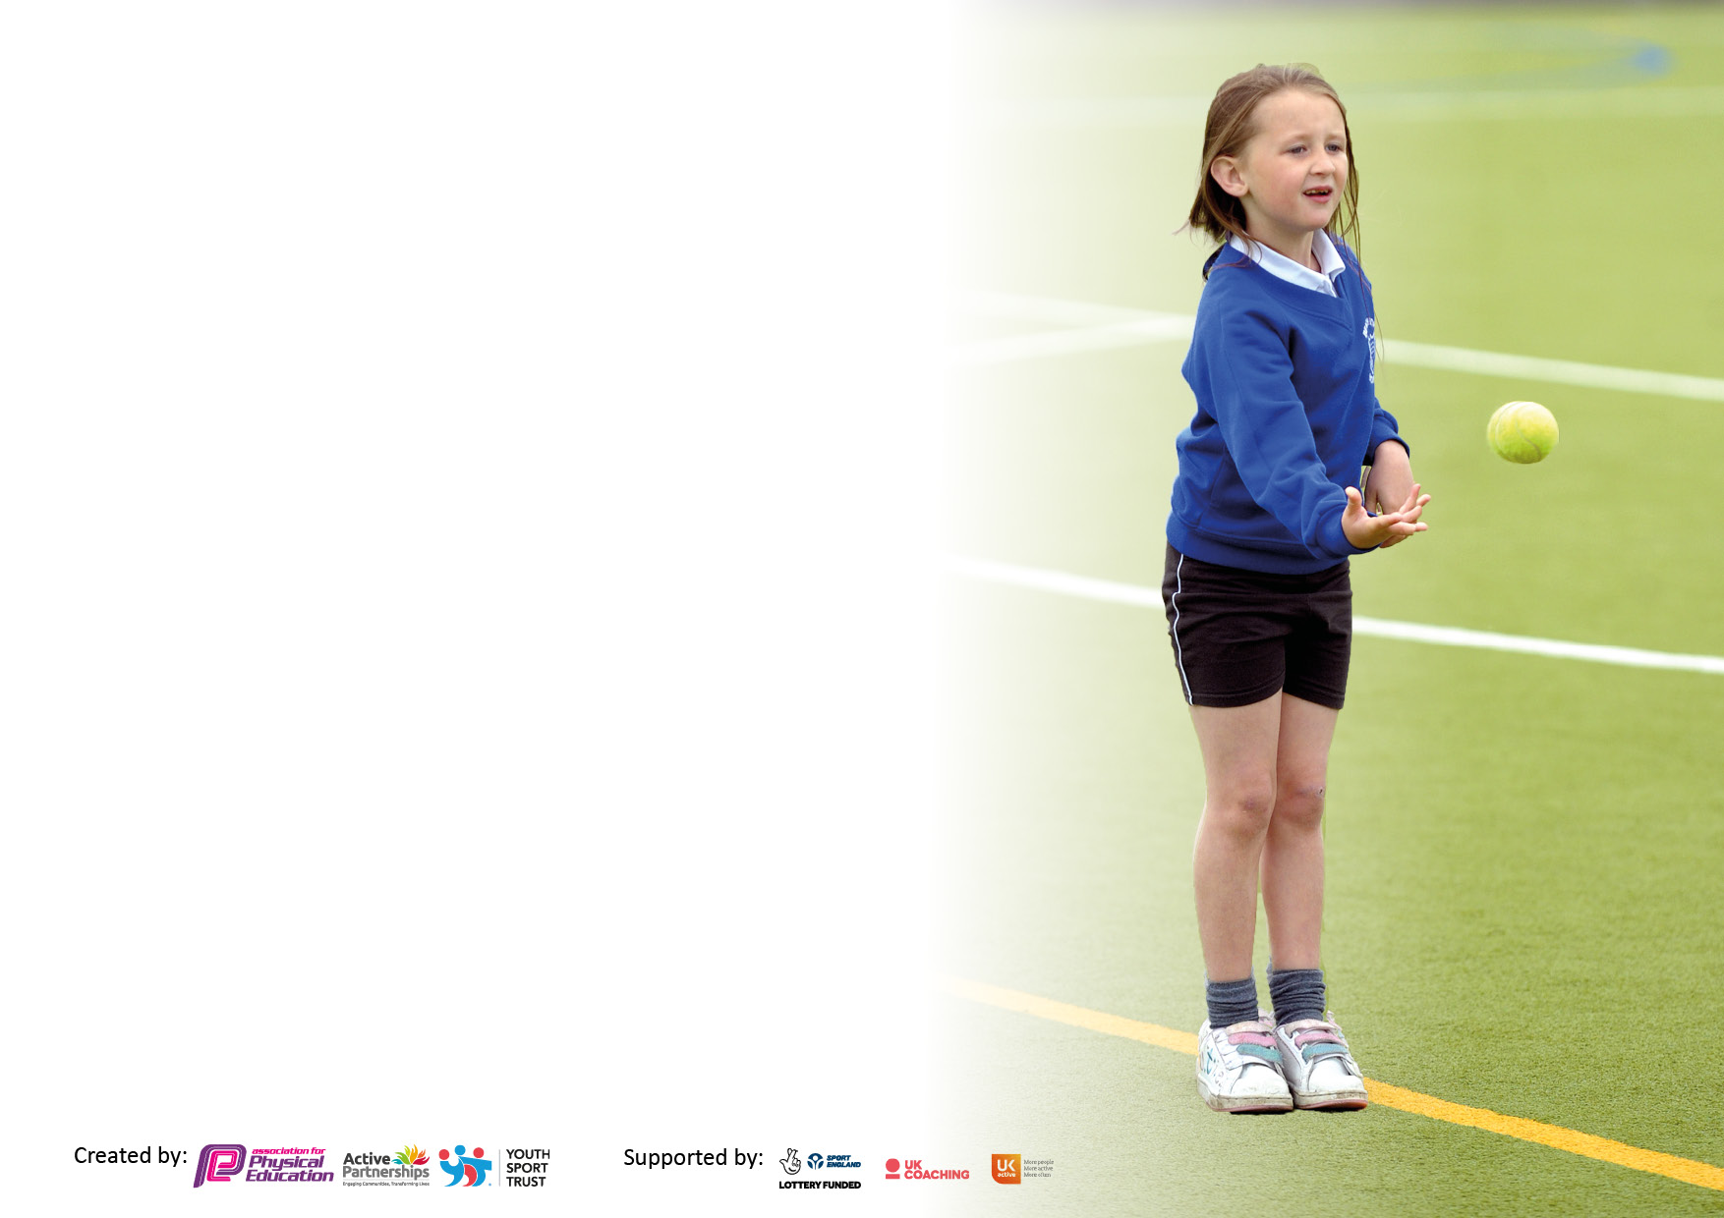

It is important that your grant is used effectively and based on school need. The Education Inspection Framework makes clear there will be a focus on **‘whether leaders and those responsible for governors all understand their respective roles and perform these in a way that enhances the effectiveness of the school’**.

Under the Quality of Education Ofsted inspectors consider:

**Intent** - Curriculum design, coverage and appropriateness

**Implementation** - Curriculum delivery, Teaching (pedagogy) and Assessment

**Impact** - Attainment and progress

To assist schools with common transferable language this template has been developed to utilise the same three headings which should make your plans easily transferable between working documents.

Schools must use the funding to make **additional and sustainable** improvements to the quality of Physical Education, School Sport and Physical Activity (PESSPA) they offer. This means that you should use the Primary PE and sport premium to:

* Develop or add to the PESSPA activities that your school already offer
* Build capacity and capability within the school to ensure that improvements made now will benefit pupils joining the school in future years
* The Primary PE and sport premium should not be used to fund capital spend projects; the school’s budget should fund these.

Pleasevisitgov.ukfortherevisedDfEguidanceincludingthe5keyindicatorsacrosswhichschoolsshoulddemonstrate animprovement.Thisdocumentwillhelpyoutoreviewyourprovisionandtoreportyourspend.DfEencouragesschools to use this template as an effective way of meeting the reporting requirements of the Primary PE and Sport Premium.

We recommend you start by reflecting on the impact of current provision and reviewing the previous spend.

Schools are required to publish details of how they spend this funding, including any under-spend from 2021/2022, as well as on the impact it has on pupils’ PE and sport participation and attainment. **All funding must be spent by 31st July 2023.**

We recommend regularly updating the table and publishing it on your website throughout the year. This evidences your ongoing self-evaluation of how you are using the funding to secure maximum, sustainable impact. Final copy must be posted on your website by the end of the academic year and no later than the 31st July 2023. To see an example of how to complete the table please click HERE.

**Details with regard to funding**

Please complete the table below.

|  |  |
| --- | --- |
| Total amount carried over from 2021/22 | £0 |
| Total amount allocated for 2021/22 | £0 |
| How much (if any) do you intend to carry over from this total fund into 2022/23? | £0 |
| Total amount allocated for 2022/23 | £17,630 |
| Total amount of funding for 2023/23. To be spent and reported on by 31st July 2023. | £17,630 |

**Swimming Data**

Please report on your Swimming Data below.

|  |  |
| --- | --- |
| Meeting national curriculum requirements for swimming and water safety.  N.B. Complete this section to your best ability. For example you might have practised safe self-rescue techniques on dry land which you can then transfer to the pool when school swimming restarts.  **Due to exceptional circumstances priority should be given to ensuring that pupils can perform safe self rescue even if they do not fully meet the first two requirements of the NC programme of study** |  |
| What percentage of your current Year 6 cohort swim competently, confidently and proficiently over a distance of at least 25 metres?  **N.B.** Even though your pupils may swim in another year please report on their attainment on leaving primary school at the end of the summer term 2022.  Please see note above | 57% |
| What percentage of your current Year 6 cohort use a range of strokes effectively [for example, front crawl, backstroke and breaststroke]?  Please see note above | 57% |
| **What percentage of your current Year 6 cohort perform safe self-rescue in different water-based situations?** | 100% |
| Schools can choose to use the Primary PE and sport premium to provide additional provision for swimming but this must be for activity **over and above** the national curriculum requirements. Have you used it in this way? | No |

**Action Plan and Budget Tracking**

Capture your intended annual spend against the 5 key indicators. Clarify the success criteria and evidence of impact that you intend to measure to evaluate for pupils today and for the future.

|  |  |  |  |  |
| --- | --- | --- | --- | --- |
| **Academic Year:** 2022/23 | **Total fund allocated:** £17,630 | **Date Updated: 11/7/23** | |  |
| **Key indicator 1:** The engagement of all pupils in regular physical activity – Chief Medical Officers guidelines recommend that primary school pupils undertake at least 30 minutes of physical activity a day in school | | | | Percentage of total allocation: |
| 42% |
| **Intent** | **Implementation** | | **Impact** |  |
| Your school focus should be clear what you want the pupils to know and be able to do and about  what they need to learn and to  consolidate through practice: | Make sure your actions to achieve are linked to your intentions: | Funding allocated: | Evidence of impact: what do pupils now know and what can they now do? What has changed?: | Sustainability and suggested next steps: |
| To increase the number of opportunities for all children to participate in physical activity and school sport. Whilst identifying and targeting the least active children and ensuring they receive additional support in order for them to meet and surpass the Chief Medical Officers guidelines. | Activall boards  Scootfit Workshops  Targeted physical activity interventions for children who require more support in order to meet the chief medical officer’s guidelines. | £6800  £750  Funding covered by school budget | 100% of children have participated in 2 inter school competitions (as of spring 2) where the children have competed to beat their own personal best scores. 100% of children have participated in a national intra school competition through the Activall website.  Available to all children with the focus of developing and improving the children’s agility, balance, co-ordination, confidence and attitude towards physical activity. Children’s comments:  “The skills I have learnt today have made me more confident on my scooter.”  “I can’t wait to go home and practise on my scooter.”  “Scooting is fun and a great way to come to school.”  Please see insight provision reviews for impact data. | Child sports leaders to be trained to support other children with the use of activall boards.  Consider ways the profile of this can be raised e.g. scoot to school days |
| **Key indicator 2:** The profile of PESSPA being raised across the school as a tool for whole school improvement | | | | Percentage of total allocation: |
| 38% |
| **Intent** | **Implementation** | | **Impact** |  |
| Your school focus should be clear what you want the pupils to know and be able to do and about  what they need to learn and to  consolidate through practice: | Make sure your actions to achieve are linked to your intentions: | Funding allocated: | Evidence of impact: what do pupils now know and what can they now do? What has changed?: | Sustainability and suggested next steps: |
| Develop teacher’s skills and  knowledge in activities that will  engage and inspire our pupils to take  part in life long physical activity.  Engage learners in new a different  experiences such as new sports and  new experiences with local providers.  - Use PE and sport to enable the  development of life skills that are  transferred to other curriculum  areas, wider school and beyond.  - High quality PE lessons delivered  during curriculum time.  - School staff better equipped/ more  confident to teach PE in school -  Monitoring use of schemes and  whole school PE coverage. | Invest in scooter equipment that will provide all children the opportunity to participate in regular physical activity.  Sports coach (JH) to deliver a range of interventions designed to develop the gross motor skills of targeted children across EYFS, KS1 and KS2. | £6800  Funding covered by curriculum budget | - PE physical activity and school  sport have a high profile and are  celebrated across the life of the  school.  - Continued progression of all  pupils during curriculum PE  lessons.  - Pupil interviews inform us that  pupils enjoy their PE lessons and  that pupils enjoy the variety of  activities on offer during  curriculum PE.  Please see insight provision reviews for impact data. | Identify the positive impact  that PE and school sport has on academic achievement,  behaviour and safety,  attendance, health and  wellbeing.  Review school policies/PE  policy - Use PE meetings to  review, evaluate and plan for  the next academic year. |

|  |  |  |  |  |
| --- | --- | --- | --- | --- |
| **Key indicator 3:** Increased confidence, knowledge and skills of all staff in teaching PE and sport | | | | Percentage of total allocation: |
| 3% |
| **Intent** | **Implementation** | | **Impact** |  |
| Your school focus should be clear | Make sure your actions to | Funding | Evidence of impact: what do | Sustainability and suggested |
| what you want the pupils to know | achieve are linked to your | allocated: | pupils now know and what | next steps: |
| and be able to do and about | intentions: |  | can they now do? What has |  |
| what they need to learn and to |  |  | changed?: |  |
| consolidate through practice: |  |  |  |  |
| Engaging all pupils in a high-quality and relevant Physical Education curriculum that is broad, balanced and inclusive.  Increase the attainment of pupils in Physical Education, including physical,  cognitive, social and emotional aspects  Raising standards of teaching and learning in Physical Education  To increase the confidence of staff in their delivery of the subject.  Lesson observations to monitor staff effectiveness and confidence.  Questionnaire to monitor pupil and staff attitudes towards progression in PE | Get Set 4 PE subscription | £550 | - Increased staff knowledge and  understanding  - All teachers able to confidently plan, teach and assess PE  - More sustainable workforce  including young leaders.  - Enhanced quality of provision  - Increased pupil participation in  competitive activities and festivals  - Increased range of opportunities  - A more inclusive curriculum which inspires and engages all pupils  -Discussions inform us that pupils  enjoy the variety of activities on offer during curriculum PE. | Review staff confidence and  competence in delivering high  quality PE and school sport and  allocate staff to upcoming CPD  opportunities - Further 1:1 lesson  observations to monitor staff  effectiveness and confidence. |
| **Key indicator 4:** Broader experience of a range of sports and activities offered to all pupils | | | | Percentage of total allocation: |
|  |
| **Intent** | **Implementation** | | **Impact** |  |
| Your school focus should be clear | Make sure your actions to | Funding | Evidence of impact: what do | Sustainability and suggested |
| what you want the pupils to know | achieve are linked to your | allocated: | pupils now know and what | next steps: |
| and be able to do and about | intentions: |  | can they now do? What has |  |
| what they need to learn and to |  |  | changed?: |  |
| consolidate through practice: |  |  |  |  |
| NHS data shows that Knowsley has one of the highest proportions of obesity in England. It is important that as a school we offer additional physical activity opportunities that impact positively on the health and wellbeing of our pupils. We recognise the potential impact we can make as a school if we utilise our facilities during the school holidays.  Ensure a wider offer is in place for all children, giving them access to a range of extra-curricular opportunities that promote physical and mental wellbeing. | Subsidised places to ensure Roby Park holiday clubs are accessible and affordable for working families. Vulnerable groups identified and free places made available to ensure our children and families are supported during holiday periods and are able to experience a broad range of sports and activities.  Extra-curricular clubs delivered by sports coach or external partners are well attended with a large percentage of the school accessing the provision see club tracking documents  Little Foot Forest | Funding covered by school budget  £4,948 Curriculum budget | Pupils have a safe environment where they are able to remain physically active during the school holidays. Activity sessions have a positive impact on the children’s levels of skill acquisition as well as their physical  and mental health.  **Numbers**  40 children taking up 238 spots across 3 weeks  Add parent/carer feedback                135 children attended a extra-curricular sports club Autumn 1  107 children attended an extra-curricular sports club in Autumn 2  161 children attended an extra-curricular sports club in spring 1  113 children attended an extra-curricular sports club in spring 2  113 children attended an extra-curricular in the summer term | Use pupil voice to find out what sports clubs the children would like to have included in the extra-curricular provision. |

|  |  |  |  |  |
| --- | --- | --- | --- | --- |
| **Key indicator 5:** Increased participation in competitive sport | | | | Percentage of total allocation: |
| 23% |
| **Intent** | **Implementation** | | **Impact** |  |
| Your school focus should be clear | Make sure your actions to | Funding | Evidence of impact: what do | Sustainability and suggested |
| what you want the pupils to know | achieve are linked to your | allocated: | pupils now know and what | next steps: |
| and be able to do and about | intentions: |  | can they now do? What has |  |
| what they need to learn and to |  |  | changed?: |  |
| consolidate through practice: |  |  |  |  |
| Provide children with an extensive  range of opportunities to play and participate in a broad range of competitive sports | By having access to the mini bus and having a number of members of staff who are able to drive it means we are able to provide our children with more opportunities to participate in competitive sport. | £4095 covered by sport premium  £2730 covered by the school budget  Mini Bus annual cost £6,825 | Increased participation in competitive sports, development of all children’s physical health and well-being and development of talents and interests.  Competition participation data. What have we entered? Who has attended? | Look at developing levels of competition so some events are aimed at participation while others are aimed at competition.  Ensure all competitions are recorded on school calendar and pupil participation is recorded. |

|  |  |
| --- | --- |
| Signed off by | |
| Head Teacher: |  |
| Date: |  |
| Subject Leader: | C Swatman |
| Date: | 11.7.23 |
| Governor: |  |
| Date: |  |